Art and craft workshop prepared by the teachers from Základní škola, Praha 2, Londýnská 34,
the Czech Republic, Prague
on the topic HAND MADE JEWELLERY
For the purpose of the project meeting in Łowicz, Poland, part of the European project Play, be free!
- DECOUPAGE
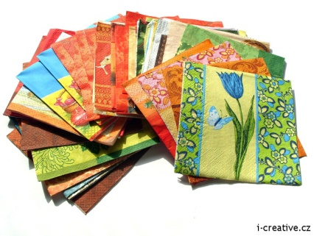
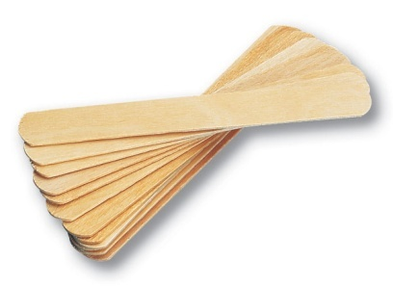
During the workshop, the pupils learnt two art techniques. The first one is called decoupage. It is the art of decorating an object by gluing coloured napkin cut-outs onto it. The objects we used were thin wooden tongue depressors that had the shape of a bracelet. Before coming to the project meeting in Poland, the tongue depressors were soaked in hot water and put in an appropriate glass let to dry. After taking out of the glass, the tongue depressors kept the right shape. Students could combine decoupage with other special paint effects and glitters to decorate bracelets according to their style.

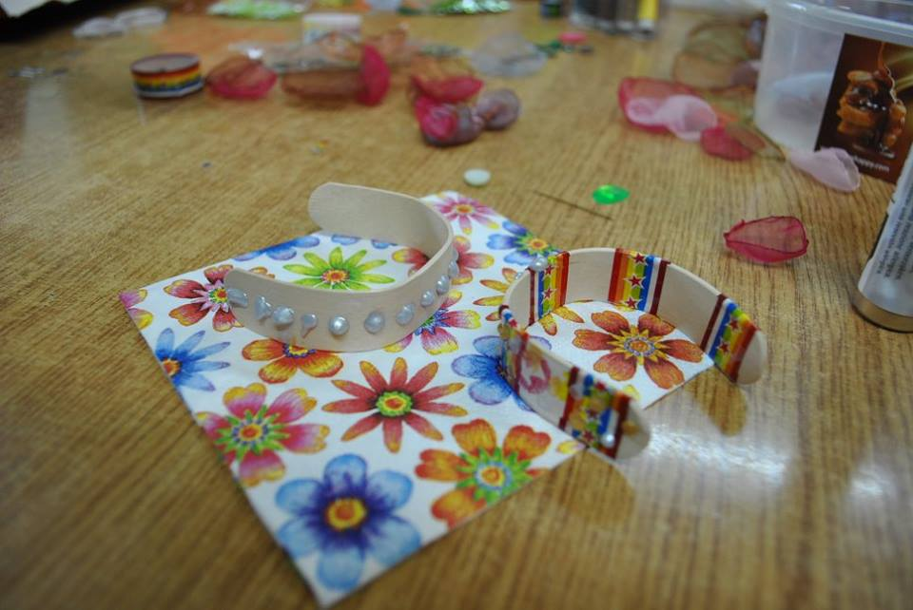
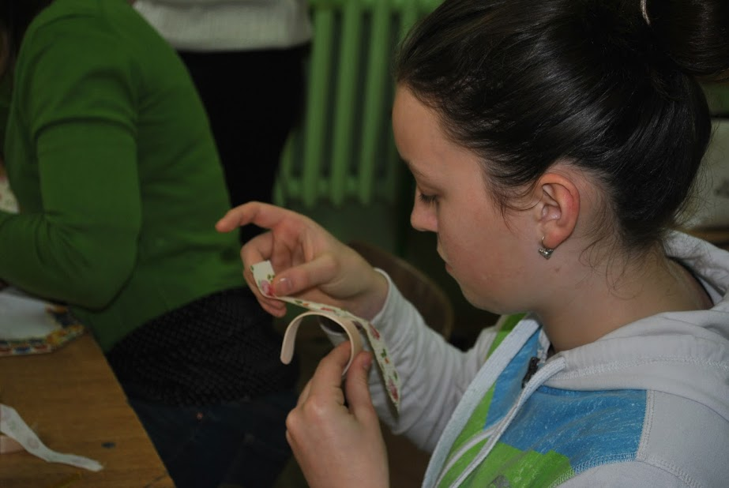

- ORGANZA FLOWERS
The second type of jewellery that students made themselves was so called “organza flower”. The name describes the material and its shape. For this technique, the students needed circular pieces of fabric called organza that were singed. Organza is usually used to make curtains, so it is not difficult to find some pieces at home. Students could choose from various size and colour. They sewed the pieces together and decorated the top with beads or glitters using the hot glue gun. Finally they glued it to a hair clip, hair elastic or sewed it to a safety pin and made a brooch. Some students also decided to make earrings.
