Hi dear friends!
We are Dimitar and Dobromir from Bulgaria. We are really happy to be part of the project’’ PLAY, BE FREE!’’
We had an unforgettable week in Lowicz, because we met so many new friends from Poland, Czech Republic and Italy.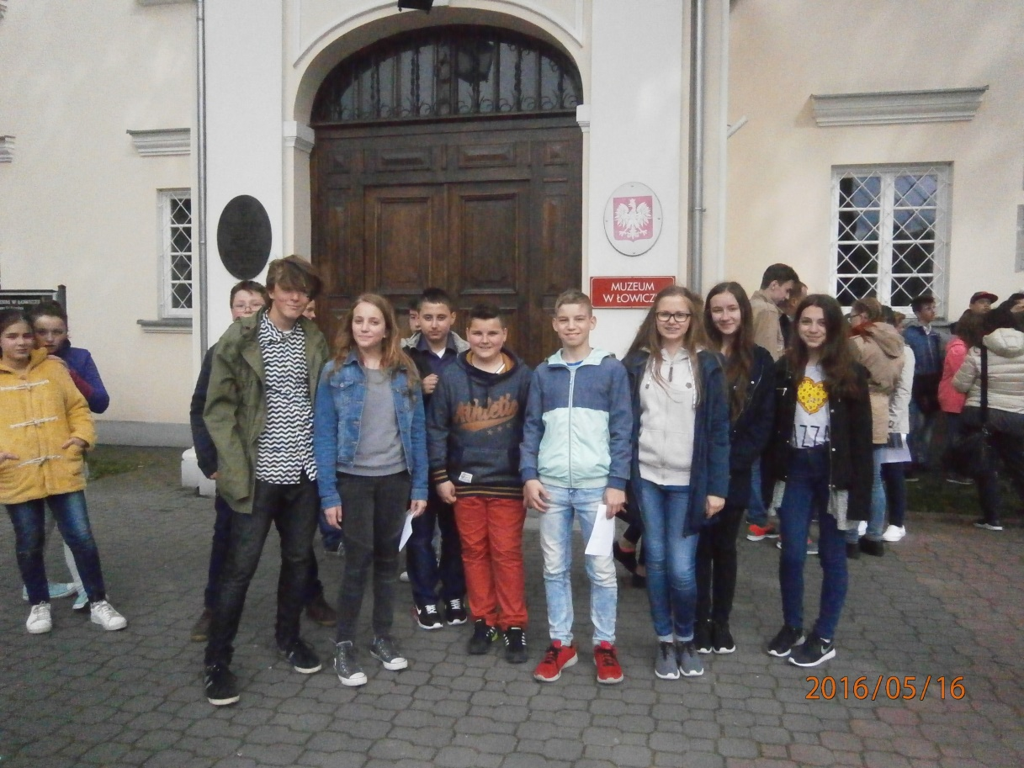
We arrived on 15th Mayat Warsaw airport.
Weronica and Artur met us at the airport.
Later, the groups from Italy and , Czech Republic arrived too.
We went to Lowicz by bus.At last we arrived in the town.
All the boys and girls from host family’s were there.The teachers from Lowicz school were there too.

The first day, 16 May,we visited school.
All the children from school welcomed us.Then we went to a big gym and watched a traditional dance called Polka. All thechildren,partners of the projectPlay Be Free!got gifts.Then we went to the Town Hall. It was perfect!We saw a mayor of Lowicz and Bulgarian group give him a T-shirt of Smolyan.We came back to have lunch in school canteens. It was very delicious.Then we had a game (Find Treasures) in the center to find some famous buildings (Gallery, Museum and cinema).We went back to host family’s house .
The second day, 17 May, we hada trip to Maurzycemuseum.We had lunch in school canteen.Later we visitedLowicz museum.It was nice!Afterwards we went to school disco.It was very fun and emotional! Then we came back to host family’s house.
The thirdday ,18 May, we went to school and showed our presentations.Then we had Workshop part 1We made Jewelry, T-shirts, paper flowers and embroidery.Dobromir and Dimitar made Jewelry and T-shirts. Then we had lunch in school canteen.We had Workshop part 2.Dobromir and Dimitar again made T-shirts and Paper flowers. That day was very creative. Then we went back to host family’shouse.
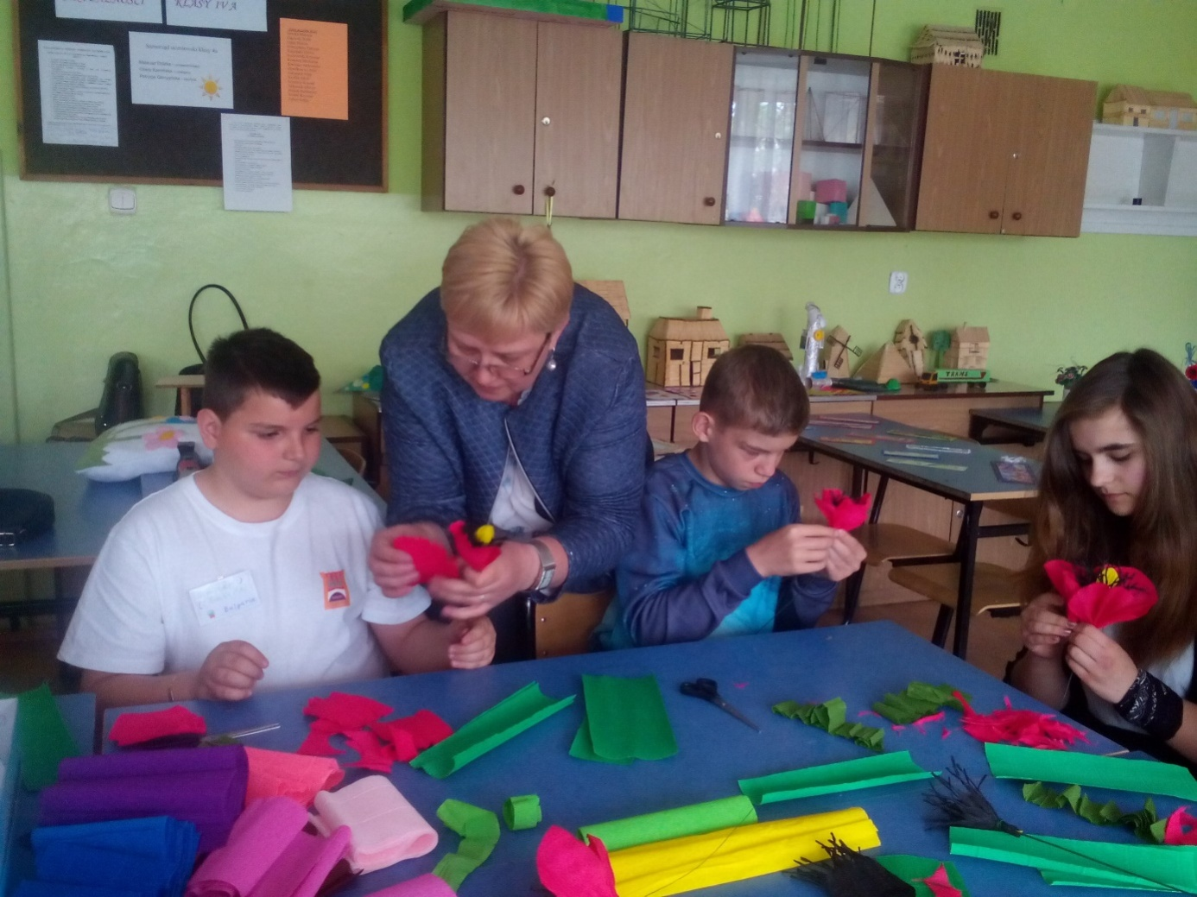

The fourth day, 19 May, we had a trip to Warsaw.We visited many landmarks and monuments.Some of them were museums- of science and culture- Old town, Royal Castle,Monument of Adam Mickiewicz, Monument of Warsaw Hero, Museum of miniatures and any more.We bought souvenirs form Old town.
We likedWarsaw Hero monument because a girl of group said, “I will defend the city fromevils.”In the museum of miniatures there were very beautiful miniatures, famous buildings too.Then we went to mall and had lunch there.
That day was really great!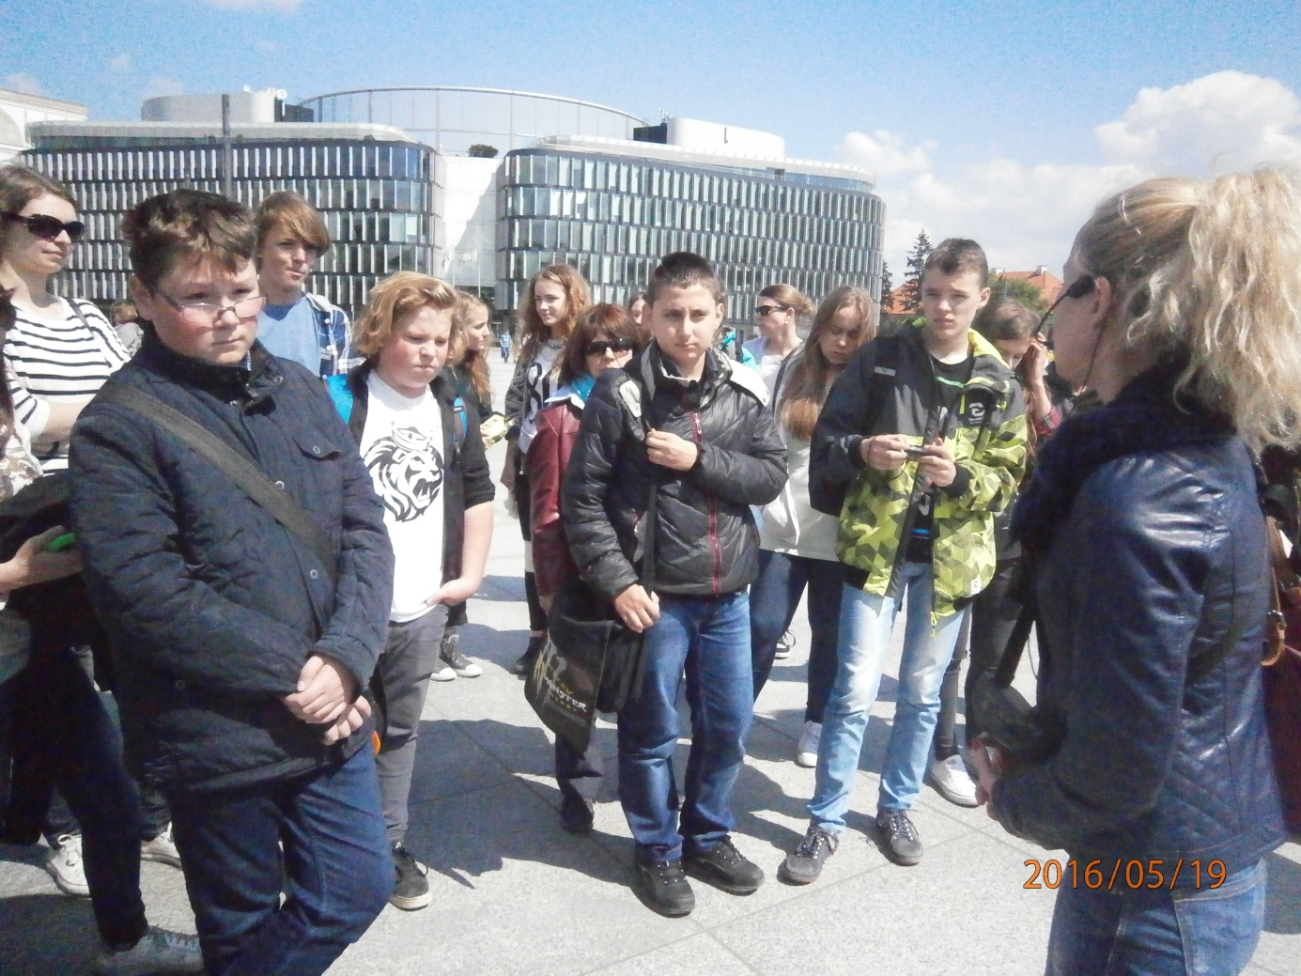
Thelatest day, 20 May, we went to school.We played game with our presentation artists.Then we presented our things from workshop.We played football, volleyball, basketball in the gym.Then we had lunch in school canteen.Then we painted pictures in the classroom.
Next we visited a country house- 15 kmaway from Lowicz.
All the children were a little sad because the next day weshoud leave from Poland.We had a camp fire there and played and sang a lot !We ate sausages roasted into the camp fire.It was exciting!The children said,”Bye-bye” each other.On the 21st May we waited a bus from school to go to Warsaw airport.
Thanks polish students, families and teachers for hospitality. Thanks everyone who gave us the opportunity to know new countries and cultures.Great thanks to our teacher, MrsDafincaNikolova, being a part of this lovely and unforgettable project!

Created by DobomirNeichev and DimitarGateshki from Smolyan, Bulgaria

