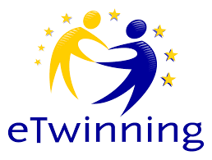
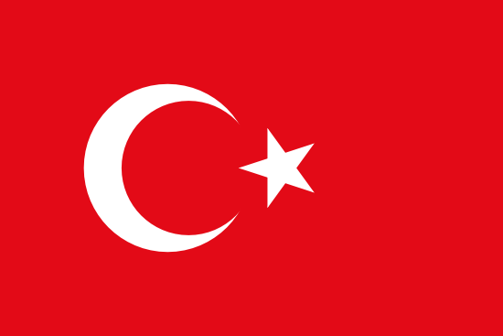

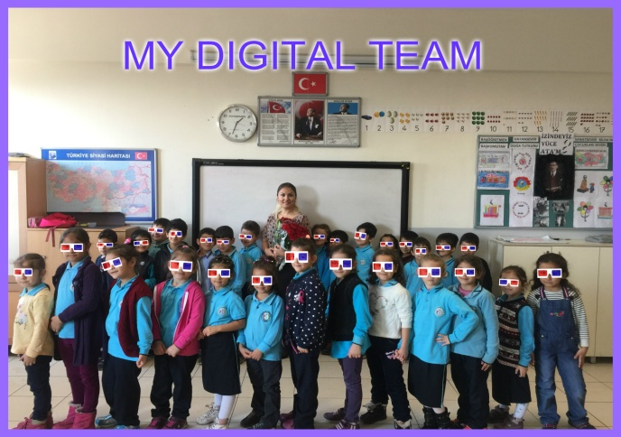

Hello my dear etwinner friends! I am Figen Köksalan Sanchezpena from İstanbul /TURKEY.
I am a member of an etwinning Project called as “ Be Digital ”.
In my opinion, etwinning : Makes the distances closer. Makes lessons more fun and efficient. Improves imagination and vitality. Solves the problems. It teaches you how to cooperate. Brings 21st century skills. The most important thing is we get new friendships.

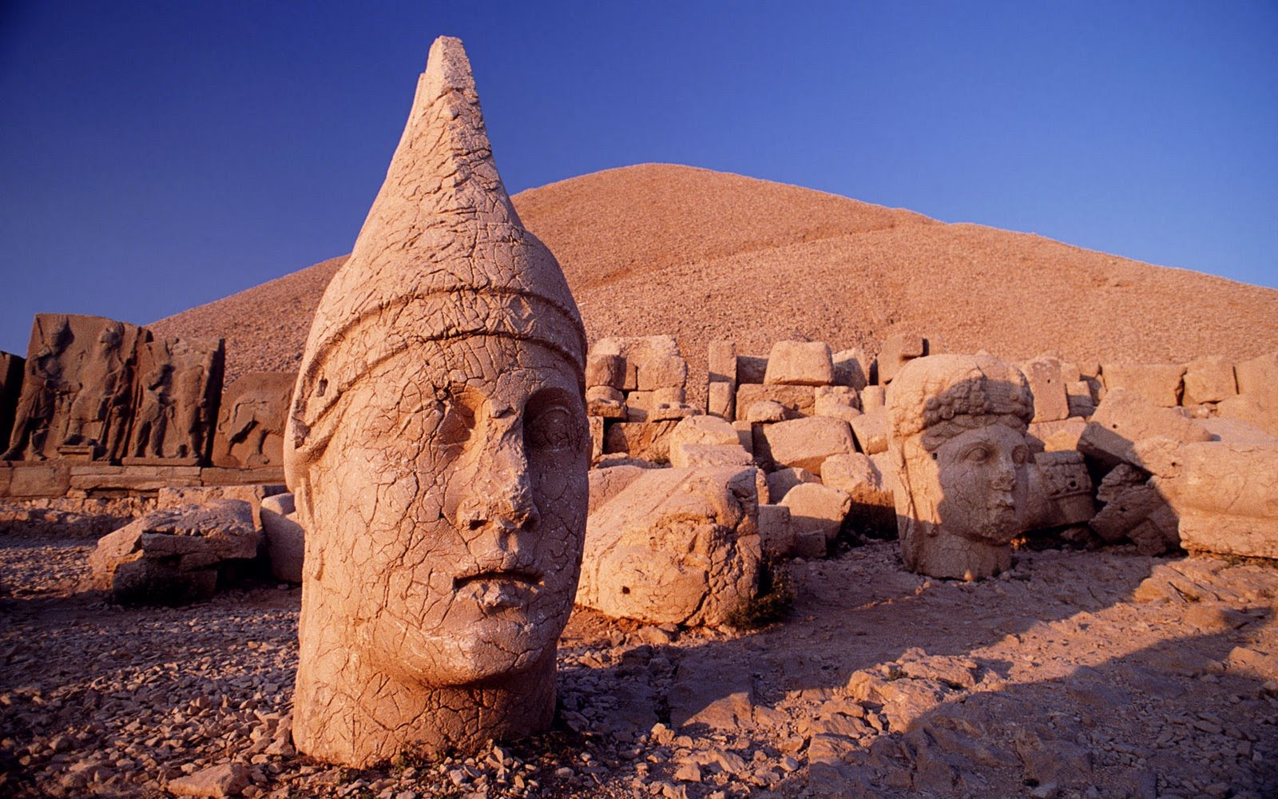

Nemrut Mountain , ADIYAMAN

