eTwinning Project Plan

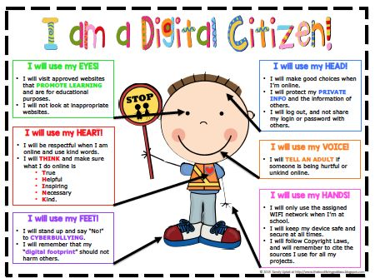
Name of the project: | Saf(eT)yLandia- Be responsible online!
Partners: | Cornelia Melcu Ro,  Georgios Konstantinou, Cy  Nektarios Farassopoulos, Gr
Details: | Age of the pupils:  Used language: English, Romanian, Greek  Duration: 8 months  School type: Primary school
Short description: | The project is designed to empower young students to think critically, behave safely, and participate responsibly in our digital world.
Goals: | To understand the basic of the digital citizenship  To improve the ST communication skills  To promote interaction  To increase motivation for learning  To work in group and help team building  To develop ICT skills  To establish better understanding of similarities and differences among cultures
ICT tools: | googledocs  blog  YouTube video  slide.com/slideshare/animoto  quizz  Smilebox  PhotoPeach  http://meetingwords.com/  Pocovise Avatar Creator  VOKI
Pedagogical basis: | Students will work collaboratively in order to understand the basic of digital citizenship concept. They will explore the basic aspects of digital citizenship included them in their curriculum and working in international groups.
Working methods: | A variety of working methods will be used according to the SS needs and expectations in order to overcome any obstacles and achieve a successful procedure.  SS have to prepare their tasks and then to upload them on the blog and in the TwinSpace then they will discuss the similarities and differences between cultures.

https://www.commonsensemedia.org/educators/scope-and-sequence

eTwinning project timetable

Time / period | Task description – tools to be used | Responsible person(s)
October | Planning the project- googledocs  (Shall we built a time line? We can use - tool to organize time - read write think time line) | Cornelia Melcu Ro
November | Introducing each other: Teachers, Pupils using avatars  My best friend…(Students will identify who are their best friends and how they spend mostly their spare time)  Spending time online…( Students will share their experience related to computer/laptop, tablet. iPads, mobiles using).  Maybe an online survey about the time they spent in internet, if they have internet ect | Talking avatars  https://sites.google.com/site/webtoolsbox/avatars/talking-avatars  Educational book:  https://www.youtube.com/watch?v=LLqi9D4EA7Q
December | How do you go places safely on the computer?  Built some collaborative flyers with advice for a good use of internet and send them to some our friends (as a christmas present, or card) - Tool - Meetingwords,
January | How can you use the alphabet to find things online ?  What kinds of information should you keep to yourself when you use the Internet?
February | How do you stay safe when you visit a website or play games.  Shall we be at the computer all day? Why is it important to play outside and have friends that are not virtual? Computer versus playing
March | How do we communicate online? (using emoticons)  Is the computer my best friend? The computer a very good mean to communicate  With the computer I can communicate with friends that live in another country - (Video conference)
April | What can you do when someone is mean to you online?  Create a short video or a puppet theater that shows what to do when you face cyberbullying
May | Create an ebook of internet etiquette made with the drawing of the students  Or mouse pad like this  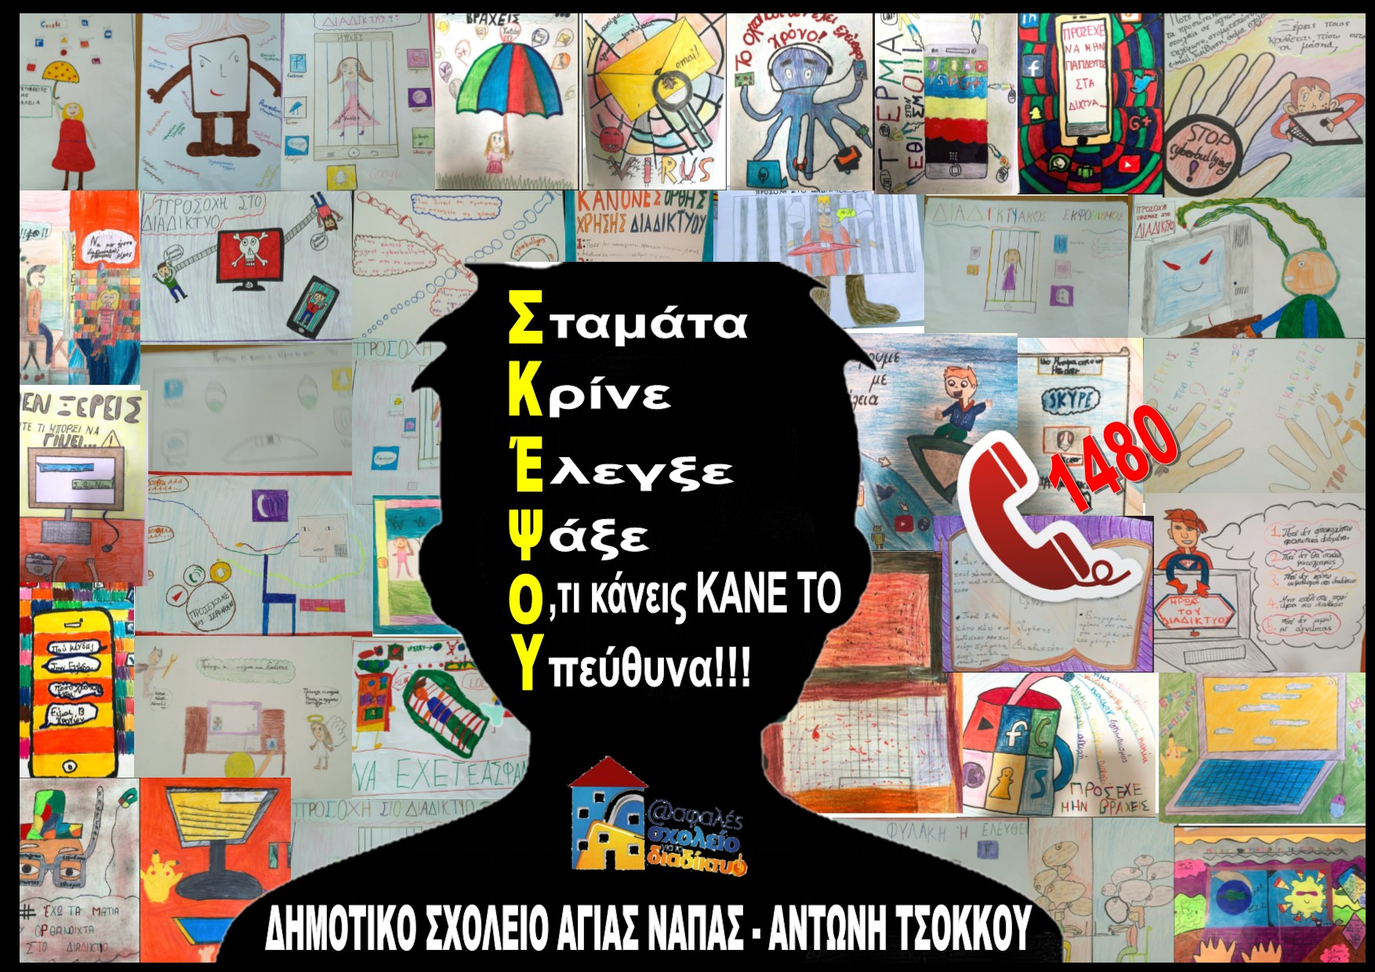
June | Project’s evaluation
George | My Digital Footprint  Children make their own digital footprint by writing down a tip for safe internet browsing. Then everything will be posted on a sign, in a busy part of the school | 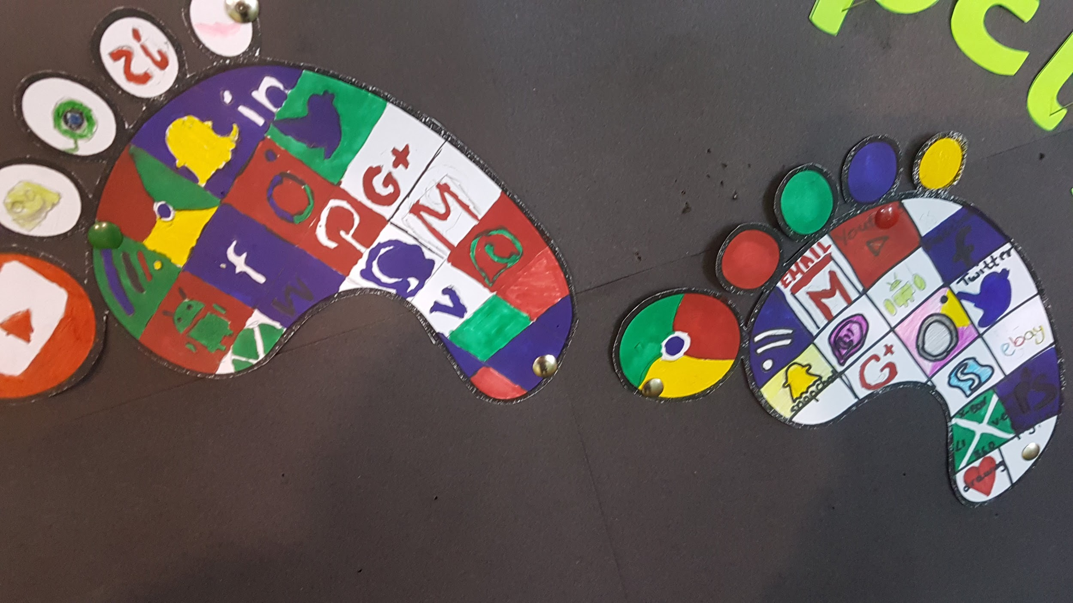  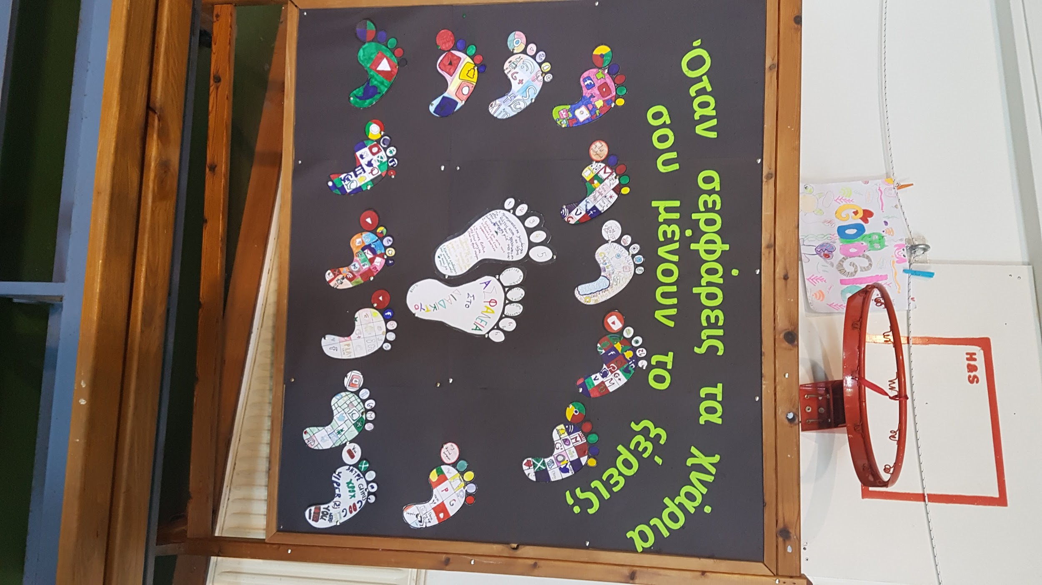
 | “Follow me if you know me”,  Student photography  School photo exhibition for parents and students, with tips for protecting our personal information online.  All of the above will be published on the school website. | 