European day of languages (26th of September)

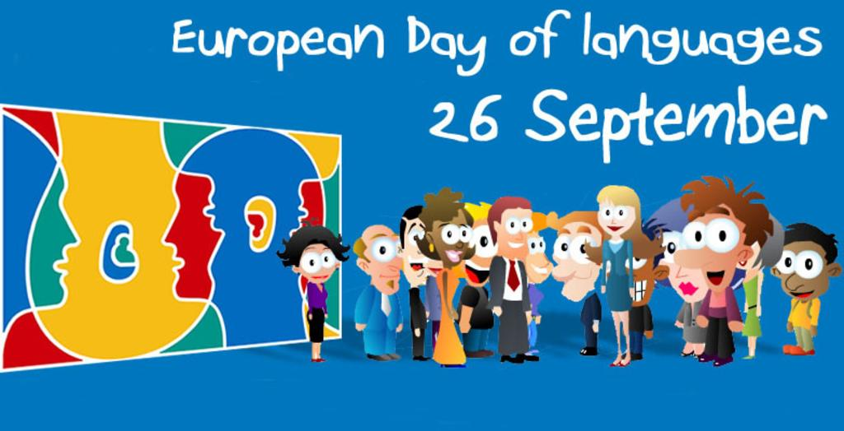

“A different language is a different vision of life”

Activity 1: Games from all around Europe
Please, add a game from your country. It can be a traditional or a modern game, that is up to you. Help us understand how we can play this game: Describe what the players are supposed to do, which is the final purpose, explain the rules.

Country | Game | Description - Rules
Poland | THE BALLOON RHYME  FATHER WIRGILIUSZ | Our tiny, tiny balloon  Please, grow big and big and round.  Balloon’s rising, that it's scary,  He has changed - and boom!  Children make a circle (balloon) and approach all inside the circle. Then they go back - and a circle (balloon) grows. At the end a circle (balloon) breaks, and kids 'fall' on the floor.  Father Wirgiliusz was teaching his children,  He had them all one hundred twenty three.  Come on, children, come on here,  come on here, come on here!  Do everything  that I do, that I do.  Children form a circle, holding hands. One child - Father Wirgiliusz - stands in the middle. The wheel rotates in the rhythm of the song. After the words „one hundred twenty three” all stop, turn to face the center of the circle and clap their hands. After the words: „Do everything that I do, that I do” Father Wirgiliusz shows some simple gestures, exercise (eg. squats, bows), and all of them are repeated until the end of the song.  Then a new Father Wirgiliusz is selected and the play begins again.
Italy | Regina, Reginella | Players must be at least 4. The ideal number is 10 players.  With a counting out rhyme, a "queen" is selected; she will stand on one side of the playground, opposite the players. Then the children chant this rhyme: " Beautiful, beautiful Queen, how many steps do I have to take to get to your castle with the faith, with the ring, with the tip of the knife?" The Queen calls out a number of steps and a name an animal; all the children must take those steps pretending to be that animal, for example, if they are ants they must take very small steps; if they are elephants they take huge steps.  The game ends when a child arrives first in front of the Queen: that child will be, in turn, the Queen for the next round of the game.
Spain | Little Blind Chick | Music and movement game.  video 1: Kids playing the game  https://www.youtube.com/watch?v=sMztRKF0v3A  Video 2: Spanish and English Lyrics.  https://www.youtube.com/watch?v=72FQUnIOlqo  Game Instructions:  It should be played in a large area with no obstacles. The players blindfold one child who was previously chosen. That kid is the "litte blind chick". They turn him around a few times so he doesn't know where he is. Then the children scatter around and sing the song. The "little blind chick" tries to catch the players, guided by their voices. In some versions of the game, he must figure out who the player he just caught is by touching them.
Romania | THE STONE BRIDGE | The stone bridge  The stone bridge is an important outdoor game, usually attended by at least 6 players.  How to play the Stone Bridge?  Of the participants in the game will be chosen 2 who will stand face to face, hands raised and raised above the head, as a bridge. Then the following song will start to sing:  „The stone bridge collapsed  The water came and took it  We'll do another down the river  The other more trainable and more beautiful.”  https://www.youtube.com/watch?v=pQ-wzwzrl6g  During this time, the rest of the participants in the game pass one by one under the bridge (under the hands of those who make up the bridge).  When the song comes to an end, the players that make up the bridge will lower their hands by catching the one who was at the moment under the bridge. He will exit the game and join one of the players forming the bridge. He will choose behind who he sits  The game continues until all the children are caught under the bridge, and in turn, they choose behind whom to sit.  In the end, 2 teams are formed, which will compete in the Rope Run. The members of each team team will cut a string, trying to draw the others beyond a marking line. Win the team that managed not to cross the marking line.
Lithuania | Don’t say yes! | Game 1: Don’t say yes!  One pupil sits on a chair and answers the others’ kids questions. They ask about his family, hobbies, favorite pets… and he isn’t supposed to say yes. If he does so or nodds his head, he will lose the game.  The goal of this game is to make the pupils express themselves and use different ways to communicate.  Game 2: Find the similarities and differences in the following pictures making comparison about this family in the past in the present.  All you need is some color pens and blank drawing sheets.  Game 3: It’s a wordsearch! Pupils have to circle words. This is a more of a fun game that allows them to show their knowledge but also helps them get familiar with different words and expressions.
Greece | The bee goes round and round | Music and movement game.  Video 1: Kids playing the game https://www.youtube.com/watch?v=EYRDmsw-YPk  Video 2: The Greek Song  https://www.youtube.com/watch?v=y42EVt4hUhA  Lyrics and guidance in English  Detailed explanation:  Two children (or teachers) stand opposite to each other. Before the game starts, these two players choose a category e.g. Flowers. Each of the two players chooses a flower (e.g. one chooses red rose, the other white jasmine) and they keep their choice a secret. The rest of the kids are creating a train.  The rest of the kids makes a train. Everyone starts singing a song (in Greek there is a specific song - you can use this song or any other). The train starts moving and it passes by the two standing players who are clapping their hands.  Every time the song ends the two players stop a kid. One of the two players whispers the two choices to the kid they stopped. The kid picks one and whispers it to the player. The player tells him/her to which team he/she is in and the kid stands behind the player he/she chose. The game goes one until every kid is stopped. The team that wins is the one that has the most children.

Activity 2: The word puzzles
Please, add the word “Game” or “Toy” in your mother language. We will write the words in big cartons and cut them into pieces to create puzzles. We will then give the pieces and a label to the children so they can look at the label and do the puzzle in order to re-write the word.

Language | The word “Game” or “Toy” in your mother language
Polish | gra (game), zabawka (toy)  for puzzles you can use the website:  https://www.jigsawplanet.com/
Italian | gioco (game) - giocattolo (toy)
Spanish | Juego (Game) - Juguete (Toy)
Romanian | Joc (Game)- Jucarie (Toy)
Lithuanian | žaidimas
Greek | Παιχνίδι - ΠΑΙΧΝΙΔΙ

Example:
Puzzle word Label

*If you wish, you can also use flags instead of words*
