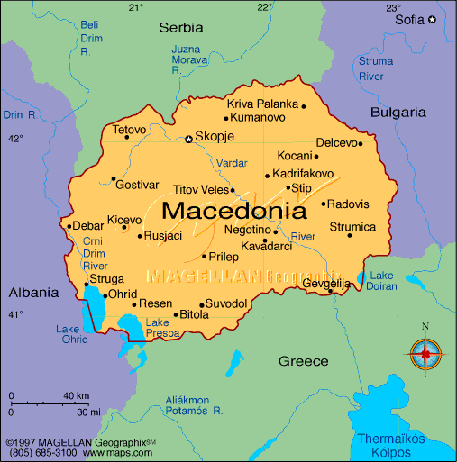

Macedonia (/ˌmæsɪˈdoʊniə/ (listen); Macedonian: Македонија, translit. Makedonija [makɛˈdɔnija]), officially the Republic of Macedonia (Macedonian: Република Македонија, translit. Republika Makedonija [rɛˈpublika ˌmakɛˈdɔnija] (listen)), is a country in the Balkan Peninsula in Southeast Europe. It is one of the successor states of the former Yugoslavia, from which it declared independence in 1991.
The country became a member of the United Nations in 1993, but, as a result of an ongoing dispute with Greece over the use of the name Macedonia, was admitted under the provisional description the former Yugoslav Republic of Macedonia (sometimes abbreviated as FYROM and FYR Macedonia), a term that is also used by international organizations such as the European Union, the Council of Europe, and NATO.
The Prespa agreement, signed by Macedonia and Greece in June 2018, will see the country change its name to the Republic of North Macedonia. A non-binding national referendum on the matter passed with 90% approval, although it did not reach the required 50% turnout due to a boycott, leaving the final decision with parliament to ratify the result. Parliament approved of the name change on 19 October, reaching the required two-thirds majority needed to enact constitutional changes. The vote to amend the constitution and change the name of the country passed on 11 January 2019 in favor of the amendment. The amendment will enter into force following the ratification of the Prespa agreement and the yet-to-be-signed Protocol on the Accession of Macedonia to NATO by the Greek Parliament.
A landlocked country, the Republic of Macedonia has borders with Kosovo to the northwest, Serbia to the north, Bulgaria to the east, Greece to the south, and Albania to the west. It constitutes approximately the northwestern third of the larger geographical region of Macedonia, which also comprises the neighbouring parts of northern Greece and smaller portions of southwestern Bulgaria and southeastern Albania. The country's geography is defined primarily by mountains, valleys, and rivers. The capital and largest city, Skopje, is home to roughly a quarter of the nation's 2.06 million inhabitants. The majority of the residents are ethnic Macedonians, a South Slavic people. Albanians form a significant minority at around 25 percent, followed by Turks, Romani, Serbs, Bosniaks, Aromanians, and Bulgarians.
This region's history dates back to antiquity, beginning with the kingdom of Paeonia, probably a mixed Thraco-Illyrian polity. In the late sixth century BC, the area was incorporated into the Persian Achaemenid Empire, then annexed by the Kingdom of Macedonia in the fourth century BC. The Romans conquered the region in the second century BC and made it part of the much larger province of Macedonia. Τhe area remained part of the Byzantine (Eastern Roman) Empire, and was often raided and settled by Slavic tribesbeginning in the sixth century of the Christian era. Following centuries of contention between the Bulgarian, Byzantine and Serbian empires, it gradually came under Ottoman dominion from the 14th until the early 20th century, when following the Balkan Wars of 1912 and 1913, the modern territory of Macedonia came under Serbian rule. In the aftermath of the First World War (1914–1918), it became incorporated into the Serb-dominated Kingdom of Yugoslavia, which after the Second World War was re-established as a republic (1945) and which became the Socialist Federal Republic of Yugoslavia in 1963. Macedonia remained a constituent socialist republicwithin Yugoslavia until its peaceful secession in 1991.
The sovereign state of Macedonia is a parliamentary republic and member of the UN and of the Council of Europe. Since 2005 it has also been a candidate for joining the European Union and has applied for NATO membership. Although one of the poorest countries in Europe, Macedonia has made significant progress in developing an open, market-based economy.

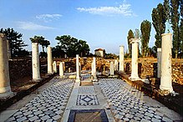
Heraclea Lyncestis, a city founded by Philip II of Macedon in the 4th century BC: ruins of the Byzantine "Small Basilica"

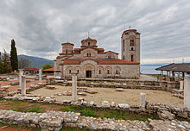
The church of St. Clement and St. Panteleimon in Ohrid.

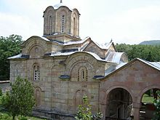
Marko's Monastery in Markova Sušica.

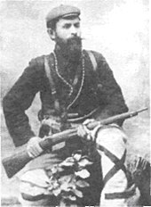
Nikola Karev, head of the Provisional Government of the short-lived Kruševo Republic during the Ilinden uprising

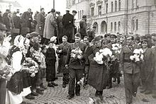
Dimitar Vlahov, Mihajlo Apostolski, Metodija Andonov-Čento, Lazar Kolishevski and others, greeted in Skopje afer the capture of the city in November 1944.

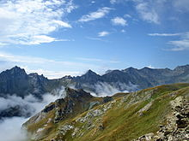
Mount Korab, the highest mountain in Macedonia

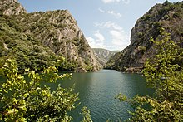
Matka Canyon

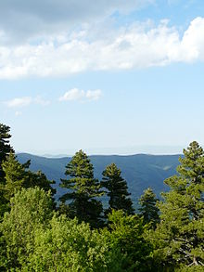
Pinus peuce, the Macedonian Pine or Molika, one of Macedonia's most recognisable trees

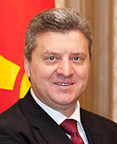 | 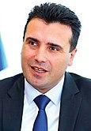
Gjorge Ivanov  President | Zoran Zaev  Prime Minister

