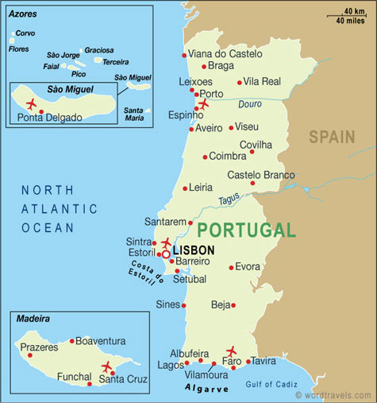

Portugal (Portuguese: [puɾtuˈɣal]), officially the Portuguese Republic (Portuguese: República Portuguesa [ʁɛˈpuβlikɐ puɾtuˈɣezɐ]), is a country located mostly on the Iberian Peninsula in southwestern Europe. It is the westernmost sovereign state of mainland Europe. It is bordered to the west and south by the Atlantic Ocean and to the north and east by Spain. Its territory also includes the Atlantic archipelagos of the Azores and Madeira, both autonomous regions with their own regional governments.
Portugal is the oldest state on the Iberian Peninsula and one of the oldest in Europe, its territory having been continuously settled, invaded and fought over since prehistoric times. The Pre-Celts, Celts, Carthaginians and Romans were followed by the invasions of the Visigoths and Suebi Germanic peoples.
Portugal as a country was established during the Christian Reconquista against the Moors who had invaded the Iberian Peninsula in 711 AD. Despite attempts at independence since its foundation as a county in 868, only after the Battle of São Mamede in 1128, where Portuguese forces led by Afonso Henriques defeated forces led by his mother, Teresa, the County of Portugal affirmed its sovereignty and Afonso styled himself Prince of Portugal. He would later be proclaimed King of Portugal at the Battle of Ourique in 1139 and was recognised as such, by neighbouring kingdoms, on the Treaty of Zamora, in 1143.
In the 15th and 16th centuries, Portugal established the first global empire, becoming one of the world's major economic, political and military powers. During this period, today referred to as the Age of Discovery, Portuguese explorers pioneered maritime exploration, notably under royal patronage of Prince Henry the Navigator and King John II, with such notable voyages as Bartolomeu Dias' sailing beyond the Cape of Good Hope (Cabo da Boa Esperança) (1488), Vasco da Gama's discovery of the sea route to India (1497–98) and the European discovery of Brazil (1500). During this time Portugal monopolized the spice trade, and the empire expanded with military campaigns in Asia. However, events such as the destruction of Lisbon in a 1755 earthquake, the Industrial Revolution, the Seven Years' War, the country's occupation during the Napoleonic Wars, and the independence of Brazil(1822), erased to an extent Portugal's prior opulence.
After the 1910 revolution deposed the monarchy, the democratic but unstable Portuguese First Republic was established, later being superseded by the Estado Novo right-wing authoritarian regime. Democracy was restored after the Carnation Revolution in 1974, ending the Portuguese Colonial War. Shortly after, independence was granted to almost all its overseas territories. The handover of Macau to China in 1999 marked the end of what can be considered the longest-lived colonial empire.
Portugal has left a profound cultural and architectural influence across the globe, a legacy of 300 million Portuguese speakers, and many Portuguese-based creoles. A member of the United Nations and the European Union, Portugal was also one of the founding members of NATO, the eurozone, the OECD, and the Community of Portuguese Language Countries. It is a developed country with a high-income advanced economy and high living standards. It is the 4th most peaceful country in the world, and its state is the 15th most stable one, maintained under a unitary semi-presidential republican form of government. Additionally, the country ranks highly in terms of democracy (10th), social progress (20th), prosperity (25th), press freedom (14th), moral freedom (3rd), LGBTI rights (7th in Europe), ease of doing business (29th) and road network (2nd).

Portuguese Republic

República Portuguesa (Portuguese)
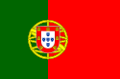
Flag
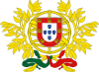
Coat of arms

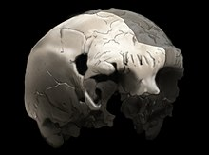
Aroeira 3 skull of 400,000 year old Homo heidelbergensis, the oldest trace of human history in Portugal

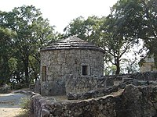
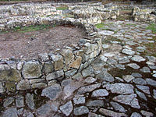
Reconstructed house in Citânia de Briteiros (up) and paved yard in Cividade de Terroso (down), examples of Celtic Castro Cultureof Northern Portugal (9th century BC – 1st century.

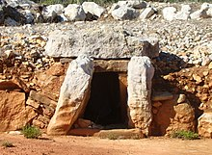
The Megalithic Monuments of Alcalar, built in the 3rd century BCSouthern Portugal

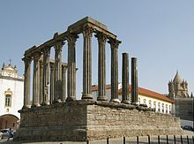
Roman Temple of Évora, in the Alentejo, is one of the best preserved Roman-built structures in the country

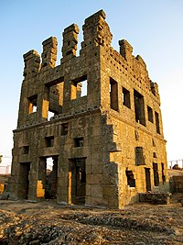
Centum Cellas, in the Beira region, is a Roman villa rusticafrom the 1st century CE.

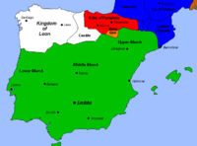
The Caliphate of Cordoba in the early 10th century

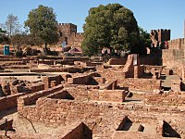
Silves Castle, a Moorish-era fortification in the Algarve

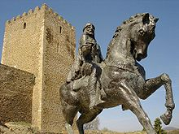
Statue of Abu-l-Qasim Ahmad ibn al-Husayn ibn Qasi outside the Castle of Mértola, in the Alentejo.

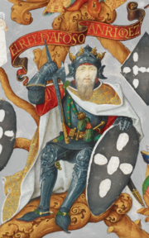
Afonso Henriques was the last Count of Portugal and the first King of Portugal after winning the Battle of Ourique in 1139. (Depicted in a 1530's illuminated manuscript)

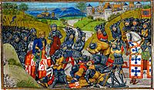
John I of Portugal's victory at Battle of Aljubarrota secured the House of Aviz's claim to the throne. Painting of 1480.

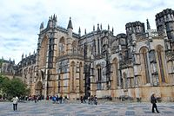
Batalha Monastery was erected by King John I to commemorate his victory in the 1383–1385 Crisisagainst Castile.

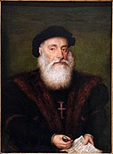
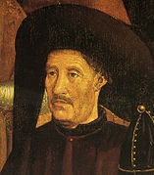
Vasco da Gama (left) and Prince Henry the Navigator (right), figures of the Portuguese discoveries

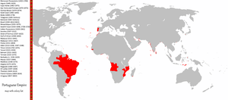
The areas across the world that were, at one point in their history, part of the Portuguese Empire.

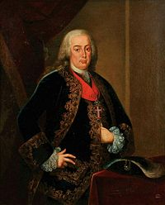
The 1st Marquis of Pombal effectively ruled Portugal during the reign of King José I.

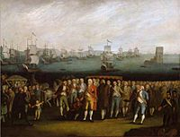
The Departure of the Portuguese Royal Court to Brazil in 1808

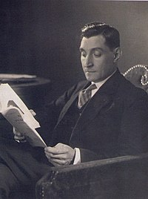
António de Oliveira Salazar ruled Portugal from 1932 to 1968, within the Estado Novo regime.

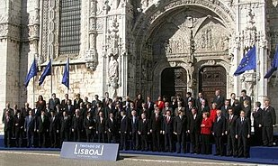
The Treaty of Lisbon was signed in 2007, when Portugal held the presidency for the European Council.

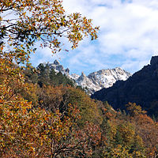
Peneda-Gerês National Park is the only nationally designated park in Portugal, owing to the rarity and significance of its environment.

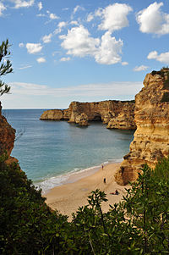
The Marinha Beach in Lagoa, Algarve is considerated by the Michelin Guide as one of the 10 most beautiful beaches in Europe and as one of the 100 most beautiful beaches in the world.

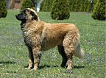
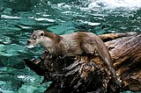
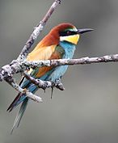
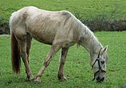
an Estrela Mountain Dog, a Eurasian otter, a European bee-eater, and a Lusitano horse.

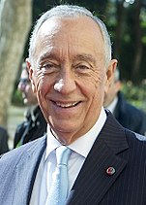
Marcelo Rebelo de Sousa, President of Portugal.
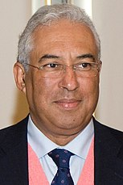
António Costa, Prime Minister of Portugal.

