Italy (Italian: Italia [iˈtaːlja] (listen)), officially the Italian Republic (Italian: Repubblica Italiana [reˈpubblika itaˈljaːna]), is a country in Europe. Located in the heart of the Mediterranean Sea, Italy shares open land borders with France, Switzerland, Austria, Slovenia, San Marino, and Vatican City. Italy covers an area of 301,340 km² (116,350 sq mi) and has a largely temperate seasonaland Mediterranean climate. With around 61 million inhabitants, it is the fourth-most populous EU member state and the most populous country in Southern Europe.
Due to its central geographic location in Europe and the Mediterranean, Italy has historically been home to a myriad of peoples and cultures. In addition to the various ancient Italian tribes and Italic peoples dispersed throughout the Italian Peninsula and insular Italy, beginning from the classical era, Phoenicians, Carthaginians and Greeks established settlements in the south of Italy, with Etruscansand Celts inhabiting the centre and the north of Italy respectively. The Italic tribe known as the Latins formed the Roman Kingdom in the 8th century BC, which eventually became a republic that conquered and assimilated its neighbours. In the first century BC, the Roman Empire emerged as the dominant power in the Mediterranean Basin and became the leading cultural, political and religious centre of Western civilisation. The legacy of the Roman Empire is widespread and can be observed in the global distribution of civilian law, republican governments, Christianity and the Latin script.
During the Early Middle Ages, Italy endured sociopolitical collapse and barbarian invasions, but by the 11th century, numerous rival city-states and maritime republics, mainly in the northern and central regions of Italy, rose to great prosperity through shipping, commerce and banking, laying the groundwork for modern capitalism. These mostly independent statelets served as Europe's main trading hubs with Asia and the Near East, often enjoying a greater degree of democracy than the larger feudal monarchies that were consolidating throughout Europe; however, part of central Italy was under the control of the theocratic Papal States, while Southern Italy remained largely feudal until the 19th century, partially as a result of a succession of Byzantine, Arab, Norman, Angevin and Spanish conquests of the region.
The Renaissance began in Italy and spread to the rest of Europe, bringing a renewed interest in humanism, science, exploration and art. Italian culture flourished, producing famous scholars, artists and polymaths such as Michelangelo, Leonardo da Vinci, Raphael, Galileo and Machiavelli. During the Middle Ages, Italian explorers such as Marco Polo, Christopher Columbus, Amerigo Vespucci, John Cabot and Giovanni da Verrazzano discovered new routes to the Far East and the New World, helping to usher in the European Age of Discovery. Nevertheless, Italy's commercial and political power significantly waned with the opening of trade routes that bypassed the Mediterranean.^{[14][15][16]} Centuries of infighting between the Italian city-states, such as the Italian Wars of the 15th and 16th centuries, left the region fragmented, and it was subsequently conquered by European powers such as France, Spain and Austria.
By the mid-19th century, rising Italian nationalism and calls for independence from foreign control led to a period of revolutionary political upheaval. After centuries of foreign domination and political division, Italy was almost entirely unified in 1871, establishing the Kingdom of Italy as a great power. From the late 19th century to the early 20th century, Italy rapidly industrialised, namely in the north, and acquired a colonial empire,^{[18]} while the south remained largely impoverished and excluded from industrialisation, fuelling a large and influential diaspora. Despite being one of the main victors in World War I, Italy entered a period of economic crisis and social turmoil, leading to the rise of a fascist dictatorship in 1922. Participation in World War II on the Axis side ended in military defeat, economic destruction and the Italian Civil War. Following the liberation of Italy and the rise of the resistance, the country abolished the monarchy, reinstated democracy, enjoyed a prolonged economic boom and, despite periods of sociopolitical turmoil (e.g. the anni di piombo, the Maxi Trial, and mani pulite) became a major advanced country.
Today, Italy is considered to be one of the world's most culturally and economically developed countries, with its economy ranking eighth largest in the world and third in the Eurozone. As an advanced economy, it has the sixth-largest worldwide national wealth, and is ranked third for its central bank gold reserve. Italy has a very high level of human development, and it stands among the top countries for life expectancy. The country plays a prominent role in regional and global economic, military, cultural and diplomatic affairs, and it is both a regional power and a great power. Italy is a founding and leading member of the European Unionand a member of numerous international institutions, including the UN, NATO, the OECD, the OSCE, the WTO, the G7, the G20, the Union for the Mediterranean, the Council of Europe, Uniting for Consensus, the Schengen Area and many more.
As a reflection of its cultural wealth, Italy is home to 54 World Heritage Sites, the most in the world, and is the fifth-most visited country.

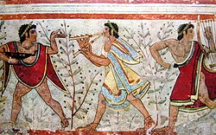
Etruscan fresco in the Monterozzi necropolis, 5th century BC.
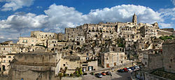
Matera, which dates from Palaeolithic, is one of the oldest continuously inhabited cities in the world.

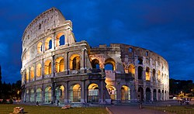
The Colosseum in Rome, built c. 70–80 AD, is considered one of the greatest works of architecture and engineering of ancient history.
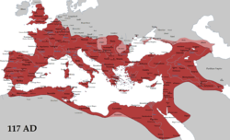
The Roman Empire at its greatest extent, 117 AD

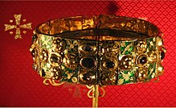
The Iron Crown of Lombardy, for centuries symbol of the Kings of Italy.

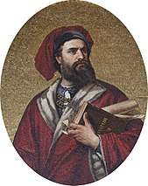
Marco Polo, explorer of the 13th century, recorded his 24 years-long travels in the Book of the Marvels of the World, introducing Europeans to Central Asia and China.

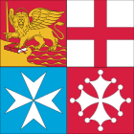
Flag of the Italian Navy, displaying the coat of arms of the most prominent maritime republics: Venice, Genoa, Pisa and Amalfi

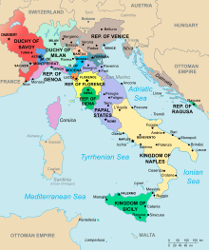
Italian states before the beginning of the Italian Wars in 1494

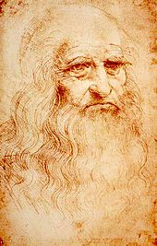
Leonardo da Vinci, the quintessential Renaissance man, in a self-portrait, c. 1512. Royal Library, Turin

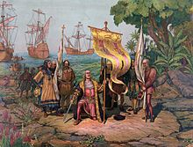
Christopher Columbus leads expedition to the New World, 1492. His voyages are celebrated as the discovery of the Americas from a European perspective, and they opened a new era in the history of humankind and sustained contact between the two worlds

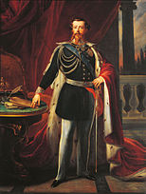
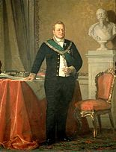
Victor Emmanuel II, 1st king of Italy, and Camillo Benso, Count of Cavour, 1st Prime Minister of Italy

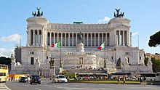
The Altare della Patria in Rome, national monument of Italy dedicated to King Victor Emmanuel II, holds the tomb of the Unknown Soldier since the end of World War I

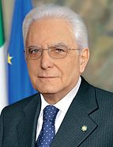
Sergio Mattarella
President of Italy
since 2015
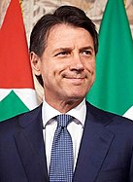
Giuseppe Conte
Prime Minister of Italy
since 2018

