Spain (Spanish: España [esˈpaɲa] (listen)), officially the Kingdom of Spain (Spanish: Reino de España), is a country mostly located on the Iberian Peninsula in Europe. Its territory also includes two archipelagoes: the Canary Islands off the coast of Africa, and the Balearic Islands in the Mediterranean Sea. The African enclaves of Ceuta and Melilla make Spain the only European country to have a physical border with an African country (Morocco). Several small islands in the Alboran Sea are also part of Spanish territory. The country's mainland is bordered to the south and east by the Mediterranean Sea except for a small land boundary with Gibraltar; to the north and northeast by France, Andorra, and the Bay of Biscay; and to the west and northwest by Portugal and the Atlantic Ocean.
With an area of 505,990 km² (195,360 sq mi), Spain is the largest country in Southern Europe, the second largest country in Western Europe and the European Union, and the fourth largest country in the European continent. By population, Spain is the sixth largest in Europe and the fifth in the European Union. Spain's capital and largest city is Madrid; other major urban areas include Barcelona, Valencia, Seville, Málaga and Bilbao.
Modern humans first arrived in the Iberian Peninsula around 35,000 years ago. Iberian cultures along with ancient Phoenician, Greek, Celtic and Carthaginian settlements developed on the peninsula until it came under Roman rule around 200 BCE, after which the region was named Hispania, based on the earlier Phoenician name Sp(a)n or Spania. At the end of the Western Roman Empirethe Germanic tribal confederations migrated from Central Europe, invaded the Iberian peninsula and established relatively independent realms in its western provinces, including the Suebi, Alans and Vandals. Eventually, the Visigoths would forcibly integrate all remaining independent territories in the peninsula, including Byzantine provinces, into the Kingdom of Toledo, which more or less unified politically, ecclesiastically and legally all the former Roman provinces or successor kingdoms of what was then documented as Hispania.
In the early eighth century the Visigothic Kingdom fell to the Moors, who arrived to rule most of the peninsula in the year 726, leaving only a handful of small Christian realms in the north, lasting up to seven centuries in the Kingdom of Granada. This led to many wars during a long reconquering period across the Iberian Peninsula, which led to the creation of Kingdom of Leon, Kingdom of Castille, Kingdom of Aragon and Kingdom of Navarre as the main Christian kingdoms to face the invasion. Following the Moorish conquest, Europeans began a gradual process of retaking the region known as the Reconquista, which by the late 15th century culminated in the emergence of Spain as a unified country under the Catholic Monarchs.
In the early modern period, Spain became the world's first global empire and the most powerful country in the world, leaving a large cultural and linguistic legacy that includes +570 million Hispanophones, making Spanish the world's second-most spoken native language, after Mandarin Chinese. During the Golden Age there were also many advancements in the arts, with world-famous painters such as Diego Velázquez. The most famous Spanish literary work, Don Quixote, was also published during the Golden Age. Spain hosts the world's third-largest number of UNESCO World Heritage Sites.
Spain is a secular parliamentary democracy and a parliamentary monarchy, with King Felipe VI as head of state. It is a major developed country^{[14]} and a high income country, with the world's fourteenth largest economy by nominal GDP and sixteenth largestby purchasing power parity. It is a member of the United Nations (UN), the European Union (EU), the Eurozone, the Council of Europe(CoE), the Organization of Ibero-American States (OEI), the Union for the Mediterranean, the North Atlantic Treaty Organization(NATO), the Organisation for Economic Co-operation and Development (OECD), Organization for Security and Co-operation in Europe (OSCE), the Schengen Area, the World Trade Organization (WTO) and many other international organisations. While not an official member, Spain has a "Permanent Invitation" to the G20 summits, participating in every summit, which makes Spain a de factomember of the group.

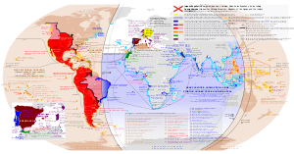
Anachronous map of the Spanish Empire, including territorial claims

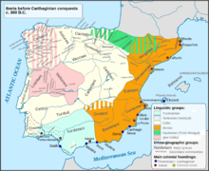
Pre-Roman map of The Iberian Peninsula

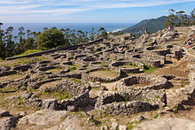
Celtic castro in Galicia

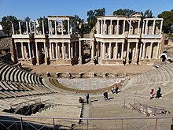
Roman Theatre, Mérida

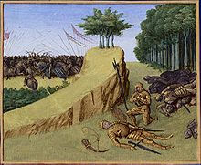
The death of the Frankish leader Roland defeated by a Basque and Muslim-Muladi (Banu Qasi) alliance at the Battle of Roncevaux Pass (778)originated the Kingdom of Navarre led by Íñigo Arista.

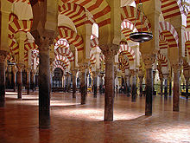
The Great Mosque of Córdoba is among the oldest mosque buildings in the world

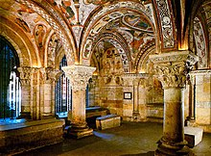
Basilica of San Isidoro, León

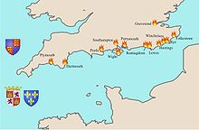
During the 1370s and 1380s, in alliance with the French, Castilian fleets launched regular raiding expeditions against the southern coast of England, while at the same time increasing numbers of traders, many of them Basques, began to ply the sea-routes that linked the Atlantic and the Mediterranean

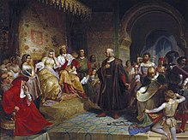
Christopher Columbus meets Isabella I of Castile and Ferdinand II of Aragon in the Alcázar of Córdoba

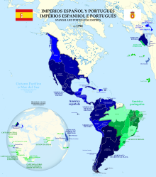
Spanish and Portuguese empires in 1790.

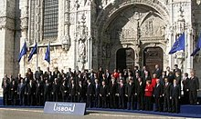
Spain has been a member of the European Union since 1986

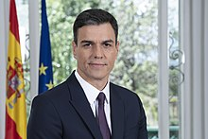
Spanish PM Pedro Sánchez in 2018

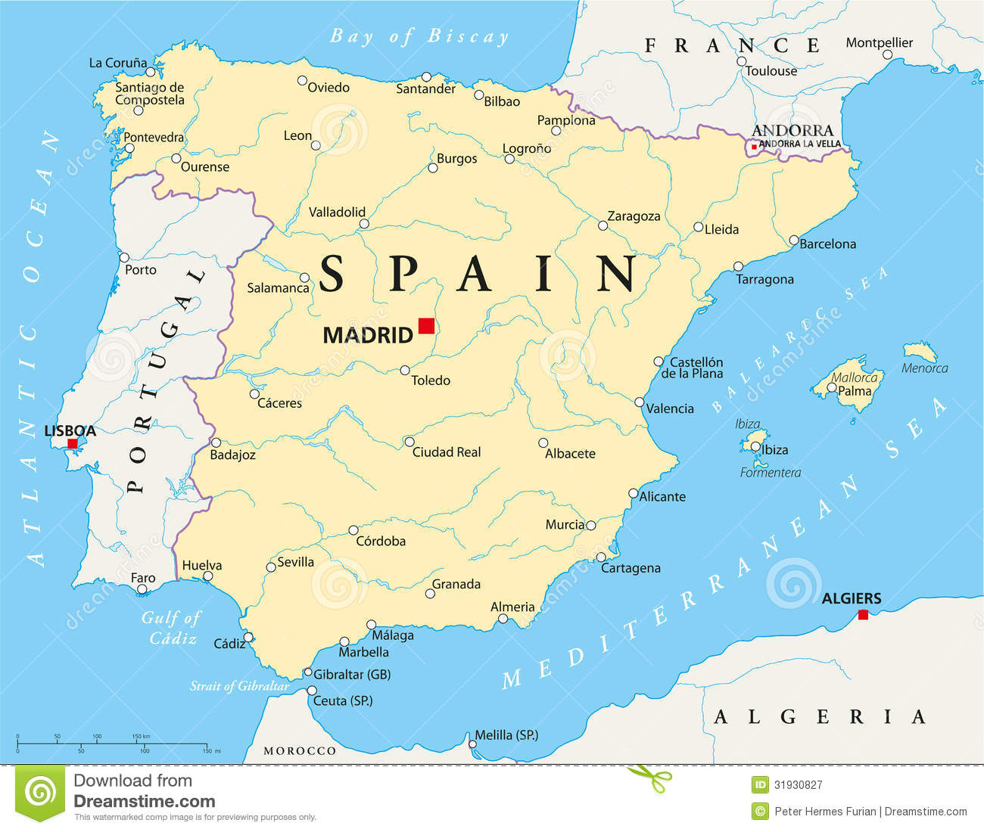

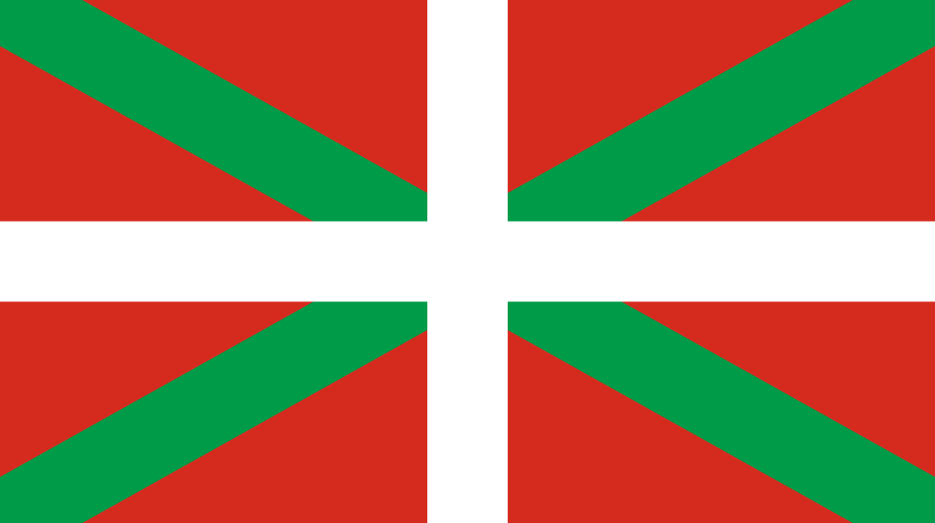

Basque Country

Euskadiª (in Basque)
País Vasco or Euskadi (in Spanish)
Autonomous community of Spain
Autonomous Community of the Basque Country
Euskal Autonomia Erkidegoa ^{b} (in Basque)
Comunidad Autónoma del País Vasco (in Spanish)
Flag | Coat of arms

The Basque Country (/bæsk, bɑːsk/; Basque: Euskadi [eus̺kadi]; Spanish: País Vasco [paˈiz ˈβasko]; French: Pays Basque), officially the Basque Autonomous Community (Basque: Euskal Autonomia Erkidegoa, EAE; Spanish: Comunidad Autónoma Vasca, CAV) is an autonomous community in northern Spain. It includes the Basque provinces of Álava, Biscay, and Gipuzkoa.
The Basque Country or Basque Autonomous Community was granted the status of nationality within Spain, attributed by the Spanish Constitution of 1978. The autonomous community is based on the Statute of Autonomy of the Basque Country, a foundational legal document providing the framework for the development of the Basque people on Spanish soil, although the territory of Navarre was left out and made into a separate autonomous community.
Currently there is no official capital in the autonomous community, but the city of Vitoria-Gasteiz, in the province of Álava, is the de facto capital as the location of the Basque Parliament, the headquarters of the Basque Government, and the residence of the President of the Basque Autonomous Community (the Palace of Ajuria Enea). The High Court of Justice of the Basque Countryhas its headquarters in the city of Bilbao. Whilst Vitoria-Gasteiz is the largest municipality in area, with 277 km² (107 sq mi), Bilbao is the largest in population, with 353,187 people, located in the province of Biscay within a conurbation of 875,552 people.
The term Basque Country may also refer to the larger cultural region (Basque: Euskal Herria), the home of the Basque people, which includes the autonomous community.

The following provinces make up the autonomous community:
- Álava (Basque Araba), capital Vitoria-Gasteiz
- Biscay (Spanish Vizcaya, Basque Bizkaia), capital Bilbao-Bilbo
- Gipuzkoa (Spanish Guipúzcoa), capital Donostia-San Sebastián

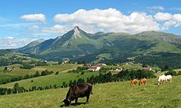
Txindoki mountain from Lazkaomendi

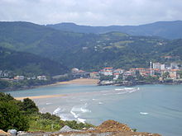
Basque coast near Mundaka

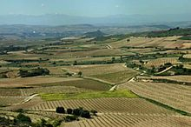
Rioja vineyards near the Ebro

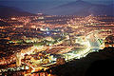
Bilbao

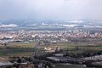
Vitoria-Gasteiz

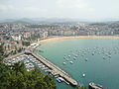
San Sebastián

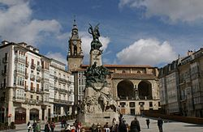
Monument to the Battle of Vitoria, part of Spanish Independence War against the French rule.

