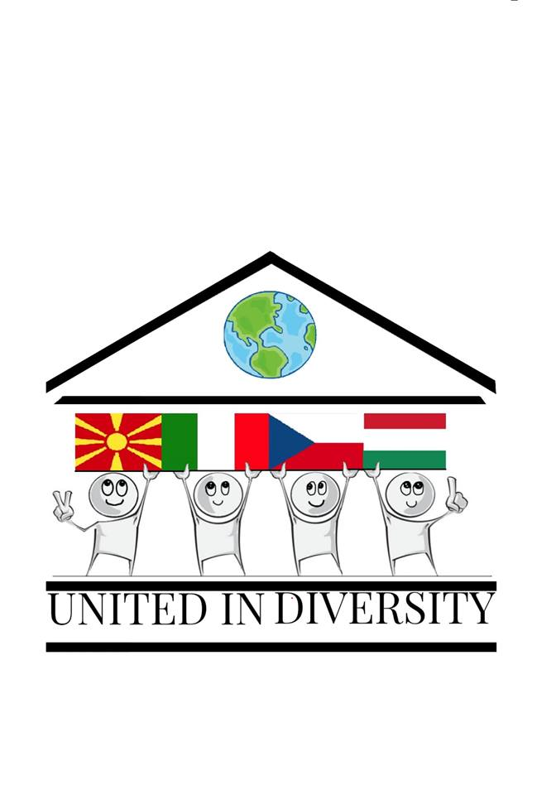
Erasmus+ KA2 Project 2018-1-MK01-KA229-047177
United in Diversity: UNESCO Regional Heritage Within European Identity

02-23-2021
Tasks for partners to contribute to the Hungarian subtopic after the Hungarian presentation:

1, Please collect example of cultural heritage from your country and share them with us!
- movable cultural heritage (paintings, sculptures, coins, manuscripts)
- immovable cultural heritage (monuments, archaeological sites, and so on) underwater cultural heritage (shipwrecks, underwater ruins and cities)
2, Please collect examples of threats to your cultural heritage
- threats because of lack of maintenance
- examples of land speculation
- façadism
- religious buildings or sites in danger
- forced urbanization
- overtourism

