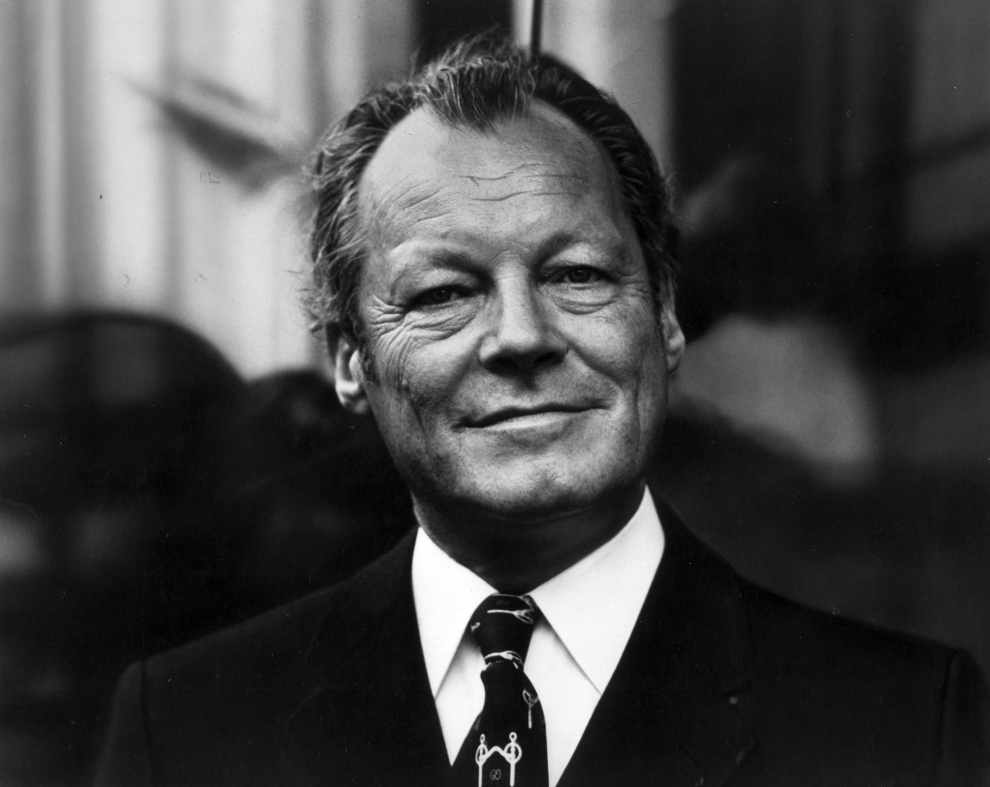
Willy Brandt
By Lara Kube and Katharina Schenkel

Willy Brandt, who was born on 18th December 1913, was a German politician who was awarded the Nobel Peace Prize in 1971 for his efforts to achieve reconciliation between West Germany and the countries of Eastern Europe. He was the chancellor of West Germany from 1969 – 1974.

Biography

1913 Willy Brandt was born illegitimately on 18th December 1913 in Lübeck in Germany under the name Herbert Ernst Karl Frahm. He was raised by his mother’s stepfather and proved journalistic and political talents early.

1930 He joined the Social Democratic Party (SPD).

1931 As he thought the SPD didn’t fight combatively enough for their goals, he left the party to join the Socialist Workers Party (SAP).

1933-1945 As he offered resistance to the Nazi regime he adopted the pseudonym Willy Brandt to avoid detection. To escape Nazi persecution he was forced to go to Norway and became a Norwegian citizen.

1945/46 Eventually he returned to Germany as a correspondent for a Scandinavian newspaper to report about the trial of the major war criminals of the Second World War.

1947 Working for the Norwegian government, Willy Brandt returned to Berlin.

1948 He became a German citizen again and joined the Social Democratic Party (SPD) because he wanted to contribute to building the democratic Germany.

1955-1957 President of the Berlin House of Representatives.

1957-1966 Mayor of West Berlin.

1961 and 1965 He was candidating for the position of chancellor, but his rivals outvoted him. They campaigned against him and criticized him for his illegitimacy, his private life and his exile in Norway.

1964-1987 Willy Brandt became the chairman of the SPD due to a big electoral success.

1966-1969 With Brandt as foreign minister and vice-chancellor, a grand coalition between the SPD and CDU (Christian Democratic Union) was formed.

1969-1974 In the elections in 1969 Brandt was the leading candidate and was elected chancellor of West Germany. He developed the new foreign policy towards Eastern Europe (in German: Ostpolitik) and made efforts to try to unite Europe.

1970 The famous Warsaw Genuflection (in German: Warschauer Kniefall) as a gesture of humility and penance.

1971 He received the Nobel Peace Prize for his work in improving and strengthening relations with East Germany, Poland, and the Soviet Union.

1974 International crises and economic changes made governing hard and when one of his closest aides was exposed as an agent of the Stasi (The East German Secret Service), he resigned.

1976-1992 President of the Socialist International

1977-1983 Chairman of the North-South-Commission to elaborate suggestions for the development policy

1979-1983 Member of the European Parliament

1987-1992 Honorary chairman of the SPD

1992 Willy Brandt died on 8th October in Unkel near Bonn.

Eastern treaties (in German: Ostverträge)

From 1970 – 1973, West Germany made contracts with East Germany, Poland, the Soviet Union and Czechoslovakia. The treaties were most of all about reconciliation between the different countries and preventing wars. The principles followed international law.

(-Permit Agreement, 1963)
- Treaty of Moscow, 1970
The first of the treaties was concluded with Moscow. It was agreed that conflicts were to be solved peacefully. And West Germany acknowledged the existing borders, particularly the border to Poland.
- Treaty of Warsaw, 1970
Few months later, the Treaty of Warsaw corroborated this acknowledgement. It was signed by Willy Brandt and Prime Minister Józef Cyrankiewicz on 7 December 1970. In the treaty, both sides committed themselves to nonviolence and accepted the Oder-Neisse as the border between Germany and Poland. In West Germany, Willy Brandt was heavily criticised for it and his policy was marked as a betrayal of national interests. The treaty of Warsaw was a very important element of the Ostpolitik.
The genuflection of Willy Brandt in front of the Warsaw Ghetto Uprising became the symbol of the new policy of détente.
- Four Power Agreement on Berlin, 1971
The allies agreed to ease the transit traffic to Berlin. Berlin still had a special status and was no part of West Berlin.
- Transit Agreement, 1971
The transit between East and West Germany was regulated. Travelling was eased and border controls were simplified. It was the first arrangement between the two of the German states.
- Basic Treaty, 1972
The acknowledgement of East Germany of the Oder-Neisse line as the western border of Poland was confirmed again. It was declared that ambassadors were sent to other countries by both countries.
- Treaty of Prague, 1973
The subject of the treaty with Czechoslovakia was the inviolability of the shared border and avoidance of violence.

Brandt’s Importance

West Germanys chancellor, Willy Brandt, represented a figure of change during his term from 1969 to 1974 with his new foreign policy and his actions had a great influence on other politicians of his time.

The most important step of Willy Brandt as a chancellor was the radical change of the German foreign policy, which had previously followed the principles of the Hallstein-Doctrine. There it had been declared that West Germany would not establish or maintain diplomatic relations with any state that acknowledged East Germany, because the West had seen itself as the only right representation of the German nation. This had also been called an exclusive mandate (in German: Alleinvertretungsanspruch). When Brandt’s term as a chancellor started, he changed the foreign policy of the FRG (BRD) drastically. With the motto “change through convergence” (in German: Wandel durch Annäherung) he developed his new foreign policy and the Eastern Treaties in order to improve the relations with East Germany, the Soviet Union, Poland, Czechoslovakia and other Eastern Bloc (communist) countries. Brandt’s intentions were the détente in Germany, making the division of Germany for the people of East and West bearable and improving the humanization of intra-German relations, the attempt to compensate for the crimes during World War II and the admission to the UN. Some claim, that the implementation of the new foreign policy towards Eastern Europe was for the sake of the reunification of the two German countries in 1990, but that was officially a misinterpretation.

In West Germany, Brandt’s foreign policy was extremely controversial and divided the populace into two parts. The first consisted of all the conservative parties and families who had been driven west (in German: die Heimatvertriebenen) from historical Eastern Germany, especially the part that was given to Poland after the end of the war, and Western Czechoslovakia (in German: Sudetenland). This group of displaced Germans and their descendants called Brandt’s new foreign policy “illegal” and “high treason”. Because of these accusations, Brandt lost a large part of the German refugee voters from East Germany. The other part encouraged and supported the new foreign policy of their chancellor. Most of their members were students and other young West German baby-boomers who dreamed of a country that would be more open and colorful than the frugal and still somewhat authoritarian Federal Republic, which had been built after World War II.

However, Willy Brandt’s New Eastern Policy brought a positive change and détente for the western and the eastern countries. For his efforts, his work and his Eastern treaties he was awarded the Nobel Peace Prize in 1971.

Warsaw Genuflection (in German: Warschauer Kniefall)

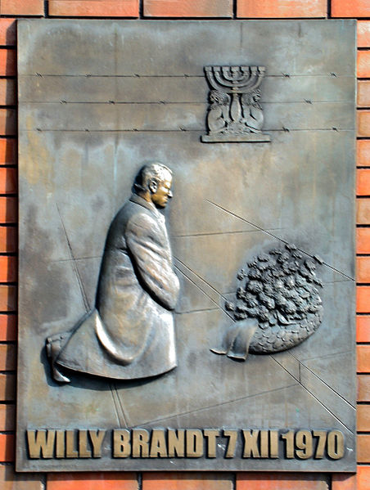
Willy Brandt, the chancellor of West Germany from 1969 to 1974, visited the capital of Poland in December 1970 to sign the Treaty of Warsaw. Subjects of the treaty between the two countries were the mutual acknowledgement of their common border, the normalization of their relationship and the commitment of both sides to non-violence in the sense of the Charta of the United Nations. Straight before the signing through the chancellor of West Germany, Willy Brandt, and Prime Minister Józef Cyrankiewicz at the Presidential Palace on 7 December 1970, Willy Brandt visited a monument to remember the victims of the Warsaw Ghetto Uprising and apologized in the name of every guilty German although Brandt never even participated in the crimes of the Germans as he fled during the Nazi-era. After laying down a wreath, Brandt did not stand up as expected, but knelt down before the monument and stayed in silence for about half a minute. This gesture of humility and penance made a great impression on the surprised people standing by and was discussed extensively afterwards.

Willy Brandt later noted that:
In German: „Unter der Last der jüngsten Geschichte tat ich, was Menschen tun, wenn die Worte versagen. So gedachte ich Millionen Ermordeter.”
In English: “Under the burden of recent history, I did what people do when words fail. In this way I commemorated millions of murdered people.”

In West Germany itself, the citizens had different opinions on the genuflection of their chancellor. Almost half of them (48%) thought, it had been an excessive act, while nearly 41% said it had been appropriate. The other 11% didn’t want to make a statement at that time. The more conservative parties of West Germany like the CDU criticized the chancellor hardly and tried to use his action against him with a constructive vote of no confidence (Misstrauensvotum) in April 1972, which he won by only two votes. Afterwards, his party gained more and more approval because of its effective policy of détente symbolized by the genuflection. In the GDR (DDR) the genuflection of Willy Brandt wasn’t even mentioned to its citizens.

On the international community Willy Brandt’s action had a positive effect and was highly acknowledged by Eastern Europe. Because of the genuflection, the reputation of West Germany, which had suffered because of the events during World War II, increased again and allowed West Germany to improve its international status. Moreover, a monument of Brandt’s genuflection was built in Warsaw and it is thought to be one of the reasons why he was awarded the Nobel Peace Prize in 1971.

Quellen:

- http://www.geschichte-der-sozialdemokratie.de/fileadmin/redaktion/bilder_persoenlichkeiten/Willy_Brandt/FA026167.jpg
- http://www.willy-brandt.de/stiftung.html

