FLIPPED CLASSROOM COMMUNITY RESOURCES

There are a lot of excellent websites that we can use to learn how to implement the Flipped Classroom Approach in our instruction. Here are some of them:

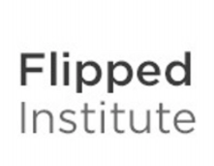Flipped Institute: Flipped Classroom Training and Technologies: serves as an online resource to provide self-help and other assistance to benefit teachers moving from a traditional classroom lecture model to a flipped model.

Flipped Learning : a community resource to connect educators from all over the world in our common interest: providing the best educational expereince we can to the students we teach.

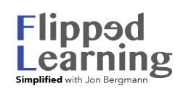Flipped Learning Simplified with Jon Bergman aims at spreading the pedagogy of flipped learning around the world. Jon Bergman is one of the pioneers of the Flipped Class Movement. He is also the founder of the Flipped Learning Global Initiative, whose mission to coordinate, orchestrate and scale the key elements required to successfully expand flipped learning.

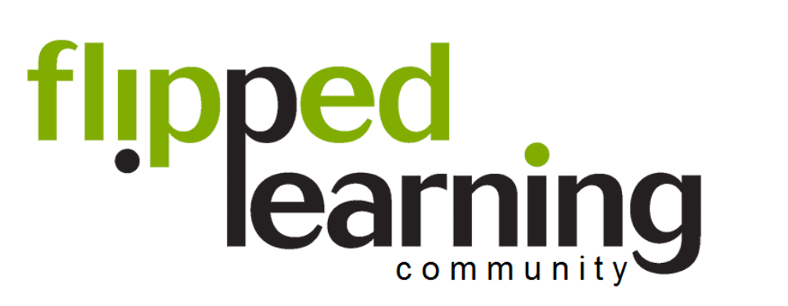The Flipped Learning Community is a professional learning community for educators using flipped learning. It comprises more than 29,000 educators from all over the world.

FLIPPED CLASSROOM EDUCATORS

Jon Bergman and Aaron Sams, the pioneers of flipped classroom
Flipping Physics by Jonathan Thomas-Palmer. His mission is to:
- Teach physics to as many people as possible.
- Make physics education fun and real.
- Provide free lecture videos for teachers to help flip their students' learning.
My Flipped Classroom by Delia Bush about her 5th grade math class
TMI Flips English by Cheryl Morris and Andrew Thomasson
Flipping the Biology Classroom by Lindsey Cole
Flipped History by Tom Driscoll
Joel Speranza - math, science, digital technology and accounting
Mr Whiting's Flipped Class - chemistry by Pete Whiting
Flipped Mind by Mark Burkholz
The Flipped Classroom in Elementary Music - by Mallory Martin

Flipped School: At Clintondale High School the flipped classroom model is fully integrated into instruction.

Flipped classroom resources in other languages:
The Flipped Classroom resources in Spanish
FlipClass by Christian Spannagel in German
Toller Unterricht by Nina Toller in German
Where maths is fun by Toni Milun in Croatian
Flipnet - la classe capovolta in Italian

