How much do you know about Ireland?

- What’s the population of the Republic of Ireland? 4.64 million
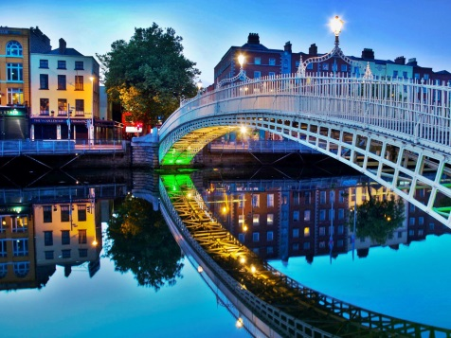
- What’s the population of Dublin? 1.3 million

- Who is the President of Ireland? Michael D Higgins

- What title does the Irish ‘Prime Minister’ have? An Taoiseach

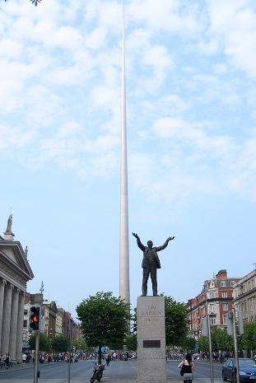
- What’s the name of the Irish parliament? Dáil Éireann

- Who is the patron saint of Ireland? When do we celebrate his feast day?
St. Patrick – March 17th
- Name three types of traditional Irish food. Irish Stew, Bacon and Cabbage, Colcannon
- Name two types of traditional Irish sport. Gaelic Football, Hurling

- What are police officers called in Ireland? Gardaí

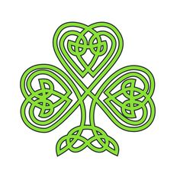
- Look at the following sentences. They all contain Dublin slang. What do you think the slang means?
- I could murder a pint. I’m very thirsty.
- Fair play to ya. That was a great result. Well done, congrats
- He’s a right eejit. He never gets anything right. idiot
- You’ve made a hames of that. You’ll have to do it again. Made a mess
- If you’re wanting a shower, you’ll find the towels in the hot press. Airing cupboard
- What are you gawking at? Haven’t you seen pink hair before? Staring at
- Take your umbrella. It’s lashing. Raining heavily
- I’m off to bed. I’m wrecked. exhausted

