How much do you know about Ireland?

- What’s the population of the Republic of Ireland?
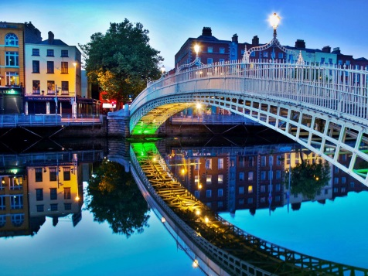
- What’s the population of Dublin?

- Who is the President of Ireland?

- What title does the Irish ‘Prime Minister’ have?

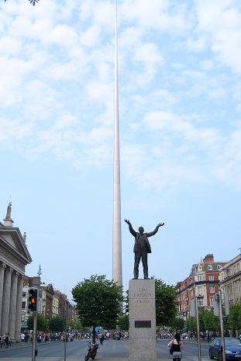
- What’s the name of the Irish parliament?

- Who is the patron saint of Ireland? When do we celebrate his feast day?

- Name three types of traditional Irish food.

- Name two types of traditional Irish sport.

- What are police officers called in Ireland?

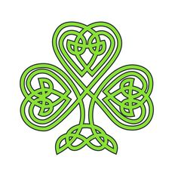
- Look at the following sentences. They all contain Dublin slang. What do you think the slang means?
- I could murder a pint.
- Fair play to ya. That was a great result.
- He’s a right eejit. He never gets anything right.
- You’ve made a hames of that. You’ll have to do it again.
- If you’re wanting a shower, you’ll find the towels in the hot press.
- What are you gawking at? Haven’t you seen pink hair before?
- Take your umbrella. It’s lashing.
- I’m off to bed. I’m wrecked.

