By @sylviaduckworth Sylvia Duckworth
Updated April 19, 2016 with the new Forms.

Note: For some reason, I get many requests for permission to access this document. Please do not send me any requests. If you want to make your own copy, go to “File > Make a copy”. (However, best just to add it to your Drive in case I update it). Much appreciated! SD.

l. Google forms

Note 1: The Google shortened links in this doc are for if you are using a printed version of this doc.

Note 2: Creating an interactive story with Google forms can be a little complicated. If you teach younger students, I would recommend Google Slides instead (scroll down to
ll. Google Slides, p. 7)

Click here for a sample story made with a Google form. (goo.gl/OTU0zw)

1. Fill out a story outline using one of the story templates here:
Normal (goo.gl/avn6bp)
Shortcut (goo.gl/YRYVzY)
Maze (goo.gl/MGkuMS)

If you have not filled one out, you can use my story outline to practice with: goo.gl/xPC2kp
2. Open up your Google Drive
3. Click on “New > More > Google Forms”
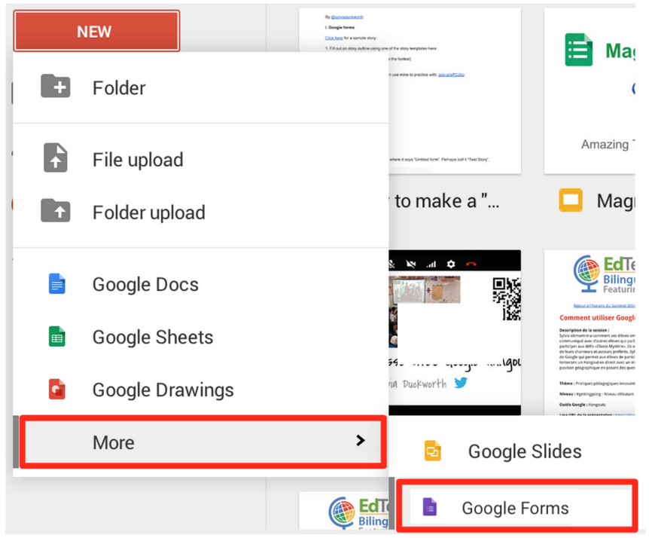

4. On “Untitled form”, give your story a name. Perhaps “Test story” or (“Halloween” if you are using my story outline.)

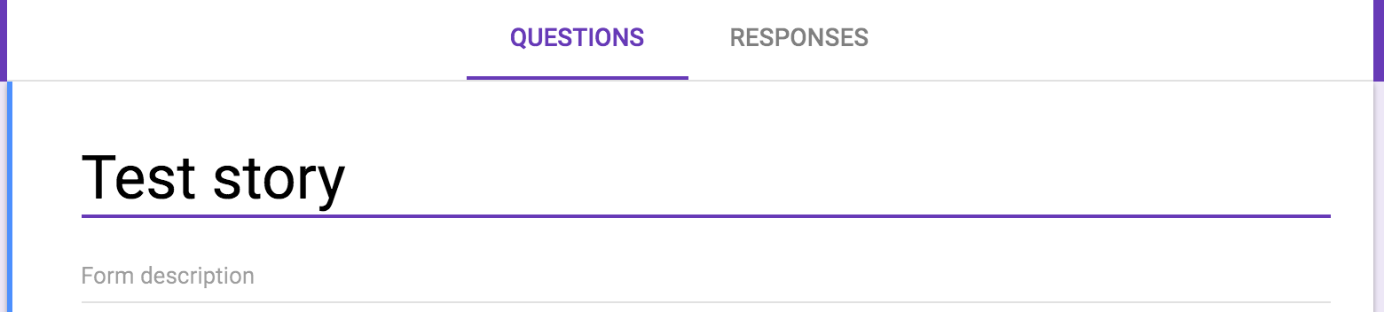

5. Before you edit the questions, you need to add more pages. To the right, click on “Add Section””
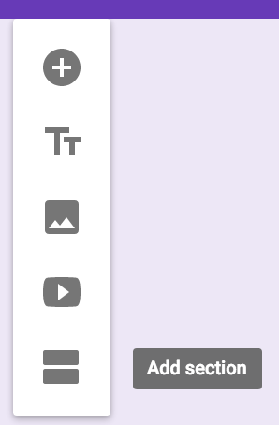
6. Rename this page (section) “Page 2”:
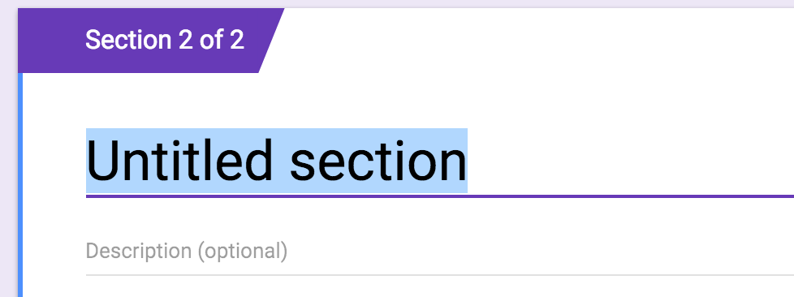
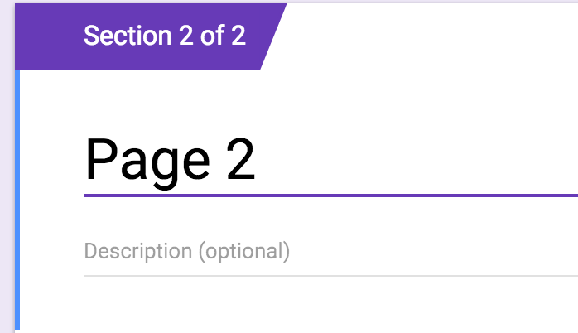

6. Look at your story outline (#1 above) and create as many pages in your form as you need this way. If you’re not sure how many you will need, start off by creating 10. Continue #5 & 6 until you have 10 pages, naming each page in sequence “Page 3, Page 4, Page 5,” etc.
7. When you have finished adding all of your pages, scroll up to the first page.
8. Go to your story outline and highlight and copy the description for page 1.
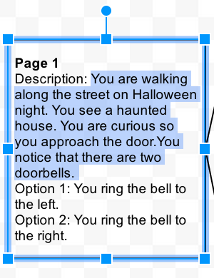
10. Go back to your form (page 1) and paste this in the description area.

It should look like this:
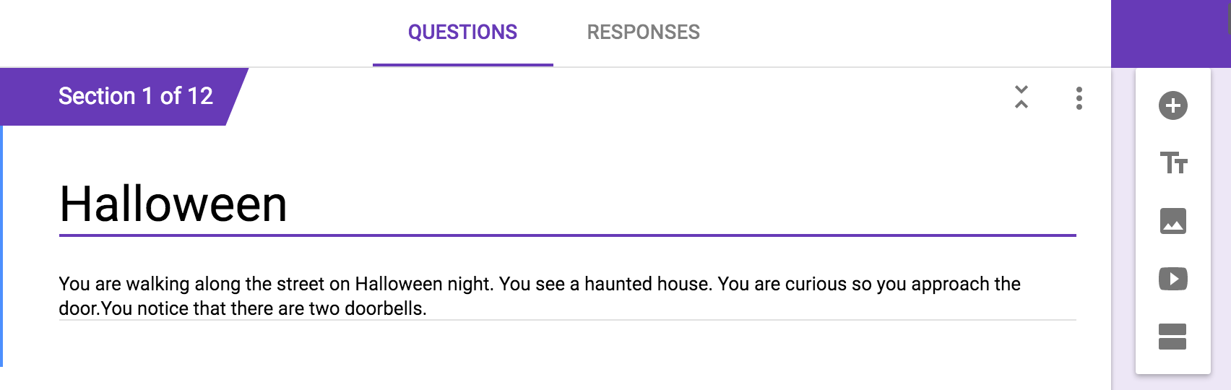
11. Add a question by clicking on the plus sign:
12. “Question type” always defaults to multiple choice.
13. Go back to your story outline and highlight and copy your option 1 for page 1:
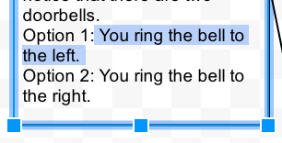
14. Go back to your form. Where it says “Option 1”, paste.
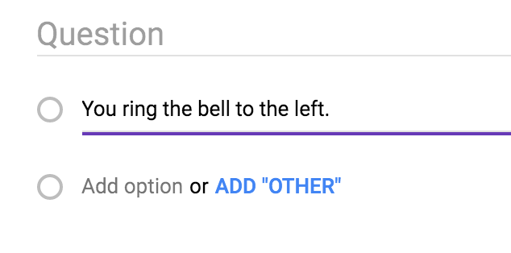

15. Click on the 3 dots, then “Go to section based on answer”:
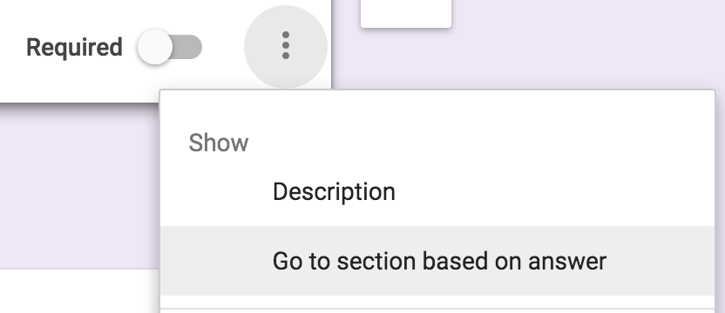
16. Click on your first option, then click on “Go to section 2 (Page 2)
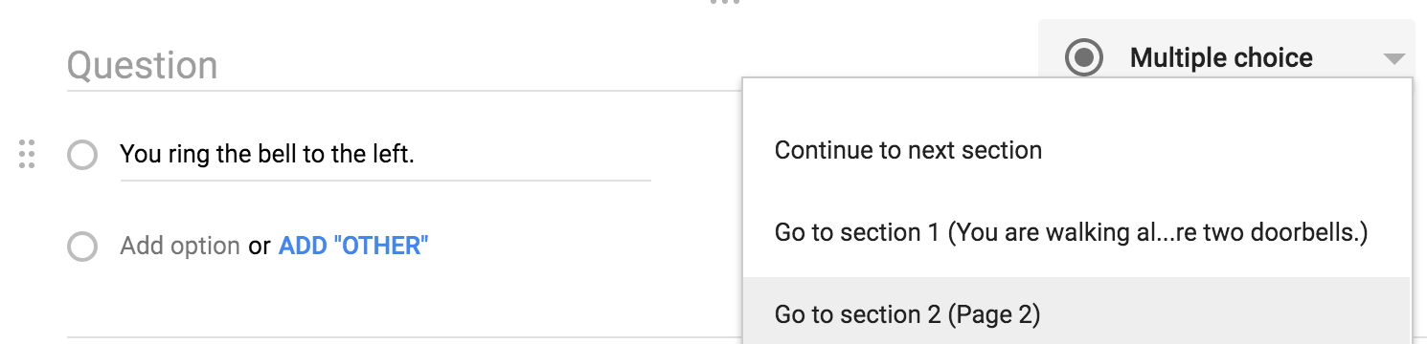

17. Go back to your story outline and highlight and copy Option 2.
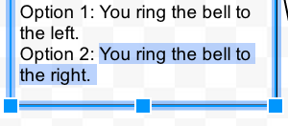
18. Go back to your form and paste it where it says “Add option” (Not ADD “OTHER”)
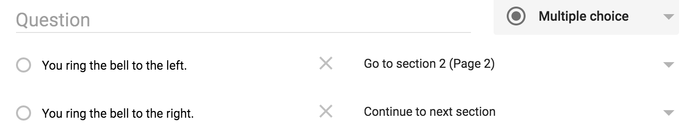

19. Click on “Continue to next section” and click on “Go to section 3”. It should look like this:
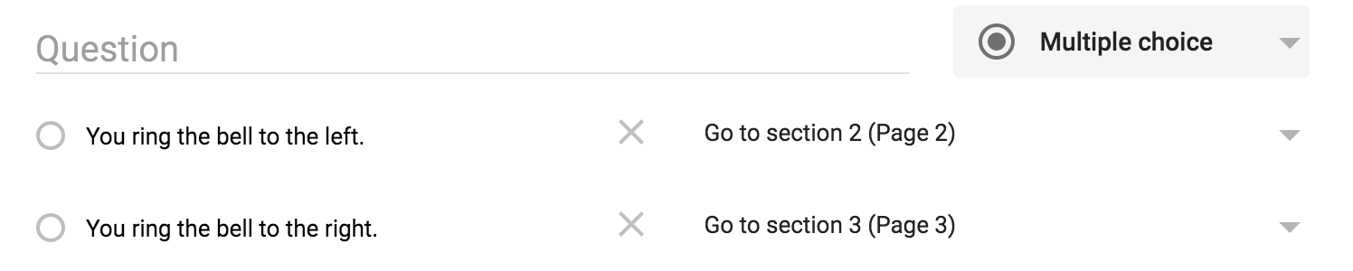
20. Turn on “Required”
21. To make your story even more interesting, you can add an image to each page.
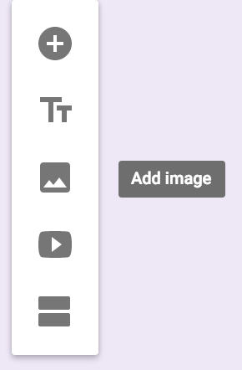

22. Notice the options for finding an image. If you don’t have an image right away, you can search for one:

23. Add a title to your story:

24. Now scroll down to Section 2 (Page 2).
Keep the page title as “Page 2”.
25. For “Description”, return to your story outline and highlight and copy the description for
page 2:
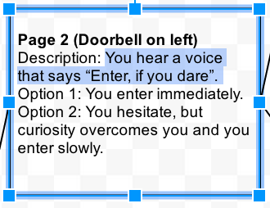
26. Go back to your form and paste this in “Description (optional)”:
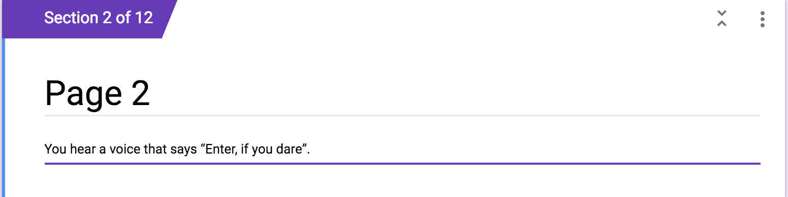

27. Tap the + and add a question.
28. “Question” leave blank.
29. For Option 1, go to your outline and highlight, copy and paste your Option 1 for Page 2.
30. Paste in Option 1 on your form (page 2)
31. Tap the 3 dots and tap “Go to section based on answer”.
32. Tap “Continue to next section” and click on “Go to section 4 (page 4)”.
33. Tap “Add option” Go to your outline and highlight, copy and paste your Option 2 for Page 2.
34. Click on “Continue to next section” and click on “Go to section 5 (page 5). Turn on “Required”.
35. Go to page 3 and continue in this manner (#24 to #34) to the end of your story, following the lines on the outline to see which page the options should link to.
36. You can cheat (ie speed up the process) by linking to pages that you have already used. (Make sure that you changed the lines on your outline to keep you from getting confused.)

ll. Google Slides

Click here (goo.gl/xs9dlR) to read an interactive story I created with Google Slides. Click here to learn how.

lll. Google Docs
Click here (goo.gl/6CTvYK) to read about how to make a Google Doc interactive with Bookmarks or Headings.
Click here (goo.gl/aeB5wo) for some information on Hyperdocs.

lV. Videos on YouTube

Click here (goo.gl/pSp28s) for an awesome interactive video called: “The Time Machine: A Chad, Matt and Rob Interactive Adventure”. Click here (goo.gl/RctQJO) to learn about how to make an interactive video with YouTube Annotations.

V. Presentation for Interactive stories
Click here (goo.gl/254gqA) for a slidedeck on creating Choose-your-own-adventure stories with Google Apps.

