Logo contest |  |  |  | 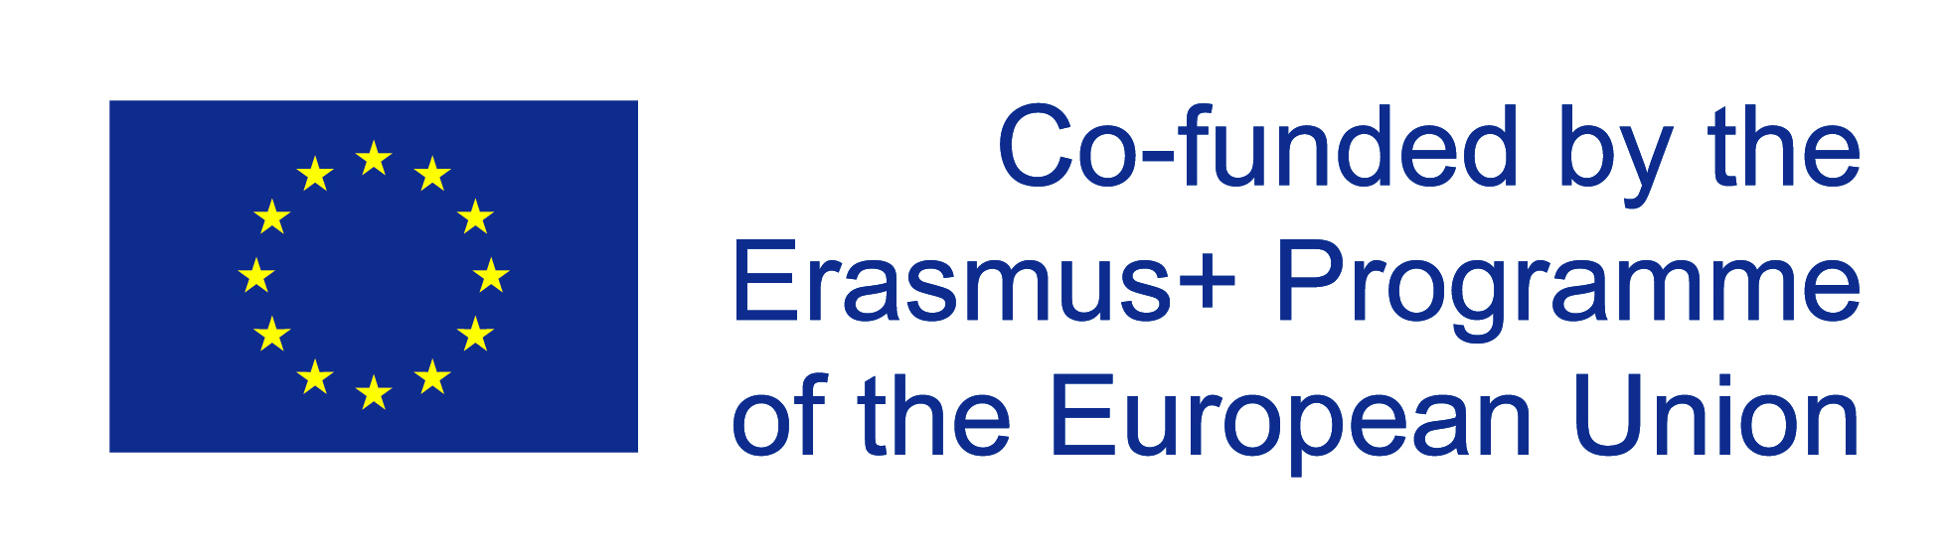
 | MONSTERS IN DANGER OF EXTINCTION  1. - Contest is open to all students of two High Schools (Ekpaidetyria Panou in Nafpaktos, Greece and IES Unamuno BHI in Bilbao, Spain)  2. - Contestants may submit up the original entries. Submission of entries is up to the 13 December, 2020.  3. - Logo should embody or portray the content of M.I.D.E. Project: MONSTERS IN CLASSICAL MYTHOLOGY.  4. - Each entry may be picture or text-based or in combination. Entries may be done by free-hand or by computer. There are no color restrictions. File formats: gif, jpeg, png.  5. - Each logo should be accompanied with a brief explanation/ description to provide context to the suggested logo (i.e. explanation of the colors, symbols used, pictures, images, etc.). |  |  |  | 6. – The design of the logo must be certified original.  7. - Winning entry will be used as the official logo of M.I.D.E. ERASMUS+ Project. It will appear in every single document related to the Project.  8.- The representatives of the target students and the key teachers reserve the right to disqualify any entry for different reasons such as offenses, rude words, not adequacy with the content of the Project…  9. - In order to choose the winner, the presented logos will be voted during the last two weeks of December, 2020.  10. - 80 euros gift card awaits the winner and the diploma.  11. - Logos may be submitted with the name of the author and send through these email address: erasmusmide522@gmail.com

