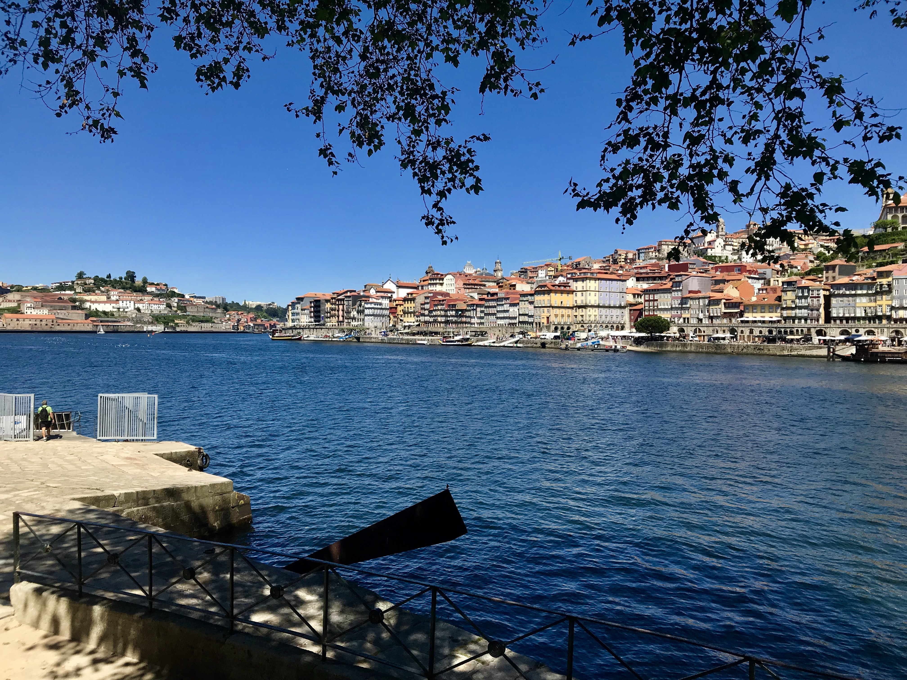
Our trip to Portugal

Christos Yiangou - 16 September 2019

My Calendar

13 May
On the first day, we met the pupils from Lixa that participated in the Erasmus program as well as the other students from foreign European countries. The Portuguese students gave us a t-shirt that on the front said Erasmus and at the back our country was written. Then we did some ice-breaking games, so we could get to know each other. Later the Portuguese students guided us to their school which was really nice, modern and contemporary design, we also passed threw some classes. Overdue we met some really kind and friendly students. Delinquent we did some other activities like we played musical chairs which was surely some fun, furthermore, we had lunch at the cafeteria of the school with the other students. Subsequently, we left school and went to our host families.

14 May 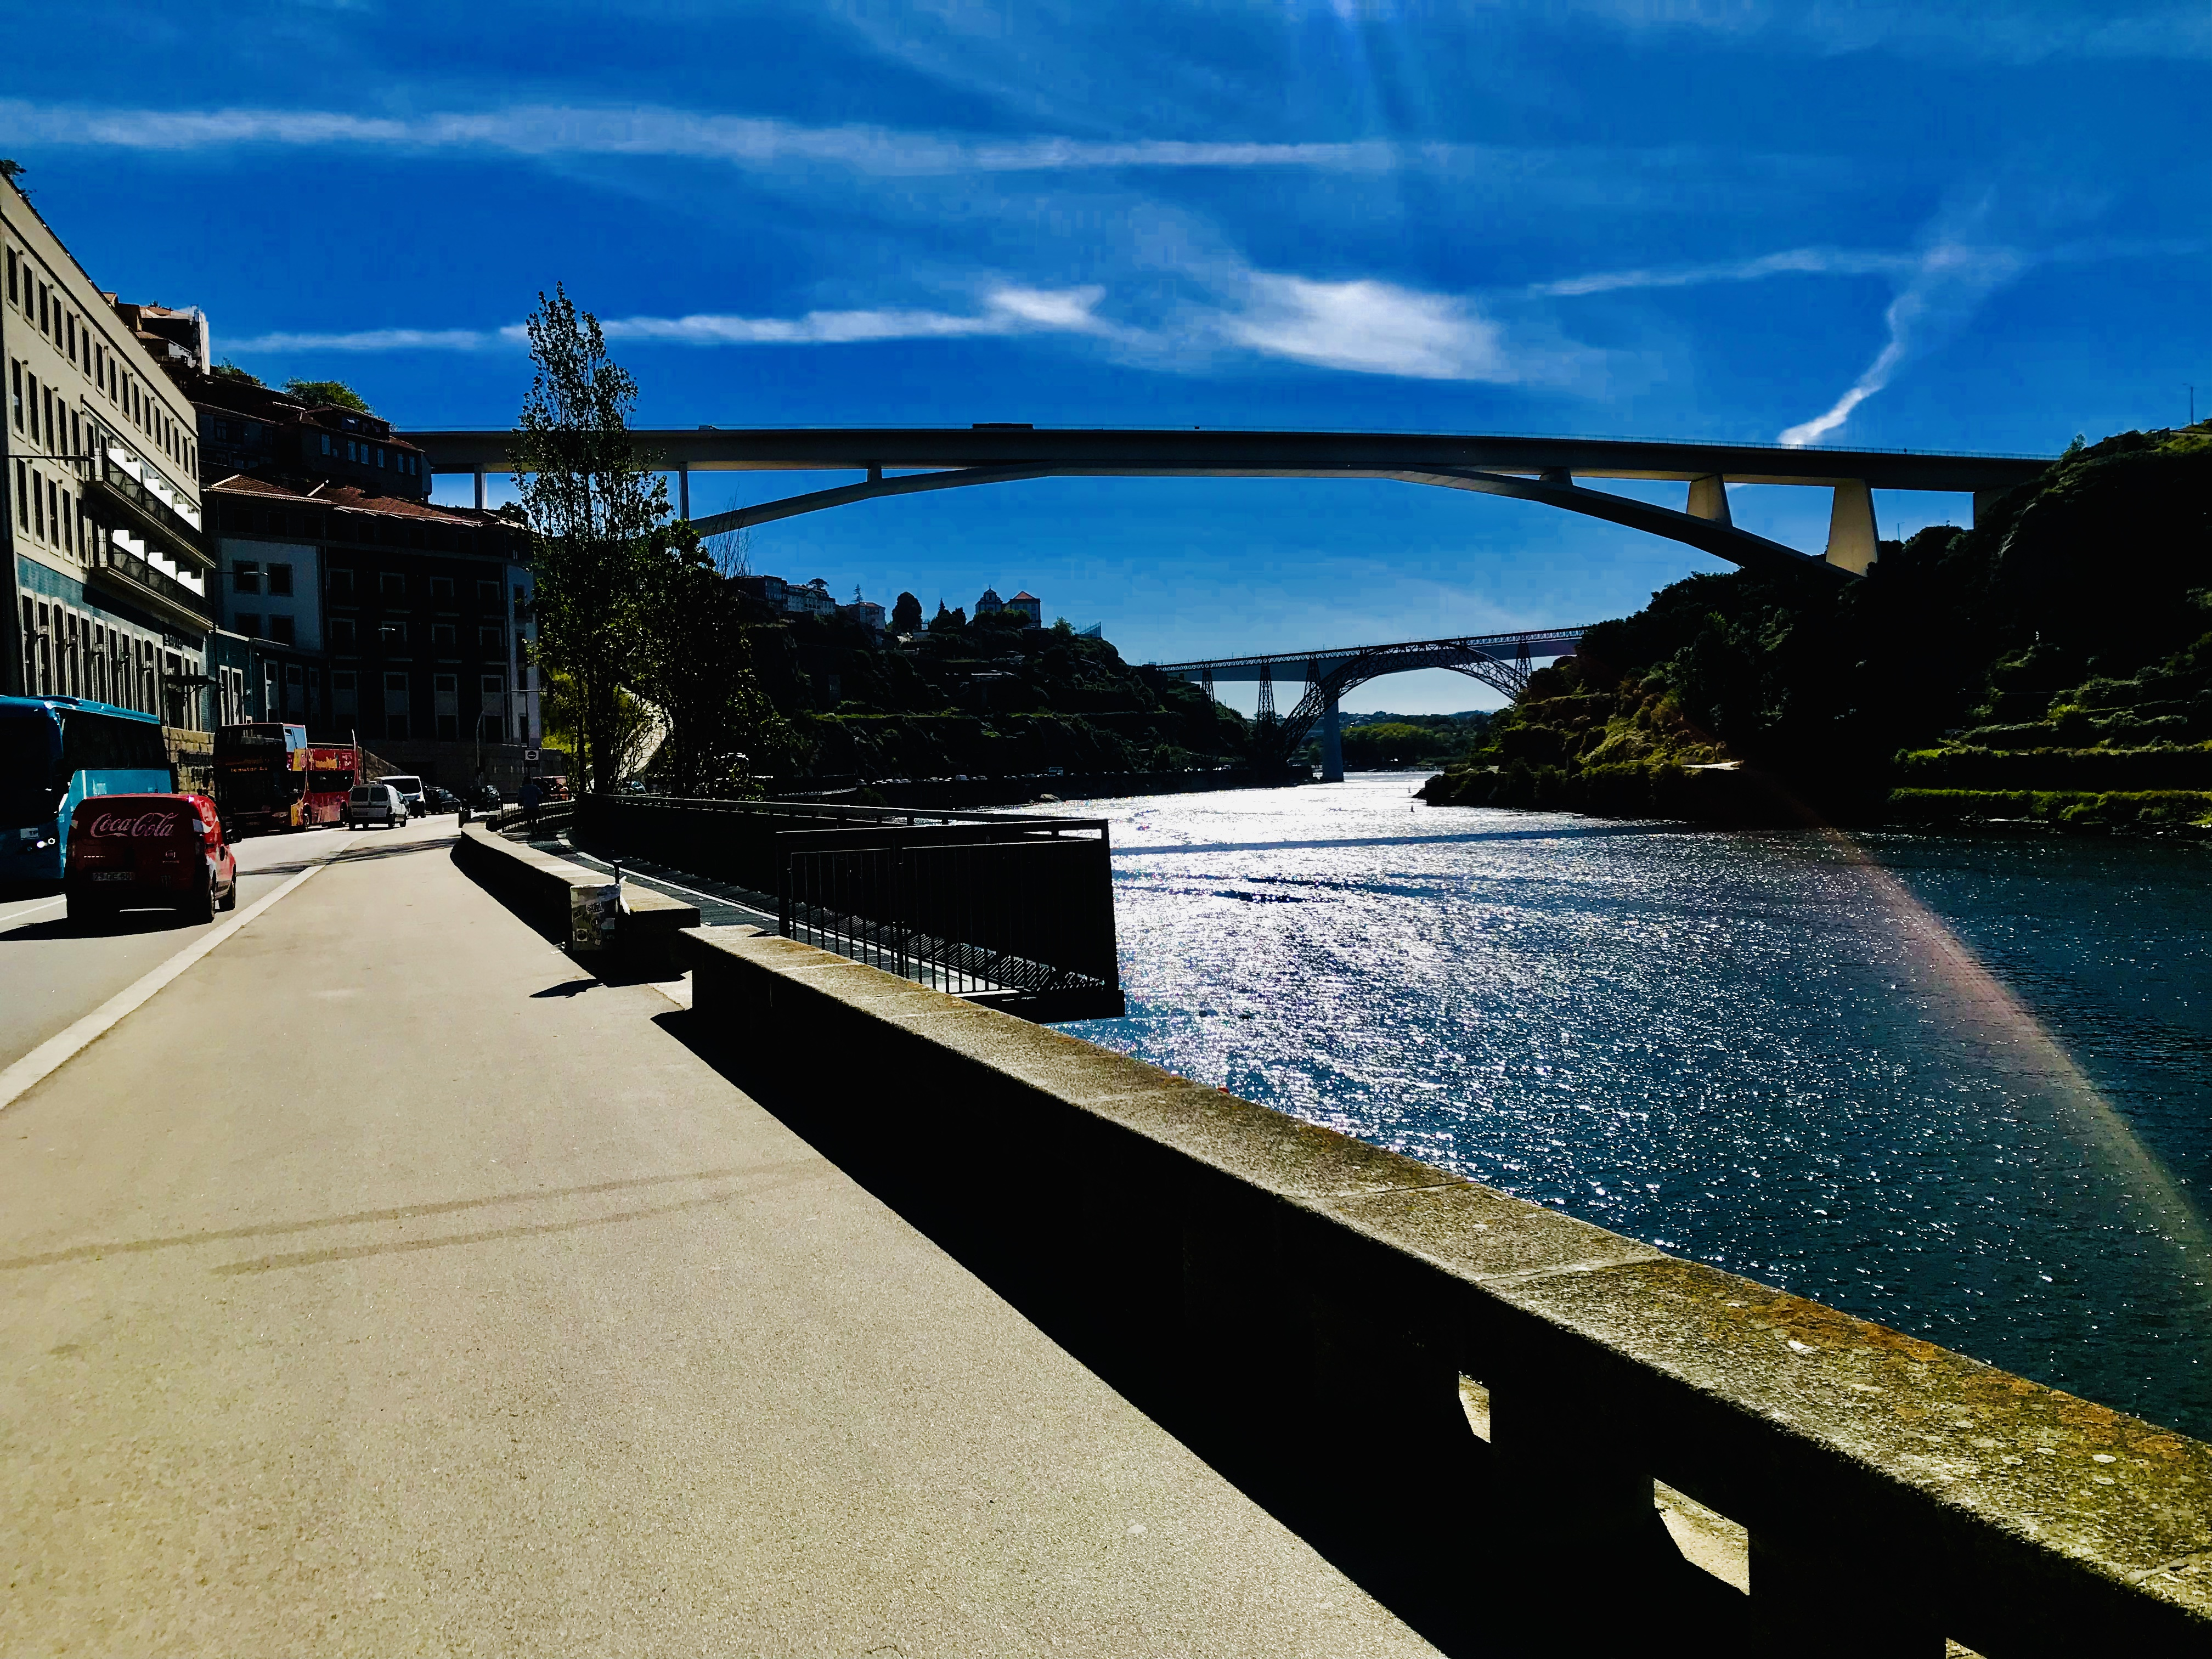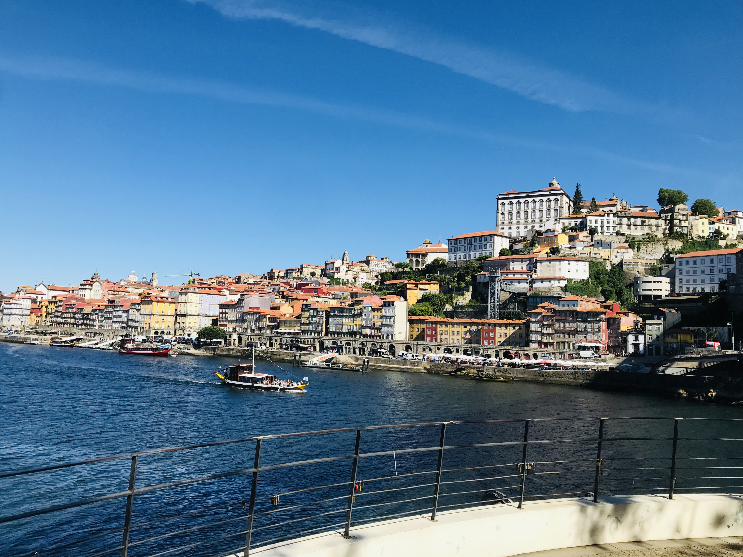
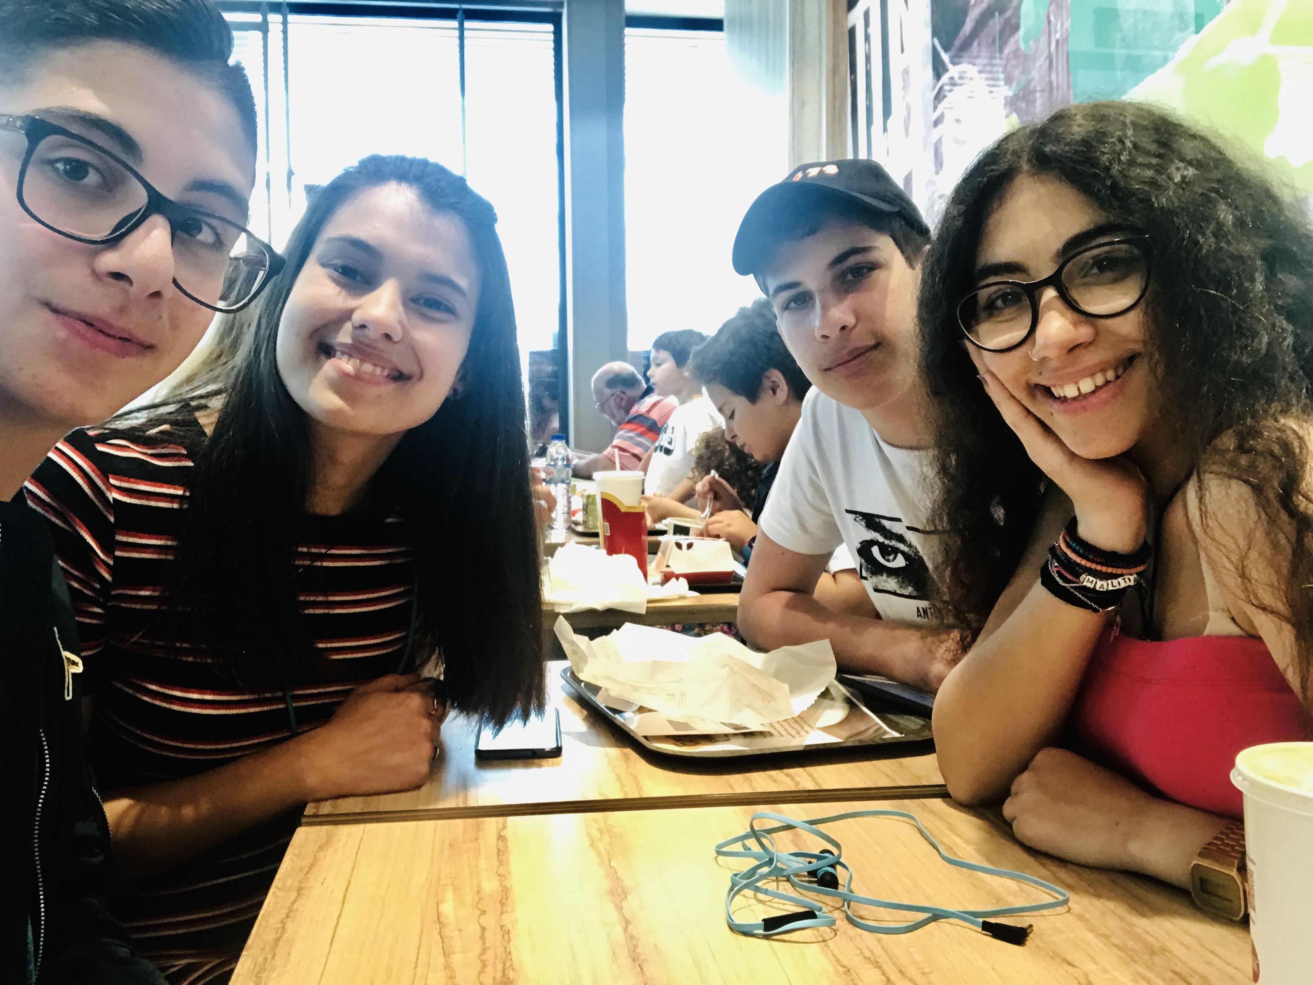
The next day was surely enjoyable, I went to school and from there we took off to Porto city where we spent all day. Later on, when we arrived at Porto we went to a wine cellar which was alright. Overdue we rent a bicycle and drove threw Porto city and finalized our ride to a park where we had a picnic, tardy we went to the beach where we learned to surf. Everyone had a lot of fun! When we finished we road back to the place where we rent the bicycles we had ice cream at a cafeteria next to the place where we rent the bicycles. Later we returned from Porto and arrived at Lixa where our hosts took us to their house.

15 May
The third day we visited Amarante, a very nice graphic area. Tardier we went to Porto where we had lunch and walked along Porto, we moreover walked along the beach which was outstanding. Subsequently, we visited a remarkable art exhibition, which I think was one of the most extraordinary places we visited in Portugal it also learned me a lot of nice stuff. At the nighttime, we went to a cafeteria in the center of Lixa where we met the other students.

16 May
On the fourth day, we went to school in the morning and all the students demonstrated they're environmental project, which displayed the environmental work that everybody does at his school. After that, we visited the city hall of Lixa where we watched a small video of Lixa town. At the afternoon we toured to Porto which was tremendous, we passed by an old train station which was pictorial. At the evening I returned to my host family and later we went to the same cafeteria that we went the day before.

17 May
This was the last day of our pilgrimage, which was and the most exhilarating! We played a game called paddy paper in which we had to find out the clues and go first to the ending mark. After we completed our game we went to buy the ingredients we needed to make our cake. Furthermore, all the exchange students gathered to the kitchen and started making their traditional cake. Thereafter we finished with the cakes we all gathered and started decorating for the party. At the evening the party started and we all danced and had fun it was a blast it ended with tears of happiness and with the promise that we will all meet again in our lives. About midnight almost all the Erasmus students including me went to a club where we stayed and had fun until 4 am I think.

