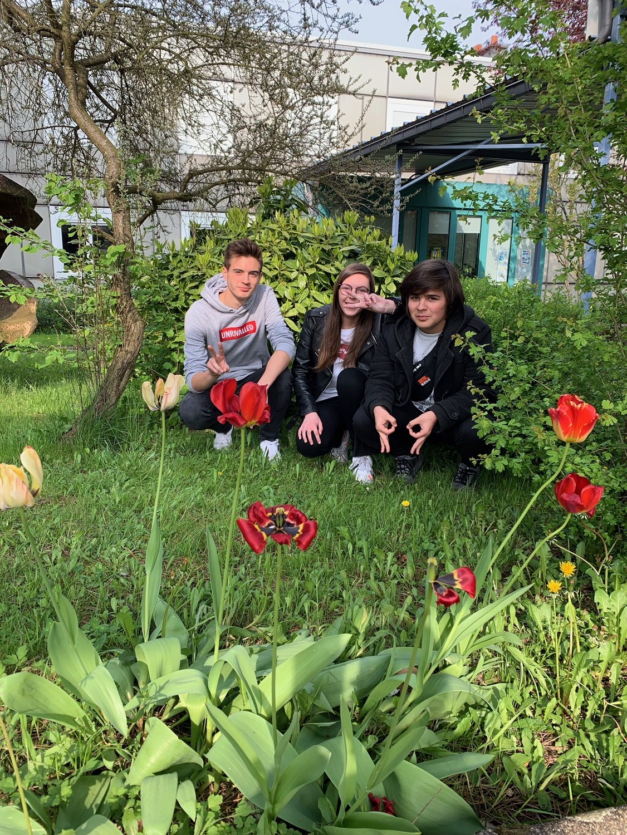

Hello ! I am Kevin (dressed in black on the right). We are the French team.
Unfortunately we do not do much to preserve the environment in our school. But we have just learnt thanks to the Hungarian presentation that France in number 7 for recycling in Europe., so we are not that bad.
A t school we let nature grow as you can see on the picture above : we do not cut trees.
We would like to build an insect hotel and why not grow flowers, aromatic plants and vegetables in a school garden.
Of course there are some elementary habits that we have to follow : switch off the lights when we leave a room, switch on the lights only when it is necessary.
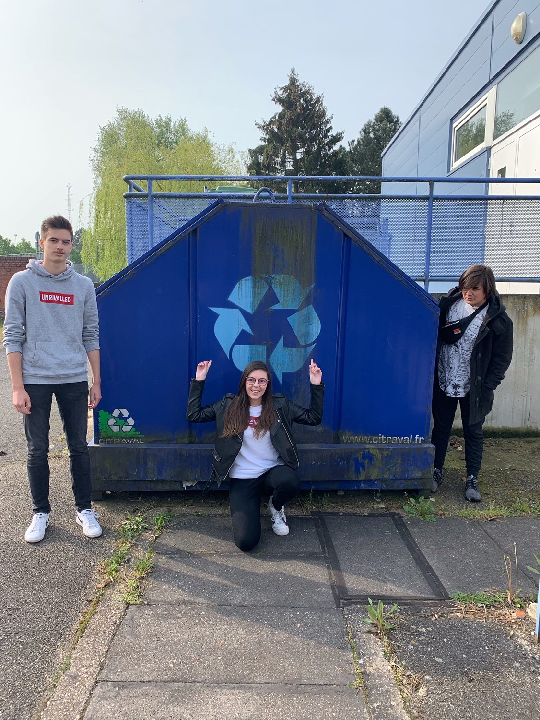

Hi I am Lilian (on the left). At school we have many bins to recycle paper, cardboard and plastic stuff.
Once the bins are full, a firm specialized in recycling empties them.
In our school, there are a lot of smokers but no ashtrays for them. So there should be some to avoid throwing cigarettes on the ground.
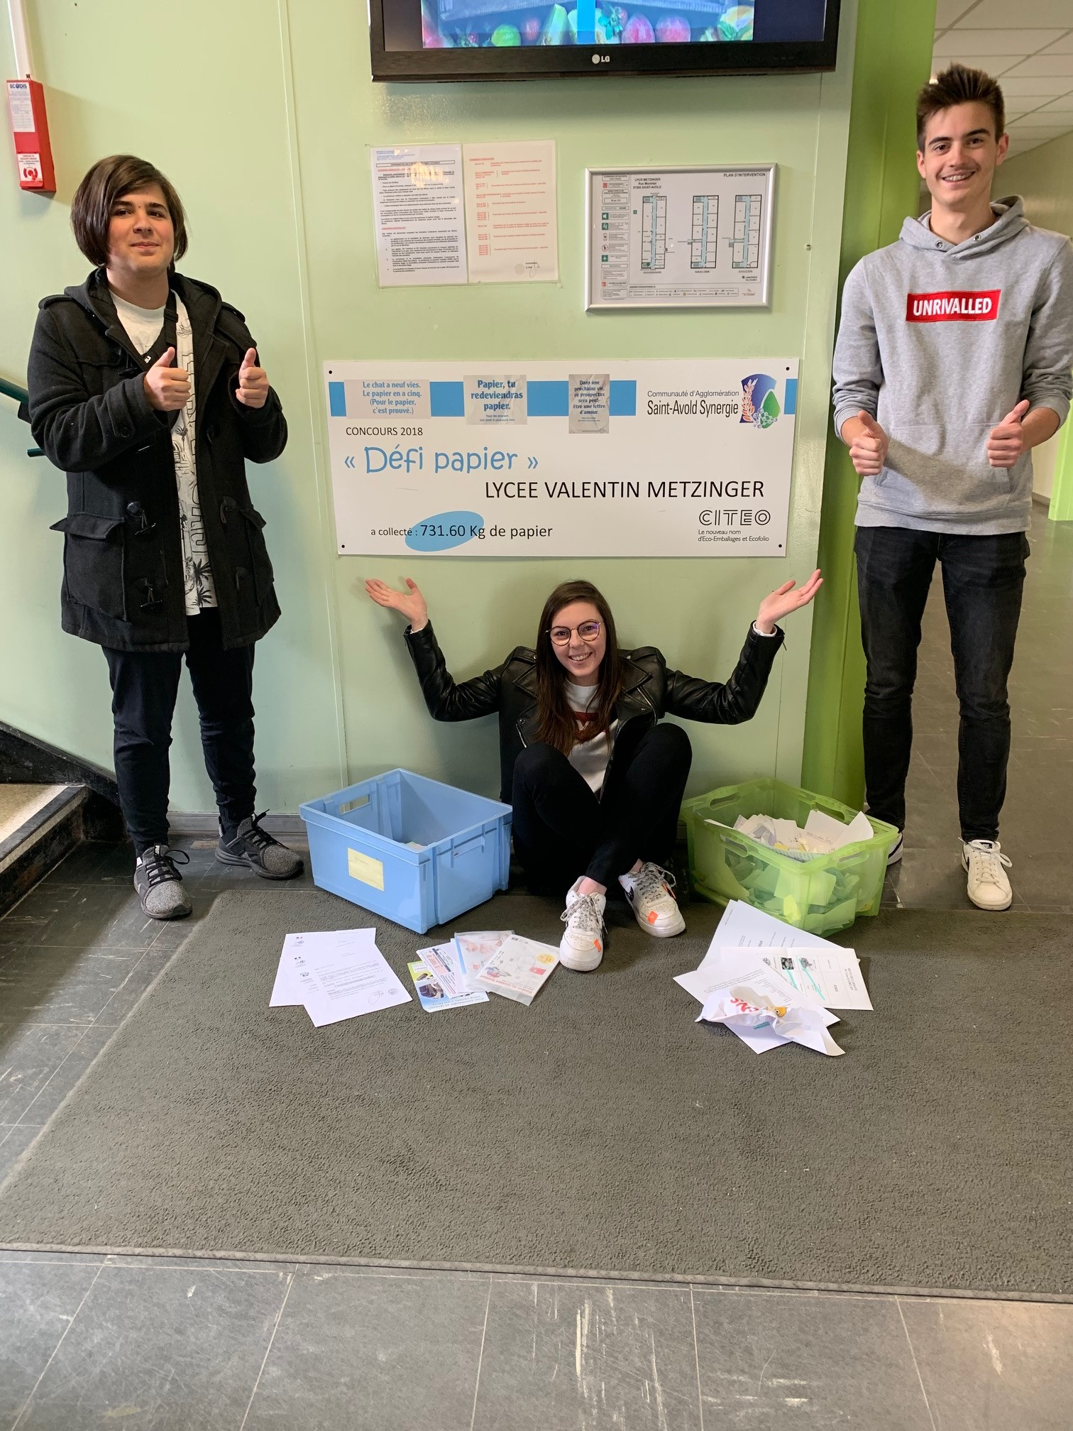

Hi, I am Amandine, sitting on the ground between Kévin and Lilian. Every year we participate in a paper challenge : we have to collect as much paper as possible to recycle it. Last year we collected more than 700 kilos as you can read on the board above my head.
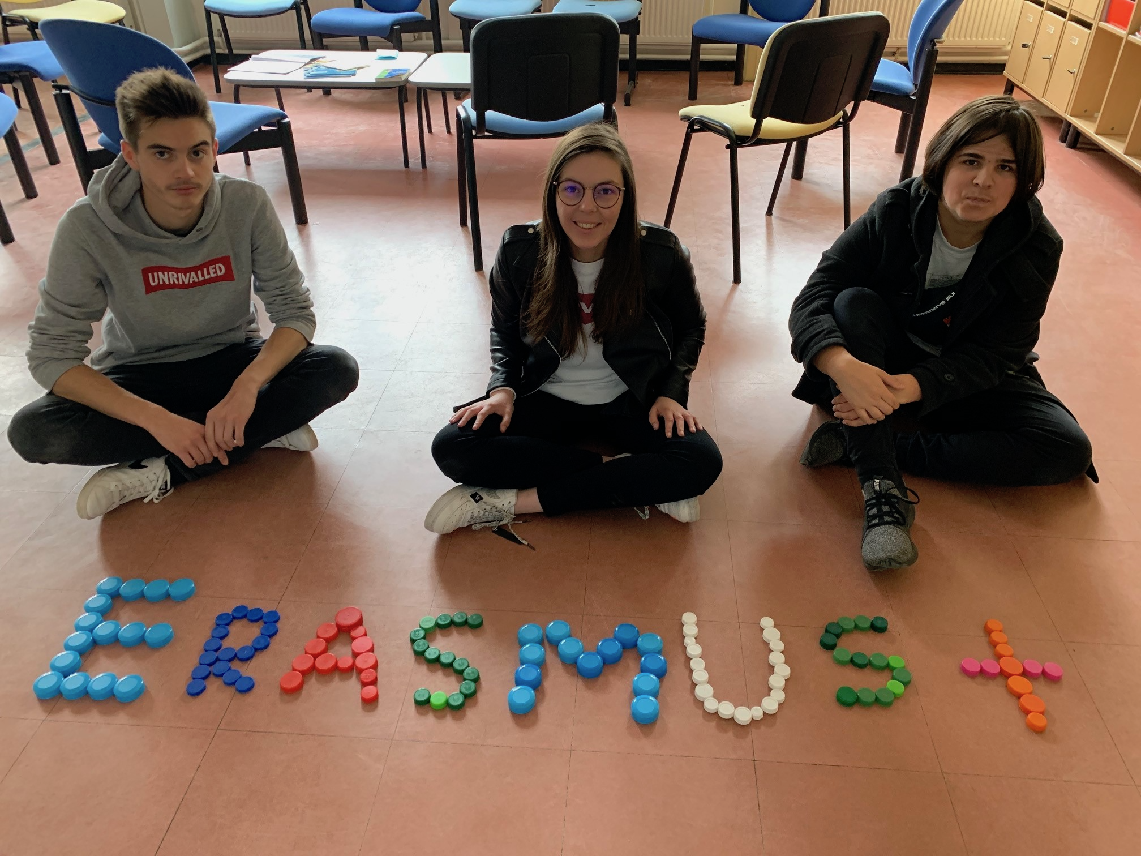

To conclude, we also support an association called Les bouchons de l’espoir located in Alsace not far from Saint-Avold (two-hour drive).
So at school we collect plastic caps. With the benefits of these recycled caps, we can help disabled people to buy special equipment which is really expensive.
This association has started in 2008 and more than 840 tons have been already collected. So do not throw plastic caps, they are worth recycling.

