My trip to Budapest by Vincenza

Thursday 10 May 2018 :

The first day I arrived in Budapest was a Thursday. I was stressed but excited at the same time. I was finally going to meet my host. At the airport we split and I met my host family. They were really welcoming and very kind to me.

Friday 11 May 2018 :

Friday was a very special day for me as I was 18. My host family prepared me a surprise when I woke up: I was really happy and touched.
During the day we played some ‘ice breaking’ games to get to know each other. It was really fun. Then in the afternoon, each team introduced their topic related to Erasmus. In the evening we had dinner together. It was prepared by the students of the school. At the end of dinner all the lights went out and everyone sang "happy birthday". Students brought a birthday cake for me and a student from Cyprus.

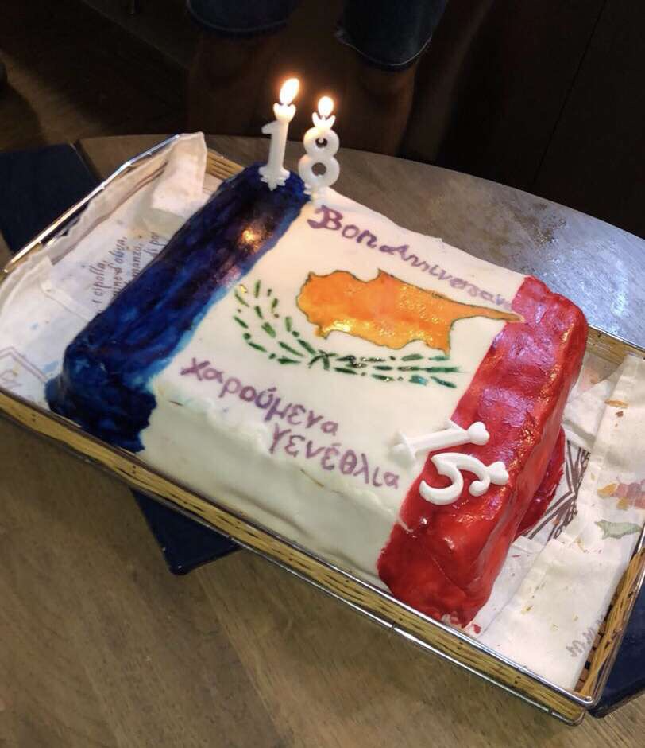

At the end of this wonderful moment we went for a walk along the Danube with all the students.

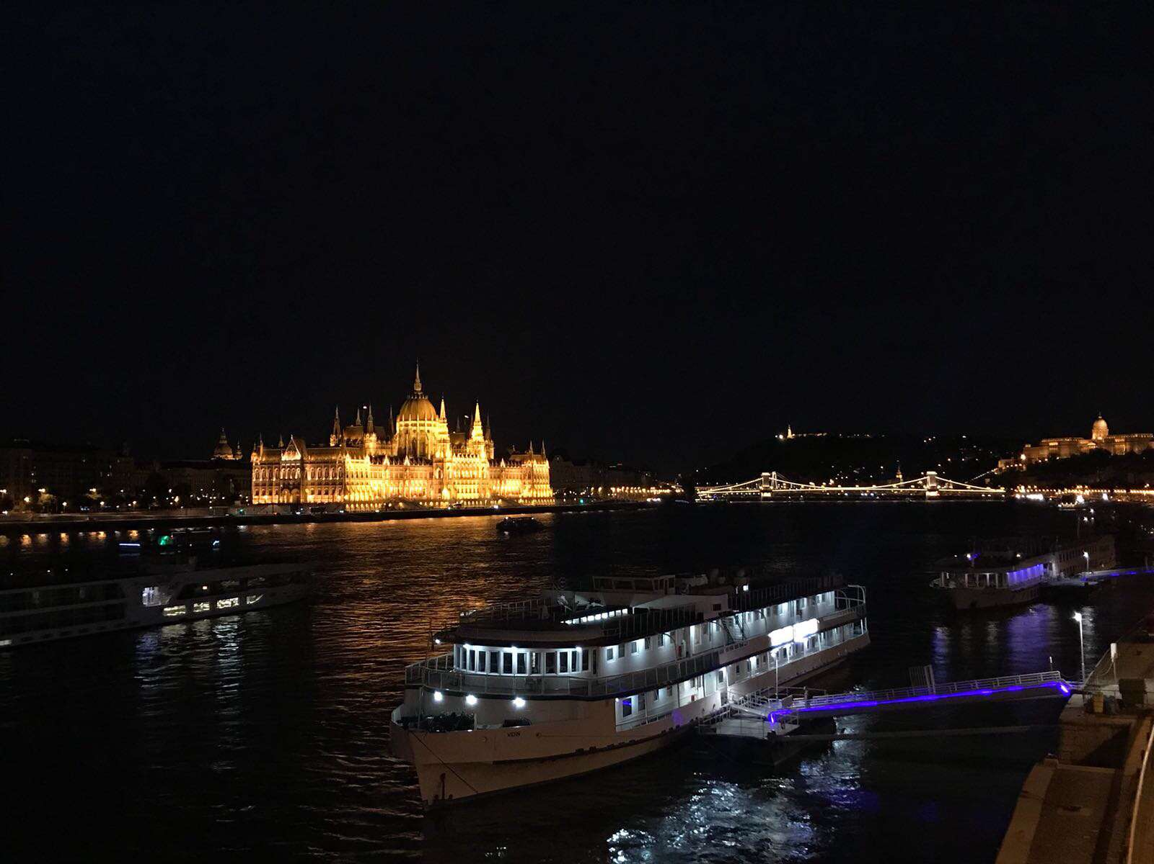
Saturday 12 May 2018 :

On Saturday there was "kapcsolda". We welcomed children with disabilities. During the day we participated in games and in the late afternoon, all the children were graduated. It made me happy to see them happy. In the evening we went to a bar, it was a nice moment!!

Sunday 13 May 2018 :

On Sunday we were in small groups: we had to create a quiz on human rights. In the afternoon we had free time and at the end of the evening I could go on the Ferris wheel with my French team. It was really beautiful: we could see the landscape of Budapest.

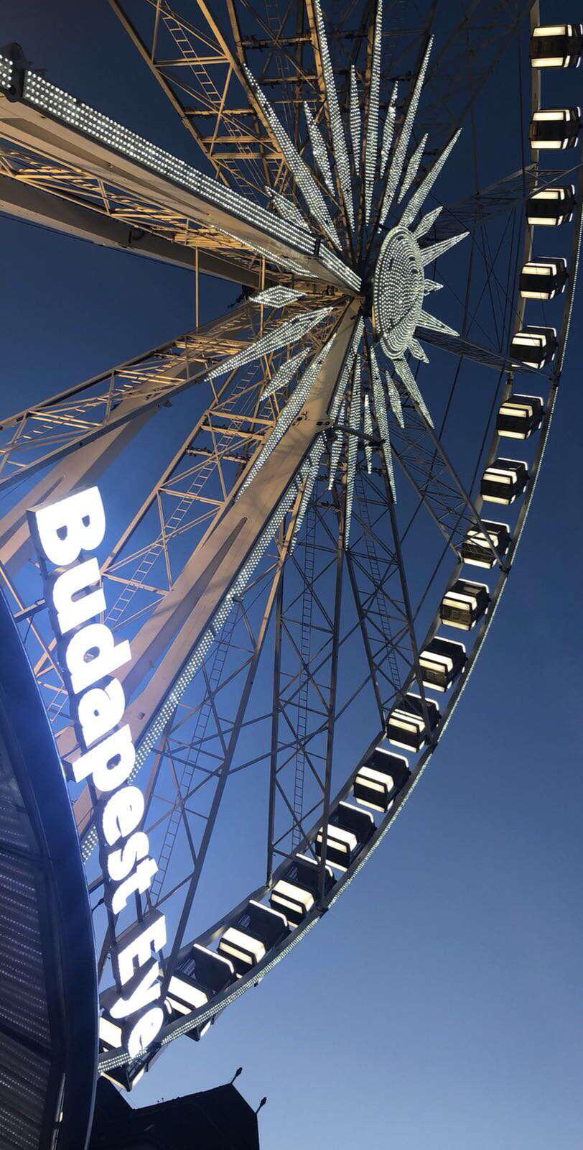

Monday 14 May 2018 :

On Monday we met at Deàk Square: we visited the Jewish Quarter and did a treasure hunt in the city of Budapest. It was very complicated and it was very hot but it allowed us to discover more things. We gathered at Millenáris Park to discover the invisible exhibition. I really enjoyed participating in this program: it was something I had never done in my life. We could imagine what blind people feel. In the evening we visited Budapest and spent another wonderful time.

Tuesday 15 May 2018 :

Tuesday was the last day in Budapest. I was a bit sad to leave after the moments spent with everyone.
We met at a café "Nem adom fel". We played the game created by the Hungarians. I loved this game even though we were not so strong with Lilla, but we had fun and that is the most important.
Later in the day we had a boat ride and went shopping. Then with all the students we went to a bar all night: we danced, we laughed. It was really great, I was really sad to go back. I thought I was lucky to meet wonderful people. I had a great time and I will never forget this week in Budapest

