DIARY

15 May
In the morning, like every day that week, I woke up at seven and I had breakfast with my host, after we took the bus and we went to school to meet the other guys. We met at the school canteen and when everybody arrived we caught the bus for Amarante. The journey wasn’t too long and meanwhile teacher Pedro tried to explain to us some geography about Portugal, but I’m not sure all the people were listening to him, honestly I wasn’t because it was quite difficult to pay attention from the last seat on the bus, In fact most of the time I talked with the other guys, but I’ve tried to pay attention, I swear ahahahah.
When we arrived we visited an ancient cathedral and I can remember that Portuguese guys told us that a spot of the cathedral was “ broken “ because of Napoleon soldiers bullets; that was pretty interesting because with “ historical objects” or monuments you can understand better what happened in the past. We also visited the inside of the cathedral and we took some photos like this…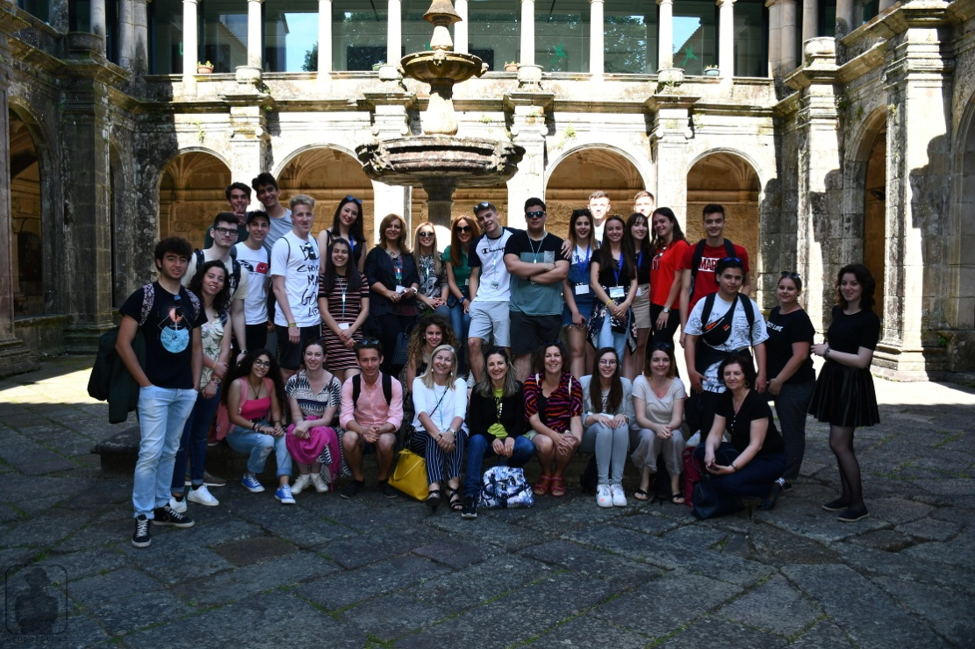
Personally , in general, I don’t like visiting cathedrals or churches but I have to admit that this one was pretty, it wasn’t too big and the decorations inside were so amazing and so “ rich” they looked like a king’s palace because of the gold , I don’t know if it was real gold and if it wasn’t it was a good fake…
After visiting the cathedral we took a break and we went to the market nearby; it’s incredible how cheap are the prices for sweets, my friend Luca took one "brioches" and it was full of chocolate,delicious..... but also the fruits ..such a good place. I would like that sweets in Italy cost the same, but if it was like that, now I’d be a fat ball. After visiting Amarante we went to a museum to see an exhibition of an artist called “Joana Vasconcelos”. Personally I don’t like art at all, and I found her works really strange. How could a person find a chandelier made with “tampax” interesting? in fact my friends agreed with me and we kidded a lot about all the works. There was also an helicopter with flamingo plumage and was quite strange but funny too. The strong feeling part of the exhibition was the last one, there was a head of woman (of course it was fake) and it was covered by a lot of textiles which were representing different countries; the head brought to a high spot by a machine, after it was let fall down on the floor unexpectedly and the sound when the head touched the floor was a bit disturbing and the feeling it gave me was quite strong.
At the end of the day we returned to the bus to go back home, this part of the day is the best one in my opinion because from the last seat of the bus me and other guys started singing a lot of different songs. We also made a native American chorus for teacher Pedro and it was like “ Teacher Pedro!...Augh!” so funny, he also answered to us “they love me, thank you!”. In conclusion it was a good day especially because of the Erasmus people, they are really amazing and open minded like us, like Italian people, so it’s easy to talk with all the guys and also enjoyable.
