Erasmus-France
MONDAY – the first day of Erasmus, the big day. We started the day with fun and interactive team activities. In the first activity we had to find clues to find our way out of a room; with this activity we put tour brain to work.
After that, we painted t-shirts with key-words from the Erasmus theme – “Your rights are my rights my rights – fighting discrimination and promoting equality”. Then we had a break for lunch.
In the afternoon we had the opportunity to get to know the city through a treasure hunt in St Avold, and that´s how our first day ended.
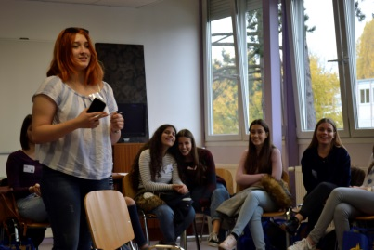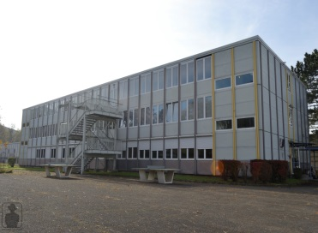
TUESDAY – the day when we had to show our presentation about Portugal to the other countries. With that presentation we wanted to pass a message about our female celebrities, about Portugal and make them curious about our country.
In the afternoon, we had one of the most special moments of this incredible week. We played basketball but it wasn’t an ordinary game. We had the chance to sit on a wheelchair to play and because of that we realised what the life of the people who really need those wheelchairs is like, and how hard it is. This experience allowed us to put ourselves in their shoes and made us give more value to the little things we have in life. It was really special for me and, I believe, to the others as well since it was a moment of fun and learning at the same time.
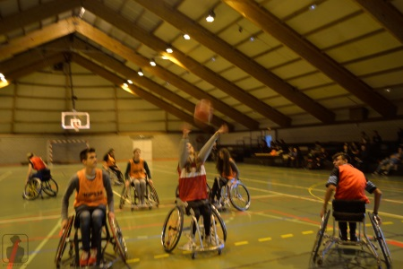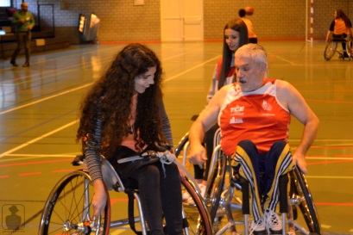
WEDNESDAY – the day of awakening our adventurous spirit and discovering a new city, Metz, guided by the French team. We visited lots of different places, such as the cathedral of Metz and also the Pompidou museum which had on display "The adventure of colour", which, as its name says, is a show of colour and this was the end of this day.
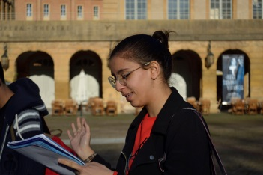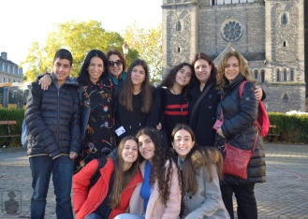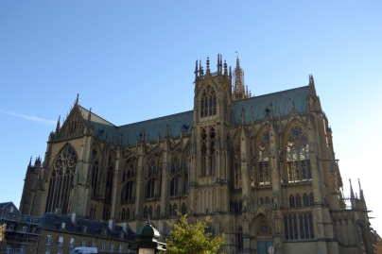

THURSDAY – on this day we meet some members of UNICEF and we listened to a short speech and later compared opinions about urgent matters of the world. The rest of the day each country worked rehearsed the stanza of the song we had previously written. Then all the countries sang their stanzas, in their own language, so as to make a song together, with the chorus sang in English. We finished the day with this fun moment. 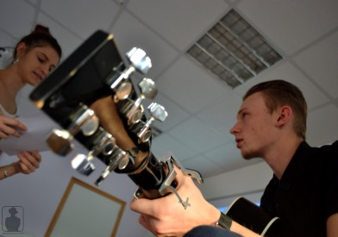 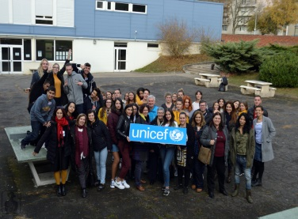 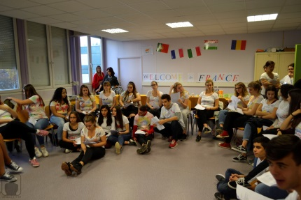

FRIDAY – the last day of this fantastic experience. On this day we stepped back a bit and went to visit the American cemetery at St Avold, a very interesting and historical visit. We also visited a city in Germany, the city of Saarbrucken, where we went to visit the Volklinger Hutle - exhibition of Queen Elizabeth II. After this we had free time to relax and get to know the city better.
At the end we returned to school feeling sad because this week, which was more than special, was coming to the end. When we arrived at school, and with tears in our eyes, we had to say bye to the new family that this unique experience has given us. In my memory I take all the friends I've made, all the moments I've spent, all the places I've seen and all the things I've learned. It is with my heart full of pride and love that I say that I was part of this project so special that is ERASMUS +.
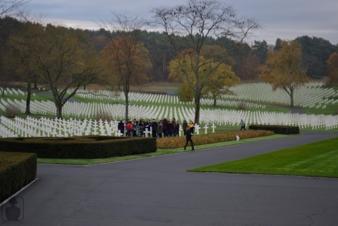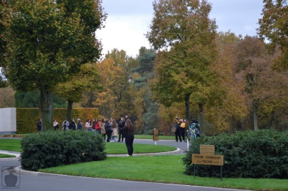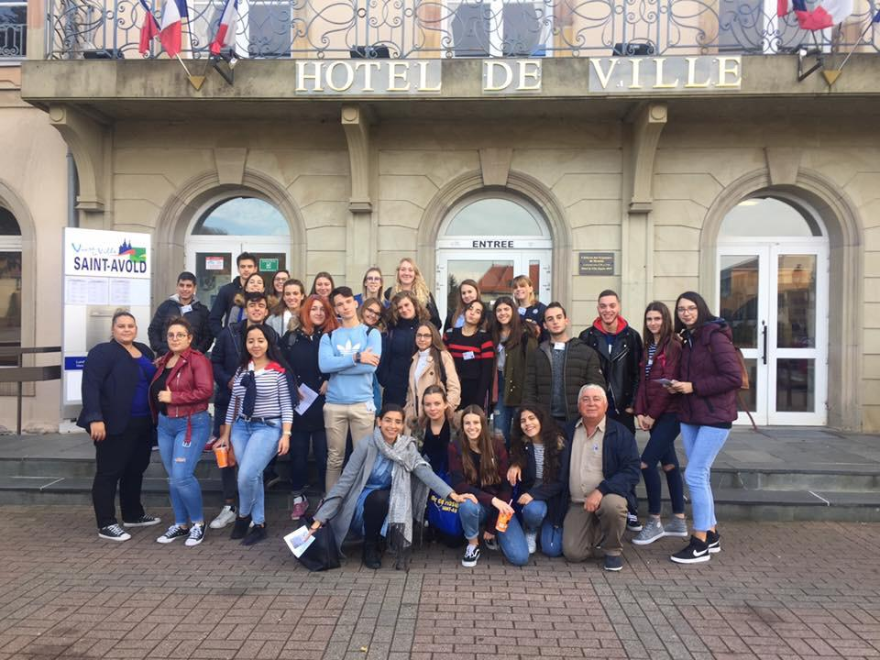

Ana Margarida Marques – Portugal

