Results of the questionnaire for students in France

- How much have you learnt about human rights, discrimination and about respecting others during this project?
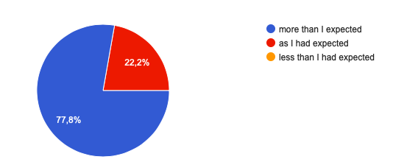

- Have you made good friends during this project?
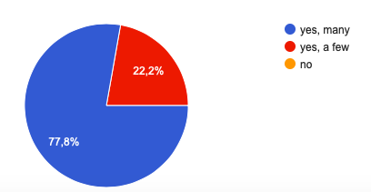

- How successful was the co-operation in multicultural groups during the workshops?

- I have improved my English skills through this project
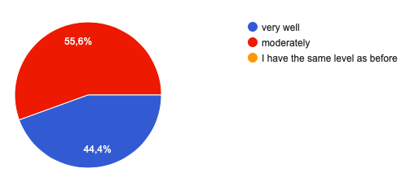

- I have improved my ICT skills through this project
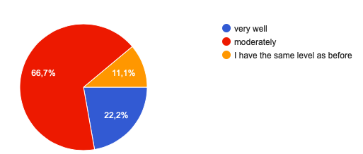
- Through this project I have become more aware of human rights.
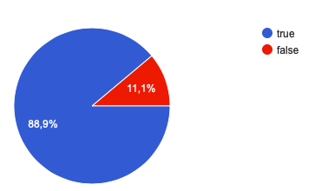
- As an outcome of this project I have become more involved in respecting and protecting human rights.
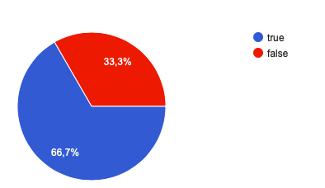
- If true, how?
- Getting involved in associations
- Fighting discriminations
- Going on respecting and protecting human rights

- What did you enjoy most in this project?
- Meeting other students form different countries
- Exchanging with students about their ideas, cultures and daily lives
- Discovering other countries and visiting some major European cities

- Would you like to participate in another Erasmus+ project? Which topic would you be interested in?
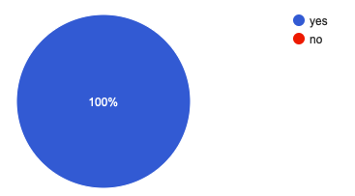
Topics such as : how to help people to integrate a country, how to fight violence, dealing with the job market and social network

