1. Creating seed bank
Planting local and organic seeds is important when growing your own food. We wanted to enrich our collection of seeds this year and also offer some of our seeds to the families. We came up with idea of seed exchange box, that we placed on one of the hallways in kindergarten.
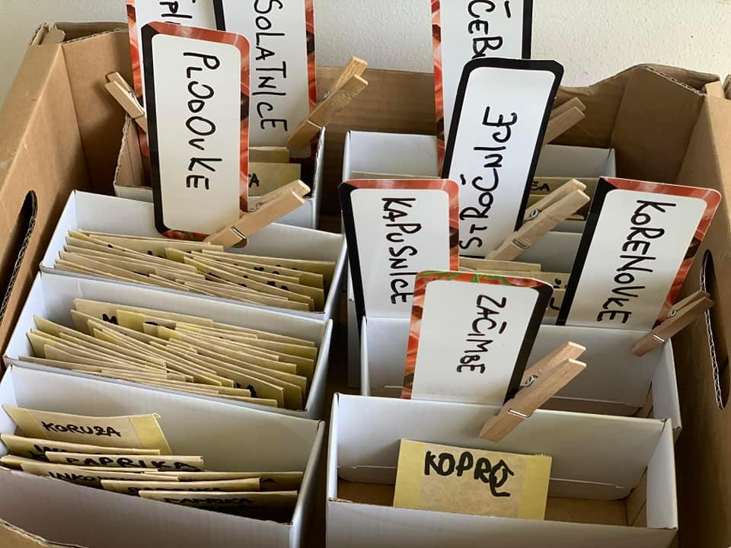

2​​​​​​​. Visiting a local farm
We visited a local farm where they produce yogurt we often eat as a sneck in the kindergarten. Friendly landlady showed us around farm and taught us aboug yogurt production.
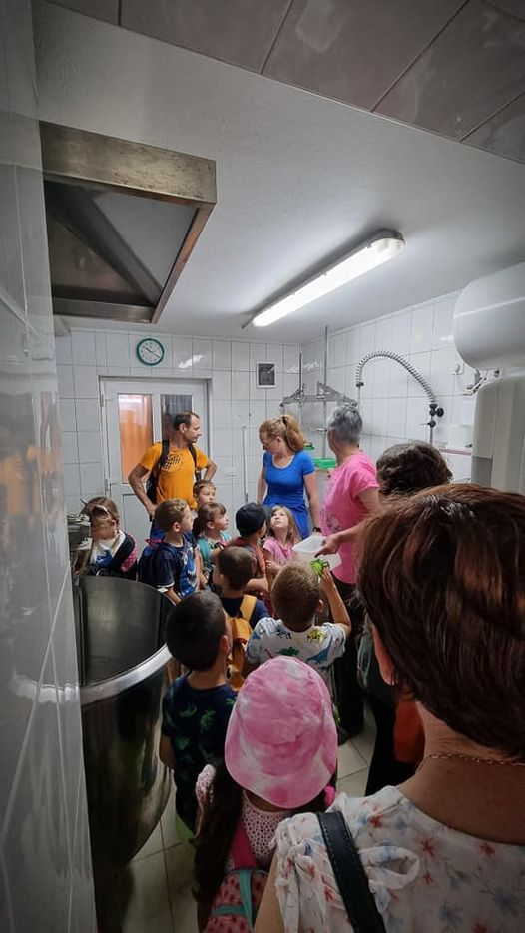

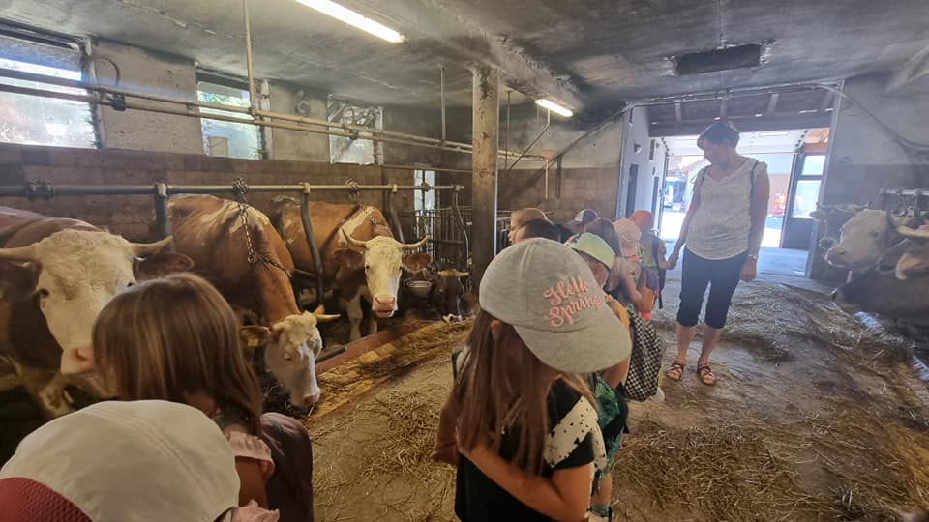

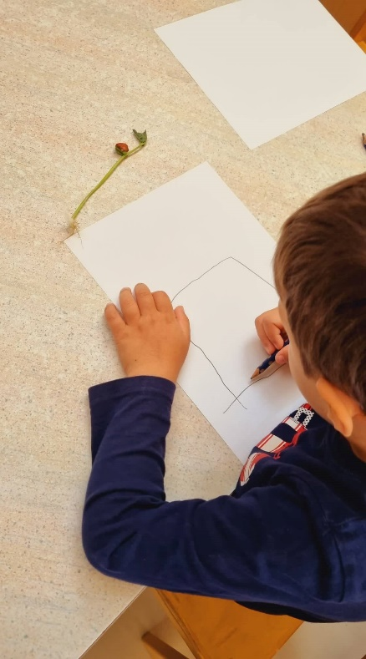
3. Learning about plants
One of the first activities when learning about importance of sustainable food was identifiying parts of the plants and getting to know plant's lifecycles. Children did simple experiments that helped them discover what conditions plants need to grow. They documented all their finding in nature journals.

4. Learning about healthy soil
Healthy garden soil is a first step in growing your own food. Children learned about topic by doing experiment (growing seeds in polluted/clean soil) and carefully examining different types of soils. They predicted the outcomes and compared the results. They gathered some soil from our compost heap and learned about the process of breaking down plant material to produce soil.
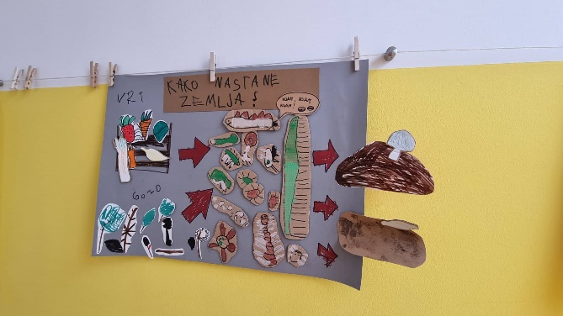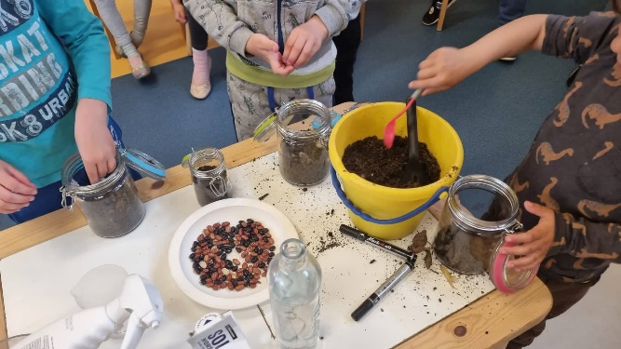

4. Learning about forest/garden grounds and composting
Do you know what is happening under the garden/forest floor? We explored what role do roots of the plants play, decomposing process and animals that help in it.

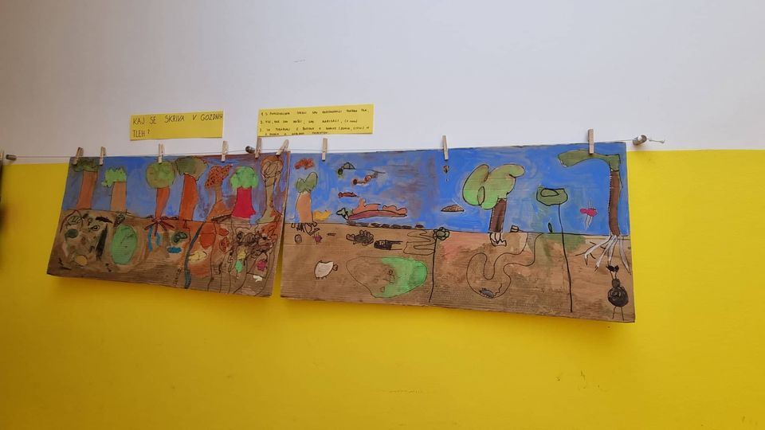
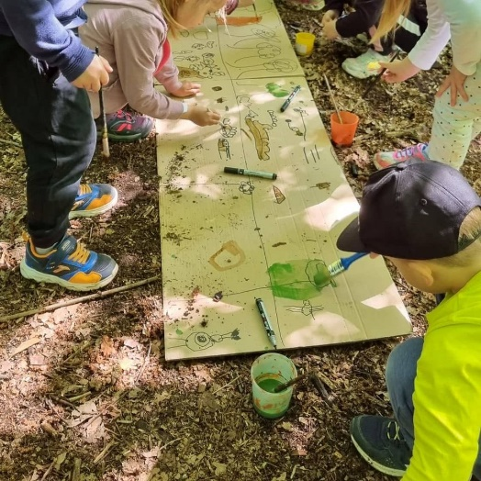

5. Learning about elements in the garden
Children learned how to design their own gardens. They identified all essential parts of the garden, draw their designs and created miniature gardens from natural and unstructured materials.

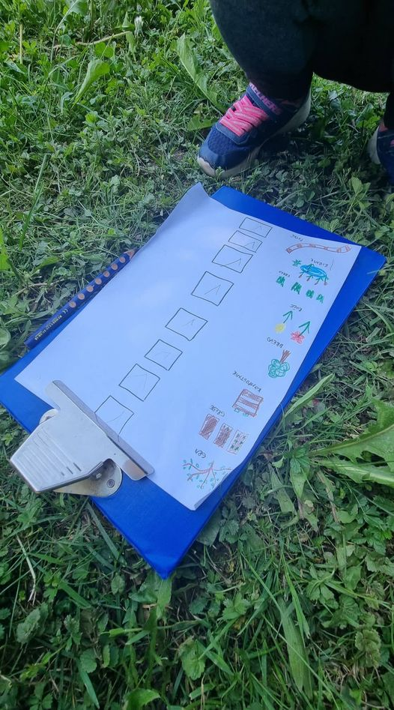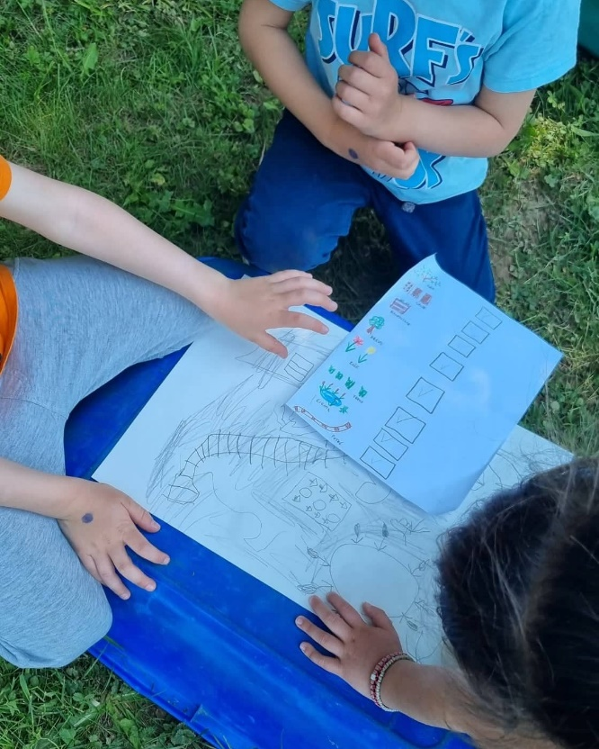

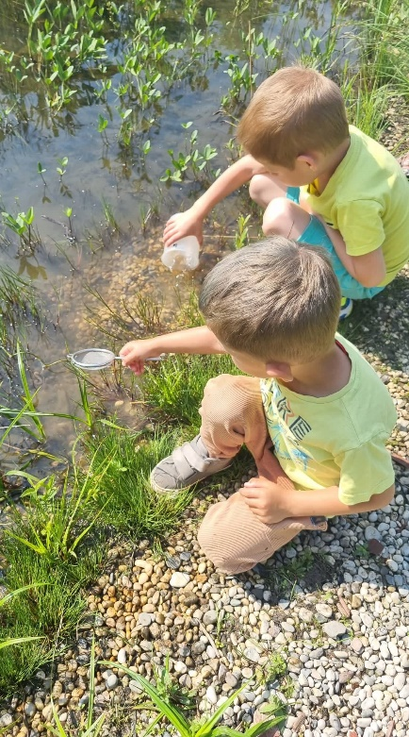
6. Importance of the garden pond
Garden pond is important part of garden ecosystem. We learned about animals and plants in the pond, how the pond is made in nature/by humans and the meaning of pond for garden ecosystem.
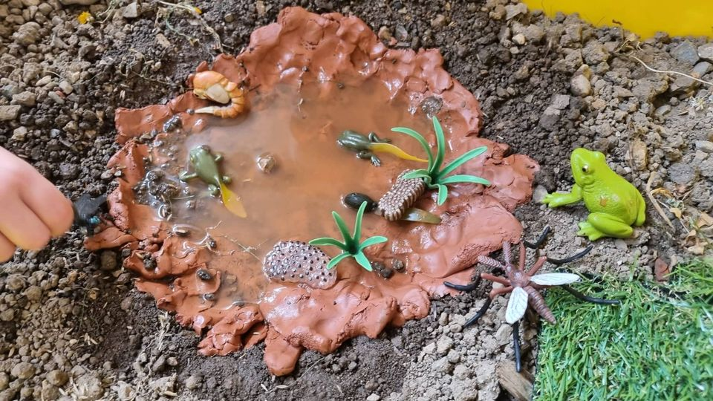

7. Discussing the importance of local organic food and doing a movement story
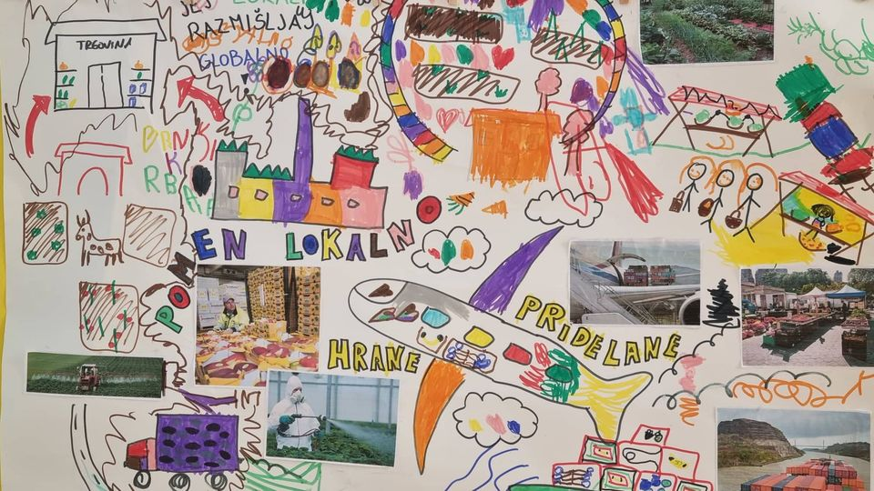

Why is local food better for our health? We created 3 different obstacle courses that represented the distance that food needs to travel to get to our homes. We compared the distance between food from foreign countries, from local farms to marketplace and from a garden at our homes. We compared the quantity of nutrients that is left in the food using balls. Children started the activity with 5 balls in their cones. Each time they passed one of the means of transportation, they discarded one of the balls. Balls represented the nutrients in food. After they finished the course, they counted the number of balls and discussed the result. We also talked about the difference between organic farming and industrial farming using pesticides.
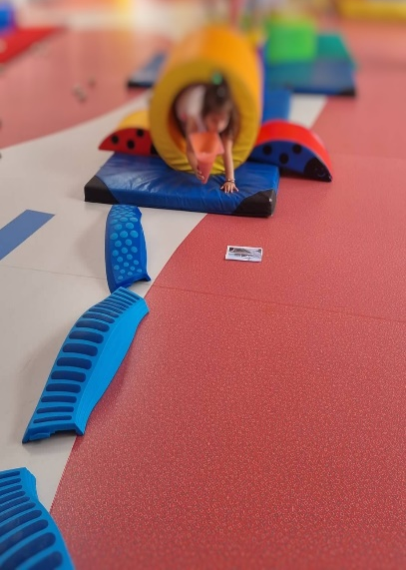

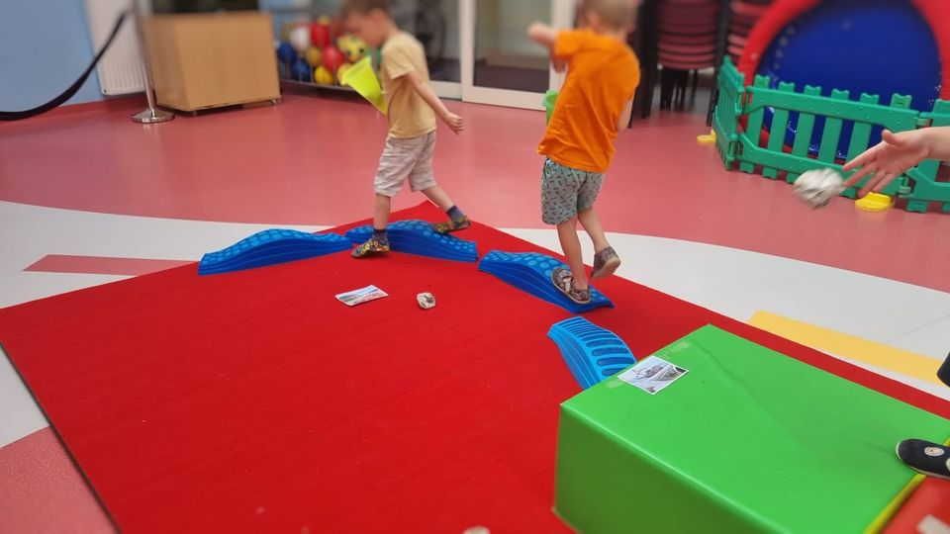

8. Visting local supplier of vegetables.
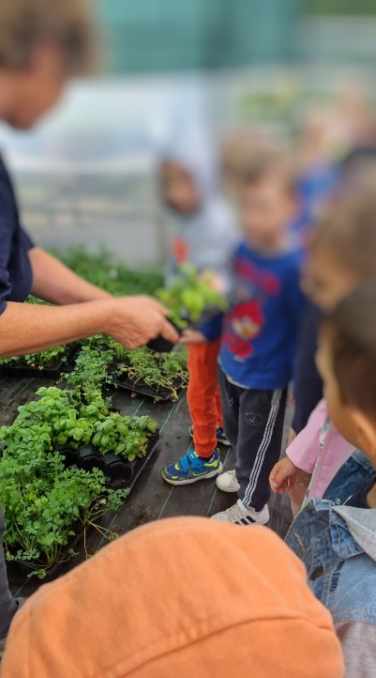

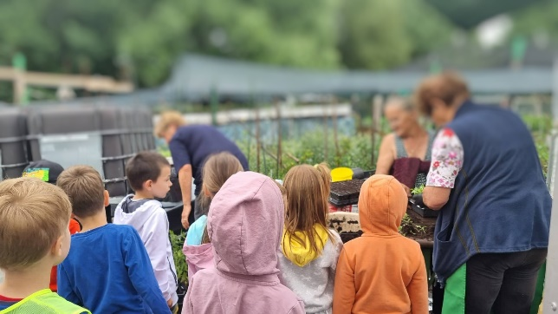

9. Making an international garden
International garden with a local twist Seeds from project seed exchange planted in a soil from the local forest.
10. Visiting of local market and supermarket
Comparing where food comes from at local market and in the supermarket. We searched for the origin of produce and local products.
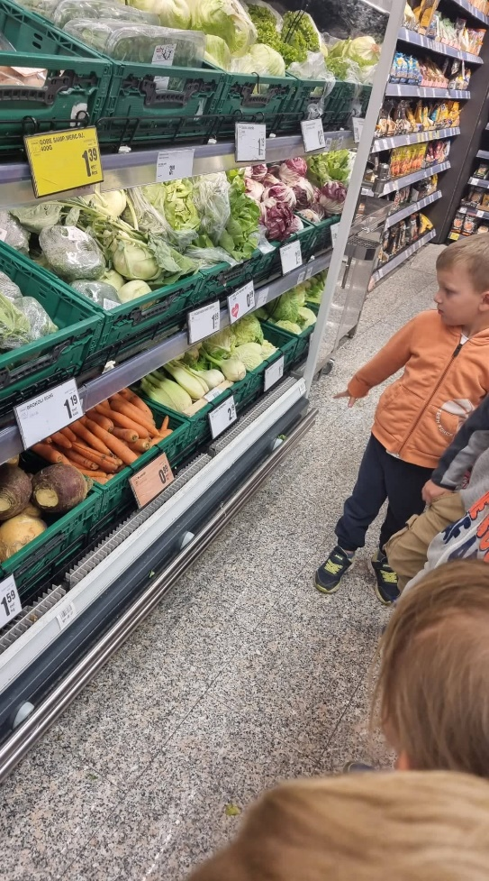
11. Making new raised beds
We got some new raised beds in unit Žabica. Children filled the beds with layers of sticks, leaves, cardboard, wool, soil and compost. Afterwards they planted them with seedling and seeds.
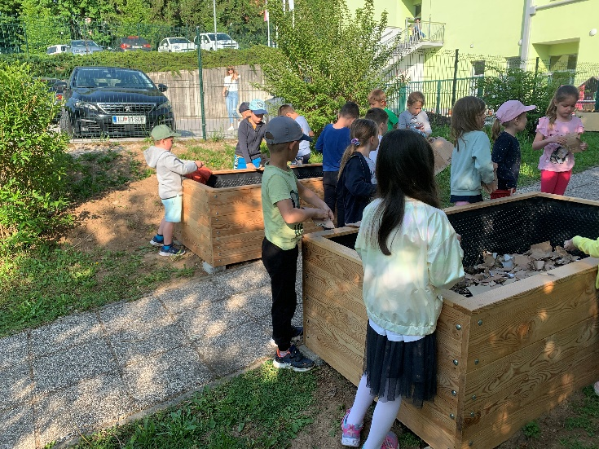
12. Planting seeds and growing seedlings
Planting seeds and growing seedlings. We were mindful to reuse waste materials.
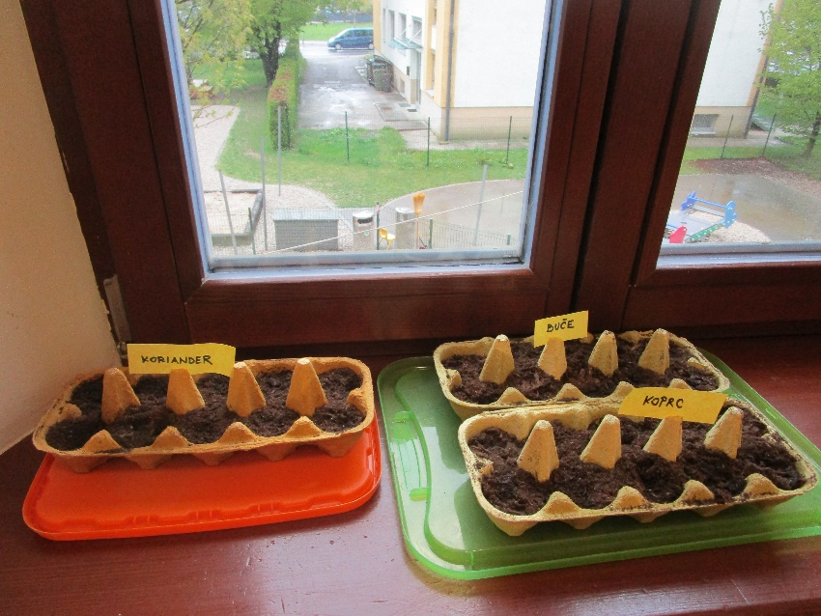
13. Making vegetable soup
2-3 year olds making vegetable soup from some of the vegetables from the garden.
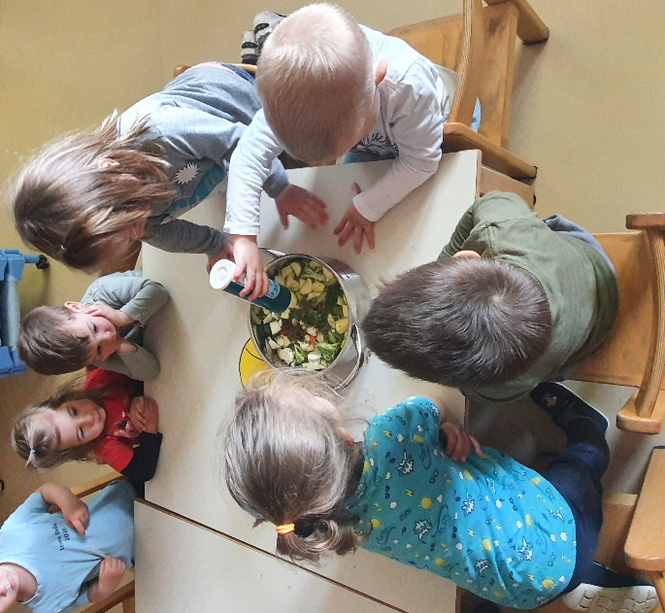
14. Making strawberry dessert
1-2 year olds planted strawberries, carefully took care of them and enjoyed the fruits few weeks later. They helped to make strawberry dessert.
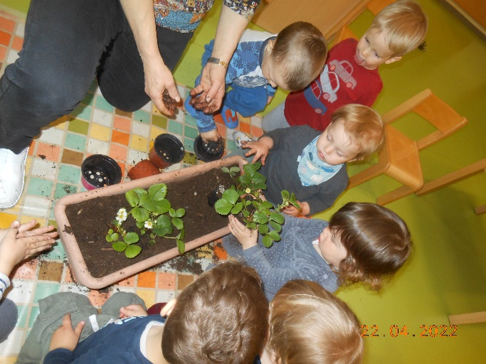
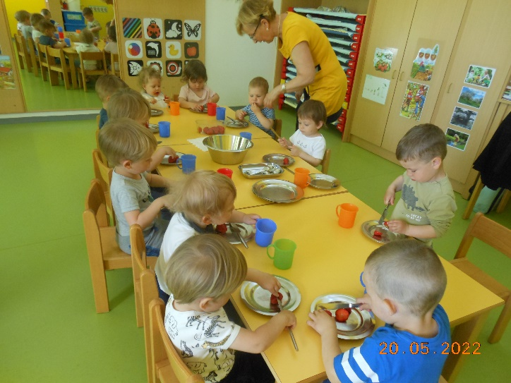
15. Planting radishes and enjoying them few weeks later.
