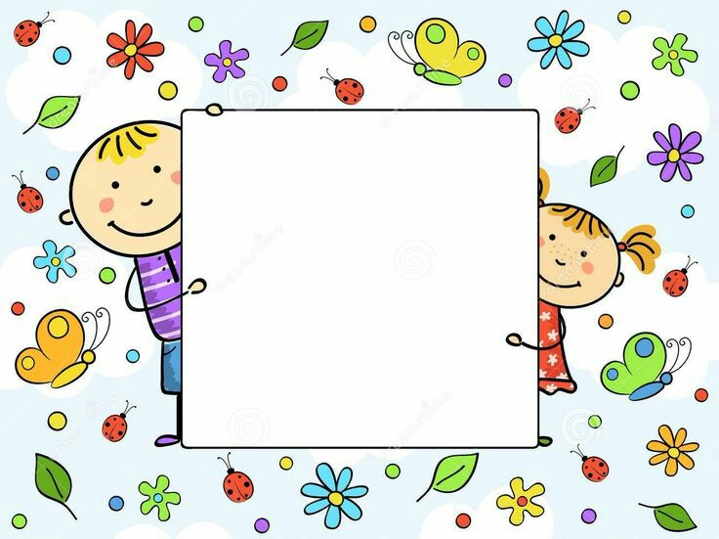

**THE WRITER – WHO ARE YOU?**

**KIRJANIK - KES SA OLED?**