Why do cats act so weird?

»Cats today retain many of the same instincts that allowed them to thrive in the wild for millions of years. This explains some of their seemingly strange behaviors. To them, our homes are their jungles.«
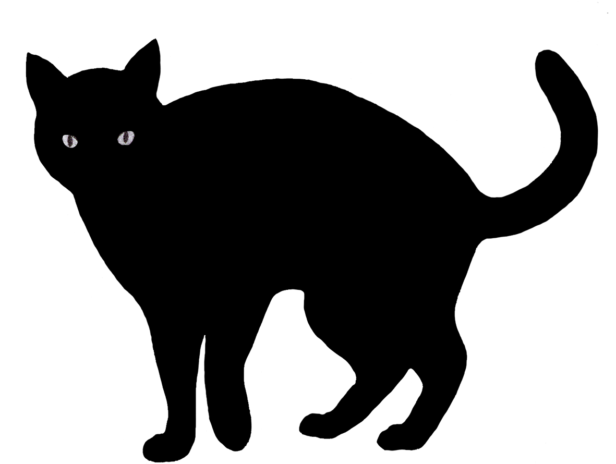
Cats are judged by the 26 billion views of over 2 million YouTube videos of them (watch the video and write down their strange behaviors):
- __________________________
- __________________________
- __________________________
- __________________________
- __________________________
- __________________________
- __________________________
- __________________________
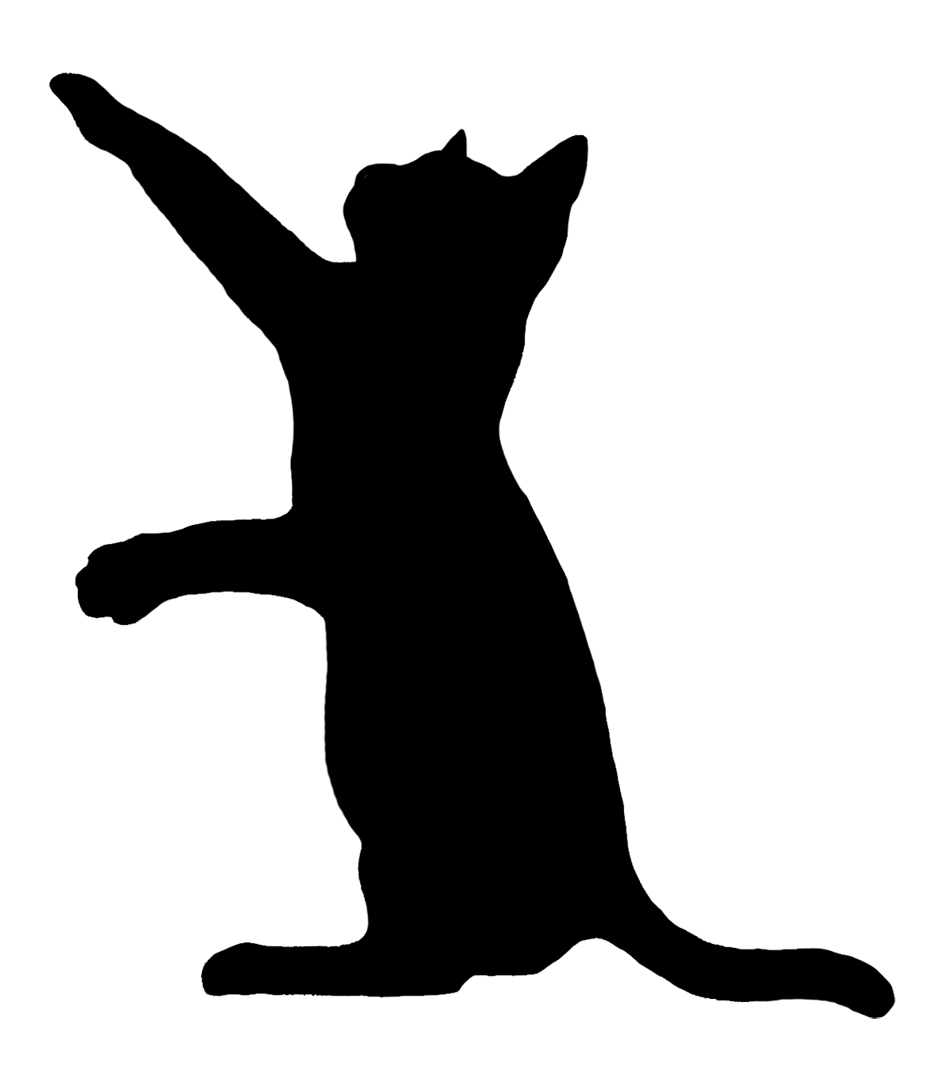
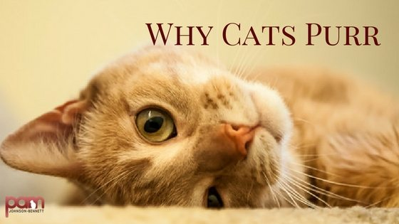
So what is the meaning of some of their strange behaviours? If you can't wait to find out, quickly do the worksheet!
1.1 Why do cats purr? Choose the right answer.
  - Because they are sad, angry or hungry.
  - Because they are sad, sleepy or confused.
  - Because they are happy, curious or frightened.
  - Because they are happy, stressed or hungry.
1.2 The frequency of their purrs is between 25 and 150 hertz. What is it good for?
_________________________________________________________________________________.

2. Why do cats »attack« your furniture?
- They think it's their prey.
- They think it's their enemy.
- They sharpen their claws to be ready for a self-defense.
- They are playing.
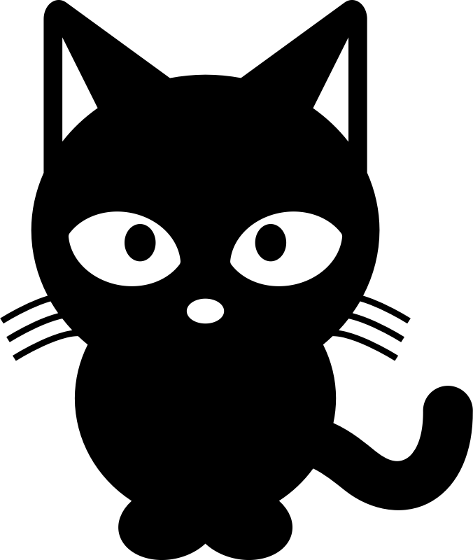
3. What is the explanation for their propensity to reach into containers and openings?
______________________________________________________________________________.
4. Why are they squeezing into small places?
- They were hiding from their predators in the wild and still have that instinct.
- They like to play »hide and seek«.
- They are shy.
- They did something wrong ...

5. As wild predators, cats are opportunistic. What does that mean?
___________________________________________________________________

