LATVIA. Results.
1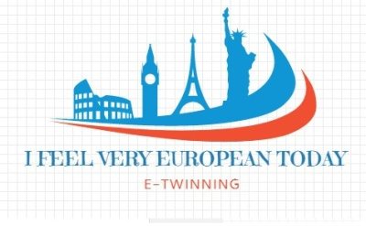 - 1 vote
2 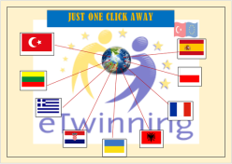
3 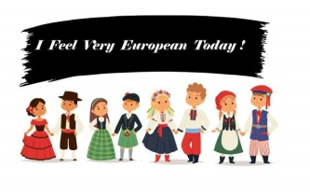-3 votes
4 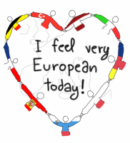 - 5 votes
5 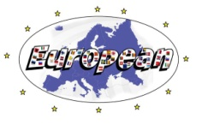This is our logo. Latvia
6
7 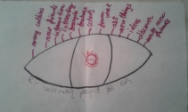
8 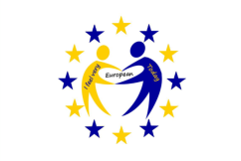 - 1 vote
9 - -3 votes

SLOVENIA
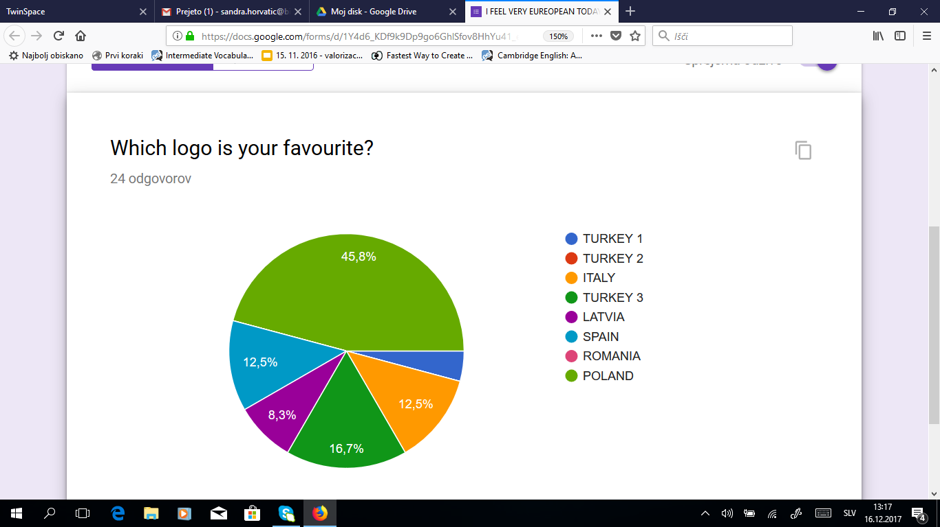

POLAND
I'd also like to share the results of the logo competition :) Slovenia is the winner - 7 votes - congratulations :), 3 votes for Spain, the third place (2 votes) goes to Turkey (logo1.jpg) - and finally, 1 vote for Latvia.
Best wishes from the Polish team :)
- Posted by Magdalena Kijek, 14.12.2017, 12:31

ROMANIA
Romanian team voted as their favorite logo Spain.
- Posted by mihaela bagut, 15.12.2017, 10:58 |

TURKEY (UGUR’S TEAM) 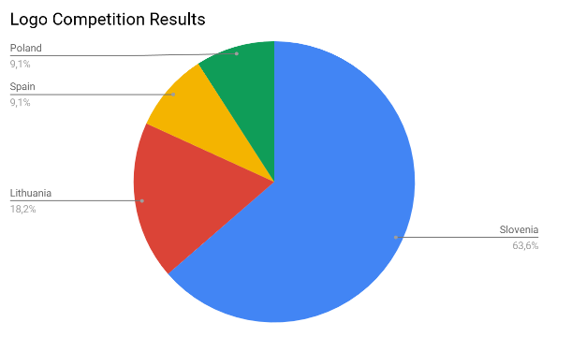

SPAIN
Sorry for the delay. Here is our voting (Online https://es.surveymonkey.com/r/W98WPWW)
1ST: POLAND
2ND: ITALY
3RD: LATVIA.
Good luck for everyone.
Keep in touch.
Best from the cold, rainy north of Spain.
Javier
- Posted by J. Javier Martínez González, 16.12.2017, 10:44 |

ITALY
Spanish team

