Enjoy a Healthy Lifestyle
(Erasmus+ Project 2018-1-ES01-KA229-049958)

Questionnaire 1
Analysis of students’ answers
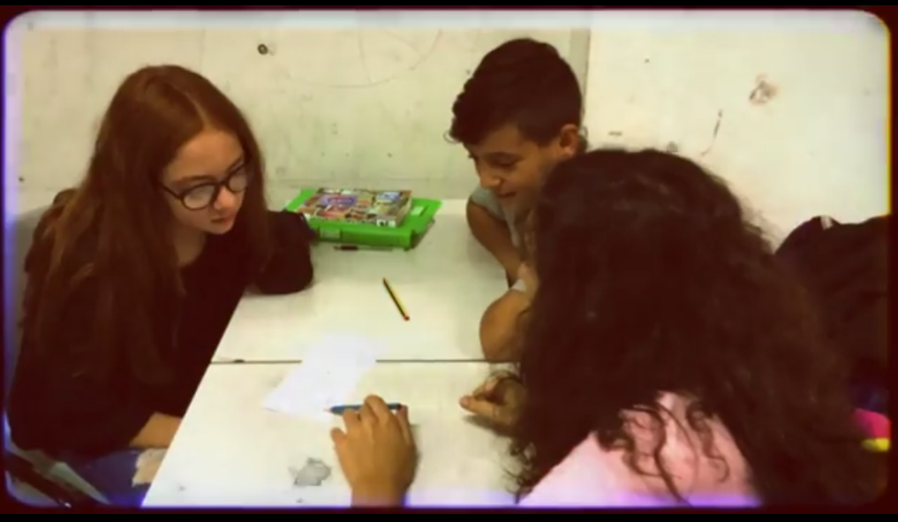

Focus on:
- Well-being
- Healthy habits
- Healthy food

- Initial information

For all questions, the sample size is around 80 students from the 4 participating countries (France, Germany, Italy and Spain)

- Weight/Height Analysis

In the first graph we can find a graphical representation of the height vs. weight measures.

According to weight and height, Body Mass Index was calculated. It was compared to the WHO standards for the 14 year-olds (with and average between boys and girls standards):
Overweight starting at 22.72 / “Underweight” starting at 17.1
(Standards from https://www.who.int/growthref/who2007_bmi_for_age/en/ )

- Personal Health Perception

83% of students think that their health is in a good or very good condition
10% of pupils take medications every day.

- About 2/3 of the students were never ill or only 1-2 times ill in the whole schoolyear

- Personal well-being

- The great majority of students (80%) feel optimistic at least sometimes
- 45% are optimistic often or always
- 2% are never optimistic

- The majority (60%) feel often or always useful when staying with friends.
- Almost all of them feel useful staying with friends, at least in some moments.

- Staying at home can be relaxing for all students, but 40% is only relaxed sometimes or a few times.

- Only 57% of students felt often or always interested for others. As students are mainly fairly sociable, we should think that it is because “interested” could be interpreted in several ways.

- Tidying student’s own thoughts is never or a few times attained by 18% of pupils

- The great majority of students have moments where they feel well with themselves

- Surprisingly, 13% of students never feel close to other people. They feel mainly alone or prefer to remain that way.

- 18% of students answer that they are never insecure.
- 64% of students feel self-confident often or sometimes

- Pupils in the survey feel they are usually able to make their own decisions, at least a few times.
- 68% of pupils are often or always able to make their own decisions.

- The majority felt loved
- 4% of students felt not loved at all

- About 2/3 of pupuls felt often or always interested in new things

- All of them felt happy at least a few moments
- 74% felt often or even always happy

- Diet analysis

How often did you have these products during the last 7 days?
(We will see some frequency graphs, one for each kind of food)

At the school break, how many days do you eat one of the following in one week?

- Activity habits
Do you practice moderately intense sport (does it make you sweat and pant, such as basketball, football, swimming, running…) outside school?

Do you practice any other physical activity such as going for a walk, riding your bike...?

Do you practice sport or any physical activity during the school timetable?

Did you do any of these activities at least for 30 minutes in your free time last week?

What do you do that does not imply physical activity when you are not at school? How many times a week?

- Rest habits

