some pictures from the meeting in Berlin

Meeting in Stahnsdorf at the Vicco-von-Bülow Gymnasium.
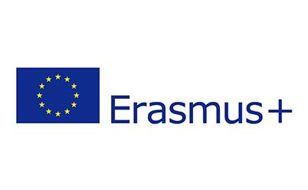
EHL- Enjoy a healthy lifestyle

Recipe No.1: Pancakes

You need:
1 ¼ cups flour
1 ½ teaspoons baking powder
Pinch of salt
1 cup buttermilk
1 extra-large egg
2 teaspoons melted butter
Sunflower oil, for greasing
Maple syrup, to serve

What to do?
Sift the flour, backing powder and salt into a bowl. Add the buttermilk, egg, and butter and best to a smooth batter. Let stand for 5 minutes.
Lightly grease a griddle pan or skillet and heat over medium heat. Spoon small spoonfuls of batter into the pan to make pancake approximately 1 ½ inches wide and cook until bubbles appear on the surface.
Turn over with a spatula and cook the other side until golden brown. Repeat this process using the remaining batter, while keeping the cooked pancakes warm.
Serve the pancakes in tall stacks drizzled with maple syrup.

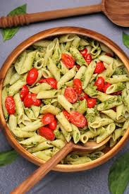

Recipe No.2: cold Pasta with pesto and fresh tomatoes

You need:

250g Pasta(whole wheat)

1 glas of pesto

4 fresh tomatoes

Olive oil and salt

What to do?

Cook the pasta in the morning, put the sauce(pesto with cut tomatoes and 2 table spoons of oil and salt) in it and- if possible- put it in the fridge for the evening.

Healthy Drinks
- Kiba

You need:

100% cherry juice

100% banana juice

What to do?

Mix the cherry and the banana juice together and enjoy it!!!

- Active Fruit

You need:

Matcha

Pineapple juice

Water

Coconut

Apple juice

What to do?

Mix everything together and enjoy it!!!

Why is the Pineapple so healthy?

Lower risk of Cancer: Bromelain is an active anti-inflammatory agent that helps prevent the spread of cancerous cells across the body.

Improves gut health: Your gut is the primary indicator of your health

Reduces risk of having a Cold: Changing seasons brings with it number of diseases. A lot of people have to face the effects of the common cold including a runny nose as well as a weak immune system.

Strengthens bones: Along with bromelain, pineapples also contain manganese that is important for bone regeneration as well as bone growth and help,

