[So erstellen Sie eine Broschüre]

Ingredients:

* 3 tablespoons olive oil
* 1 onion, chopped
* 1 (can diced) tomatoes in juice
* 1 tablespoon sun-dried tomato paste
* 1 teaspoon paprika
* 1 big red paprika
* 2 tablespoons chopped fresh flat-leaf parsley, plus extra garnish
* 1 pound dried penne
* Salt and pepper
* Crusty bread, to serve

How to cook:

1. Heat 2 tablespoons of the oil in a large, heavy skillet over medium heat. Add the onion and paprika and cook, stirring occasionally, for 5 minutes or until softened .
2. Stir in the pepper and salt, tomatoes with juice and paprika and bring it to a boil.
3. Bring the onions and the paprika together with the tomato sauce and boil it for 10-15 minutes.
4. Boil water with salt, fill the dried penne into the water and boil it for 10-15 minutes or until softened.
5. Mix the tomato sauce with the pasta. Then fill the dish on a plate and serve it with crusty bread and the fresh parsley to your family.

Our big meal: Pepperoni Pasta

ERASMUS PROJECT 2018/20

A WEEK FULL OF EXPERIENCES

von *Lina Sophia Ummethun*

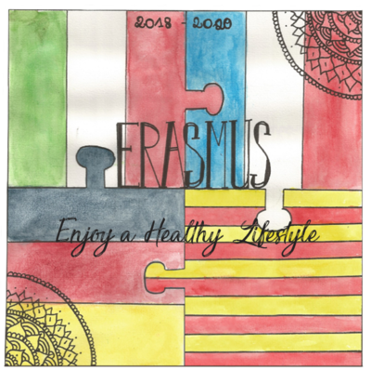

ERASMUS PROJECT

Our delicious drink: KiBa

Ingredients:

* Cherry juice
* Banana juice

How to make it:

Mix both juices together in a glass and serve it with ice cubes 

[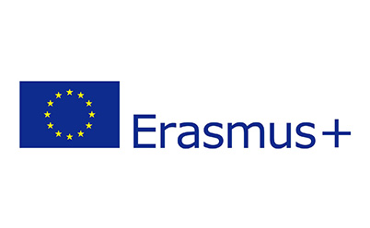](https://www.google.com/url?sa=i&rct=j&q=&esrc=s&source=images&cd=&ved=2ahUKEwiY8976hNLiAhUHKVAKHWuCCgsQjRx6BAgBEAU&url=/url?sa=i&rct=j&q=&esrc=s&source=images&cd=&ved=2ahUKEwiY8976hNLiAhUHKVAKHWuCCgsQjRx6BAgBEAU&url=/url?sa=i&rct=j&q=&esrc=s&source=images&cd=&ved=2ahUKEwiY8976hNLiAhUHKVAKHWuCCgsQjRx6BAgBEAU&url=https%3A%2F%2Fwww.erasmusplus.de%2F&psig=AOvVaw15dSedZmsnJEctqrnd7Fpi&ust=1559813690868587&psig=AOvVaw15dSedZmsnJEctqrnd7Fpi&ust=1559813690868587&psig=AOvVaw15dSedZmsnJEctqrnd7Fpi&ust=1559813690868587)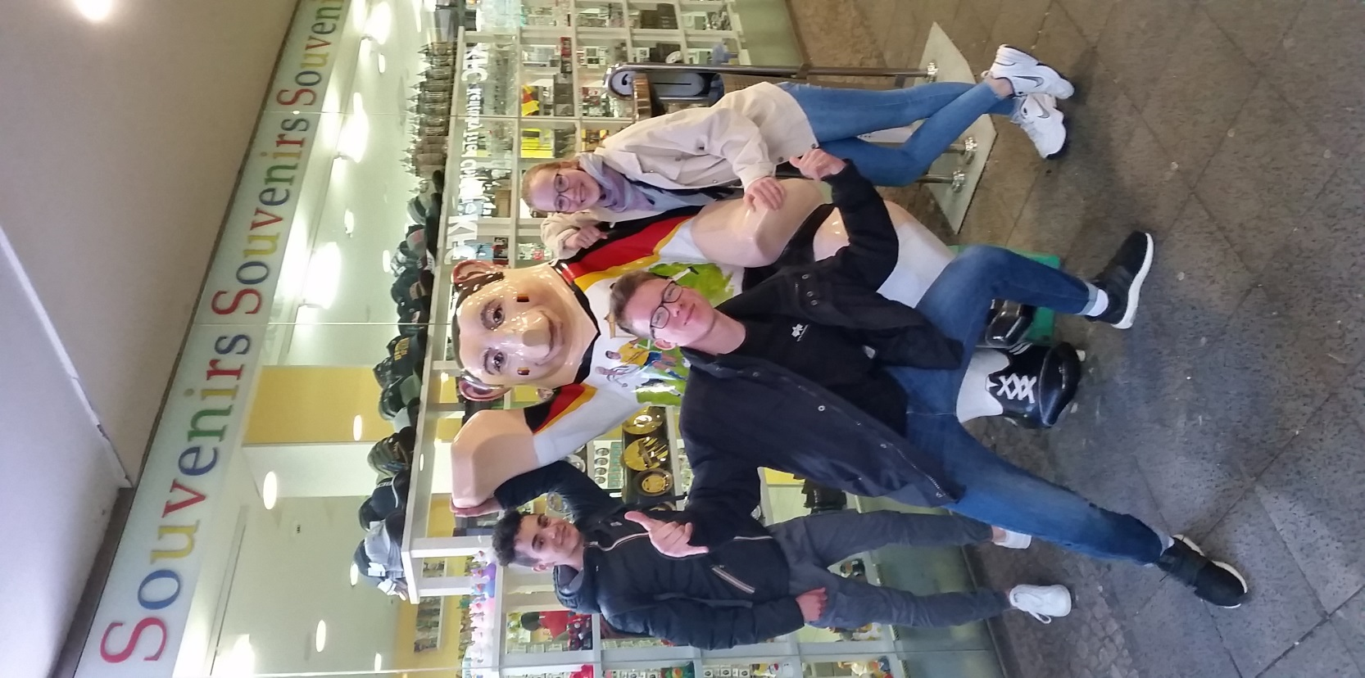

EHL – Enjoy a healthy lifestyle

This brochure is based on the workshops held during the meeting at the Vicco-von-Bülow-Gymnasium in Stahnsdorf, 6 -10 May 2019