CHICKEN TACOS

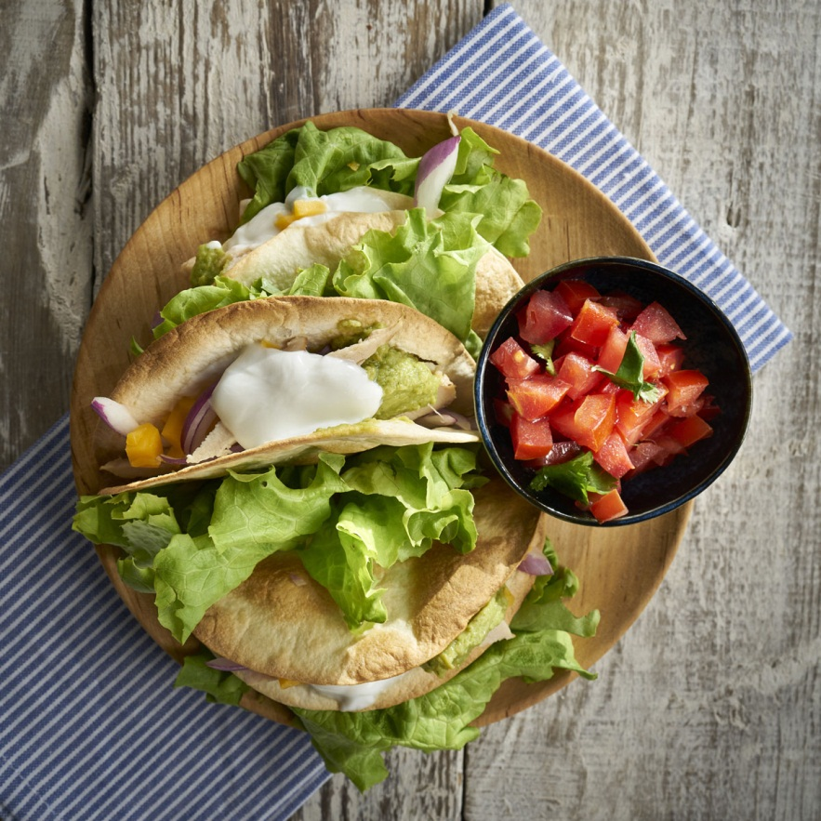
SALSA
INGREDIENTS
½ red onion diced
2 jalapeño peppers seeded and diced
2 tablespoon
Fresh cilantro
3 tablespoon lime juice
½ teaspoon
CHICKEN FILLING

CHICKEN TACOS

2 teaspoons packed light brown sugar
2 teaspoons ground cumin
1 teaspoon chili powder
½ teaspoon salt
½ teaspoon pepper
1 pound skinless, boneless chicken breat
8 small con tortillas, to serve 4 cups shredded lettuce, to serve
- Make the salsa by putting the onion, jalapeño peppers, and tomatoes into a medium bowl and stirring well. Add the cilantro, lime juice, and salt and stir to combine.
RECIPE
- To make the chicken filling, preheat the boiler to high or put a rigged grill pan over high heat.
In a small bowl, combine the brown sugar, cumin, chili powder, salt and pepper. Rub the spice mixture all over the chicken breasts over high heat for about 4 minutes per side, or until lightly browned on the outside and cooked through with no signs of pink when cut through with a sharp knife. Remove from beat and let cool for about 5 minutes, then slice into ¼ -inch thick slices.
- To serve, heat the tortillas briefly in the boiler, the top with the chicken, salsa, and lettuce serve inmediatly.

Stahnsdorf – Germany
May 6th to May 10th

Vicco-von-Bülow-Gymnasium
FOOD SOURCES

ENJOY

A

HEALTHY

LIFESTYLE

