GERMANY BROCHURE

We separated the people in two big groups vegetables and fruits, and inside them we made little groups. My group was in the fruits class and we were “grapes “
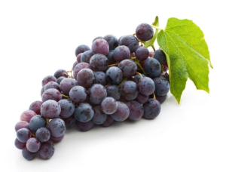
First, we learned why grapes are healthy.
They…
- Are anti-inflammatory food
- Are a heart-healthy snack
- May help protect your skin
- Can lower your risk of diabetes
- Count toward hydration ( enough water in the body)
- Eating more of them can reduce risk of some cancer

Secondly, we took some energetic drinks and we read all their ingredients to classify them in good or bad for our system.
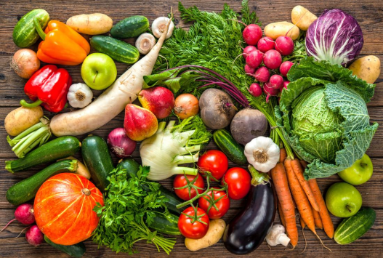

Then we had to prepare two dishes of healthy food. We choose “Pepperoni Pasta “ and “ a “ Blueberry and Honey Yogurt”.
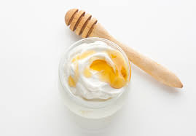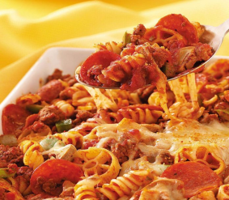

GERMANY TRIPTIC
Vam separar a la gent en dos grups grans segons si els hi havia tocat ser verdures o fruites. I dins d'aquests en van fer de petits. El meu grup estava dins de les fruites i eram el raïm.
Primer, vam mirar per què el raïm és saludable.
I vam descobrir que...
Són un aliment antiinflamatori
Són un berenar saludable per al cor

Pot ajudar a protegir la seva pell

Pot reduir el risc de diabetis

Comptar per hidratació (aigua suficient al cos)
Menjar-ne més pot reduir el risc de patir cáncer
Menjar-ne més pot reduir el risc de patir càncer

En segon lloc, vam observar unes begudes energètiques i vam llegir tots els seus ingredients per classificar-los en bons o en dolents per al nostre sistema.

Llavors vam tenir que escollir dos plats saludables a cuinar en grup. “ Pepperoni pasta” i “ Honey Iogurt “.

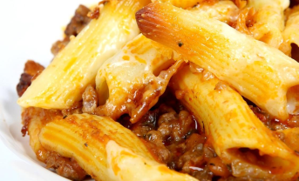

Duna Sampedro

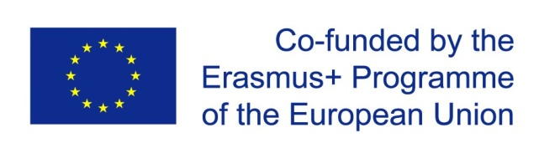

Enjoy a Healthy Lifestyle
EHL
Vicco-von-Bülow Gymnasium
Stahsndorf May 2019

