My Food Diary

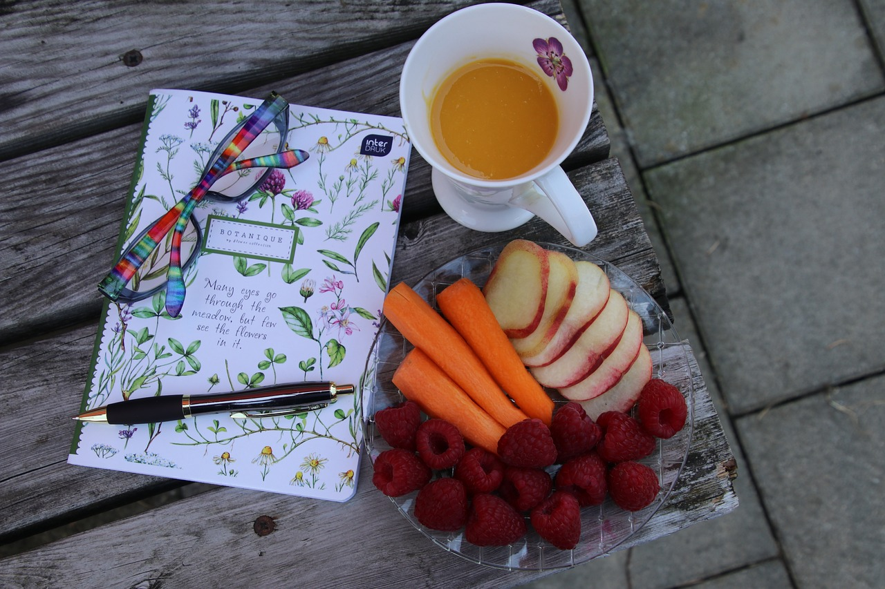 | Monday | Tuesday | Wednesday | Thursday | Friday | Saturday | Sunday
Breakfast

Lunch

Dinner

Snacks - Drinks

Physical activities
Relaxing activities

