English & ICT / Edible Insects; LESSON PLAN
Lesson 1
- Organizing groupse:
Names on colourful pieces of paper – used for randomly choosing the members
Providing group information:
- The number of the letters of all the names of group members + CHOOSE A GROUP NAME (bugs handout)
- The number of legs that their animals / pets at home have
- The last insects they have seen recently (help – images of insects with vocabulary)
- The insects that they find cute / useful
- The insects that they dislike

- Discussion: Finding out what students already know about EDIBLE INSECTS
PPT
http://www.aketta.com/blog/cricket-nutrition-facts-cricket-vs-beef.aspx
https://www.westernexterminator.com/bug-control/edible-insects/
http://www.ift.org/Knowledge-Center/Learn-About-Food-Science/Food-Facts/7-Reasons-to-eat-insects.aspx
https://www.eatcrickster.com/blog/pros-and-cons-of-eating-insects

- Kahoot on edible insects facts – 10 questions
https://create.kahoot.it/share/edible-insects/f2b99cb4-4dbd-4f85-8b39-d8886ae37dc7

- BBC video & after watching activity using www.mentimeter.com
https://learnenglishteens.britishcouncil.org/study-break/video-zone/eating-insects

https://www.mentimeter.com/s/2378cc794ed66f4d35f6d97c71166fb4/1c96d59c8368/edit

Lesson 2
Breaking news – CRUNCY CRICKER restaurant
- Filming an advertisement for the restaurant using school’s tablets or students’ phones
- App to be used: https://www.videoshop.net/
- Materials to be used: photos attached below
ADVERTISMENT
INTERVIEW WITH THE OWNER
INTERVIEW WITH THE GUESTS
PRESENT A RECIPE

- 3 scenes - writing the script first

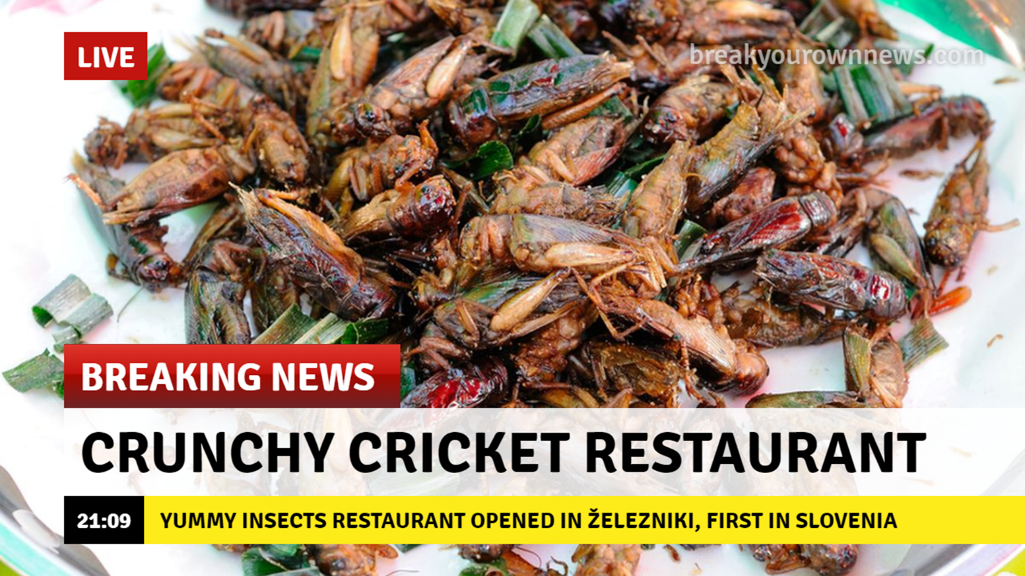

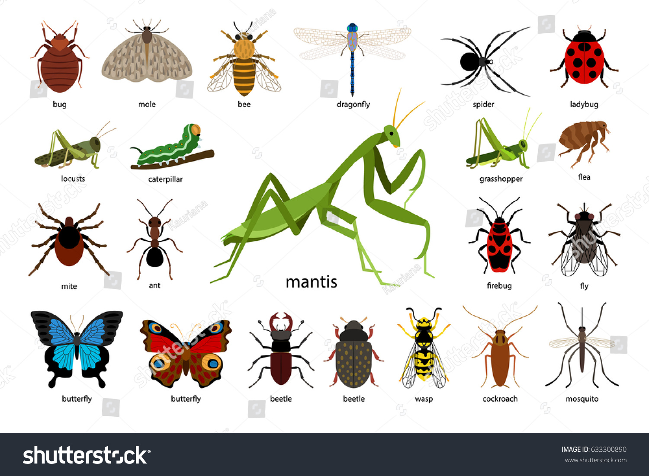
CRUNCHY CRICKET RESTAURANT - ADVERTISEMENT SCRIPT
 | Who | Where | Text
Scene 1
Scene 2
Scene 3

