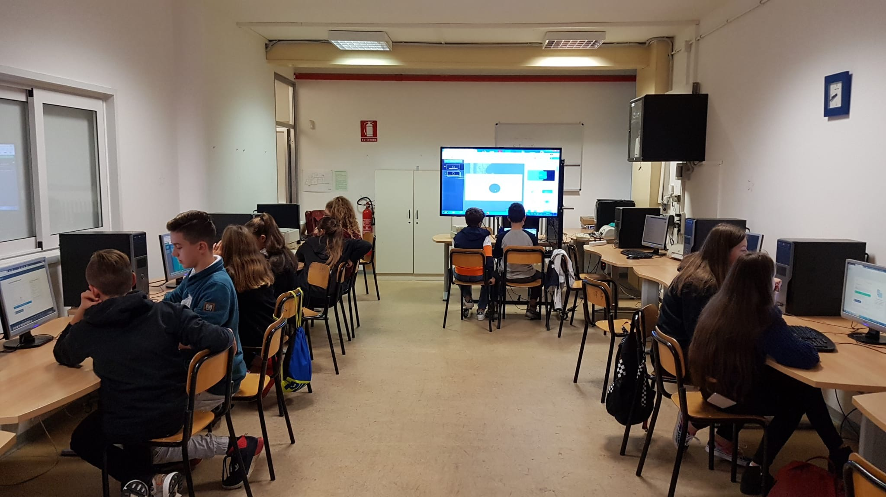

Art laboratory:
the students partecipated in Art laboratory and involved in making a craft by using plastic bottle taps.
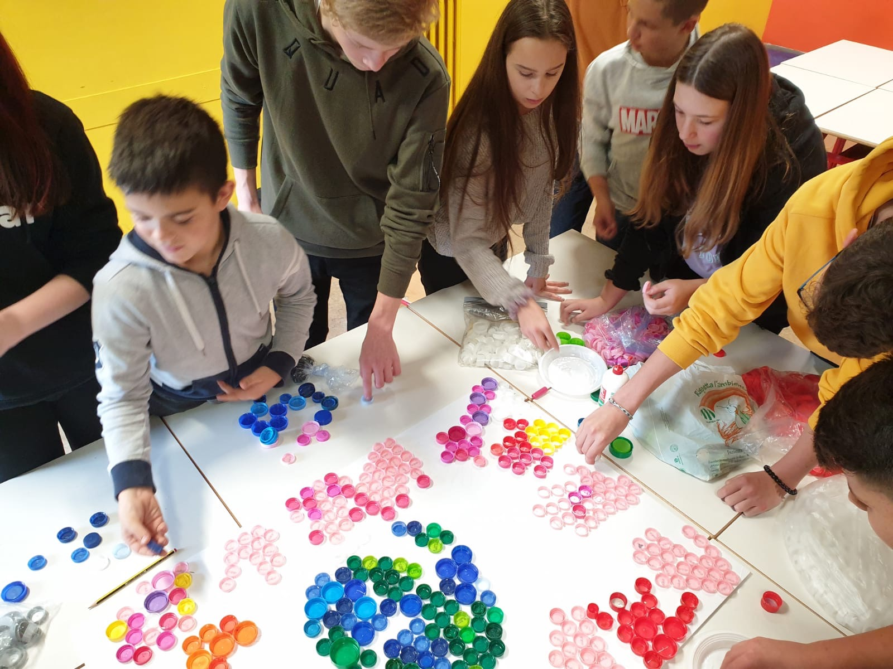
Teachers visited Montessori primary school

Montessori lab:students present Montessori activities using naterials for maths, cosmic education, Language and music.

Finally they visited the Montessori pre primary school (Casa dei bambini) and experienced different Montessori materials.

Students and teachers visited The Riserva Naturale Oasi Ripa Bianca Jesi nearby Ancona.
Here they were guided to the discovery of natural reserve with observation of different habitats such as river, lake and wood. They could experience birdwatching of different species of birds. Finally in groups they took part of a treasure hunt in the wood.

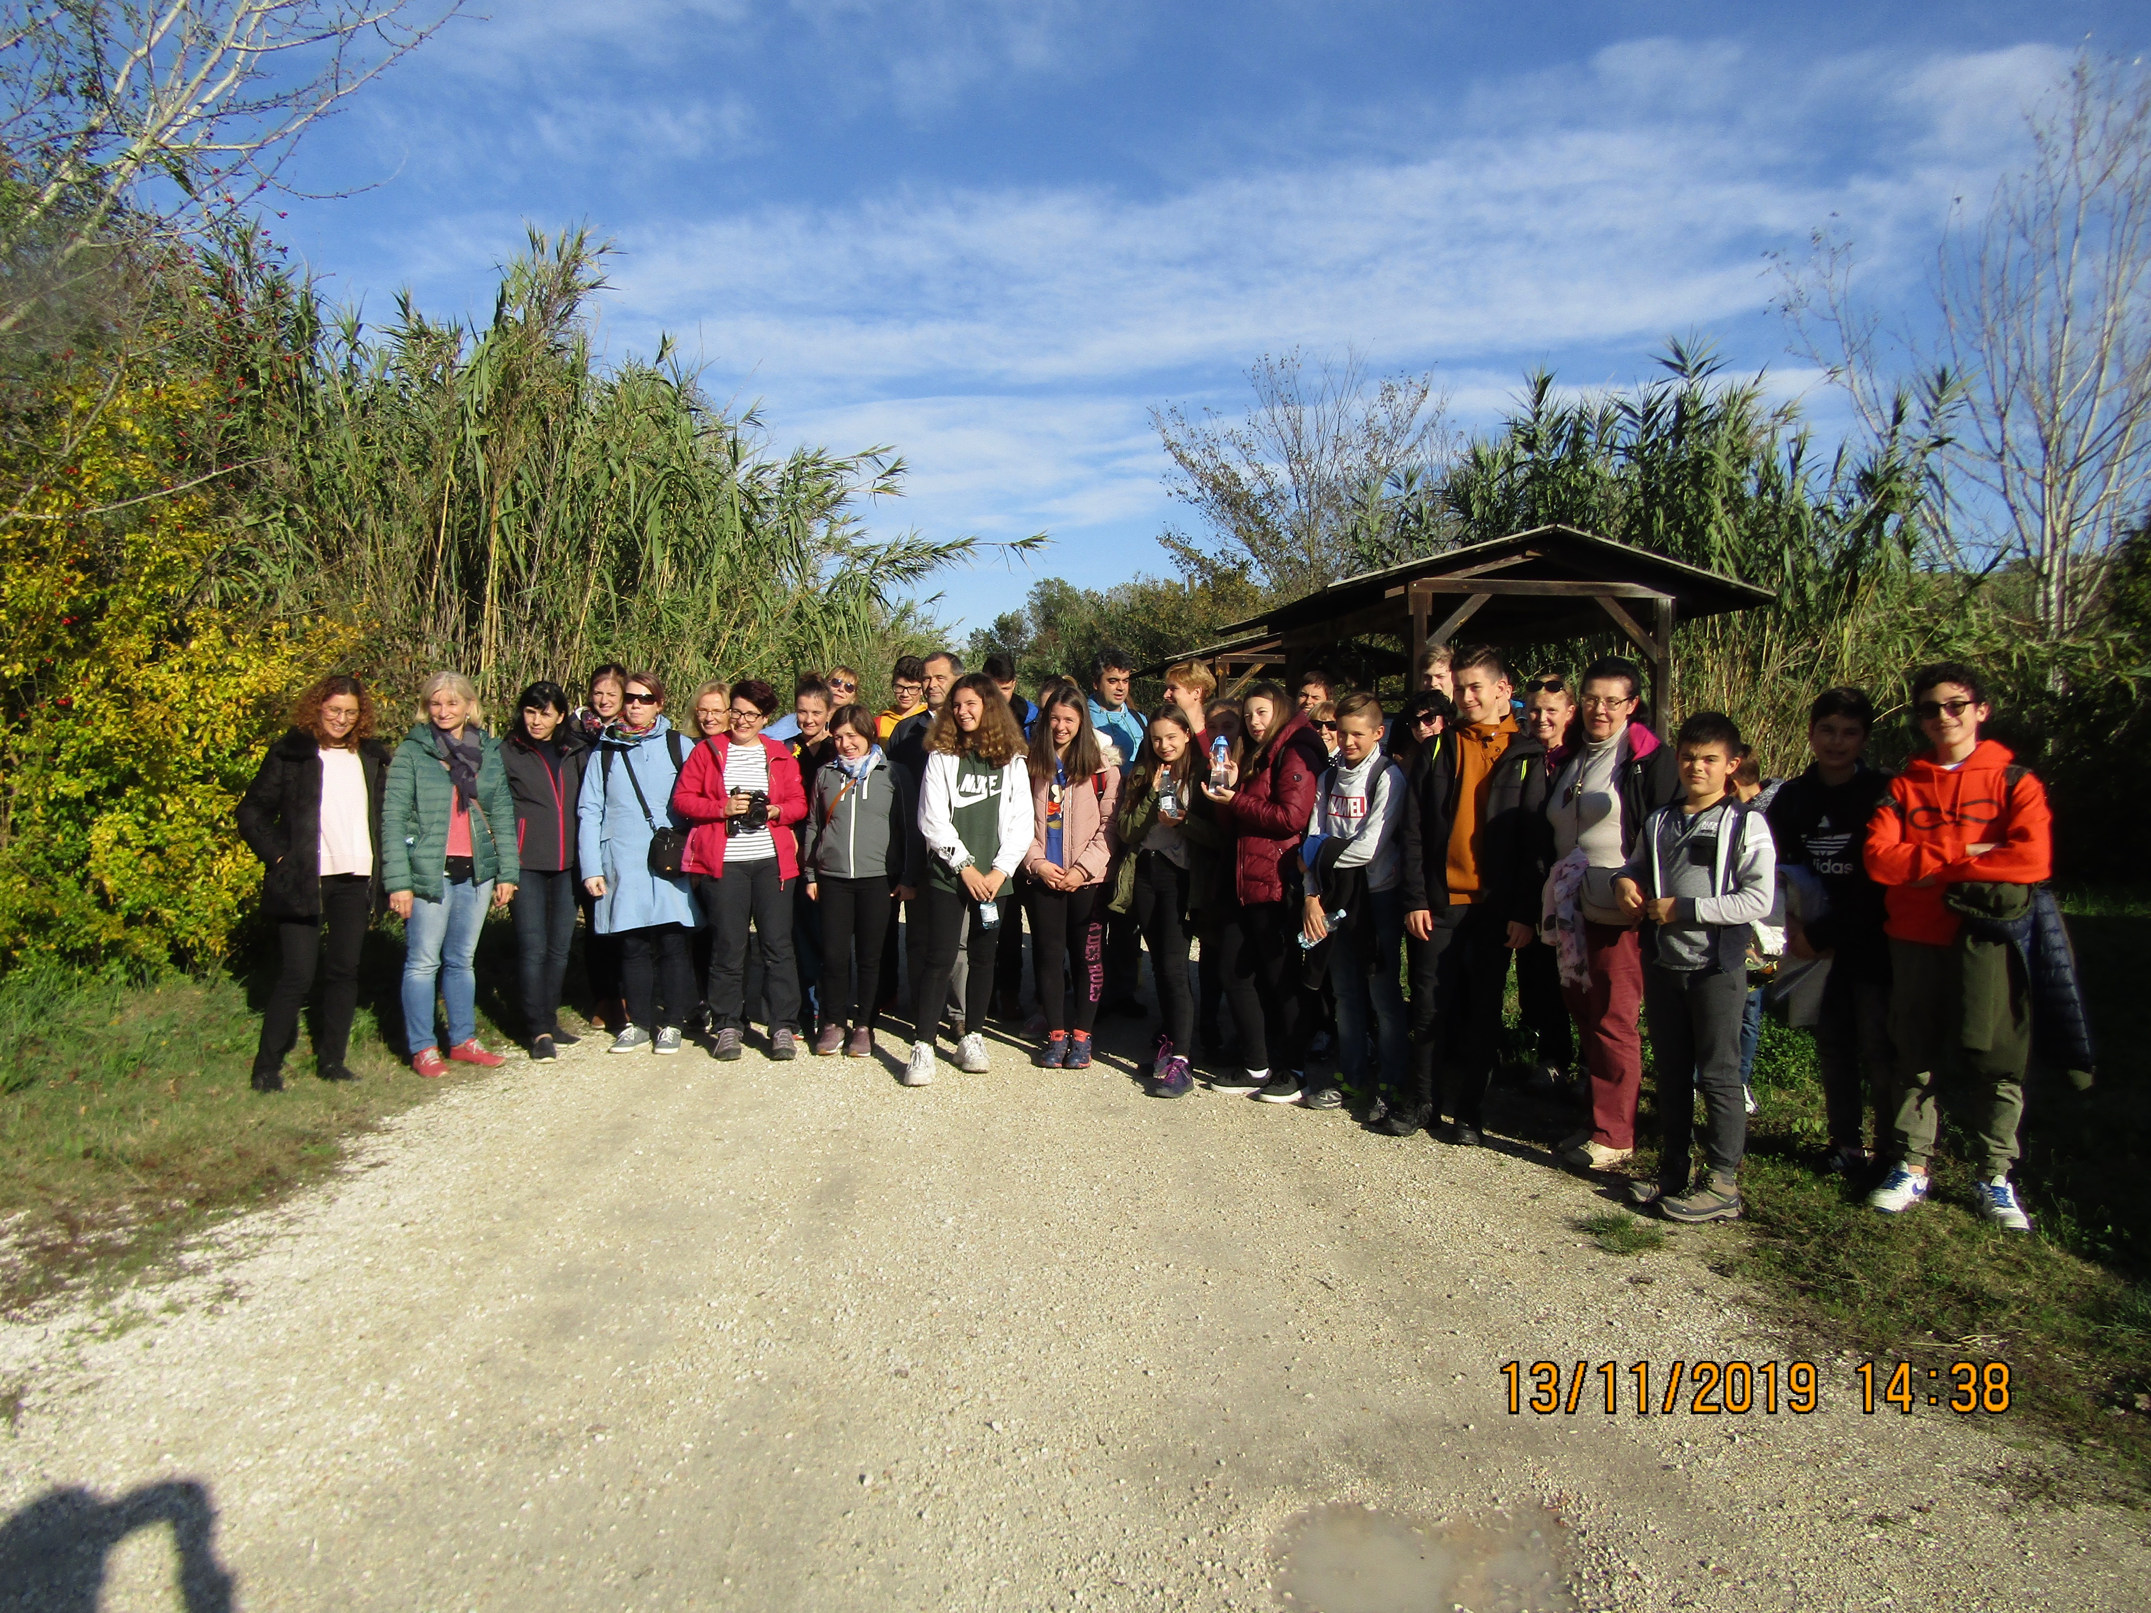

On 14th november

Students at school were involved in workshop: Apply the waste recycling with Junker. They could experience Junker smartphone application that enable to ricognize the products and indicates the right bin to be recycled.

A group of teachers went to visit Primary school Pietralacroce and Pre-primary school Acquario
They could observe different approaches in teaching science and maths using English (Clil approach) and unplugged coding

. 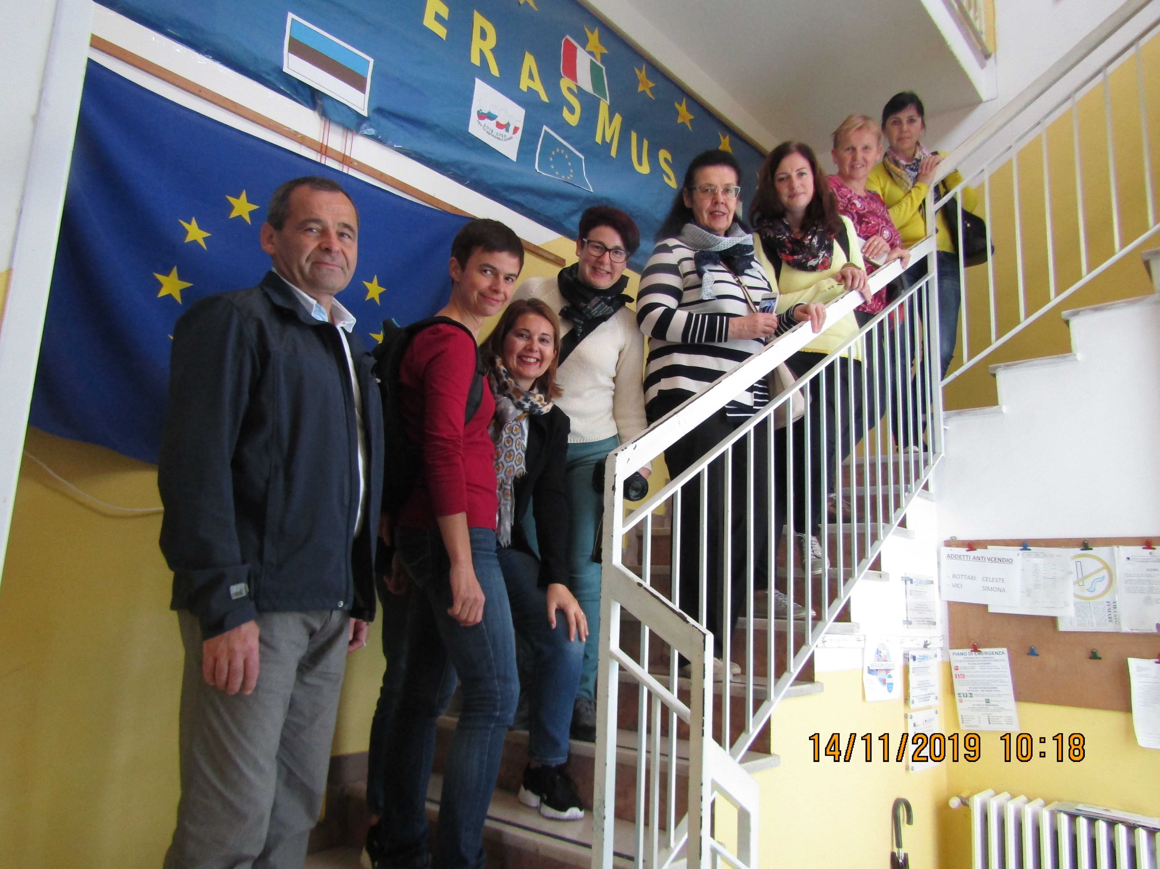

At Lunch time all the teachers and students visited the sourranding areas: Portonovo bay and Sirolo. 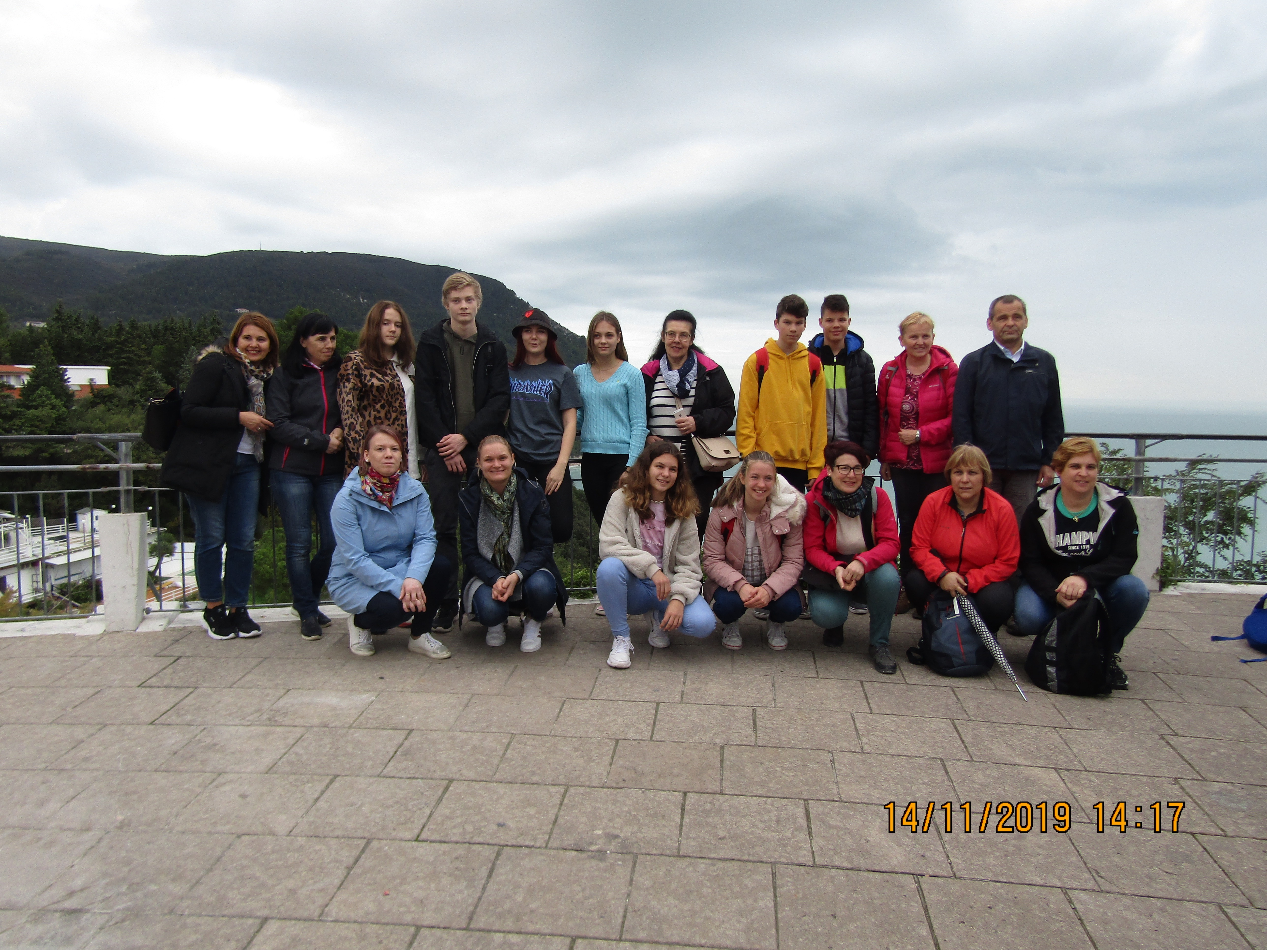
In Sirolo tourist centre the students could follow a laboratory on water microorganisms: they could observe the small “inhabitants” of Adriatic sea with references on environment problems.

The day turned to a visit to a canteen in order to taste regional wines and to the famous Cathedral of Loreto guided by a tourist guide to discover the beauty of paintings and the house of Madonna.

