SUBJECT: SCIENCE CLASS: 7
LESSON: LIGHT

1. Teacher asks questions about light. Reason: to find out what students already know about light. (5 minutes)
2. Teacher gives students worksheet (attachment) about light. Students give answers. They work in groups of 3 or 4. Teacher gives students didactic accessories to do an experiment. Students do 2 experiments from workbook, too. (30 minutes)
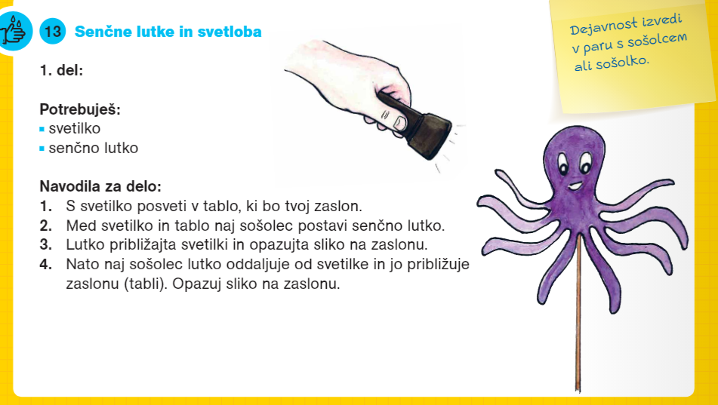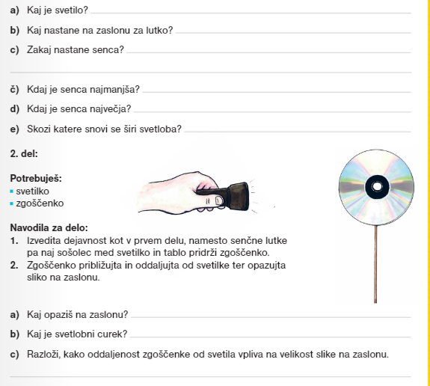
3. Students with teacher`s help check the answers and define concepts: illuminant, illuminated object, light beam, light spurt, laser, shadow, dappled shadow. (10 minutes)

Handout – Light – where from, where and how

1. There are some statements written below. How are the statements connected to the light in the forest? Explain each statement. Why do you think it is like that?

The light in the forest is not evenly broaden. Some parts are always dark.
________________________________________________________________________________________________________________________________
In the leafy forest there is more undergrowth than in the conifer forest.
________________________________________________________________________________________________________________________________
Yew grows in the shadows of other trees. Its growth is slow.
________________________________________________________________________________________________________________________________

2. Mark all objects that radiate light.

The last day of our summer camp, we decided to do the cooking instead of our lovely cook. So she wouldn’t need to spend the afternoon cooking dinner on the gas stove. We invited our cook to join us at the farewell party. So, after washing the dishes, she turned off the lights in the kitchen and came to the garden. The sun was just setting down and we could see the first quarter of the moon. Our party was already in full swing. We baked sweet corn on the campfire, there were garden lights and hot flame torches lit in front of the tents. Our group leader was busy baking sausages on the gas grill. In the distance we could see fireflies flying around. As we turned our flashlights towards the place were we kept our bikes, we could see the reflection of the pedal reflectors.

3. Draw, how the light expands through the area which makes objects on your desk visible.

4. Is the Moon illuminant or illuminated object?
________________________________________________________________________________________________________________________________
What about planets?
________________________________________________________________

5. Look how the light wides/spreads.
What you need: 3 pieces of a large cardboard (one whole that serves as a screen, one with a small hole in the middle and one with larger hole), flashlight
Hold the cardboard in an upright position. The first one is the one with a larger hole, second one is with a small hole and the last one is screen. In a dark place flash through the holes on the cardboard.

What do you see on the screen?
________________________________________________________________________________________________________________________________
Move the flashlight back/away and look the light on the screen. Draw what you see and write down the findings that you’ve learned .

Findings:
________________________________________________________________________________________________________________________________
________________________________________________________________

6. Fill in the pictures by drawing light beams and light spurts.

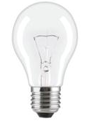

7. The picture shows lunar eclipse. Earth throws shadow and dappled shadow on Moon. Mark the area of shadow and area of dappled shadow on the picture.

