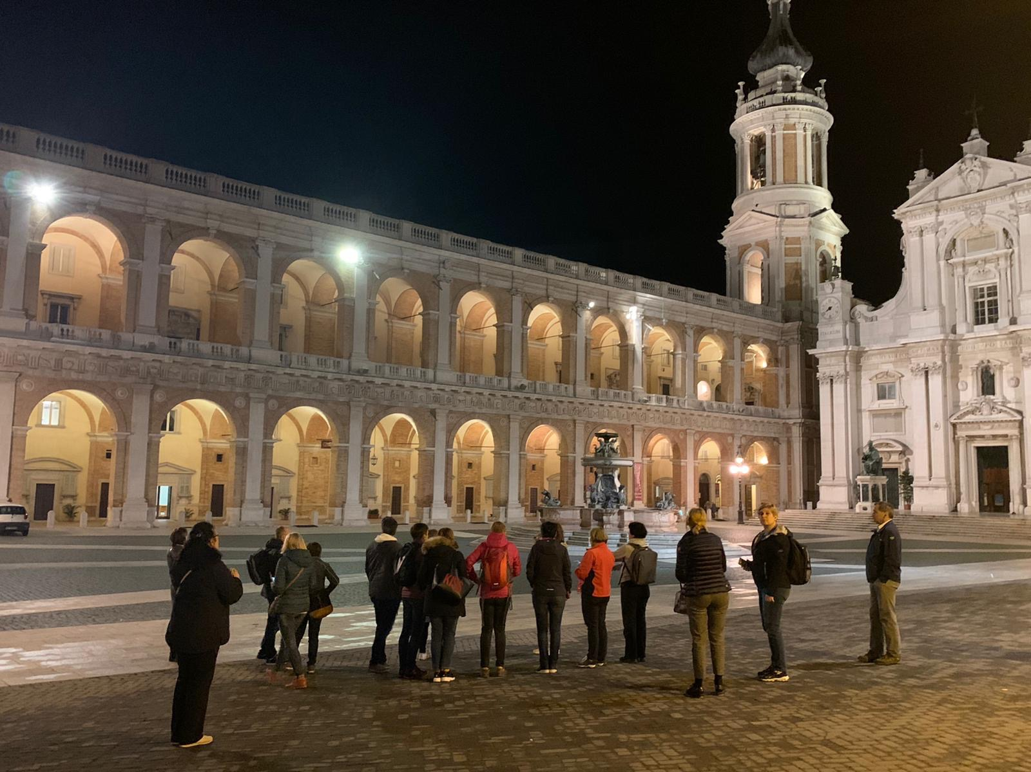
The tour ended to a shop of local products where we could taste different types of oil, cheese and wine.

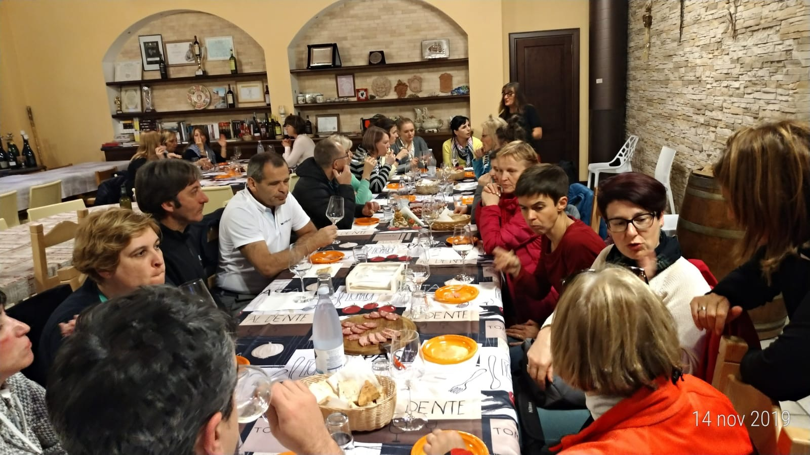

Friday 15th

Students were involved in Maths games in a lesson organized by the Polish Maths teacher .

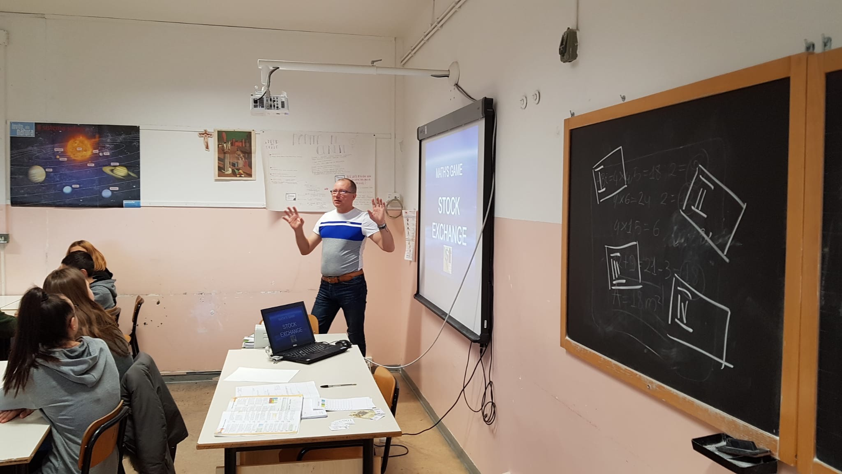

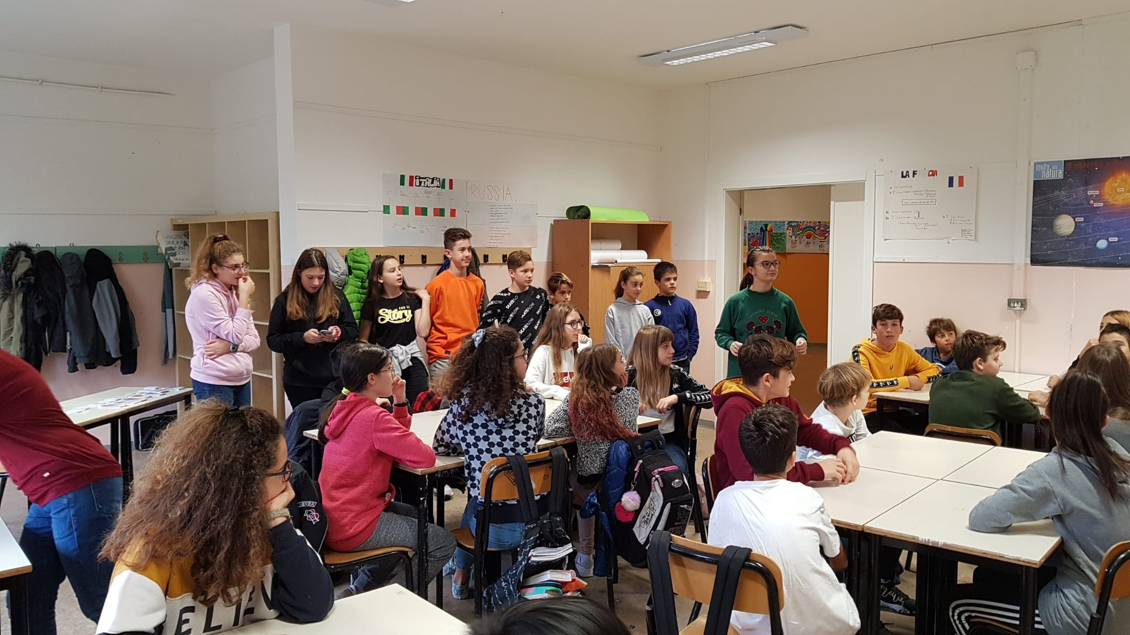

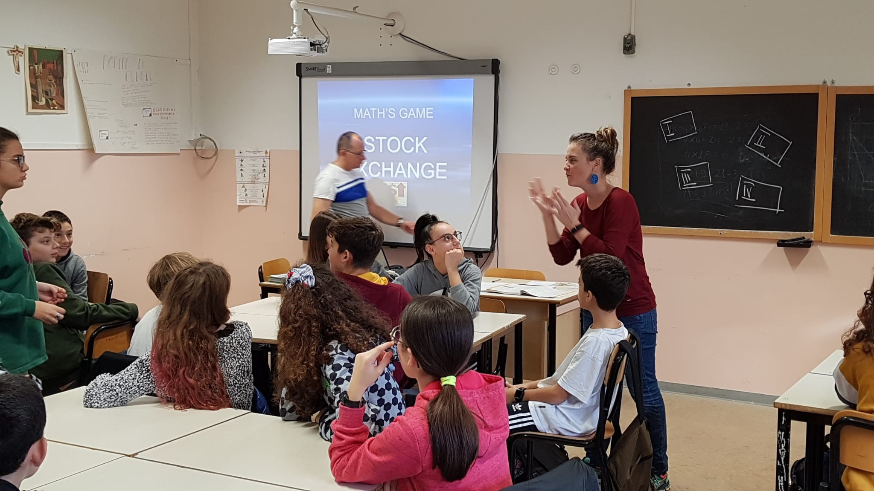

Some teachers visited the pre-primary school “A. Freud” and enjoyed having a delicious break with the little kids.
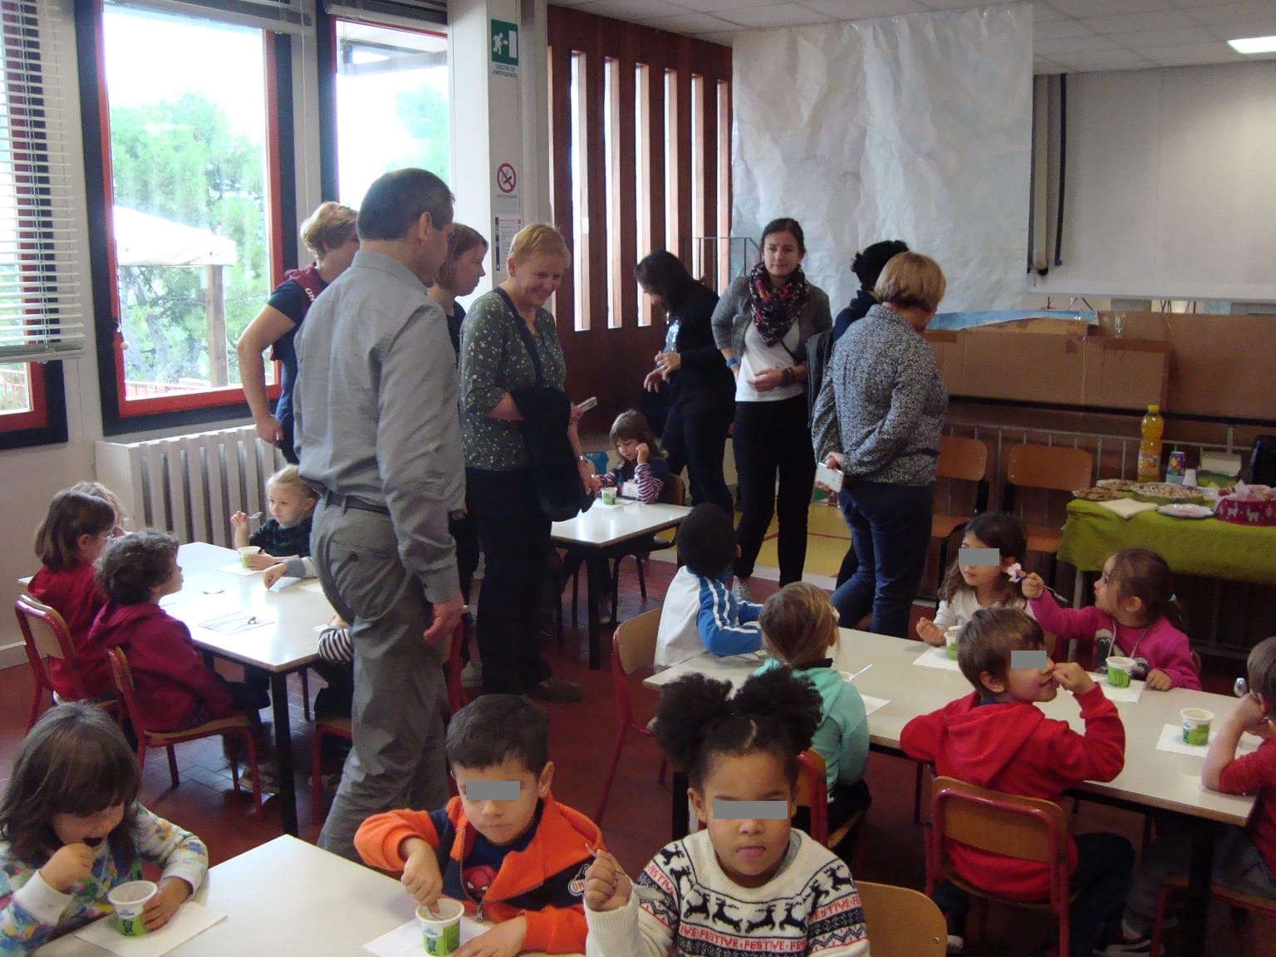
Next the staff were invited to join the gymn for the farewell: group of different schools performed dances, music, and roleplays.

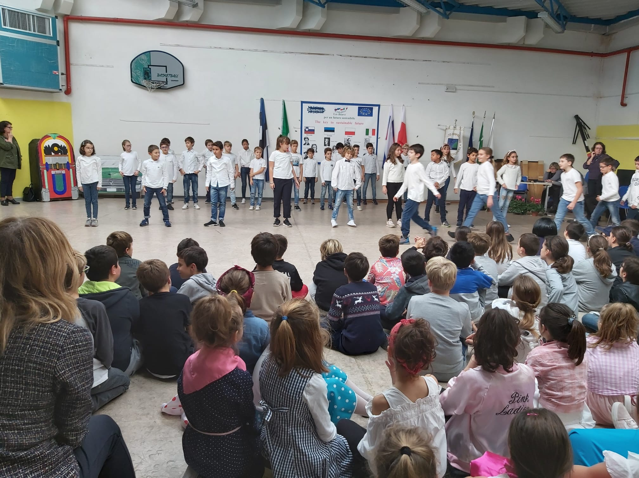
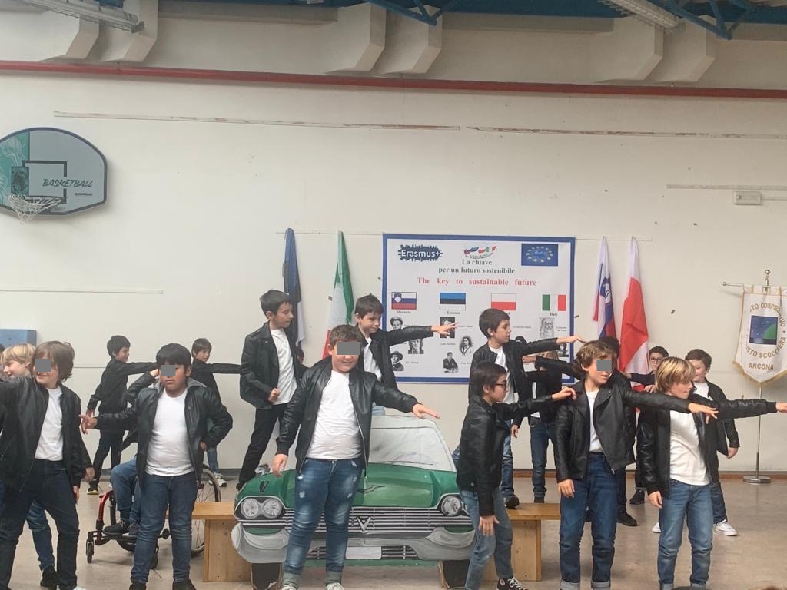Time of departure: after hugs and tears the students and teachers left to Bologna airport.

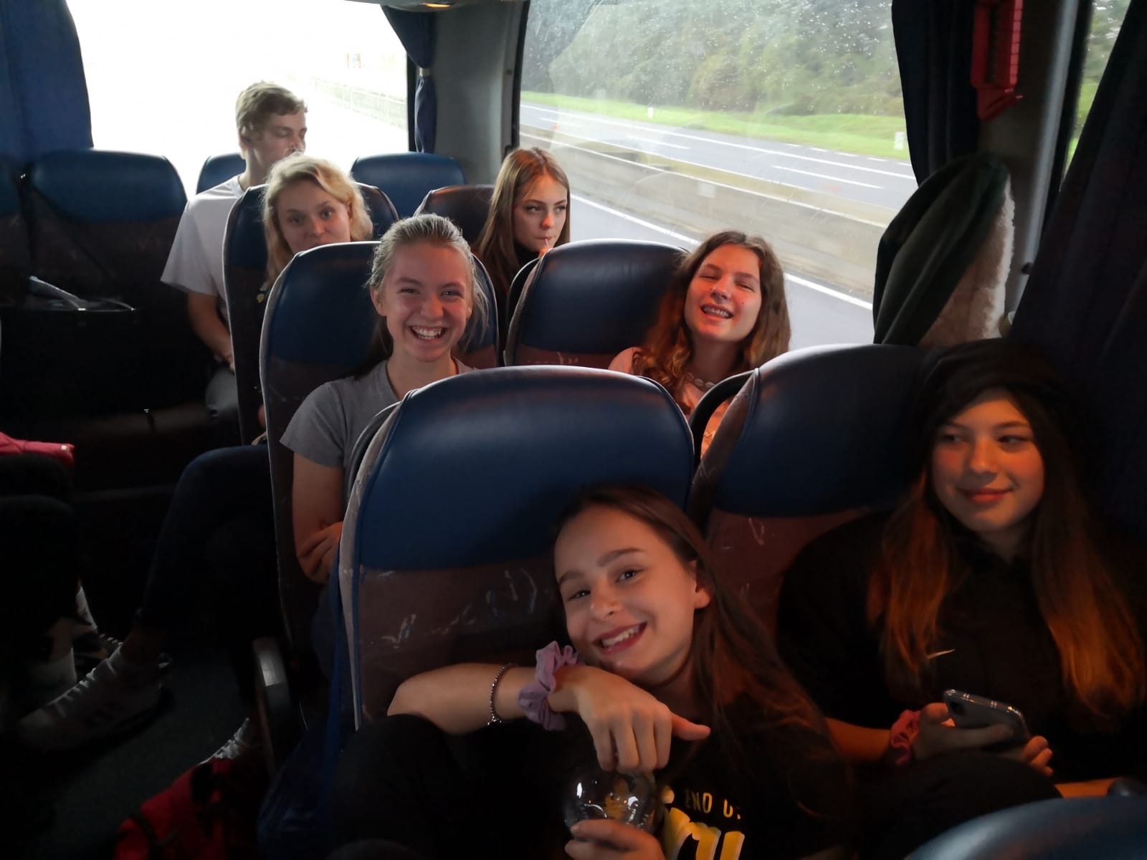

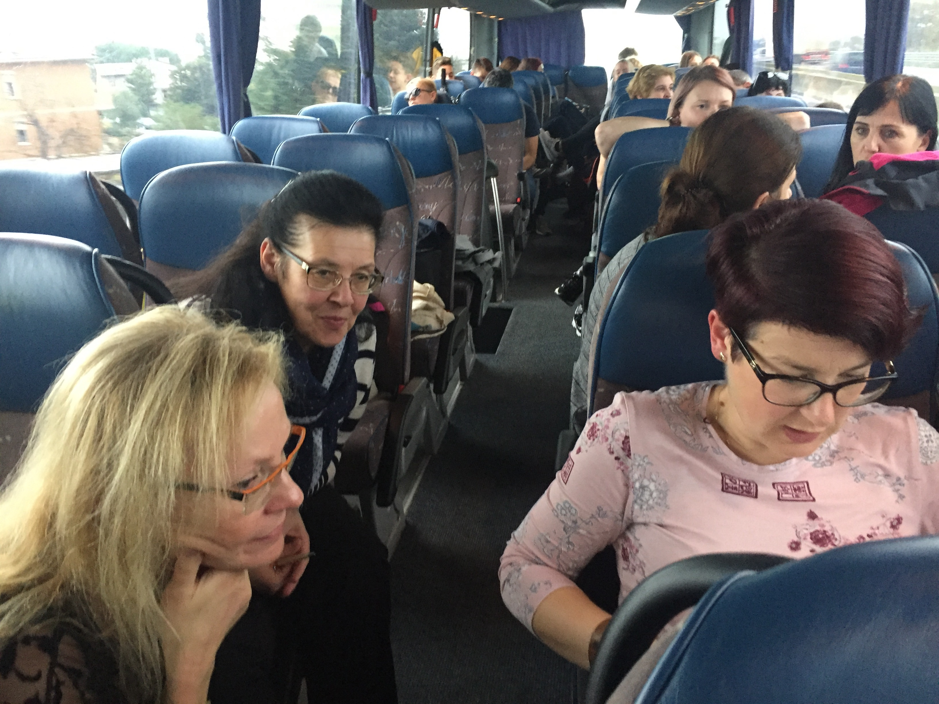

But still at work!

