REPORT
VISIT TO ITALY – part 1

11TH -15 NOVEMBER 2019

The third transnational meeting took place from 11th to 15th november 2019 in Italy: 12 students and 18 teachers from Slovenia, Estonia and Poland joined to students and school staff in italy at “Istituto Augusto Scocchera” – Ancona – Italy.
On Sunday 10th november we met at Bologna airport and we took the chance to visit the town. It was a really an exiting experience to walk long Indipendenza road, visit San Petronio Cathedral, have a look at Asinelli Tower and taste a delicious slice of pizza!

On the 11th november
All the students at school: they were involved in activities to introduce themselves.
At 9,00 teachers and students went to Regional Council for a dissemination event with the partecipation of local representatives and Legambiente (asssociation for environment issues) embodied by its regional President Francesca Pulcini. The event started with an introduction by the Regional Council President followed by Maria Costanza Petrini the headteacher of host school “Istituto Augusto Scocchera” and Gianna Paprotnich regional school office. After a video about the mobilities in Poland and Slovenia students from the three countries had the opportunity to interview the local representatives on environment and sustainability issues.
It was a really an important opportunity to make the project known to the community and regional representatives.

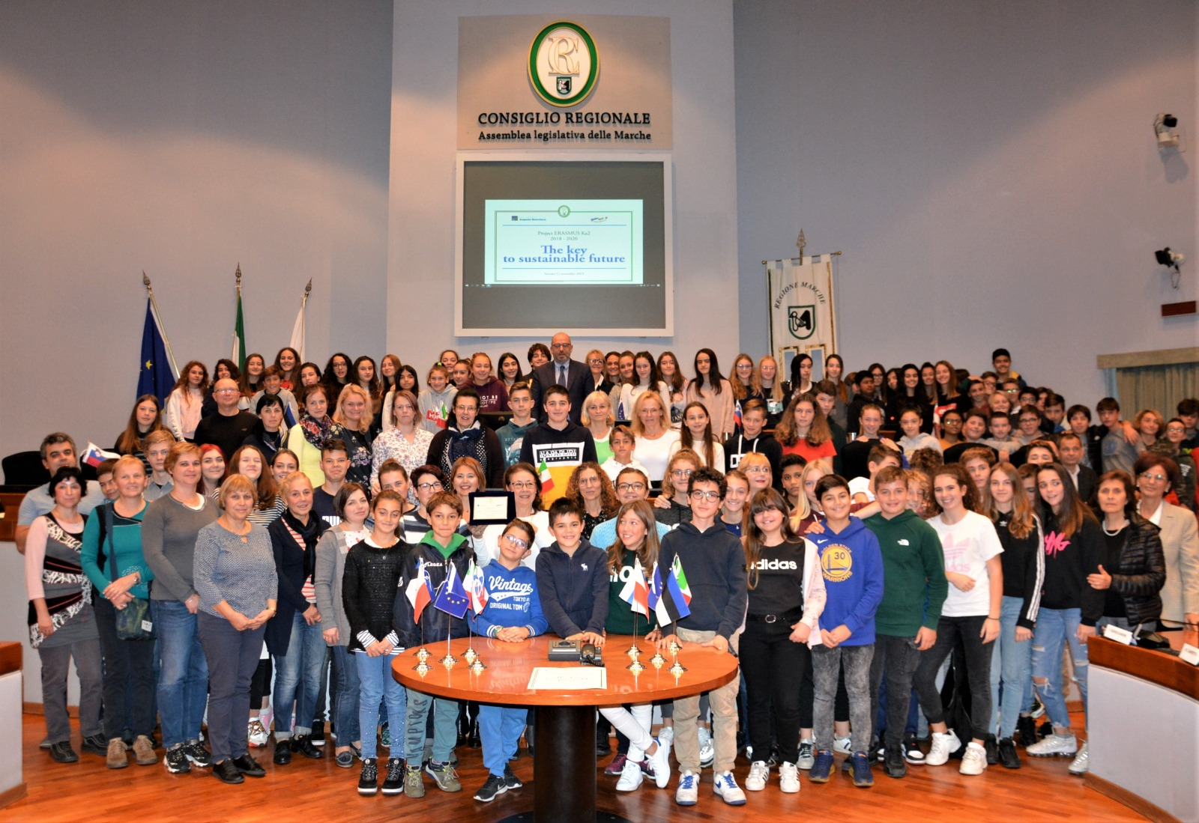

in the afternoon let’s visit Ancona. Students and teachers discover the beauties of Ancona.
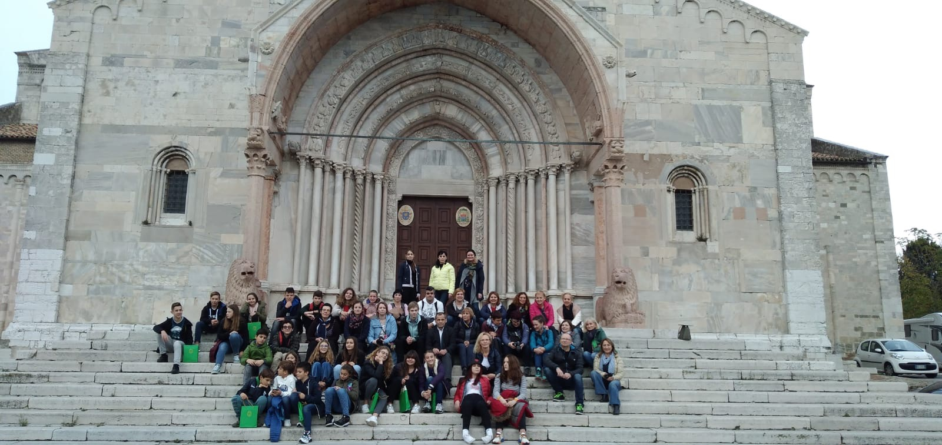

On 12th november students, accompanied to school “Secondary school Conero” by host family and teachers walked to school.
We welcomed the guests to the school. After welcoming students were drawn to a short visit to school and they partecipated to a music lesson and involved in singing some famous songs in the class.
The students were involved in WATER workshop
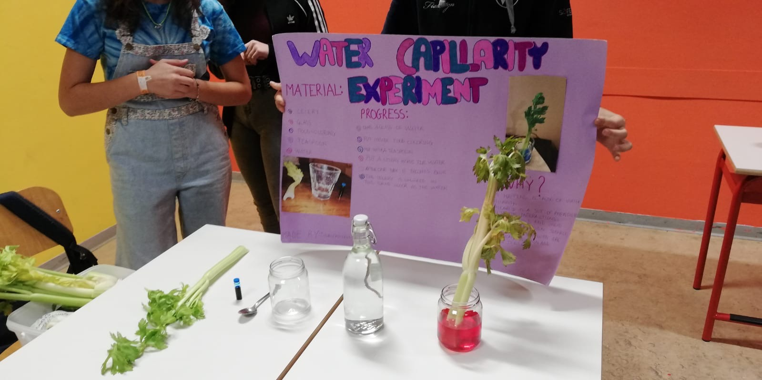
The intent of the project is to address the issue of "environment" by bringing the student into contact with what is around him, urging him to acquire knowledge of the reality in which he lives and skills.
Execution of laboratories to discover the characteristics of water:
• Capillarity and surface tension
• Acids and bases: the pH value in water
• Water purification and purification: filter model with different soil samples
• Analysis of water consumption by students' families: cubic meters and amounts in euros

Welcoming to school with performances by Secondary and Primary school Conero.

Activities in Primary school Conero. The students were involved in “Libropoli” a listening and reading competition.
Objectives: 1- introducing the children to literature 2- stimulate the learning process trough ludic activities Description: The first phase starts with the reading of the novel from Gianni Rodari "Favole al telefono". After that the teacher divided the class in two teams and the students play a game with the same rules of monopoly. The teams follow the trail on the board after they trow dices and move pawns until they reach the end. During the game the teams will have to answer questions about the novel and the author.
Aims: The objective of the game is to arrive first at the end answering questions and having fun.

In the afternoon students and teachers visited to the Town hall. Mrs Tiziana Borini, member in educational policies in Town hall ans Susanna dini the chaiman of town council received students and teachers. After that the students reached Omero Museum (sensorial museum) where students experienced touching statues in blindness.

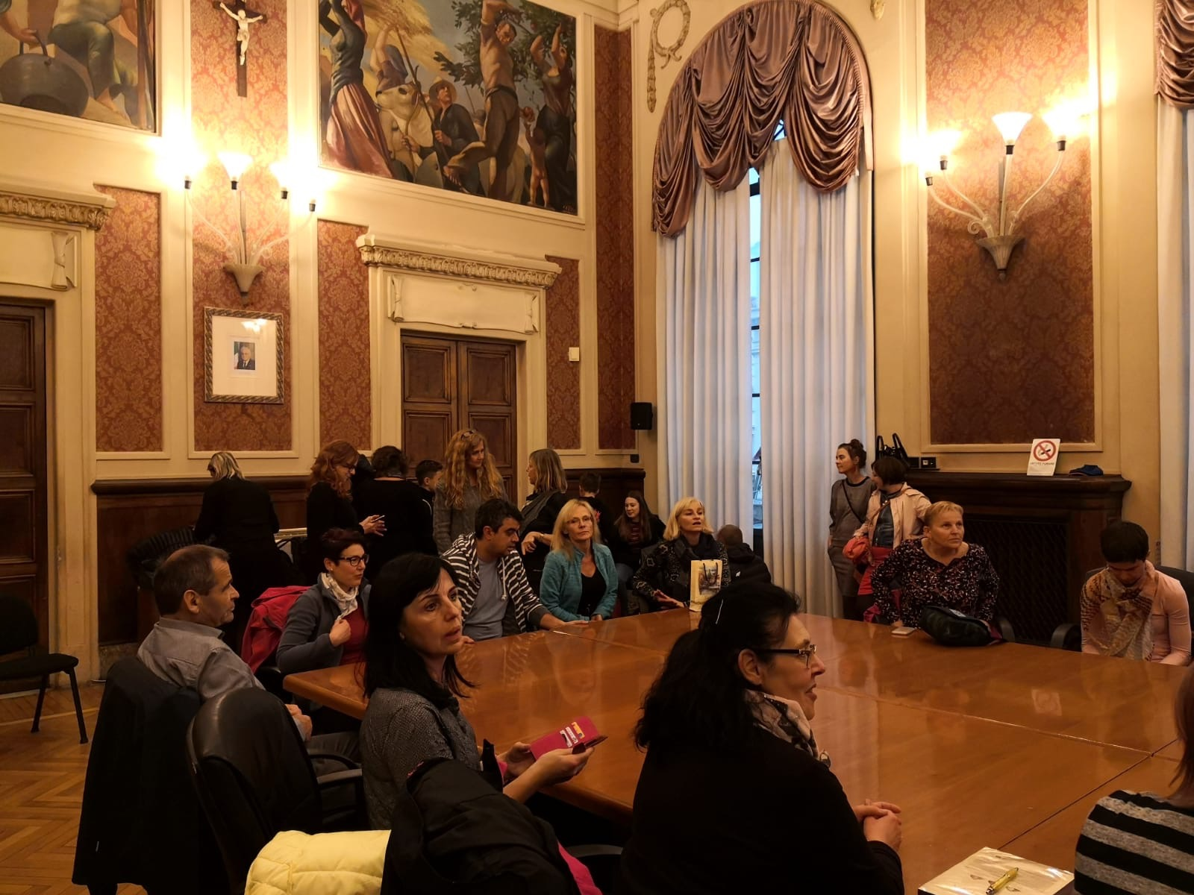
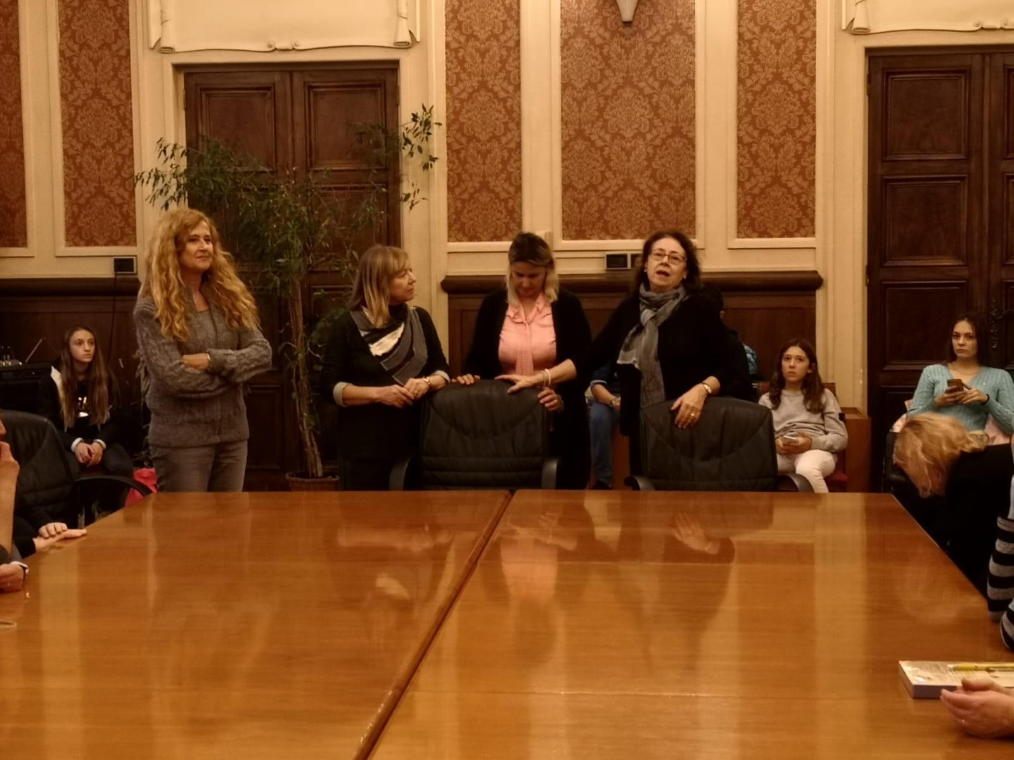

After that the students reached Omero Museum (sensorial museum) where students experienced touching statues in blindness.
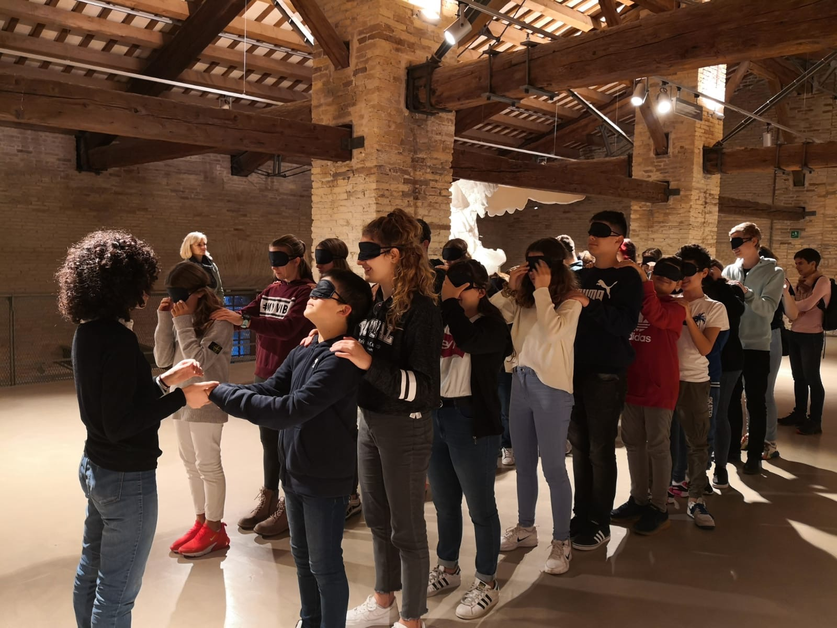

On 13th november
Students were involved in the following activities and workshops such as ICT laboratory with a coding approach
Using Scratch program
They realized simple projects Computational thinking
(in groups of 2/3 students)
Thye used of other programs (power point - Prezi)

