THE HUMAN BRAIN - handout 1
1.Number the amazing facts as they are mentioned in the video: https://www.youtube.com/watch?v=D33Aj5w061g
meditation improves health | 100 billion neurons sending information | 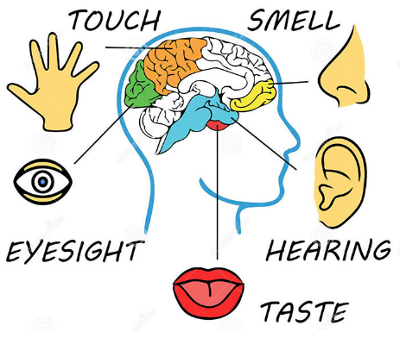
70 000 thoughts / day (on average) | practice and repeated actions help the brain to function better
mediation increases memory power | the shape of the brain doesn't stay the same all the time
the power of imagination | information speed = 270 mph  = ______kmph
human brain feels no pain | the fattest organ in the human body (60% fat)

2. EXERCISES TO INCREASE YOUR BRAIN POWER - https://www.youtube.com/watch?v=FiDFjSQ8Vqw
Write short instructions for the exercises to speed up your brain and improve concentration.
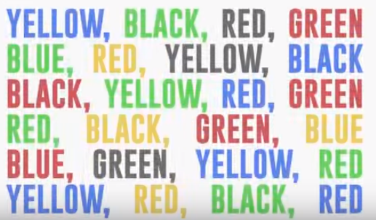
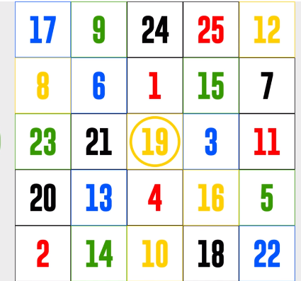
(English Plus 2; student's book)
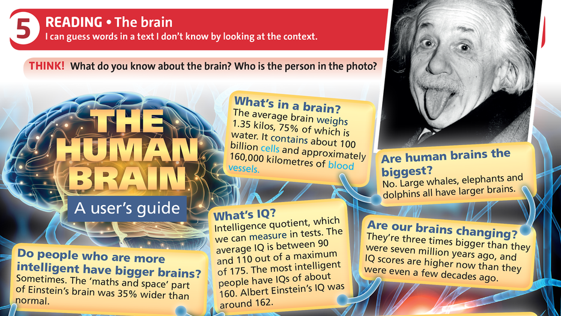
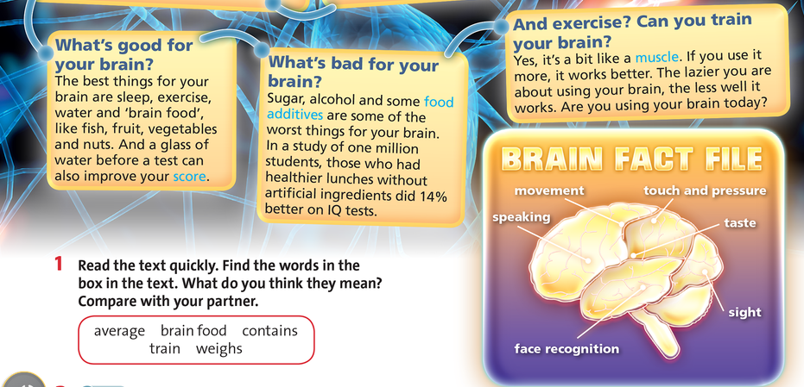

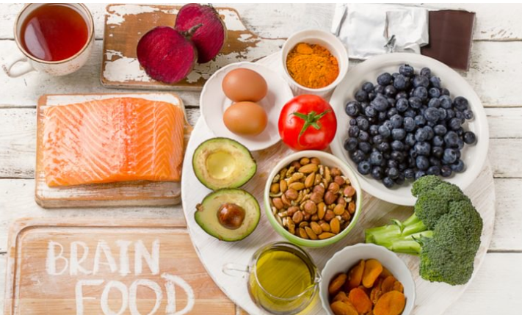
FOODS TO BOOST YOUR BRAINPOWER
(improve concentration & sharpen your memory)

Group the food items.

blueberries, strawberries, raspberries, cranberries, avocado, clementines, bananas, apples, peanut butter, roasted pumpkin seeds, sunflower seeds, dark chocolate, kale, carrots, cherry tomatoes, broccoli, beetroot, peanuts, almonds, walnuts, salmon, tuna, brown rice, whole grain cereals, green tea, soya beans, hazelnut, sardines, eggs, blackcurrants, sage tea, oranges, beans, pomegranate juice, oranges

vegetables | fruits | meat | nuts & seeds | drinks | other food

