"DETECTIVES IN ACTION" - MATHEMATICAL ESCAPE ROOM

*Based on lesson scenario by Katarzyna Kujawa*

Purpose of the classes in the student's language:

You will use your math skills to open the treasure suitcase.

Developed skills:

- the use of ICT in the educational process,

- the use of mathematical tools in everyday life situations,

- reading comprehension,

- educating mathematical thinking,

- team work (in a group).

Teaching content appearing in the tasks - detailed requirements:

I.3 - the student compares natural numbers,

II.1 - the student adds and subtracts natural numbers,

II.3 - the student multiplies and divides natural numbers in memory,

II.7 - the student recognizes numbers that are divisible by 2, 5,

II.11 - the student applies the rules regarding the sequence of actions,

III.5 - the student makes simple memory calculations on whole numbers,

VI.1 - the student uses simple patterns in which there are letters, describes the pattern in words,

VI.2 - the student solves the first degree equations with one unknown on one side of the equation,

VII.4 - the student measures sections with an accuracy of 1 mm,

IX.1 - the student recognizes and names triangles,

IX.4 - the student recognizes and names: square, rectangle, rhombus, parallelogram and trapezoid,

IX.5 - the student knows the most important properties of the rhombus, parallelogram, trapezoid,

XI.1 - the student calculates the perimeter of the polygon with the given sides (rectangle),

XI.2 - the student calculates the areas: triangle, square, rectangle, rhombus, parallelogram and trapezoid,

XIII.2 - the student reads and interprets the data presented in the tables,

Working methods: group work

Teaching aids:

- smartphones or tablets with Internet access with an application for reading QR codes,

- multimedia presentation,

- interactive whiteboard,

- props (envelopes with tasks, QR codes with task content, QR codes to be completed, polygons with QR codes glued in a selected place in the class, encyclopedia volumes (these can be, for example, properly labeled binders) with hidden envelopes containing information about padlock codes), drawings of gates with QR codes placed in a selected place in the classroom, suitcase closed with a padlock, material to cover the suitcase, treasure in the suitcase - these can be sweets, cards with grades or other awards, a letter, rulers, writing utensils cards for tables with numbers: 40, 50, 100, 200).

Course of classes:

Organizational activities, allocation to groups (4 groups). On each table there are: a telephone, pens, a sheet of paper with one of the numbers: 40, 50, 100, 200, envelopes with tasks needed to solve the puzzles. Each group receives the same set. There is enough material in each envelope so that, despite the fact that the groups are composed of six, students can work in pairs. Together, however, they decide on the final solution to the puzzle.

Students can also take out their own telecommunications devices for use

in later work. In the middle of the classroom there is a table with a mysterious covered object on it

material.

Familiarizing students with the aim of the lesson - a short multimedia presentation aimed at intriguing and curious students and involving them in a mathematical game. Explanation of the principle of "lights": by lifting - students can signal the need for help from the teacher at any time.

CONTENT OF THE PRESENTATION:

Janek and Jacek decided to help their grandparents do spring cleaning.

They started cleaning the attic.

There were many dusty cardboard boxes full of old, useless items.

When Janek was taking out one of those boxes, he tripped over something that was lying on the floor and it was covered with a blanket.

At this point, the teacher reveals an object hidden under the material - a closed suitcase.

It turned out to be a closed suitcase.

When Janek picked up the suitcase, Jacek noticed that there was a worn piece of paper underneath it.

It was a secret letter ...

The teacher picks up the suitcase lying on the table and asks one of the students to read the letter under the suitcase.

CONTENT OF THE LETTER:

A certain place, a long time ago.

Dear Detective!

If you are reading this letter, you have found a mysterious suitcase. When I was about your age, I hid my most precious treasures in it.

I don't want it in the wrong hands, so I locked it firmly. It can only be opened by those who, like me, enjoy maths, solving puzzles and can cooperate with others.

If your curiosity is so great that you will try to solve a few puzzles, start with what you like best. From the bills. Good luck.

Mat Ematyk

Work in groups.

All groups do the first task together. Only after its completion, each group begins to work at its own pace.

EXCERCISE 1

The students face the first challenge together - the game "The Counting Master" at www.learningapps.org. The task of the students is to solve an interactive quiz. Each group looks for those activities whose result is the same as the number on the piece of paper lying on the table. Each student approaches the blackboard. One person takes turns from the next table.

By correctly executing memory bills, they reveal the QR code hidden under the actions.

A selected person from each group approaches the interactive whiteboard and scans the code with one of the devices (iPad or phone). He returns to the table and the students together read the text: "Bravo!" The teacher instructs the students to scan the code from the yellow envelope.

EXERCISE 2

The QR code on the number 1 envelope (yellow) has the following content: “Inside there is a piece of paper with the next task. When you solve the envelope tasks, you will receive another clue that will bring you closer to the treasure. "

In the envelope, students find a text, a table with room dimensions. They read the text together. Then they solve the problems.

“In the table you found, I once noted the dimensions of the floors in some rooms in my house. In one of them I hid the keys to the suitcase. Make the appropriate calculations, complete the table, and then answer the questions that you will also find in the envelope. On the code card, fill in all the boxes with numbers that answer the questions about my house. Once done - scan the code. "

Room Dimensions of a rectangular floor. Circumference of floor. Floor area

hall 2 m × 4 m

kitchen 3 m × 3 m

office 3 m × 4 m

bathroom 2 m × 2 m

What is my kitchen area? What is half the circumference of my office floor? How much m2 is the difference between the kitchen area and the bathroom area? Where is the bathroom located if you list the names of the rooms listed starting with the one with the smallest floor circumference? Where is the office located, if you list the names of the rooms listed starting with the one with the smallest floor area?

The numbers that are the answers to the given tasks form the code (codes hidden in the class - glued on the walls). Scan the appropriate code to get another clue.

EXERCISE 3

In the green envelope, students will find a text, a riddle, a map, and a table with tasks. They read the text together, each pair solves the puzzle and performs calculations, together they draw the appropriate route on the map (Annex 1)

Numbered paper gates are glued in a visible place in the classroom. Each has a QR code. A selected student from the group approaches the code and scans it. The code on gate number 5 hides the information "Detectives! You did a great job. You managed to get out of the garden without any problems. You are getting closer to the treasure. Further instructions are in the red envelope ", while the codes from the other gates - the information" Unfortunately, this is not the gate. Please try again. Good luck!".

TASK 4

In the envelope, students find: text, three identical sets of polygons cut out of paper (a triangle with a base of 8 cm and a height of 5 cm, a parallelogram with a base of 5 cm and a height of 4 cm, a trapezoid with a base of 6 cm and 8 cm and a height of 3 cm, and a rhombus 10 cm and 4 cm diagonals), one for each pair, rulers for measurements, sheets for calculations.

"You came out of the garden. There is a street in front of you, and on the other side there are four houses in which they live: Mr. Adam, Mr. Bartłomiej, Mr. Cezary and Mr. Dobromir. One of them is waiting for you with another tip. Which man is this?

Work in groups.

All groups do the first task together. Only after its completion, each group begins to work at its own pace.

EXCERCISE 1

The students face the first challenge together - the game "The Counting Master" at www.learningapps.org. The task of the students is to solve an interactive quiz. Each group looks for those activities whose result is the same as the number on the piece of paper lying on the table. Each student approaches the blackboard. One person takes turns from the next table.

By correctly executing memory bills, they reveal the QR code hidden under the actions.

A selected person from each group approaches the interactive whiteboard and scans the code with one of the devices (iPad or phone). He returns to the table and the students together read the text: "Bravo!" The teacher instructs the students to scan the code from the yellow envelope.

EXERCISE 2

The QR code on the number 1 envelope (yellow) has the following content: “Inside there is a piece of paper with the next task. When you solve the envelope tasks, you will receive another clue that will bring you closer to the treasure. "

In the envelope, students find a text, a table with room dimensions. They read the text together. Then they solve the problems.

“In the table you found, I once noted the dimensions of the floors in some rooms in my house. In one of them I hid the keys to the suitcase. Make the appropriate calculations, complete the table, and then answer the questions that you will also find in the envelope. On the code card, fill in all the boxes with numbers that answer the questions about my house. Once done - scan the code. "

Room Dimensions of a rectangular floor. Circumference of floor. Floor area

hall 2 m × 4 m

kitchen 3 m × 3 m

office 3 m × 4 m

bathroom 2 m × 2 m

What is my kitchen area? What is half the circumference of my office floor? How much m2 is the difference between the kitchen area and the bathroom area? Where is the bathroom located if you list the names of the rooms listed starting with the one with the smallest floor circumference? Where is the office located, if you list the names of the rooms listed starting with the one with the smallest floor area?

The numbers that are the answers to the given tasks form the code (codes hidden in the class - glued on the walls). Scan the appropriate code to get another clue.

EXERCISE 3

In the green envelope, students will find a text, a riddle, a map, and a table with tasks. They read the text together, each pair solves the puzzle and performs calculations, together they draw the appropriate route on the map (Annex 1)

Numbered paper gates are glued in a visible place in the classroom. Each has a QR code. A selected student from the group approaches the code and scans it. The code on gate number 5 hides the information "Detectives! You did a great job. You managed to get out of the garden without any problems. You are getting closer to the treasure. Further instructions are in the red envelope ", while the codes from the other gates - the information" Unfortunately, this is not the gate. Please try again. Good luck!".

TASK 4

In the envelope, students find: text, three identical sets of polygons cut out of paper (a triangle with a base of 8 cm and a height of 5 cm, a parallelogram with a base of 5 cm and a height of 4 cm, a trapezoid with a base of 6 cm and 8 cm and a height of 3 cm, and a rhombus 10 cm and 4 cm diagonals), one for each pair, rulers for measurements, sheets for calculations.

"You came out of the garden. There is a street in front of you, and on the other side there are four houses in which they live: Mr. Adam, Mr. Bartłomiej, Mr. Cezary and Mr. Dobromir. One of them is waiting for you with another tip. Which man is this?

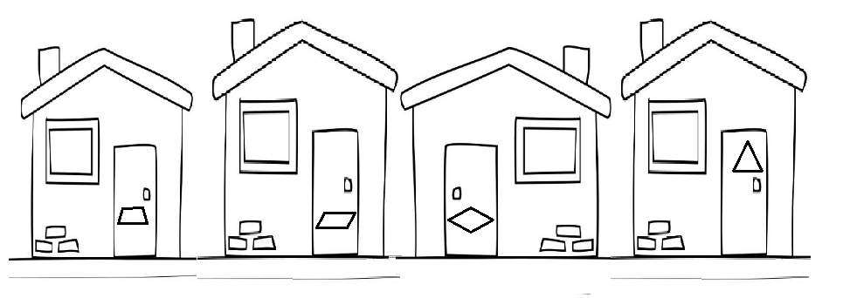

You will find him very easily. He lives in this house, on the door of which hangs a decorative plaque with the largest surface area. However, he doesn't like much company and only one of you can cross the street and knock on the right door.

However, you must hurry! You don't have much time. "

Your task now is to calculate the areas of the polygons found in the envelope, select the one with the largest area and scan the appropriate code (photo d

You will find him very easily. He lives in this house, on the door of which hangs a decorative plaque with the largest surface area. However, he doesn't like much company and only one of you can cross the street and knock on the right door.

However, you must hurry! You don't have much time. "

Your task now is to calculate the area of ​​polygons found in the envelope, select the one with the largest area and scan the appropriate code (pictures of houses).

In a prominent place in the classroom there are large polygons with QR codes. A student selected from the group approaches the code and scans it.

The QR code on the trapeze hides the following information: “Great! Mr. Cezary has already prepared another clue in a blue envelope. You are really very close to finding the keys to the suitcase ... "However, the codes on the other polygons hide the information" Unfortunately! You have not been able to find the right home. Recalculate the area of ​​the polygons and choose the right one. Good luck!"

TASK 5

In a blue envelope, the students find a mysterious square.

Solve the puzzle. The treasure is really close☺

Divide the square with the numbers entered in the squares into equal parts so that the sum of the numbers in each part is the same.

|  |  |  |  |
| --- | --- | --- | --- |
| 7 | 3 | 6 | 3 |
| 6 | 4 | 6 | 4 |
| 1 | 9 | 3 | 7 |
| 4 | 7 | 6 | 4 |

A 3-digit code must be entered to open a padlock in a suitcase. The code should be created according to the instructions:

1st digit: number of parts into which the square has been divided;

2nd and 3rd figures: sum of the numbers in each part of the square.

Good luck☺

The final stage of the lesson is that the winning team opens the suitcase.

✓ Summary of the classes.

Attachment. 1

“From the window of my office you can see a beautiful large garden, to which several gates lead. Some of them are covered with ivy and are hardly visible anymore. When you open one of the ones in the southern part of the garden, you will find another clue where to find the keys to the suitcase. But which one is the right one? First, find the one I always enter the garden. Read and solve the riddle and you will easily find it on the set. Then make the appropriate calculations and mark the route on the drawing.

Once you reach the south gate, look carefully around you, find it and read the information on it. "

Riddle: What is the letter?

"Darek and Dorota have me,

You can meet me in the boat too.

I'm at home and in a drawer

I really like aunt Jadzia.

I hum in the rain

I ring the bell, but me

there are no larks. "

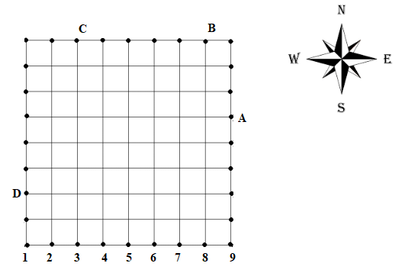

Task 1. Which of the fractions from the cloud is irreducible, if only one of them is known.



 

$1. \frac{9842715}{18271580}$

Task 2 Digit of hundreds of the number resulting from the operation of CCXLVII + MXXVIII

Task 3 Result of the activity (2 ^ 2- (3-1)) / 2

Task 4 The denominator of the fraction to be inserted after x: x: 5/3 = 5

Task 5 Digit of fractions of the number resulting from the action: 0.02 + 1/4 + 0.385 + 0.75

Task 6 Result of the activity 10 - 9 + 8 - 7 + 6 - 5 + 4 - 3 + 2 - 1

Task 7 What number should be put in the box: (2 ∙ ∎ + 1) ∙ 5 = 35

Task 8 Result of the action (36 ÷ 3 ∙ 2-5 ∙ 2) ÷ 2

Way of getting around

|  |  |
| --- | --- |
| **Task number** | **Action result (this is how many boxes we move)** |
| **1** | **Horizontally** |
| **2** | **Verticaly** |
| **3** | **Horizontally** |
| **4** | **Verticaly** |
| **5** | **Horizontally** |
| **6** | **Verticaly** |
| **7** | **Horizontally** |
| **8** | **Verticaly** |