Lesson plan RENOVATION - math classes
as part of the Erasmus + project
May 7, 2021

Main goal:
The student is able to plan the renovation of the apartment (on the basis of the apartment plan, calculate the area of ​​walls and floors, plan the amount of building materials needed and make a renovation cost estimate

Detailed objectives:
- developing the ability to work in a group according to the instructions received;
- developing reading comprehension skills;
- shaping the ability to plan subsequent stages of task solving;
- developing mathematical imagination in the context of practical situations,
- improving the method of calculating figure areas;
- consolidation of actions on rational numbers;
- analyzing the obtained results;
- introducing to independence and self-control.

Teaching aids and resources: apartment plan, Teams platform (use of Office tools - PowerPoint - multimedia presentations), self-assessment card of students' work (summary questionnaire).

Link to the summary survey: https://docs.google.com/forms/d/e/1FAIpQLSdiUJ1veqdpxXyby9bMbJqKD0DetJh93W8BJQAdcLMa3IVHVQ/viewform?usp=sf_link

Forms of work: group work (online - Teams platform).

Working methods: exercise and problem.

The course of the lesson:

1. Welcoming, dividing students into groups (students work in online rooms on the Teams platform).

2. Familiarizing students with an introductory letter to the topic (multimedia presentation of the teacher).

The teacher informs the students that in today's lesson they have to imagine that they are designers working for a certain service company, and at this point they are reading a letter addressed to the company's director. After getting acquainted with the problem that they will have to solve, students receive a work instruction from the teacher.

Letter

Zofia and Jan Adamek
Cieszyn, ul. Freedom 123

To the Director
"Dom" service company

We ask your company to design the expenses for the renovation of our apartment, which consists of: bathroom, kitchen and three rooms. We want you to take into account our proposals for materials under which the renovation is to be performed (purchase of materials in Castorama, Leroy Merlin, Mrówka online stores).

SINCERELY
Zofia and Jan Adamek

3. Familiarizing students with the apartment plan:
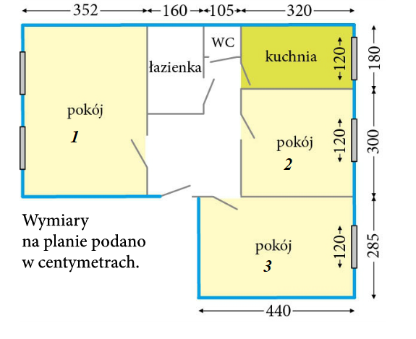
The dimensions are in centimetres.
Pokój 1 = room 1
Pokój 2 = room 2
Pokój 3 = room 3
Kuchnia = kitchen
Łazienka = bathroom
Wysokość mieszkania - wszystkich pomieszczeń to 2,6 m. Każde drzwi mają 2 m wysokości i 90 cm szerokości, okna mają 120 cm wysokości.

- Grupy uczniów losują dane pomnieszczenia, w których będą wykonywać remont.

- Podanie instrukcji wykonania zadania - remontu.

Wyobraźcie sobie, że jesteście projektantami, którzy muszą wykonać remont u państwa Adamków. Waszym zadaniem jest zaplanowanie remontu - obliczenia pól(podłogi, ścian), następnie wyszukanie materiałów budowlanych niezbędnych do remontu(farby, panele, płytki, wymiana drzwi). Pola podłogi, ścian wyraźcie w liczbach całkowitych(np. wynik 14,67 zaokrąglij do 15). Swoje efekty pracy przedstawcie w prezentacji multimedialnej.

- Prezentacja wyników pracy poszczególnych grup.

- Obliczenie całkowitego kosztu remontu.

- Podsumowanie pracy - ankieta podsumowująca.
https://docs.google.com/forms/d/e/1FAIpQLSdiUJ1veqdpxXyby9bMbJqKD0DetJh93W8BJQAdcLMa3IVHVQ/viewform?usp=sf_link
Sources:
The plan of the apartment - the textbook Mathematics with a key, grade 6, ed. New era
The lesson plan was developed on the basis of the scenario of Ms. Marta TSCHURL and on the basis of materials from the website:
https://zpo-radziszow.org/remont-mieszkania-projekt-wykonany-przez-uczniow-klasy-iii-gimnazjum-na-lekcjach-matematyki/

