LESSON PLAN

TOPIC: Let’s be healthy!

Aims:

- promote and encorage a healthy attitude towards food

Learning objectives:

- Students will be able to identify healthy and unhealthy foods.
- They’ll be able to use verbs and words linked to food
- They’ll be able to make dialogues about the right or wrong attitudes towards food

Age/level: 10/11 year olds

Time: 3 lessons (7 hours)

LESSON 1 (2 hours)

THE HEALTHY EATING SONG

https://www.youtube.com/watch?v=-JldSBUQB34

- The teachers shows a song to introduce the food vocabulary. Then gives one food picture to each student. The students say if it is healthy or unhealthy and if they like it.

- On a whiteboard or chalkboard, make two columns. One column should be labeled "healthy" and one column should be labeled "unhealthy." Put a smiley face next to the word healthy and a sad face next to the word unhealthy to help students understand the chart.
- Then, call students up one by one to select magazine cutouts of different foods and decide whether they are healthy or unhealthy.
- When they choose one, discuss with the class why they think that is correct or incorrect. Then, help students tape them to the right side of the chart.
- Continue until each student had a turn or until you have used all of the pictures.

Then they cut some food pictures and stick them in the right column (healthy or unhealthy)
The students cut out food pictures from brochures and categorize them in healthy and unhealthy
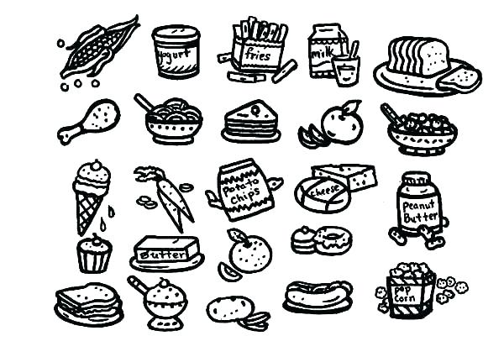
The teachers show students a video about healthy and unhealthy food.
The students make a quiz on healthy/unhealthy food

https://www.youtube.com/watch?v=GnfTHsdTodA

