From 12th to 16th November teachers and students from partner schools of Estonia, Slovenia and Italy participated in first project meeting in Poland - short exchange of students and short staff training.
This unforgettable time was a fantastic opportunity not only to make new friends, get new experiences and have a lot of fun together but also to cooperate, share ideas, learn from each other ecological thinking and use English in real life situations.
We met each other on Sunday 11th November at airport in Cracow. Since we were so close to this beautiful, majestic city we took an opportunity and went on a short sightseeing tour in Cracow. We had a lot of luck to witness celebration of Independence Day; Independence Run with hundreds or thousands participants wearing national colours, military parade, concerts at the main square and streets full of inhabitants with flags celebrating a hundredth anniversary of independence regaining.
On the 12th November which was a national holiday in Poland as well the group of guest teachers and students together with their host peers went to visit “The Bees Town” and learnt all the curiosities concerning bees’ lives, their importance in ecosystem and dangers threatening these insects.
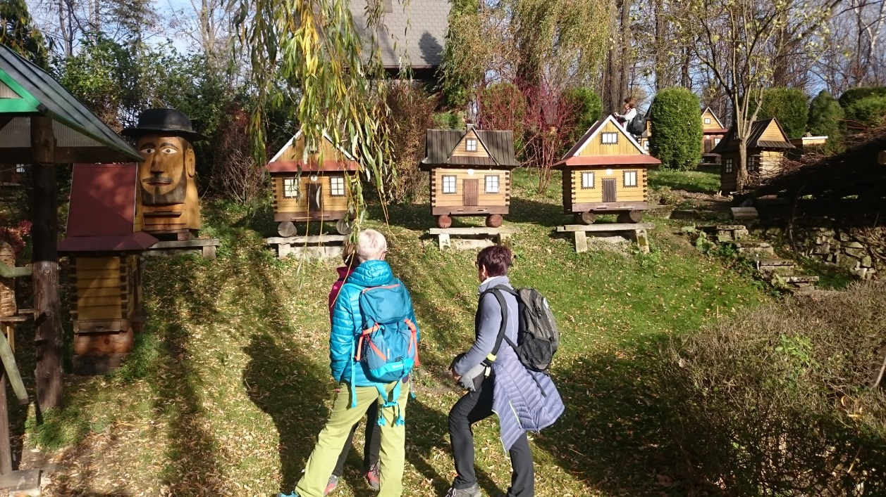
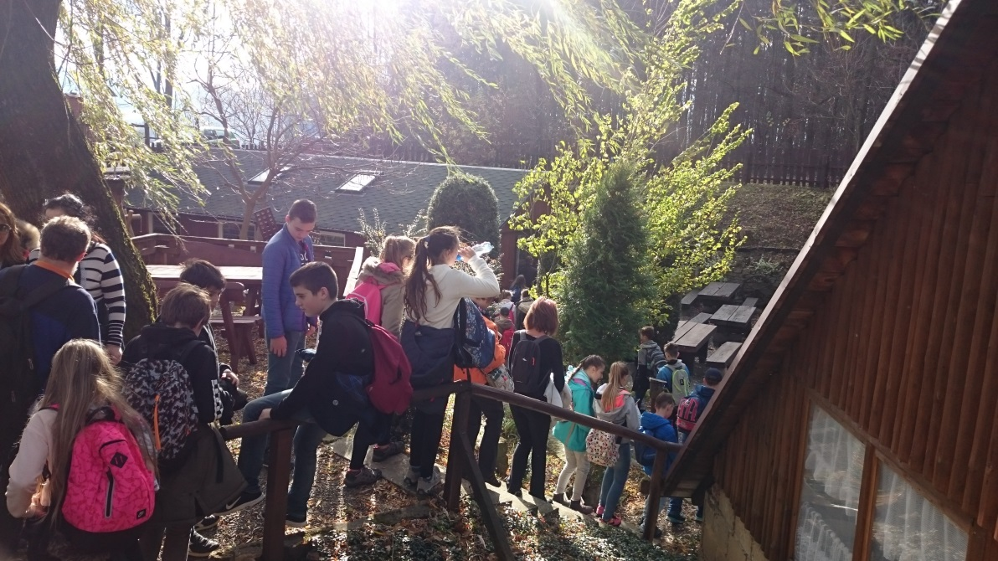
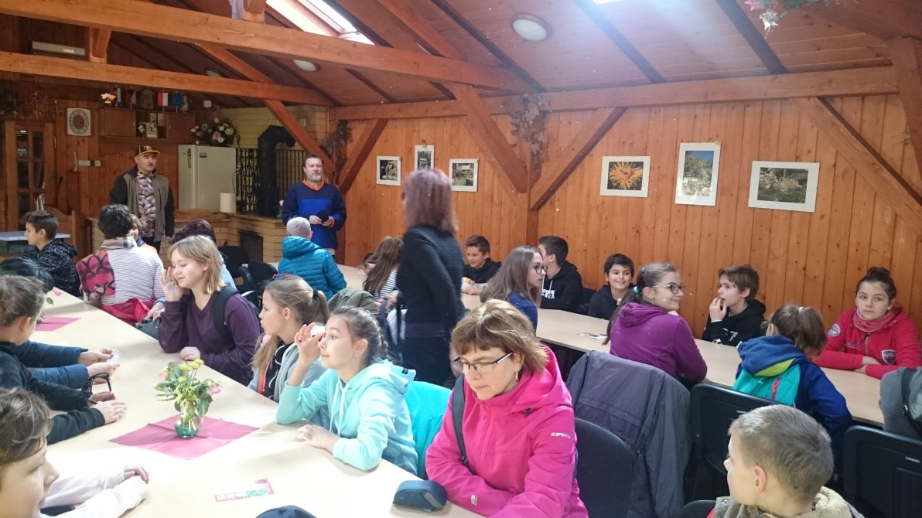
After an interesting and comprehensive lecture on bees we went to “The House of Bread” where we learnt how to produce home-made food which of course is totally ecological, without any chemical additives. We had an opportunity to produce white cheese and butter on our own and taste fresh buttermilk, bake bread and enjoy it with honey or traditional home-made lard with fried onion and herbs and drink delicious grain coffee with milk. After that we were lucky to admire spectacular view of the area by night from Równica Mountain.
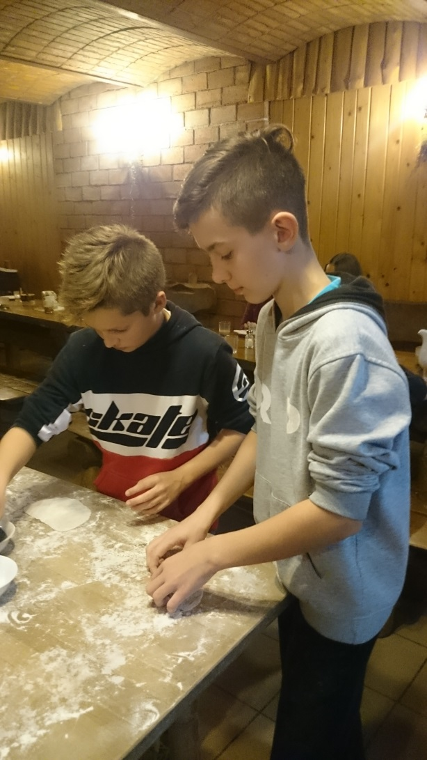
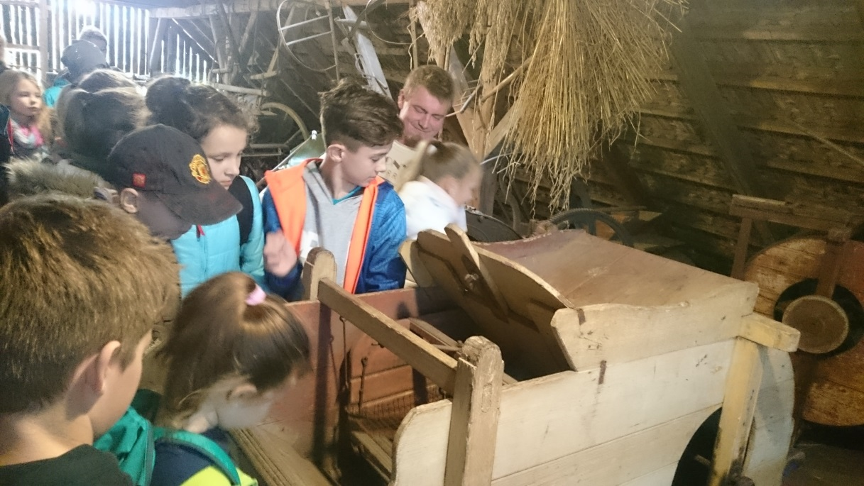
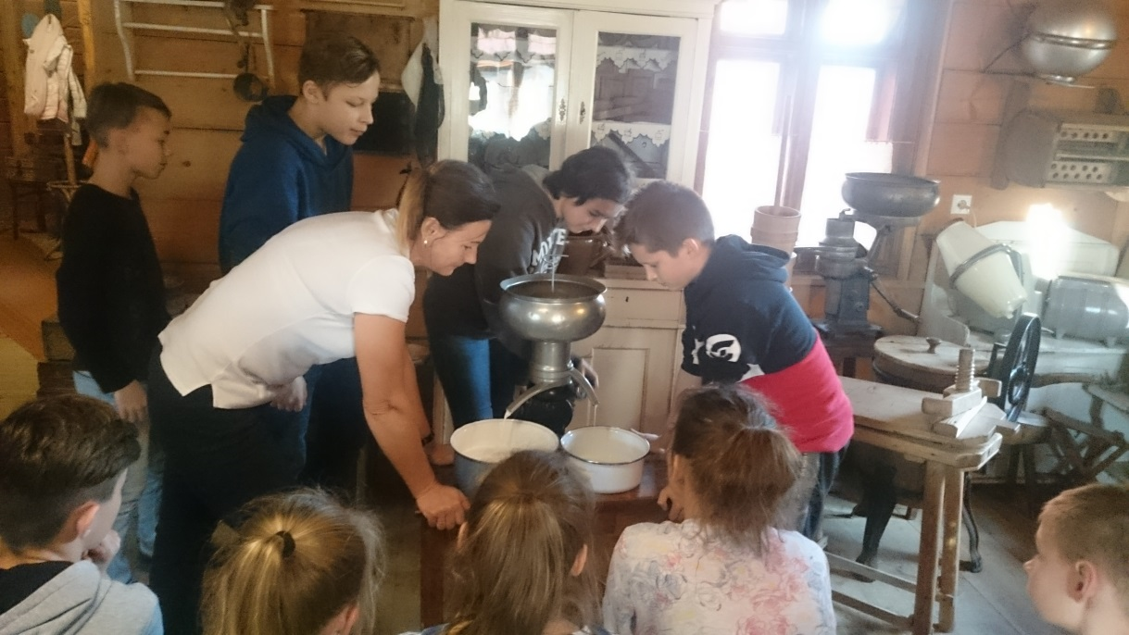
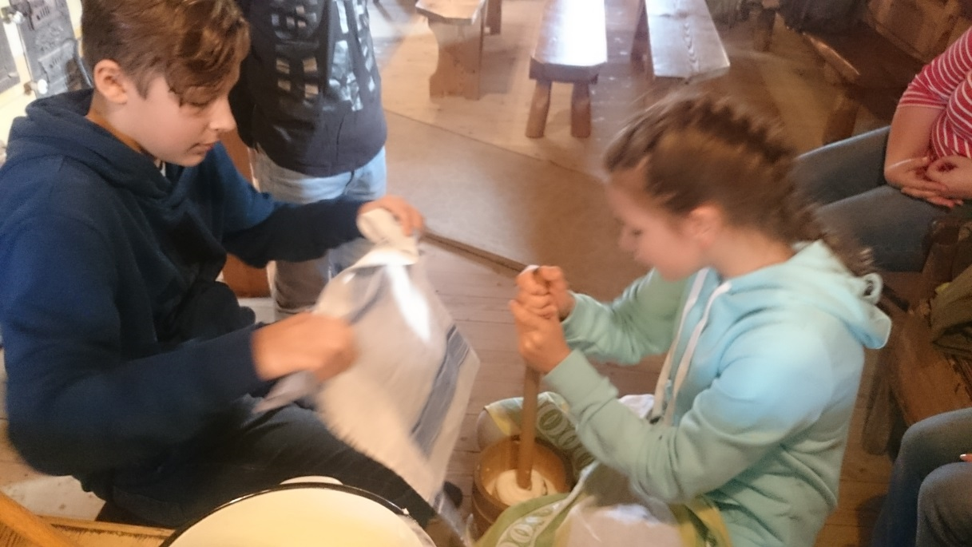
On 13th November we welcome the guests at our school. After a welcome assembly and short multimedia presentations of partner schools all guests were taken for a short walk at school and visited all the most important places. They were also presented an animated film of Janusz Korczak -the patron of Polish school. This extraordinary film was created by 3rd -grade students of Polish school and told the story of an unusual doctor and teacher who accompanied his pupils to the very end in concentration camp during the 2nd World War. After that the guest students were invited to play together with class 5C English language games just to have fun and learn more about each other. Next they sang together an English hit by Lenka “Everything at Once” but only after detailed vocabulary preparation.
Finally the guest students participated and guest teachers observed an extraordinary, outdoor lesson of Maths “Mathematical paper chase”. On that day we visited the Museum of Cieszyn Silesia and the Mayor of Cieszyn as well.
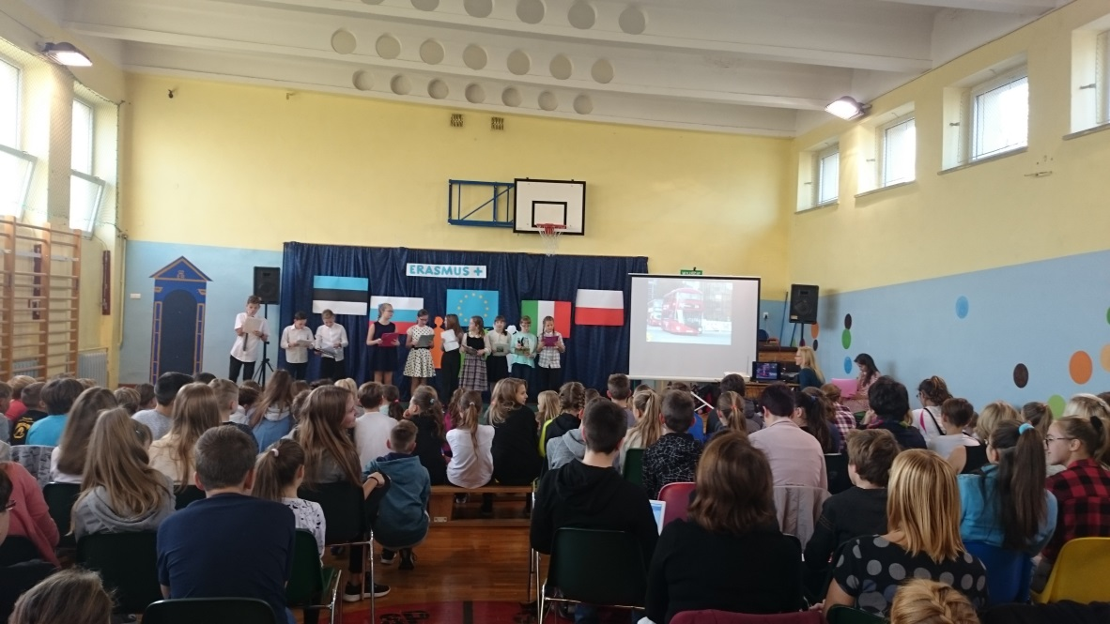
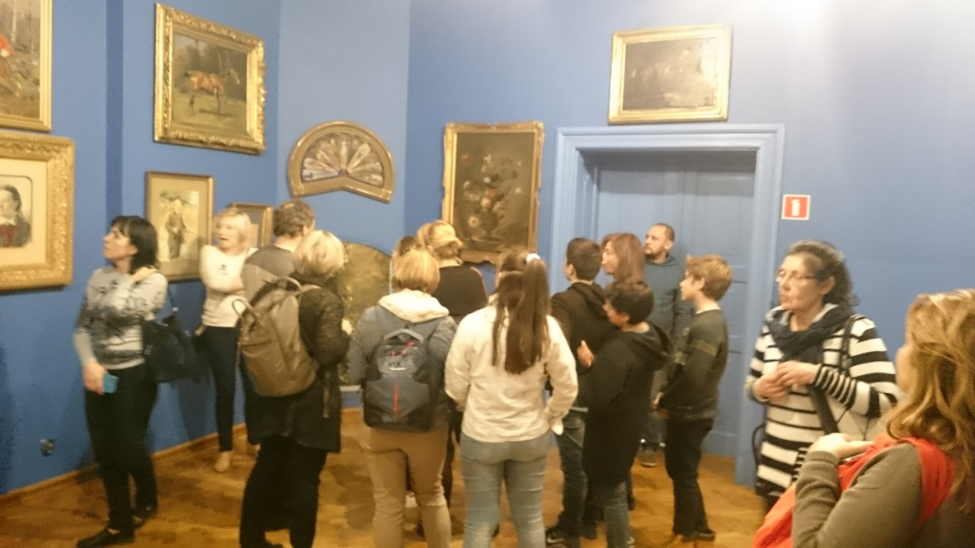
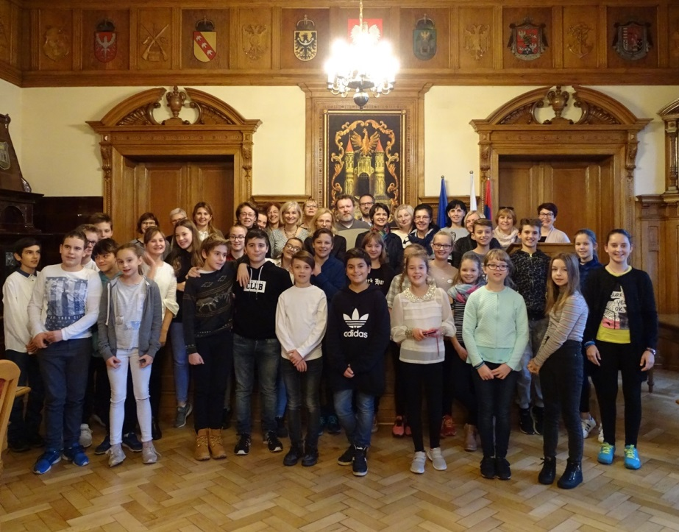
On 14th November all guest students and teachers participated in literary lessons on authorities; they read an interesting text by a Polish philosopher Marcin Fabjański which evoked a discussion on what it means to be an authority nowadays, how to select an authority or if it is easy to become an authority nowadays. At the end they created common posters on people they consider to be real authorities e.g Janusz Korczak – the patron of Polish school or Martin Luther King.
Next guest students and guest teachers were invited to English language lesson on green-house effect based on the film “Inconvenient truth”. They learnt what it is, what the reasons of its appearance are and what can be done to fight it.

After this demanding topic guest students and teachers participated in Maths classes on “Food pyramid with coding elements”. These lessons contributed considerably into healthy lifestyle topic of the project.
This day after lessons we went to Istebna to visit the museum “Kawulok’s cottage” and learn about hardship of living in remote area of mountains, close to nature and according to its rules as well as traditional ways of musical instruments production.
The 15th November the guest students and teachers started from literary education based on the poem by Jan Brzechwa “The Locomotive” read in two languages; Polish and English. They learnt how to work on the text in an extraordinary, innovative way using elements of drama and body language.
Next celebration of the “Day of Health” started at our school prepared by students’ government. It was supposed to draw attention to healthy diet in entertaining and stimulating way. It started from the funny performance prepared by second grade students on healthy fruit and vegetables. Next the guest students and host students were divided into four international groups and they had some tasks to do: masterpiece of art made of colourful jelly, international crossword with the clue “fruit salad”, next they created their own fruit salads prepared according to their own ideas. Jury consisting of guest teachers tried all fruit salads and appreciated their tastes. The next task was to create a “vegetable monster” and the last one squeezing fresh fruit. The winner was the team which produced the largest amount of juice at given time.
The last point of the “Day of Health” was a practical lesson on a portion – what portion is, how big it should be, what ingredients it should consist of.
This day we visited the majestic castle of nearby Pszczyna and learnt a lot about history of this region.
Last day - 16th November was busy from the very beginning. Host teachers were invited to English lesson for young learners on storytelling with elements of drama whereas guest students participated in music lessons and had lots of fun to play different melodies having only one plastic pipe in their hand.
Later guest students and guest teachers were involved in an unusual English language lesson – paper chase . All the tasks and activities concerned ecological issues.
Next they attended English language lesson dealing with demanding topic of “Renewable and non-renewable sources of energy”.
Then they could taste traditional and delicious Cieszyn sandwiches with herrings or vegetable salad with mayonnaise.
After this feast they were invited into farewell English language party prepared by younger learners and their fantastic teachers.
At the end of our guests’ stay at our school a lot of tears were shed…

