Khan Academy Report

As part of the Erasmus + project, students from our school together with students from partner schools solved various mathematical and IT tasks using the khanacademy platform (https://pl.khanacademy.org/).

As part of homework in computer science (given on the platform), students learned simple programming techniques, using functions to create simple drawings in Java Script.
Below are some drawings of the students:
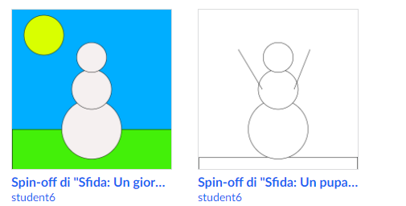

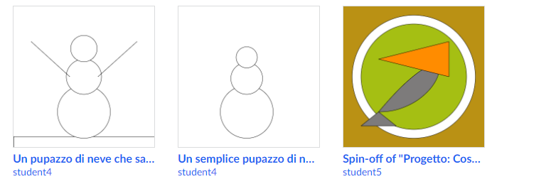

As part of the mathematical tasks, students developed their accounting skills in the field of addition, subtraction, multiplication and division. Children improved both the memory account and the written account by solving various tasks. After completing the exercises, the students took on a quiz summarizing and consolidating the learned skills.

Here are the results of the quizzes:
Quiz - addition and subtraction
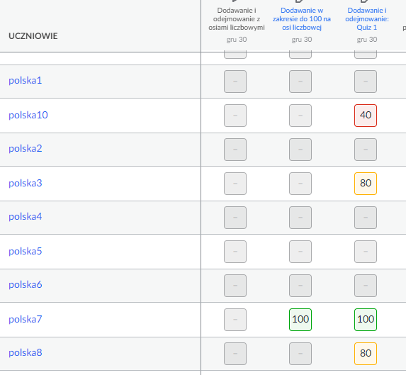

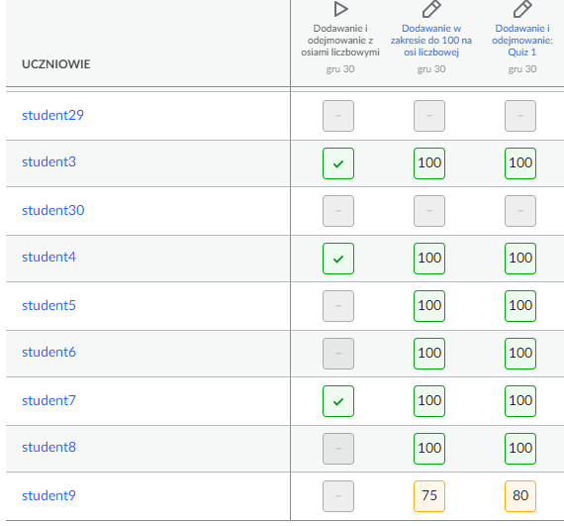

Quiz - multiplication and division
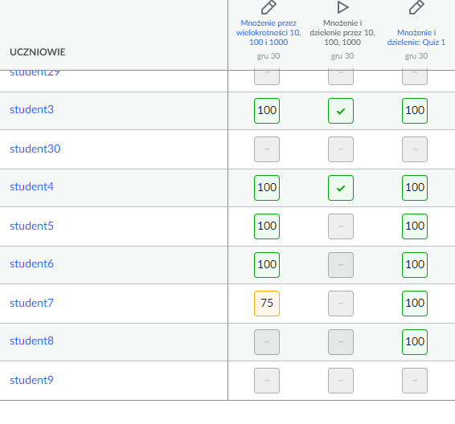

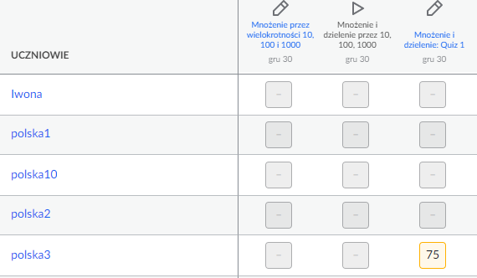

As can be seen from the above results, students from all countries coped well with the tasks they performed. The interactive form of the tasks was great fun to consolidate the calculations and learn mathematics and computer science.

