TRADITIONAL OLD HOUSES, MUSEUMS, CASTLES, MOSQUES AND CHURHES

1-Muğdat Mosque

The mosque was built in 1980s in the Yenişehir second-level district of Mersin. Although the official name of the neighbourhood is Gazi, it is usually called Muğdat after the name of the mosque. The mosque is situated at the north of Mersin Archaeological Museum and the Mersin Naval Museum. The total area of the mosque including the yard is 7,900 square metres (85,000 sq ft) and the base area of the building is 3,070 square metres (33,000 sq ft)
The mosque has a capacity to offer service to 5500 people. With this capacity it is the largest mosque in Mersin and the third largest mosque built during the Republican era of Turkey. It is also one of the three six-minaret mosques of Turkey. (Originally the mosque had four minarets, the next two were added recently) The height of the minarets is 81 metres (266 ft). On each minaret there are three minaret balconies.
Muğdat mosque is actually a complex like the traditional Ottoman mosques. In addition to religious services, the mosque has facilities including a conference room, a library, a guest house a condolences room and a health center. The basement of the building is a supermarket.

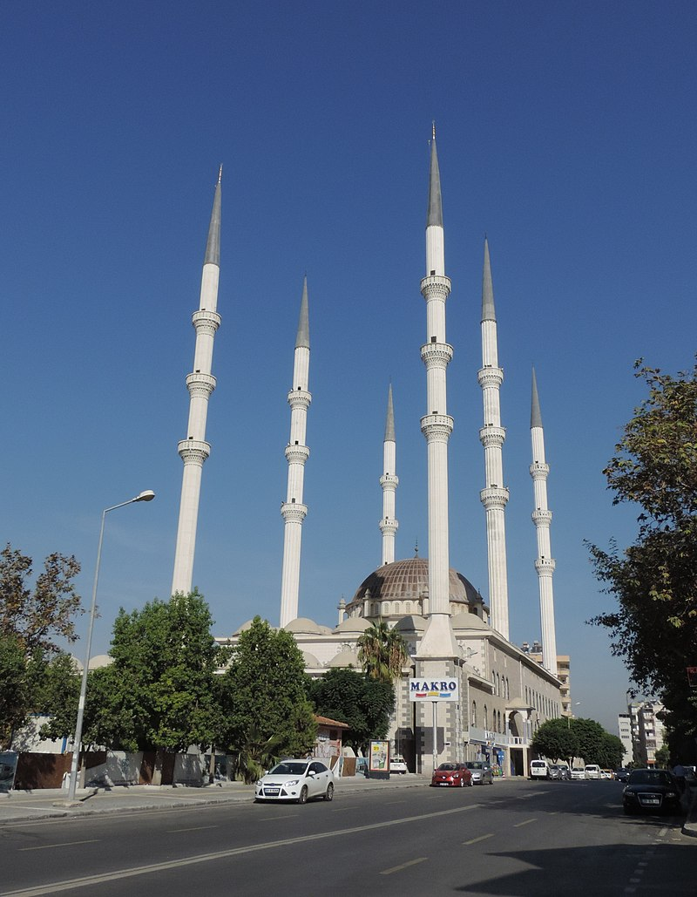

2. Maiden Castle

*History
According to Strabo, the island was used by the pirates in the ancient age. But the castle was probably built by Alexios I Komnenos of the Byzantine Empire after the First Crusade. It was extensively rebuilt in the 13th century by Leo I and at least one subsequent monarch of the Armenian Kingdom of Cilicia. Archaeological surveys published in 1982 and 1987 found that the original Byzantine plan survives primarily at the south with the characteristic square towers. The Armenians rebuilt the north and west sides of the castle with their distinctive rusticated ashlar masonry (not spolia from the late antique city) and round towers. They also put new facing stone on most of the Greek construction. Two Armenian inscriptions reportedly mention the rebuilding of this site by King Leo I (1206) and King Het‛um I (1251). The Armenians also built a barrel vaulted chapel inside the fort. The island was once connected to the mainland fort, Corycus castle, by a breakwater. The Armenians called this fortress Gorygos).In the 14th century the Cilician Kingdom was on the verge of collapse and in 1360 Peter I of Cyprus captured the island at the request of the inhabitants. The castle was captured by İbrahim II of Karaman of the Karamanids, an Anatolian beylik, in 1448, and by Gedik Ahmet Pasha of the Ottoman Empire in 1471. The name Goygos was changed to Kızkalesi.

*Legend of Kızkalesi
According to the legend of Kızkalesi, a fortune teller informs the king that his beautiful daughter will be poisoned by a snake. He adds that even the king is unable to change her fate. Shocked by the fortune teller's words, the king tries to save the princess by building a castle on an island where no snakes live. He sends his daughter to live in the castle. But a snake hides in a grape basket sent from the mainland and poisons the princess.^{[1]} This legend is not unique to Kızkalesi and some other localities in Turkey share the same story.
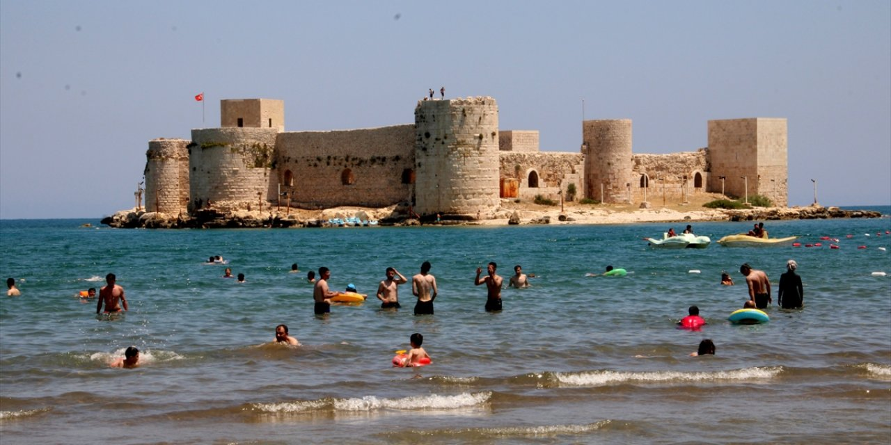

3- Old Tarsus Houses
The old houses of Tarsus with unique characteristics are also an important touristic value. It is possible to see the traces of these houses in the old Muslim and non-Muslim neighborhoods in the southern part of the district, known as Old Tarsus.
The most well-known of the Old Tarsus Houses are the houses on the streets starting right next to the Saint Paul's Well and extending towards the south, and then continuing until the Roman Bath. Some of these have been restored and are structures that can be described as the symbol of Tarsus. Some of the old houses, which have been renovated in accordance with their originality, serve as boutique hotels, cafes and restaurants.
While constructing the Historical Tarsus Houses, various subtleties that are difficult to see elsewhere due to the warm climate and respect for privacy were considered.
Due to the hot climate, thick limestones containing calcium carbonate brought from the Taurus Mountains were used in the buildings, thus ensuring that the interior of the houses is cooler in the summer and warmer in the winter.
Again, with the effect of the hot climate, the distance between the streets was kept narrow, and it was aimed to ensure that the houses were in the shadow of each other, as well as to find a shaded area to walk on the streets. In general, the direction of the streets is designed to receive the cool wind blowing from the southwest.
While planning the Old Tarsus Houses, privacy was also taken into consideration. The best example of this is the double knocker doors seen in some houses. One of the knockers makes a deep and full sound, the knocking of this knocker means that it is a man who comes to the house, and the man of the house opens the door. On the other hand, women knock on the thin-voiced knocker and the woman of the house opens the door. Again, in some buildings, there is a cage system made in such a way that the owner of the house can see the person knocking on the door from above, and the person who knocks on the door cannot see the owner of the house.
Another interesting detail about the doors in the Old Tarsus Houses is that if the owner is not at home but will come immediately, he tie the rope lightly to the door, and if he will not be at home for a long time, the rope is tied tightly so that those who come to the house understand when the host will return.
Another reflection of the warm climate and the importance given to privacy is that the houses have high walls and courtyards.
One of the most striking features of the Old Tarsus Houses is their magnificent doors. The reasons for keeping these doors high are to allow pack animals to enter and to fit cotton, a bulky plant that is grown extensively in the region.
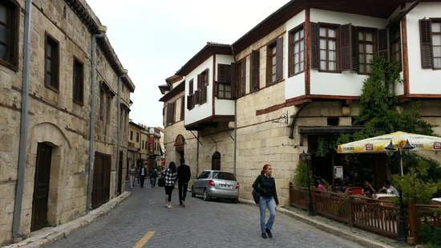

4. Co-Cathedral of St. Anthony of Padua (Mersin)

The Co-Cathedral of St. Anthony of Padua also St. Anthony Latin Catholic Church of Mersin (Turkish: Aziz Antuan Latin Katolik Kilisesi) is a church in Mersin, Turkey. Is a Co-Cathedral of the Roman Catholic Vicariate Apostolic of Anatolia.
At the beginning of the 19th century Mersin was a small village and the Christian population of the region was concentrated in nearby Tarsus (birthplace of St Paul) . But towards the mid 19th century, Mersin flourished as a port of Çukurova (Cilicia). Meanwhile because of Druze-Christian disturbances in Lebanon, many Christians migrated to Mersin. Also at this time the French consulate moved from Tarsus to Mersin and with it went most of the Catholic population of Tarsus. With every passing day, Mersin became more important and in 1853 it was decided that a church should be built in Mersin. In May 1854 Peder Antonio moved from Tarsus to Mersin.
On 18 September 1855, the Ottoman sultan Abdulmejid I gave the firman (decree) to build a church. The church and an accompanying school under the direction of Capucine friars continued up to the World War I in which both Italy and France were opposers of Turkey. After a temporary halt during the war, the school reopened at the conclusion of the war. But it was closed in 1923 and the buildings were transferred to public authorities. (See Mersin Üçocak İlkokulu) The church is still active.

