Bacalhau à Bras Traditional Recipe
How to prepare bacalhau à bras, one of the most famous Portuguese recipes: a traditional dish made with salt cod, potatoes and eggs.

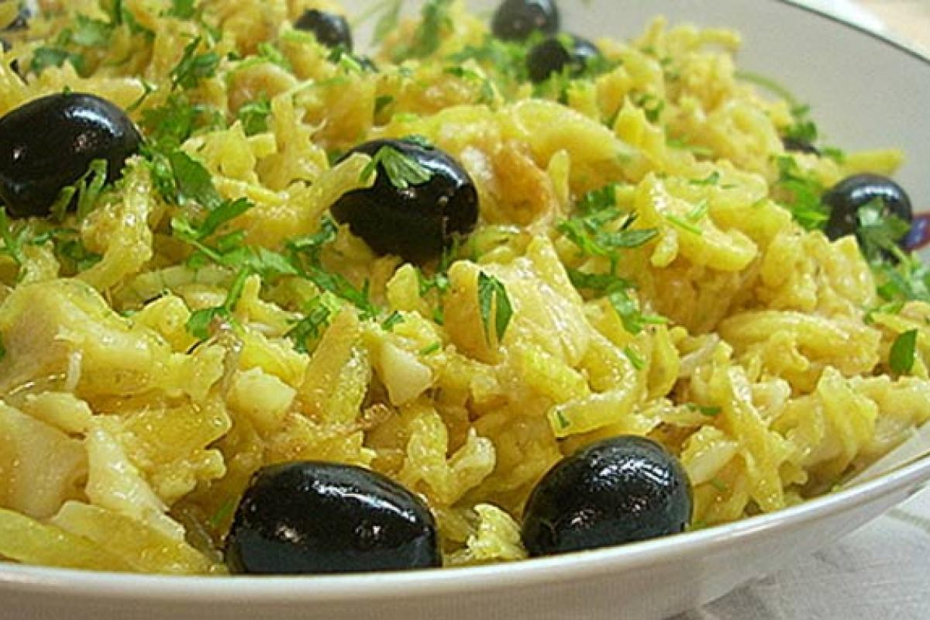

How to prepare a delicious Portuguese Bacalhau à Bras

Step01
To prepare the Portoguese Bacalhau à bras recipe, start having soaked the salt cod, then remove the skin and bones, and break it apart with your hands.

Step02
Meanwhile, cut the potatoes into matchsticks by first cutting a small slice off the potato to give it a flat base, then cutting the potato lengthwise into slices, which is then laid flat and cut into matchsticks. Cut the onion into fine rings using a similar technique of first taking a thin slice off the side of the onion to keep it from rolling while you cut the rings.

Step03
Fry the potatoes in a pan and set them to one side, drying them on kitchen paper.

Step04
At the same time, in a deep pan, sweat the onions and garlic until golden, then add the pieces of salt cod, and cook for a few minutes, until it soaks up the oil.

Step05
At this stage, add the potatoes and stir whilst adding the lightly beaten eggs with salt and pepper. Stir for a few minutes, turning off the heat before the eggs solidify and become an omelette.

Step06
The bacalhau à bras has to be served hot, with parsley and black olives.

Pataniscas de Bacalhau – Salt Codfish Cakes

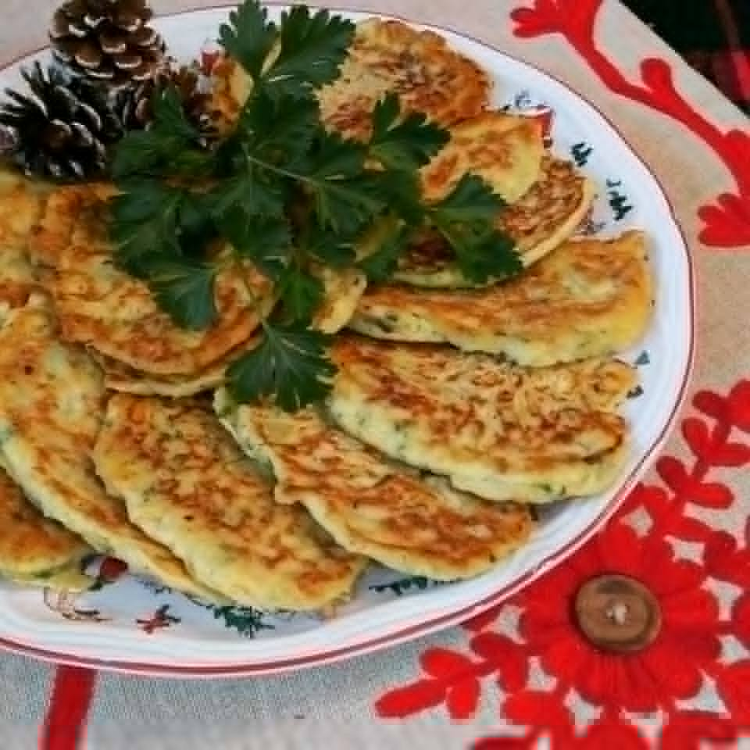

Did you know that there’s an old Portuguese saying?
“There are 365 recipes for Bacalhau – one for each day of the year.”

Try this easy and delicious recipe for Pataniscas (Salt Cod Fish Fritters). They are similar to clam fritters made in New England but these are pan fried into a flat shape.
This recipe brings me back sweet memories of my dear mother who taught me how to make them when I was a little girl. We would make these on Sunday mornings for family trips to the beach or during family trips with a long driving distance. We’d stop half way into the trip at the roadside rest stops to enjoy these along with good Portuguese cheese, presunto, bread, and Portuguese wine.
If you love Bacalhau you’ll love these. They’re so simple yet so good, the intense flavor of the Bacalhau, combined with the sweetness of the onions and parsley in the batter gives this classic a taste, which you’ll crave again and again.
Serve them as an appetizer, or as a main dish. By the way, make extra because they taste even better the next day! Enjoy!

https://www.youtube.com/watch?v=74CE-gnABKE

Cozido à Portuguesa (Portuguese Stew)

Ingredients

beef for cooking 200 g
pork shoulder 200 g
chicken meat 300 g
black pudding 1 pc.
smoked bacon 150 g
Meat sausage 1 pc.
savoy cabbage 400 g
leek 1 pc.
Potato 4 pc.
Turnip 2 pc.
Carrot 4 pcp.
Garlic 3 cloves

Preparation

Step 1
Wash the meats well and place them in a pressure cooker to cook for 25 minutes. Once cooked, reserve the meats and the broth.
Step 2
Wash and cut into pieces the cabbage and the leek. Wash, peel and cut in half the potatoes, turnips, carrots and garlic. Then place them in a pan.
Step 3
Add the previously cooked meat and cover half of it with water. The other half, with the meat stock.
Step 4
Cook covered for 15 minutes, or until the vegetables are cooked.
Step 5
Remove the meats and cut them into pieces.
Step 6
Place the meats and vegetables on a wide platter and serve.
Step 7
We suggest that you serve with white rice cooked in the remaining cooking water.

Feijoada à Transmontana

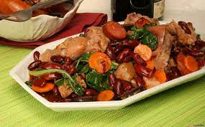

Ingredients

- dried red beans 500 g
- ribs 400 g
- bacon 100 g
- pork foot 1 pc.
- pig's ear 1 pc.
- blood sausage 1 pc.
- meat sausage 1 pc.
- small cabbage 1 pc.
- large onion 1 pc.
- garlic 3 cloves
- tomatoes 4 pc.
- tomato pulp 0,5 dl
- olive oil 1,5 dl
- bay leaf 1 pc.
- Salt and pepper to taste
Preparation

Step 1
To prepare this feijoada recipe, choose the beans and soak them in water overnight. Arrange the spare ribs, the bacon, the foot and the ear, season everything with coarse salt and leave it to soak overnight in the cold.

Step 2
On the day, boil the beans in water seasoned with salt, 2 soup spoons of olive oil and the bay leaf, remove from the heat and set aside. Rinse the meat and cook them together with the chorizos. As they are cooked, remove them from the water and cut them into small pieces. Finally, separate the cabbage leaves, wash them and cook them ''al dente'' in salted water. Remove and place in cold water.

Step 3
Peel and wash the onion and garlic and chop finely. Wash and scald the tomatoes, remove the skin and seeds and dice them. Heat the remaining olive oil in a pan, add the onion and the garlic and fry until the onion is transparent, add the tomato and the tomato pulp and fry a little more.

Step 4
Add the cooked meats, the beans and a little of the cooking broth so that it becomes very soupy and let it cook for a while. Then add the cabbage and the chorizos, let it simmer, adjust the seasoning, remove from the heat and serve with white rice.

Pastéis de Nata ~ Portuguese Custard Tarts

This pastéis de nata recipe makes as-close-to-authentic Portuguese custard tarts with a rich egg custard nestled in shatteringly crisp pastry.

For the pasteis de nata dough
- ▢2 cups minus 2 tablespoons all-purpose flour plus more for the work surface
- ▢1/4 teaspoon sea salt
- ▢3/4 cup plus 2 tablespoons cold water
- ▢2 sticks (8 oz) unsalted butter room temperature, stirred until smooth

For the custard
- ▢3 tablespoons all-purpose flour
- ▢1 1/4 cups milk divided
- ▢1 1/3 cups granulated sugar
- ▢1 cinnamon stick
- ▢2/3 cup water
- ▢1/2 teaspoon vanilla extract
- ▢6 large egg yolks whisked

For the garnish
- ▢Confectioners’ sugar
- ▢Cinnamon
GET INGREDIENTS Powered by Chicory

DIRECTIONS

Make the pastéis de nata dough
- In a stand mixer fitted with a dough hook, mix the flour, salt, and water until a soft, pillowy dough forms that pulls away from the side of the bowl, about 30 seconds.
- Generously flour a work surface and pat the dough into a 6-inch (15-cm) square using a pastry scraper. Flour the dough, cover with plastic wrap, and let it rest at room temperature for 15 minutes.
- Roll the dough into an 18-inch (46-cm) square. As you work, use the scraper to lift the dough to make sure the underside isn't sticking to your work surface.
- Brush the excess flour off the top of the dough, trim any uneven edges, and, using a small offset spatula, dot and then spread the left 2/3 portion of the dough with a little less than 1/3 of the butter being careful to leave a 1 inch (25 mm) plain border around the edge of the dough.
- Neatly fold the unbuttered right 1/3 of the dough (using the pastry scraper to loosen it if it sticks) over the rest of the dough. Brush off any excess flour, then fold over the left 1/3 of the dough. Starting from the top, pat down the dough with your hand to release any air bubbles, and then pinch the edges of the dough to seal. Brush off any excess flour.
- Turn the dough 90° to the left so the fold is facing you. Lift the dough and flour the work surface. Once again roll it out to an 18-inch (46-cm) square, then dot the left 2/3 of the dough with 1/3 of the butter and smear it over the dough. Fold the dough as directed in steps 4 and 5.
- For the last rolling, turn the dough 90° to the left and roll out the dough to an 18-by-21-inch (46-by-53-cm) rectangle, with the shorter side facing you. Spread the remaining butter over the entire surface of the dough.
- Using the spatula as an aid, lift the edge of dough closest to you and roll the dough away from you into a tight log, brushing the excess flour from the underside as you go. Trim the ends and cut the log in half. Wrap each piece in plastic wrap and chill for 2 hours or preferably overnight. (The pastry can be frozen for up to 3 months.)

Make the custard
- In a medium bowl, whisk the flour and 1/4 cup milk (60 ml) until smooth.
- Bring the sugar, cinnamon, and water to a boil in a small saucepan and cook until an instant-read thermometer registers 220°F (104°C). Do not stir.
- Meanwhile, in another small saucepan, scald the remaining 1 cup milk (237 ml). Whisk the hot milk into the flour mixture.
- Remove the cinnamon stick and then pour the sugar syrup in a thin stream into the hot milk-and-flour mixture, whisking briskly. Add the vanilla and stir for a minute until very warm but not hot. Whisk in the yolks, strain the mixture into a bowl, cover with plastic wrap, and set aside. The custard will be thin; that is as it should be. (You can refrigerate the custard for up to 3 days.)

Assemble and bake the pastries
- Place an oven rack in the top third position and heat the oven to 550°F (290°C). Remove a pastry log from the refrigerator and roll it back and forth on a lightly floured surface until it's about an inch (25 mm) in diameter and 16 inches (41 cm) long. Cut it into scant 3/4-inch (18-mm) pieces. Place 1 piece pastry dough, cut side down, in each well of a nonstick 12-cup mini-muffin pan (2-by-5/8-inch [50-by-15-mm] size). If using classic tins, cut the dough into generous 1-inch (25-mm) pieces. Allow the dough pieces to soften several minutes until pliable.
- Have a small cup of water nearby. Dip your thumbs in the water, then straight down into the middle of the dough spiral. Flatten it against the bottom of the cup to a thickness of about 1/16 inch (1.5 mm), then smooth the dough up the sides and create a raised lip about 1/8 inch (3 mm) above the pan. The pastry bottoms should be thinner than the tops.
- Fill each cup 3/4 full with the cool custard. Bake the pastries until the edges of the dough are frilled and brown, about 8 to 9 minutes for the mini-muffin tins, 15 to 17 minutes for the classic tins.
- Remove from the oven and allow the pasteis to cool a few minutes in the pan, then transfer to a rack and cool until just warm. Sprinkle the pasteis generously with confectioners' sugar, then cinnamon and serve. Repeat with the remaining pastry and custard. These are best consumed the day they're made.

https://www.youtube.com/watch?v=D7qo84QYQoI

