Theatres of ancient Rome

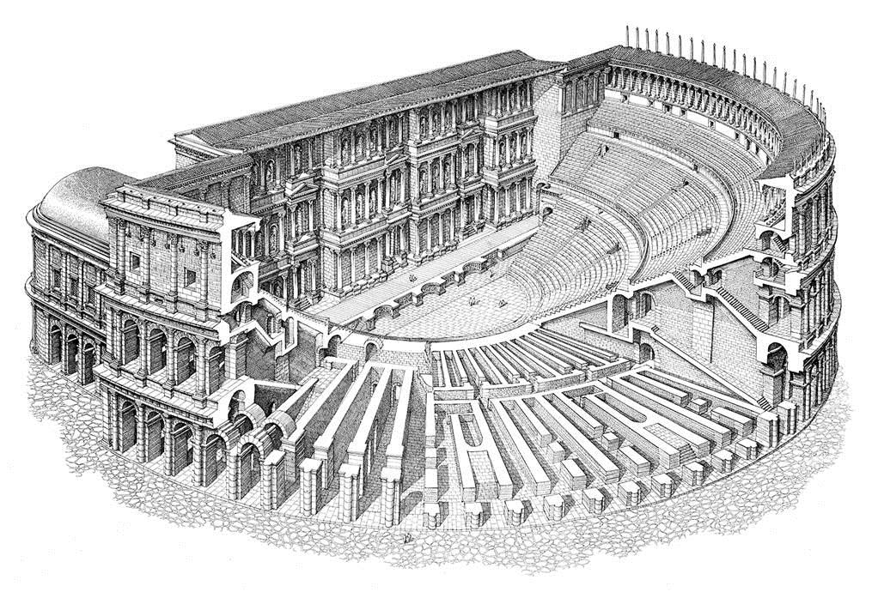

INTRODUCTION
Roman theatre is to a great extend the evolution of ancient Greek theatre. The architectural evolution of ancient Greece is evident in the Roman era and theatre is no exception. However, there are obvious differences. Theatres are constructed on flat ground, based on separate foundations, whereas Greek ones were built exploiting the natural inclination of the ground. The dimensions are getting bigger as we move from the Classic to the ΗHellenistic and Roman period. The indoors imposing Roman theatre succeeded the outdoors frugal Greek one.

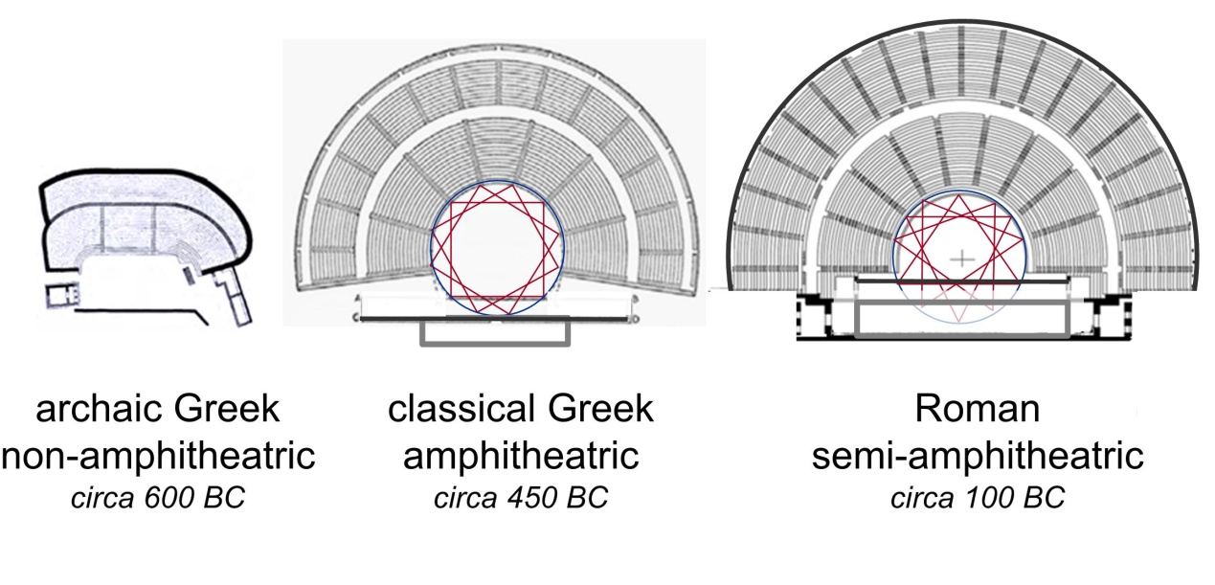

Structure
These buildings were open -plan and covered all its three parts. They were semi-circular, thus enhancing natural acoustics -unlike Roman amphitheatres constructed in the round - and possessed certain inherent architectural structures, with minor differences depending on the region in which they were constructed. Roman theatre is an excellent model for the designers of modern theatre.
The scaenae frons was a high back wall of the stage floor, supported by columns. The proscaenium was a wall that supported the front edge of the stage with ornately decorated niches off to the sides. The Hellenistic influence is seen through the use of the proscaenium. The Roman theatre also had a podium, which sometimes supported the columns of the scaenae frons. The theatre itself was divided into the stage (orchestra) and the seating section (cavea or auditorium). Vomitoria or entrances and exits were made available to the audience.
The auditorium, the area in which people gathered, was sometimes constructed on a small hill or slope in which stacked seating could be easily made in the tradition of the Greek Theatres. The center of the auditorium was hollowed out of a hill or slope, while the outer radian seats required structural support and solid retaining walls. This was not always the case as Romans tended to build their theatres regardless of the availability of hillsides. All theatres built within the city of Rome were completely man-made without the use of earthworks. The auditorium was not roofed; rather, awnings (vela) could be pulled overhead to provide shelter from rain or sunlight.

Origins of Roman theatre

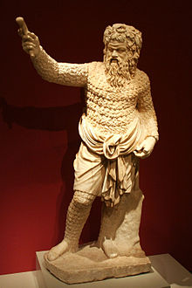
The early drama that emerged was very similar to the drama in Greece. This was due to extensive contact between the Romans and the Greeks, which allowed the Romans to develop an interest in a new form of expression.
While Greek literary tradition in drama influenced the Romans, the Romans chose to not fully adopt these traditions, and instead the dominant local language of Latin was used. These Roman plays that were beginning to be performed were heavily influenced by the Etruscan traditions, particularly regarding the importance of music and performance.
The theatre of ancient Rome was a thriving and diverse art form, ranging from festival performances of street theatre, nude dancing, and acrobatics, to the staging of Plautus's broadly appealing situation comedies, to the high-style, verbally elaborate tragedies of Seneca.

PLAYS

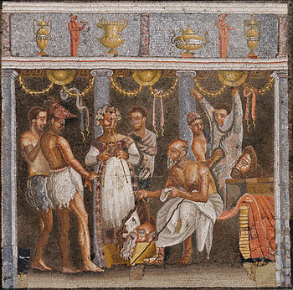

Roman history is divided in two phases: Democracy (509-27 BC) and Empire (27BC-476 AD). We can trace the political development of Rome and elements of change into Roman theatre. During democracy tragedy was in bloom; the appeal of tragedy can be explained as tribute to the democratic notions of virtue, honour and fidelity, while comedy was the light, frivolous confrontation of familiar situations and complications with a happy ending. None of the two types of drama seem to taint philosophical problems or question the Roman values. During the Empire, normal drama was abandoned for the sake of various spectacles. Theatre grew gradually, exclusively, for amusement. New types of entertainment were set by demand and offer.

Notable Roman Playwrights

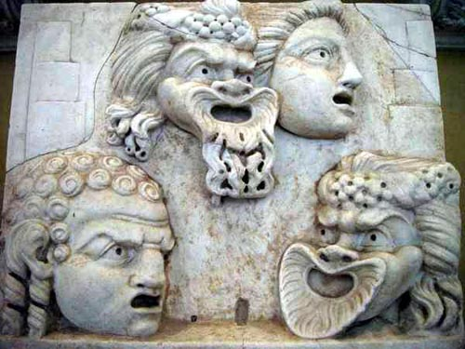

Livius Andronicus, a Greek slave taken to Rome in 240 BCE, who wrote plays based on Greek theatre. Rome's first playwright.
Plautus, 3rd century BC comedic playwright and writer of Miles Gloriosus, Pseudolus, and Menaechmi.
Terence, who wrote between 170 and 160 BC.
Gaius Maecenas Melissus, 1st century playwright of a "comedy of manners"
Seneca, 1st century dramatist most famous for Roman adaptations of ancient Greek plays like Medea and Phaedra.
Ennius, contemporary of Plautus who wrote both comedies and tragedies
Pacuvius, Ennius's nephew and tragic playwright.

The most important ancient Roman theatres

1. Odeon of Herodes Atticus, Athens-Greece

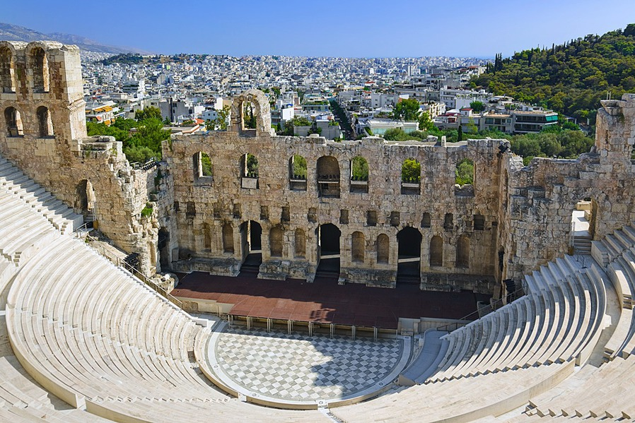

The Odeon of Herodes Atticus is located in Athens: Built at the base of the Acropolis, the ancient amphitheatre of Herodeion, also known as the Odeon of Herodus Atticus, is today one of the best places to experience a live classical theatre performance.
This ancient theater was built in the Roman times, in about 161 AD by the Roman philosopher, teacher and politician Herodes Atticus. It was built in the memory of his wife Aspasia Regilla who died in 160 AD.
This semi-circular amphitheater has a wide 1,250 feet radius with a seating capacity of more than 6,000 people. The original wall of the stage stood three storeys high and was decorated with marbles and ceramic pieces while today it stands in ruins. The stage and seating area was laid with marble while it has been renovated today. A cedar-wooden roof covered the theatre in the ancient times.
The audience stands and the orchestra (stage) were restored using pentelic marble in the 1950s. Since then it has been the main venue of the Athens Festival, musical concerts and classical tragedies under the night sky with a marvelous acoustic experience which runs from May through October each year, since the theatre is open ,featuring a variety of acclaimed Greek as well as International performances. The Herodeion Theatre stands on Dionysiou Areopagitou Pedestrian Street, right under the Acropolis.

2. Theatre at Orange, France

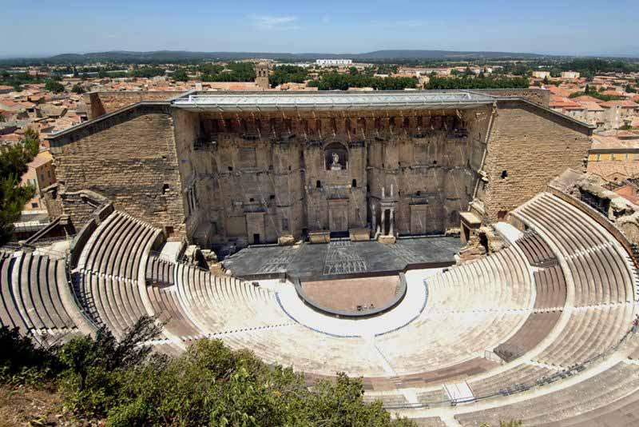
The Theatre of Orange is an ancient Roman theatre, in Orange, southern France, built early in the 1st century CE. It is owned by the municipality of Orange and is the home of the summer opera festival, the Choregies d'Orange. It is one of the best preserved of all the Roman theatres in the Roman colony of Arausio .
As the Western Roman Empire declined during the 4th century, by which time Christianity had become the official religion, the theatre was closed by official edict in AD 391 since the Church opposed what it regarded as uncivilized spectacles. After that, the theatre was abandoned completely. It was sacked and pillaged by the "barbarians" and was used as a defensive post in the Middle Ages. During the 16th-century religious wars, it became a refuge for the townspeople.

3. Mérida, Spain
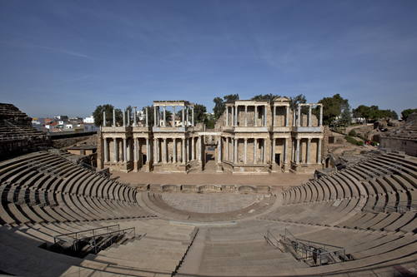

The theatre is located in the archaeological ensemble of Mérida, one of the largest and most extensive archaeological sites in Spain. It was declared a World Heritage Site by UNESCO in 1993. It was constructed in the years 16 to 15 BC by the consul Vipsanius Agrippa. In its time it had a seating capacity of 6,000. The stands are divided into three areas corresponding to the social status of the spectators.
The theatre has undergone several renovations, notably at the end of the 1st century or early 2nd century, when the current facade of the scaenae frons was erected, and another in the time of Constantine I (between 330 and 340) which introduced new decorative-architectural elements and a walkway around the monument. In the 1960s and 1970s the front stage was rebuilt and has been preserved since then. . Besides being the most visited monument in the city, it has been home to the development of the Festival de Mérida (Festival of Classical Theatre of Mérida) since 1933. The Mérida Classical Theatre Festival is the oldest of its kind celebrated in Spain.

4. The theatre in Amman, Jordan

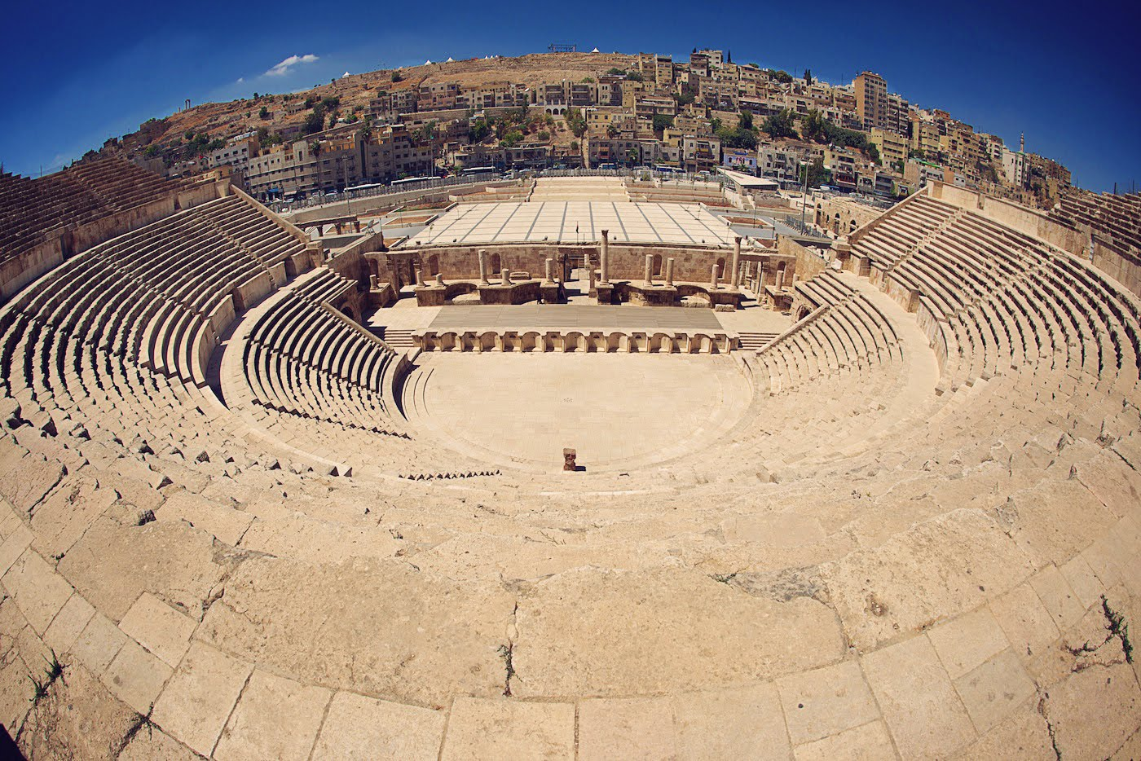

This magnificently restored theatre is the most obvious and impressive remnant of Roman Philadelphia, and is the highlight of Amman for most foreign visitors. The theatre was probably built in the 2nd century AD during the reign of Antoninus Pius (AD 138–61). It was built on three tiers: the rulers, of course, sat closest to the action, the military secured the middle section, and the general public perched and squinted from the top rows.
Pillars of Corinthian style existed in front of the theatre as well as an ancient stone-paved road, a part of which has been discovered and restored. Full restoration of the theatre began in 1957. Unfortunately, non-original materials were used, which means that the present reconstruction is partly inaccurate.

5. Bosra, Syria

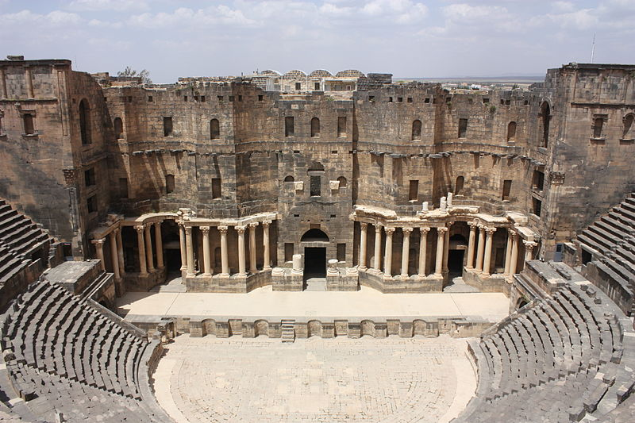

Situated 140 Km south of Damascus in Syria, Bosra is one of the most ancient cities on earth which was already mentioned in the 14th century BC by Egyptians hieroglyphs. The city was conquered by the Romans in 106 AD who made it the capital of their Arabia province.
It was built in the second quarter or the second half of the second century AD, and is constructed of black basalt. The theatre is 102 meters across and has seating for about 15,000 people.
Because a fortress was built around the theatre by the Ayyubids it is now one of the best preserved Roman theatres in the world. It has excellent acoustics, a three storey high proscenium and 30 rows of seats.

6. Side, Turkey
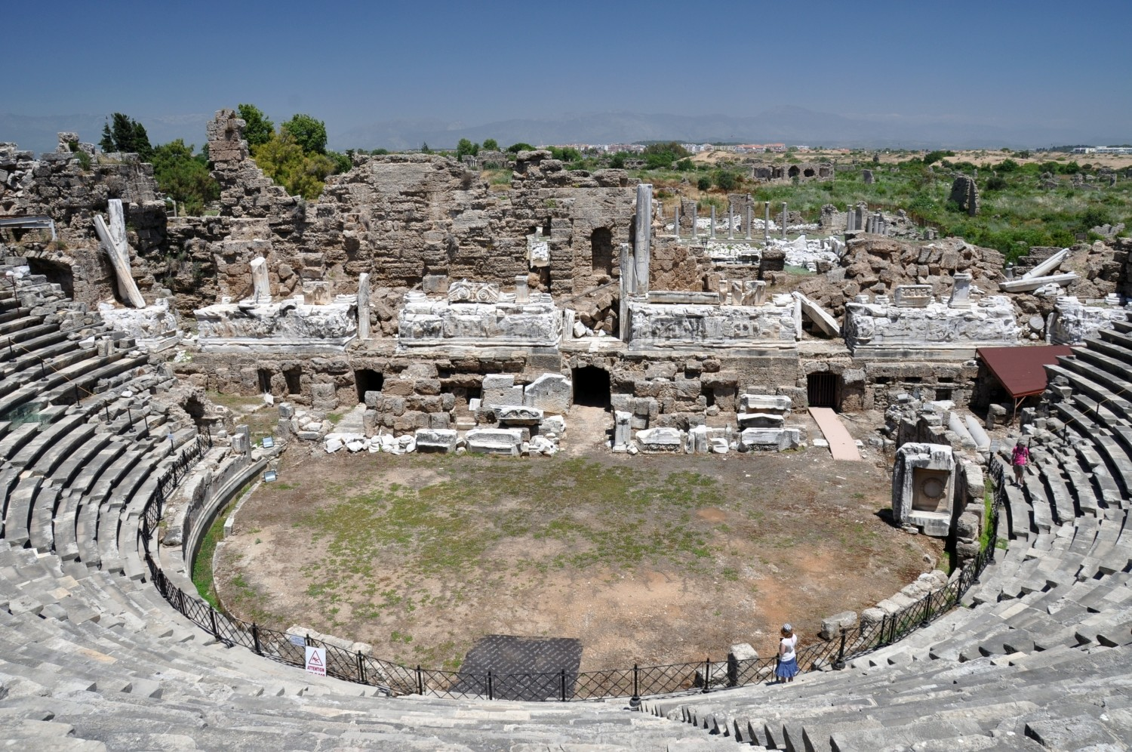

This ancient theatre, located in the narrowest point of the peninsula where the ruins of ancient Side are scattered, is the greatest of the preserved historical buildings of this magnificent city. The stage of this theatre consisted of a building called skene and a podium where events were organized.
It could accommodate 15,000 people. Side is a popular resort on the Mediterranean coast of South Turkey. The town was a colony of Greeks in the 7th century BC and was one of the most important commercial centres of that era. At 25BC Side became a part of the roman Gaule and thrived thanks to the oil and slave commerce.
The theatre was the main cultural venue of the city for a long period of time and attracted remarkable people from all over the Mediterranean. In the late Roman Empire times, gladiatorial combats and shows with wild animals became more popular, the theater was modified to better suit the needs of these forms of entertainment. According to inscriptions found in the theatre, in the end of 5th century AD the building was transformed into an open-air church.
7. Theatre of Marcellus, Rome –Italy
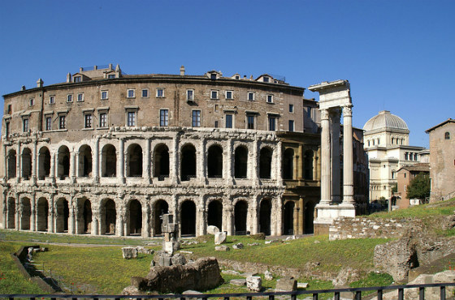

The theatre of Marcellus was constructed in 13BC by emperor Augustus and was named after Marcellus who was bound to succeed him. It was the greatest and one of the oldest theatres in ancient Rome. Its height was 30m, its diametre 130m. and it could seat 15,000-20,000 people.The design on various levels consisted of Doric, Corinthian and Ionic columns. It was a model for Coliseum which was built decades later.
It has been a venue for cultural events such as plays, music and poetry festivals. After the rise of the popularity of ‘carriage races’ and duels which took place in Circus Maximus and the Coliseum the Marcellus theatre was not in use anymore. Nowadays only one section of the first levels of the original theatre can be seen due to the numerous alterations over the centuries.

8. Sabratha, Libya
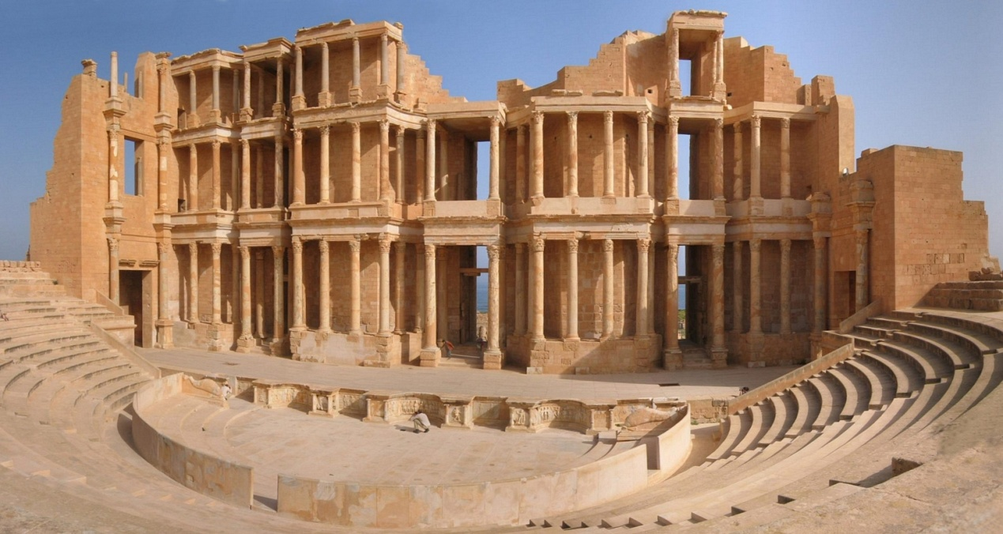

The Roman city of Sabratha became a UNESCO World Heritage site in 1982. The port was established as a Phoenician trading-post around 500 BC and rebuilt in the 2nd and 3rd Centuries AD. The theatre was constructed from 175-200 AD. It was started by Emperor Marcus Aurelius.
The theatre of Sabratha had 25 entrances and could seat approximately 5,000 people. Due to its restoration by Italian archaelogists in the ‘30s its Roman stucture remained almost intact. The area which best survived to our time is the base of the stage which was decorated with reliefs portraying gods and scenes from comedies and dances.

9. Cartagena , Spain

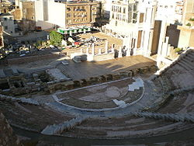
The theatre was built between 5 and 1 BC, as has been proven by the dedication of the edifice to Gaius and Lucius Caesar, grandsons of Augustus, who had designated them as his successors.
In the 3rd century AD a market was built over the theatre, reusing its materials. The market was perhaps abandoned after a fire caused by the Vandals in 425. In 1988 the first remains of the theatre were discovered during the construction of the Centro regional de artesanía. The archaeological excavations and the restorations were completed in 2003. In 2008 a museum, designed by Rafael Moneo, was opened.

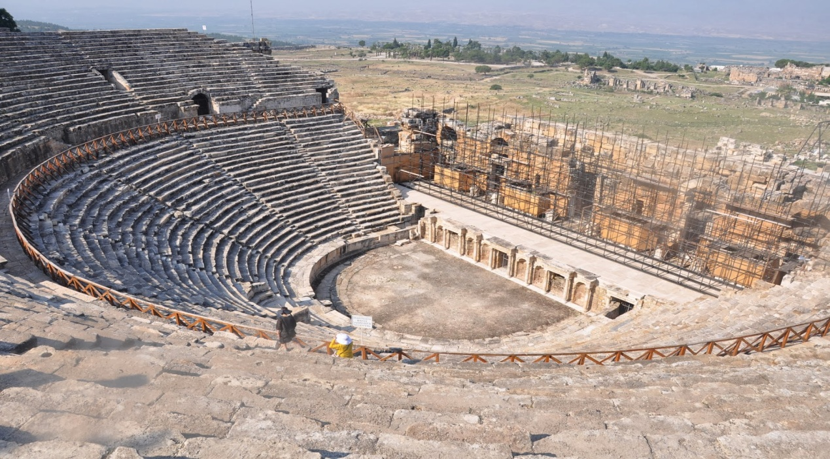
10. Hierapolis, Turkey

The theatre at Hierapolis was built in the second century AD under the Roman Emperor Hadrian during a period of extensive rebuilding following a devastating earthquake in 60 AD. It was later renovated under Septimus Severus (193-211 AD). Renovation work since 1977 has restored many of the arches and a portion of the stage floor.
The edifice had forty-five rows of seats separated by two diazomata. Recent reconstruction efforts have restored most of the cavea which could accommodate approximately 15,000 people.
It is made mostly of marble, but the renovations made during the reign of Septimus Severus used recycled stones from an ancient theatre to the north of the city.

The theatre at Hierapolis has some of the best-preserved decorative features of any theatre in Turkey. Several decorative friezes from the elaborate scaenae frons have survived intact.

11. Aspendos, Turkey
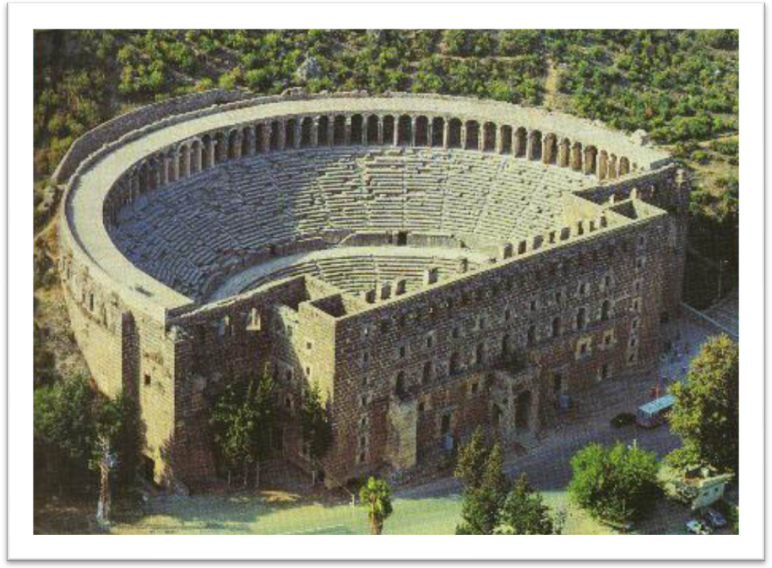
The theatre in Aspendos is considered to be the best-preserved theatre of antiquity. The Roman builders of this structure managed to express the state of ideal balance between the auditorium and the skene building and, what's more, the whole theatre matches perfectly into the landscape.
The theatre was actually built in the 2nd century AD, during the reign of the Roman emperor Marcus Aurelius (161-180 AD), on the basis of the project created by Zeno - a Greek architect born in Aspendos.
Despite the fact that the theatre was build in the Roman period, the building displays many features typical to Greek theatres. The auditorium rests in part against a hillside. Moreover, a horseshoe shape of the auditorium also is a Greek feature. It could accommodate up to 7 thousand spectators.
When Mustafa Kemal Atatürk visited Aspendos he ordered its renovation that stirred many controversies among historians and architects. Since then the theatre is used as a venue for various cultural events, the International Ballet and Opera Festival amongst them.

12. Jerash Theatres, Jordan

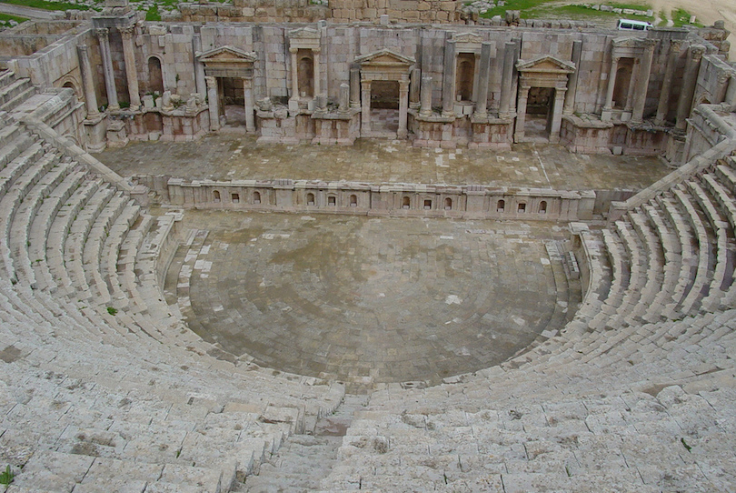

Jerash is a popular archaeological site in Jordan, second only to Petra. The city’s golden age came under Roman rule and the site is now generally acknowledged as one of the best preserved Roman provincial towns in the world.
Jerash contains not one but two Roman theatres. The north theatre, with a capacity of 1600, was built in 165 AD and was mainly used as the city council chamber. The larger south theatre was built between 90-92 AD and could seat more than 3000 spectators. The south theatre has a focus in the centre of the pit in front of the stage, marked by a distinct stone, and from which normal speaking can be heard easily throughout the auditorium.

