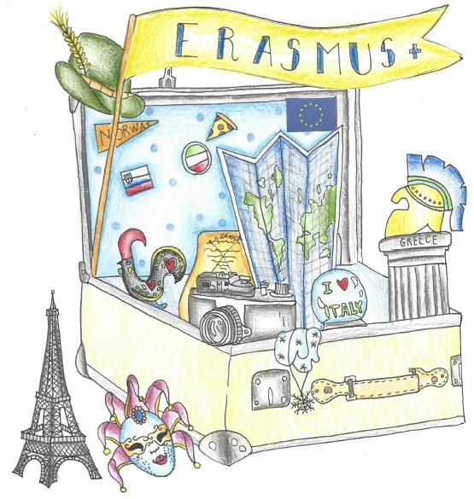

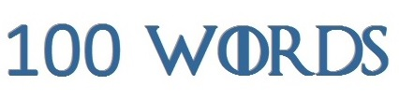
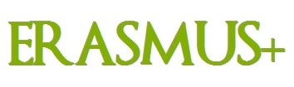
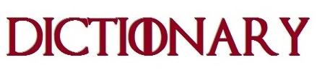

English: address |  | Slovene: naslov
German: Adresse |  | Norwegian: adresse
French: adresse |  | Portuguese: Endereço
Italian:  indirizzo |  | Greek: Διεύθυνση

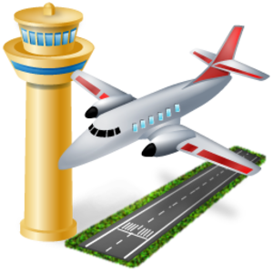
English: airport |  | Slovene: letališče
German: Flughafen |  | Norwegian: flyplass
French: aéroport |  | Portuguese: Aeroporto
Italian:  aeroporto |  | Greek: Αεροδρόμιο

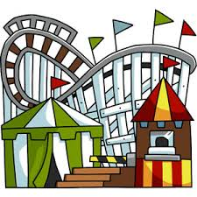
English: amusement park, funfair |  | Slovene: zabaviščni park
German: Kirmes |  | Norwegian: fornøyelsespark
French: fête foraine |  | Portuguese: Parque de diversões
Italian:  Parco divertimenti |  | Greek: Πάρκο διασκέδασης

English: beach |  | Slovene: plaža
German: Strand |  | Norwegian: strand
French: plage |  | Portuguese: Praia
Italian:  spiaggia |  | Greek: Παραλία

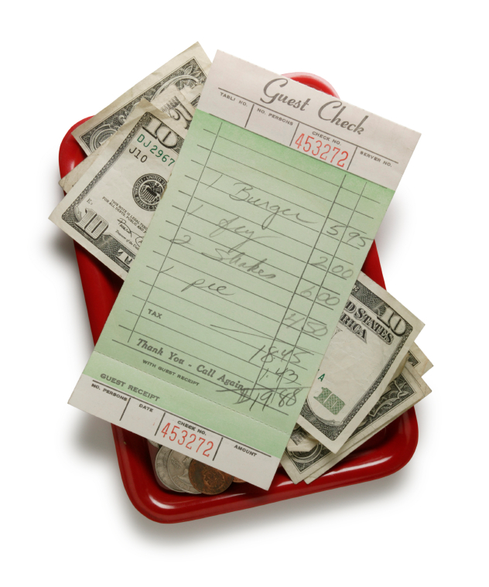
English: bill  (Am. check) |  | Slovene: račun
German: Rechnung |  | Norwegian: regning
French: addition |  | Portuguese: Conta
Italian:  conto |  | Greek:  Λογαριασμός

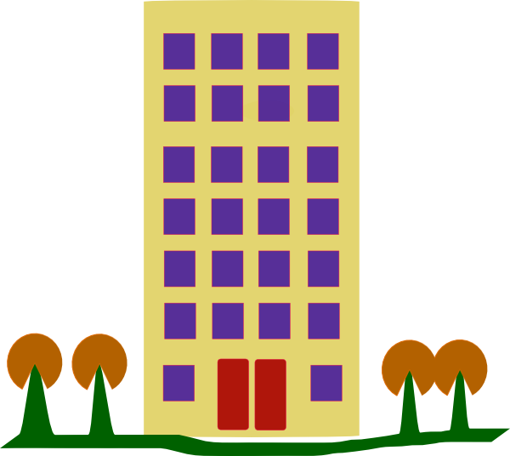
English: block of flats  (Am. apartment building) |  | Slovene: blok
German: Wohnhaus |  | Norwegian: blokk
French: appartement |  | Portuguese: Bloco/Prédio de apartamentos
Italian:  condominio |  | Greek: Πολυκατοικία

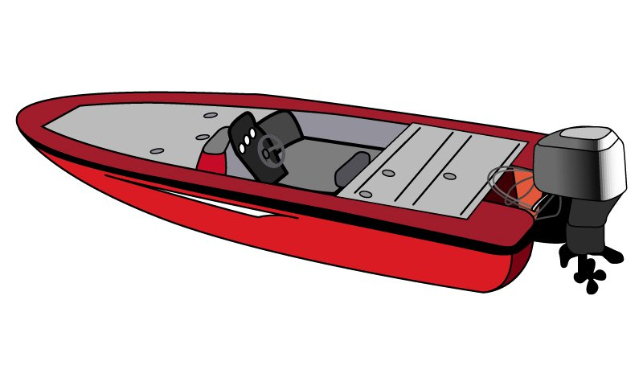
English: boat |  | Slovene: čoln
German: Boot |  | Norwegian: båt
French: bateau |  | Portuguese: barco
Italian:  barca |  | Greek: Βάρκα

English: book |  | Slovene: knjiga
German: Buch |  | Norwegian: bok
French: livre |  | Portuguese: livro
Italian:  libro |  | Greek:Βιβλίο

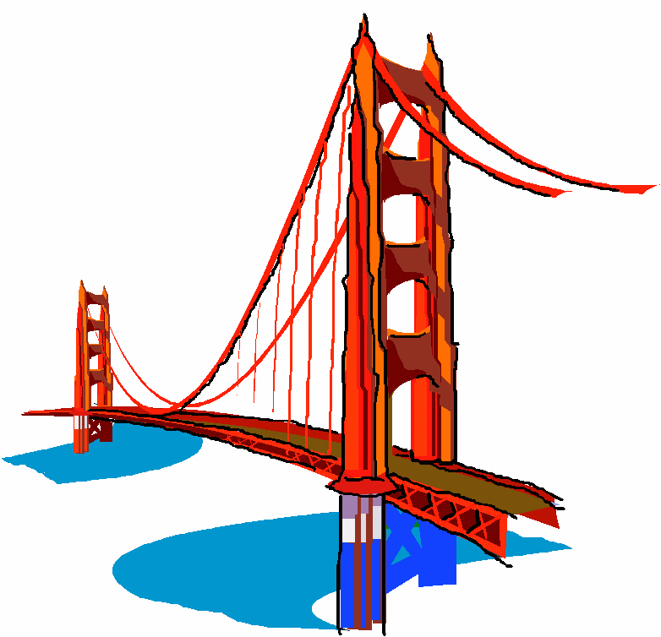
English: bridge |  | Slovene: most
German: Brücke |  | Norwegian: bro
French: pont |  | Portuguese: ponte
Italian:  ponte |  | Greek: Γέφυρα

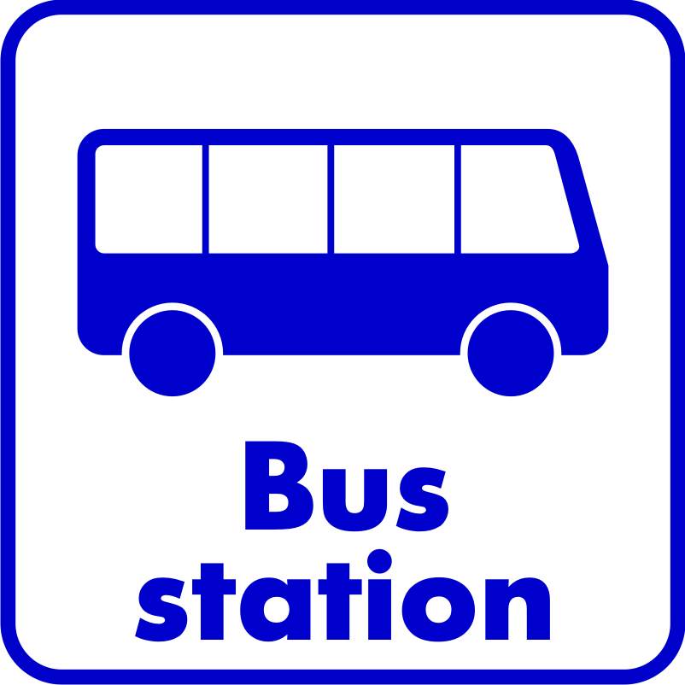
English: bus station |  | Slovene: avtobusna postaja
German: Bushaltestelle |  | Norwegian: busstasjon
French: station de bus |  | Portuguese: Estação de autocarros
Italian:  Stazione degli autobus |  | Greek: Σταθμός Λεωφορείων

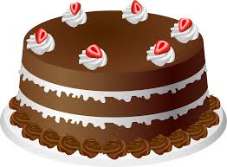
English: cake |  | Slovene: torta
German: Kuchen |  | Norwegian:kake
French: gâteau |  | Portuguese: bolo
Italian:  torta |  | Greek: Τούρτα

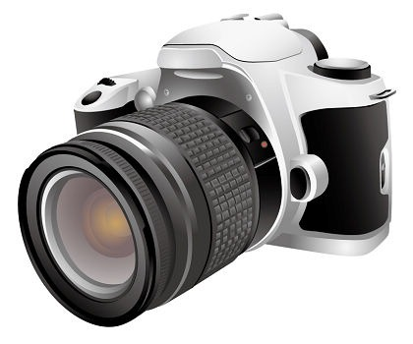
English: camera |  | Slovene: kamera
German: Kamera, Fotoapparat |  | Norwegian: kamera
French: appareil photo |  | Portuguese: Câmara fotográfica
Italian:  Macchina fotografica |  | Greek: Φωτογραφική Μηχανή, Κάμερα

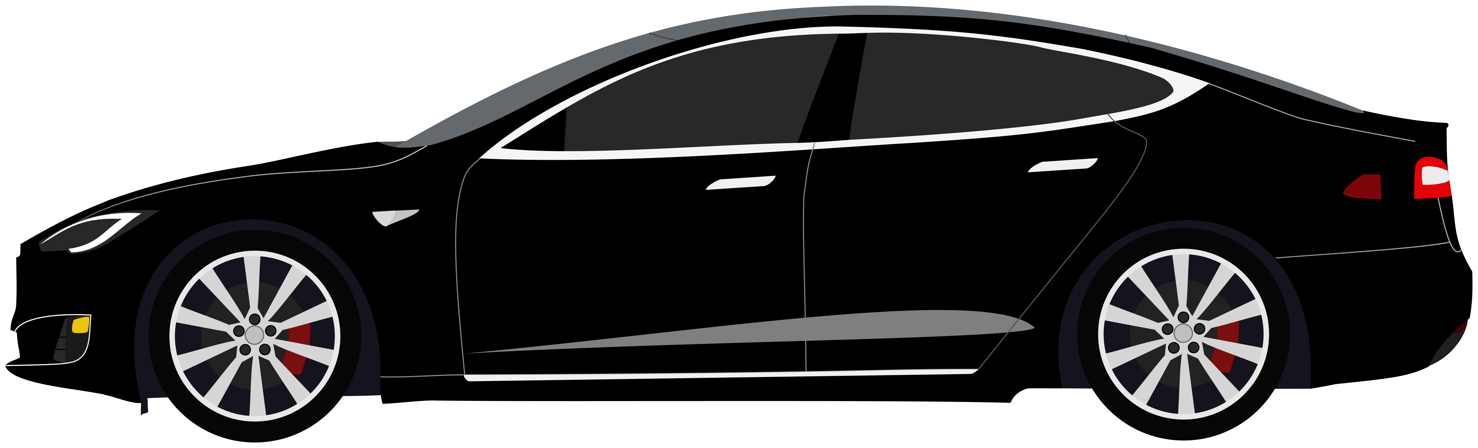
English: car |  | Slovene: avto
German: Auto |  | Norwegian: bil
French: voiture |  | Portuguese: carro/automóvel
Italian:  Automobile/macchina |  | Greek: Αυτοκίνητο

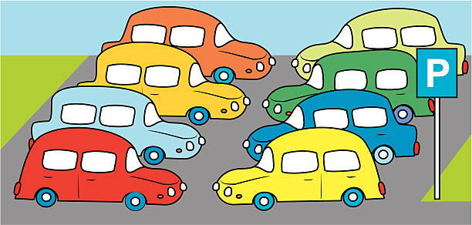
English: car park  (Am. parking lot) |  | Slovene: parkirišče
German: Parkplatz |  | Norwegian: parkeringsplass
French: parking |  | Portuguese: Parque de estacionamento
Italian:  Parcheggio |  | Greek: Χώρος Στάθμευσης Οχημάτων, Πάρκινγκ

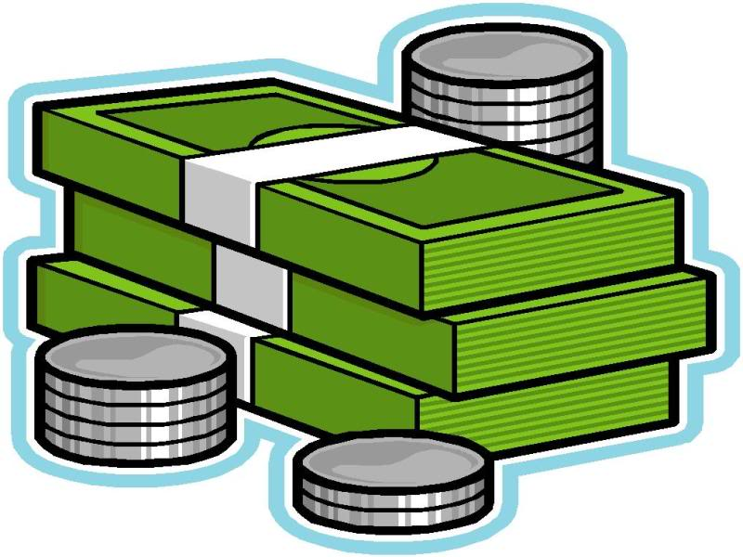
English: cash |  | Slovene: gotovina
German: Bargeld |  | Norwegian: penger
French: argent |  | Portuguese: Dinheiro
Italian:  Contanti |  | Greek: Μετρητά, Χρήματα

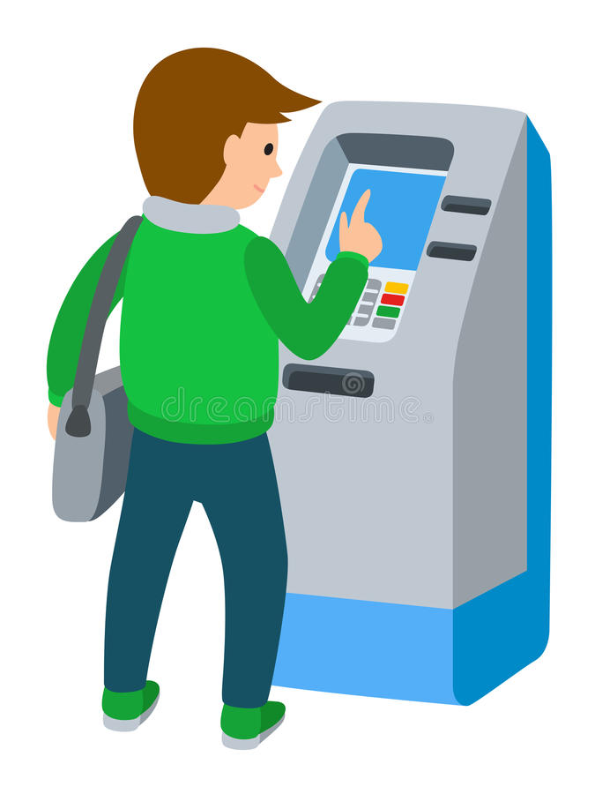
English: cash machine  (Am. ATM) |  | Slovene: bankomat
German: Geldautomat |  | Norwegian: minibank
French: distributeur (automatique) |  | Portuguese: Multibanco
Italian:  Bancomat |  | Greek: ΑΤΜ

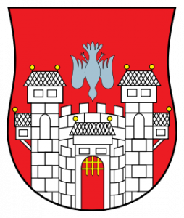
English: castle |  | Slovene: grad
German: Schloss |  | Norwegian: slott
French: château |  | Portuguese: castelo
Italian:  castello |  | Greek: Κάστρο

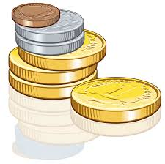
English: change |  | Slovene: drobiž
German: Klleingeld |  | Norwegian: veksel
French: monnaie |  | Portuguese: troco
Italian:  Resto |  | Greek: Κέρματα

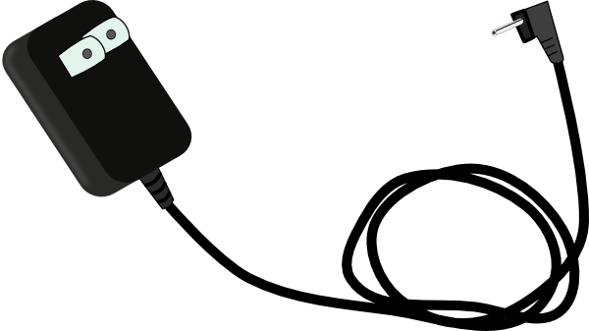
English: charger |  | Slovene: polnilec
German: Batterieladegerät |  | Norwegian: lader
French: chargeur |  | Portuguese: Carregador
Italian:  caricabatterie |  | Greek: Φορτιστής

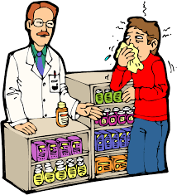
English: chemist's  (Am. pharmacy, drugstore) |  | Slovene: lekarna
German: Apotheke |  | Norwegian: apotek
French: pharmacien |  | Portuguese: Farmácia
Italian:  Farmacia |  | Greek: Φαρμακείο

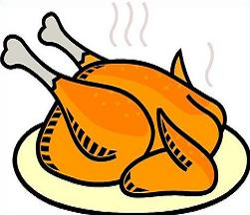
English: chicken |  | Slovene: piščanec
German: Hühnchen |  | Norwegian: kylling
French: poulet |  | Portuguese: Frango
Italian:  pollo |  | Greek: Κοτόπουλο

English: chips  (Am. French fries) |  | Slovene: ocvrt krompirček
German: Pommes |  | Norwegian: fries
French: frites |  | Portuguese: Batatas fritas
Italian:  Patatine fritte |  | Greek: Τηγανητές Πατάτες

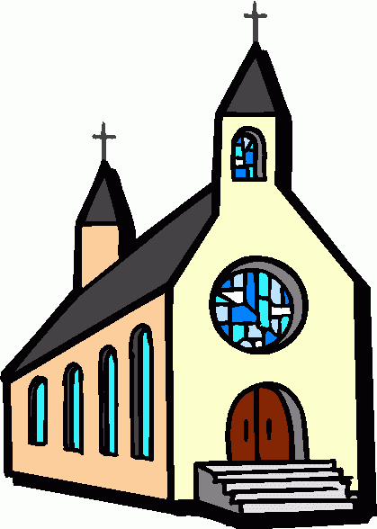
English: church |  | Slovene: cerkev
German: Kirche |  | Norwegian: kirke
French: église |  | Portuguese: Igreja
Italian:  chiesa |  | Greek: Εκκλησία

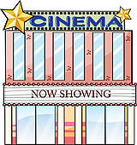
English: cinema |  | Slovene: kino
German: Kino |  | Norwegian: kino
French: cinéma |  | Portuguese: Cinema
Italian:  Cinema |  | Greek: Κινηματογράφος, Σινεμά

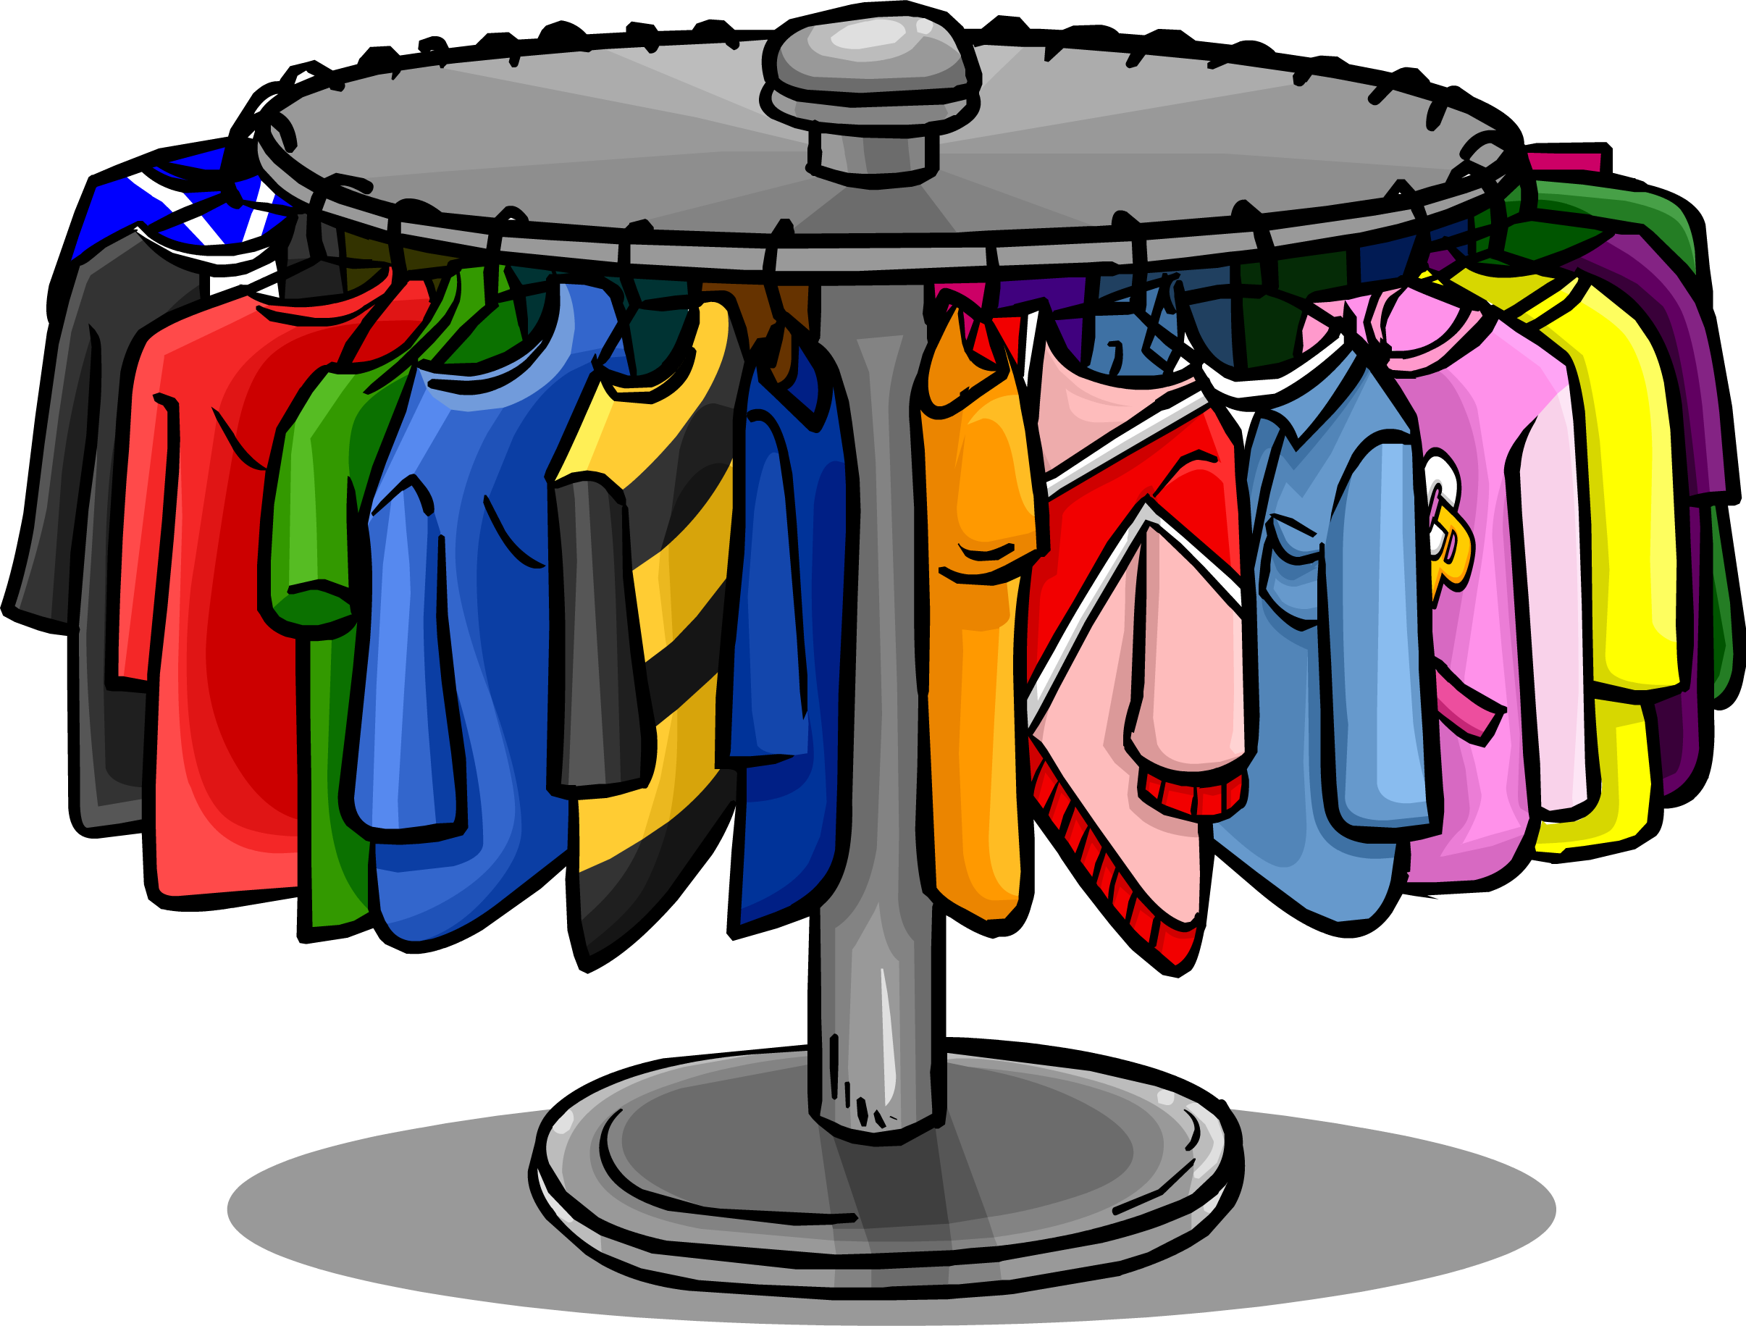
English: clothes, wears |  | Slovene: oblačila
German: Anziehsachen |  | Norwegian: klær
French: vêtement |  | Portuguese: Roupas
Italian:  vestiti |  | Greek: Ρούχα

English: coffee |  | Slovene: kava
German: Kaffee |  | Norwegian: kaffe
French: café |  | Portuguese: Café
Italian:  Caffè |  | Greek: Καφές

English: computer |  | Slovene: računalnik
German: Computer |  | Norwegian: PC
French: ordinateur |  | Portuguese: Computador
Italian:  computer |  | Greek: Ηλεκτρονικός Υπολογιστής

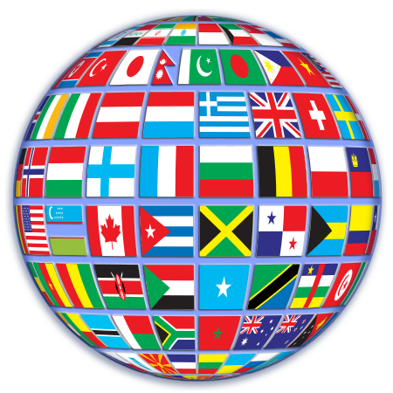
English: country |  | Slovene: država, pokrajina
German: Land |  | Norwegian: Land
French: pays |  | Portuguese: País
Italian:  Nazione |  | Greek: Χώρα

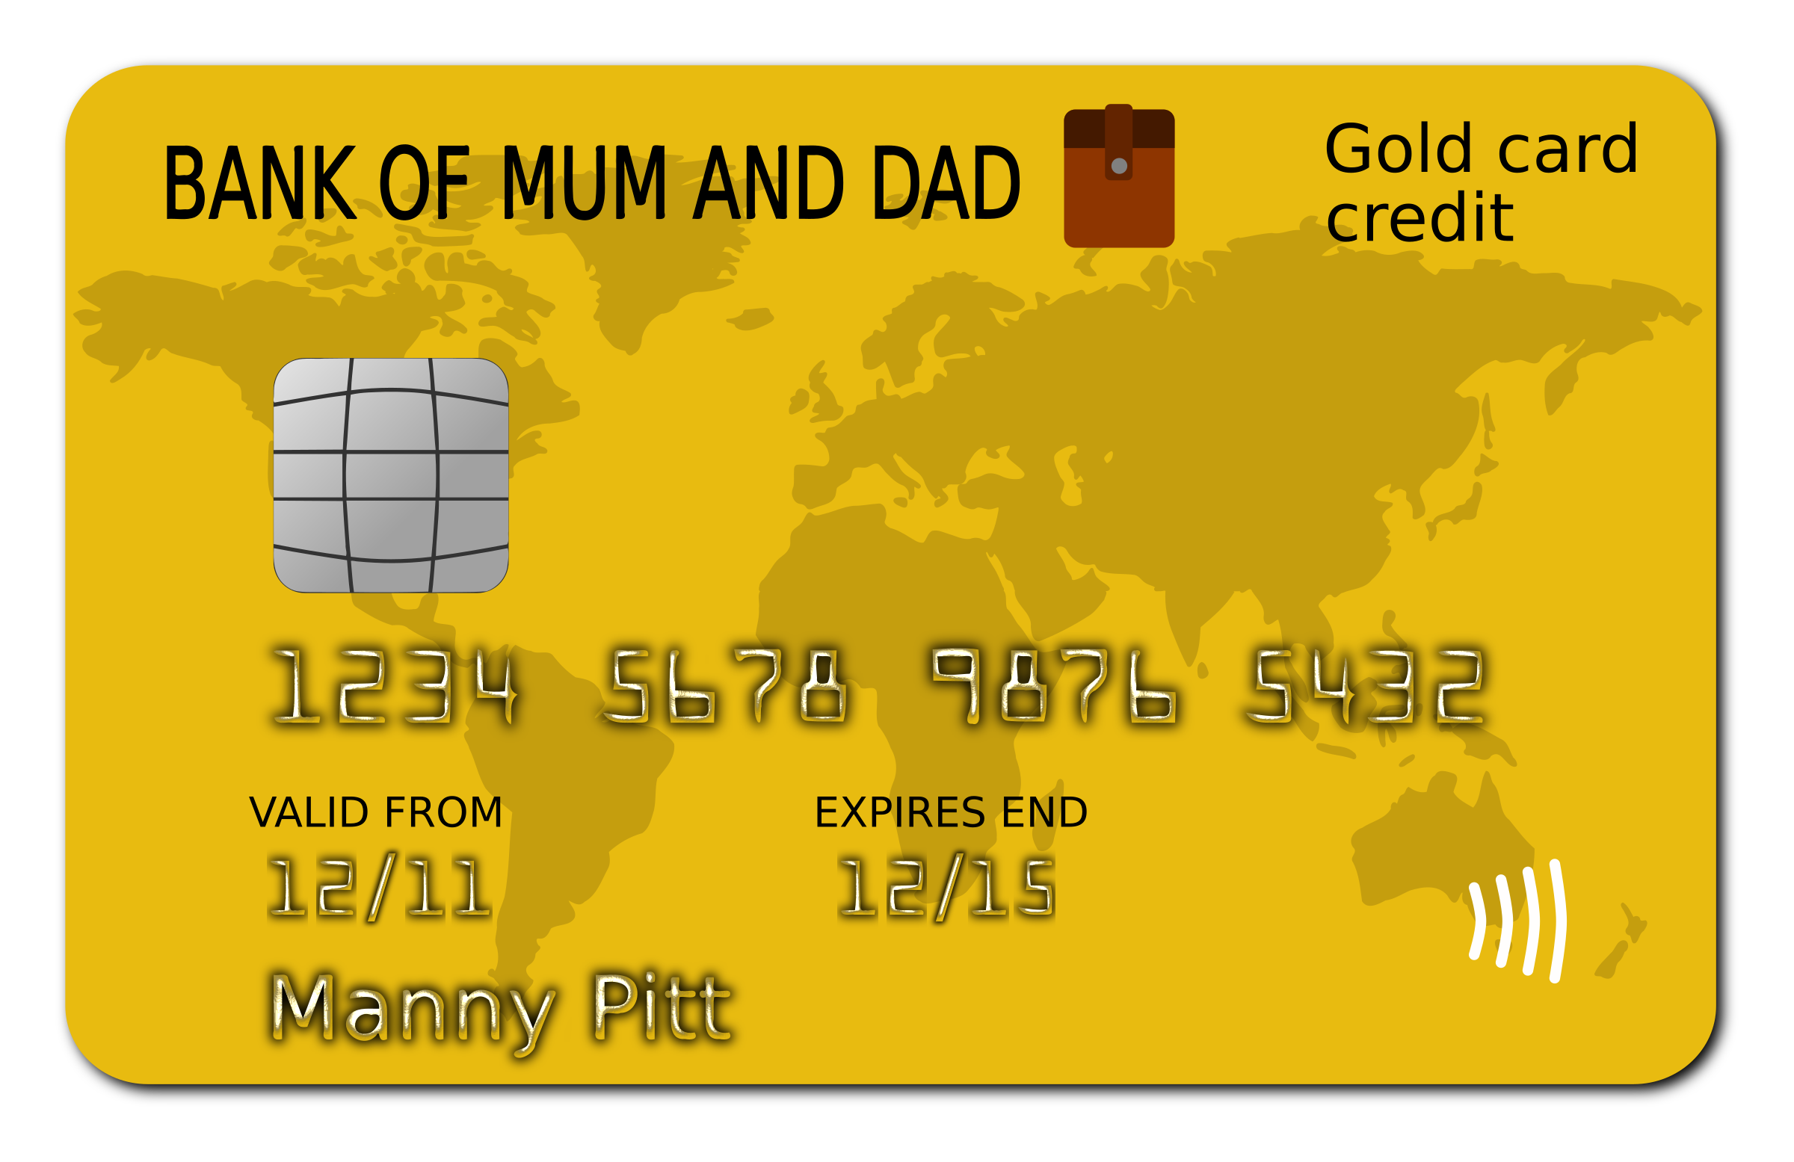
English: credit card |  | Slovene: kreditna kartica
German: Kreditkarte |  | Norwegian: kredittkort
French: carte de crédit |  | Portuguese: Cartão de crédito
Italian:  Carta di credito |  | Greek: Πιστωτική Κάρτα

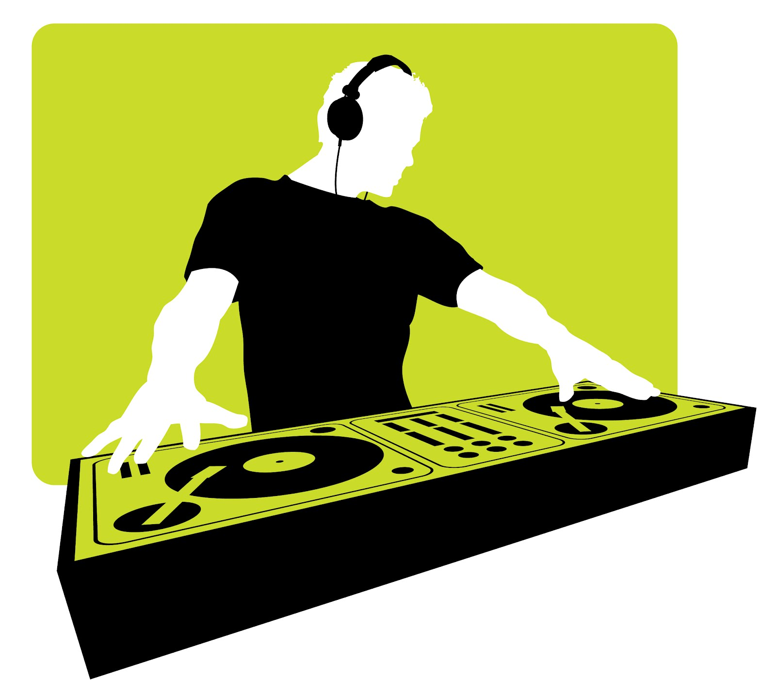
English: disco |  | Slovene: disko
German: Disco |  | Norwegian: disko
French: discothèque (fam. = Boîte de nuit) |  | Portuguese: disco
Italian:  Discoteca |  | Greek: Ντίσκο

English: documents |  | Slovene: dokumenti
German: Dokumente |  | Norwegian: dokumenter
French: documents |  | Portuguese: Documentos
Italian:  documenti |  | Greek: Έγγραφα

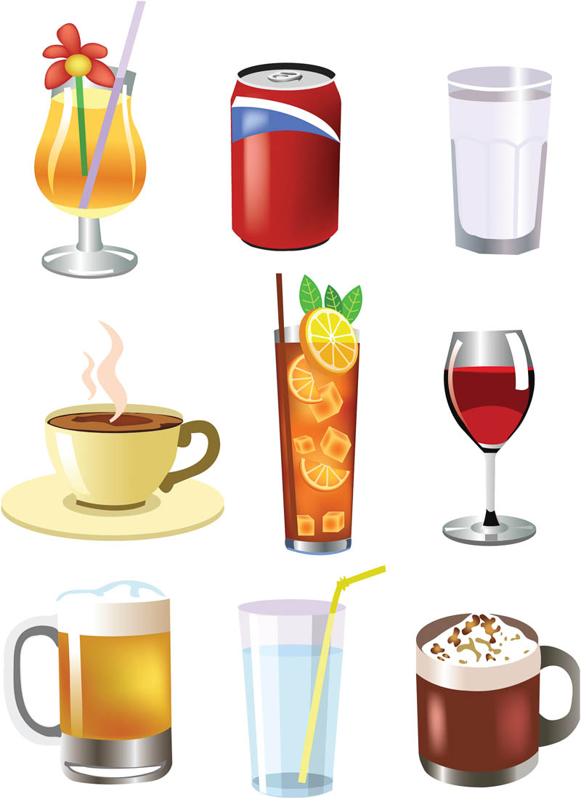
English: drink, beverage |  | Slovene: pijača
German: Getränk |  | Norwegian: drink
French: boissons |  | Portuguese: bebidas
Italian:  Bevanda |  | Greek: Ποτά, Ροφήματα, Αναψυκτικά

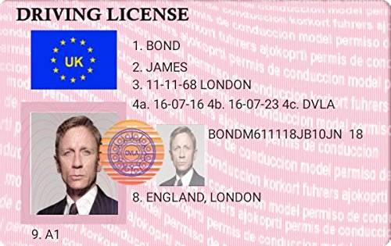
English: driving licence  (Am. driver's license) |  | Slovene: vozniško dovoljenje
German: Führerschein |  | Norwegian: førerkort
French: permis de conduire |  | Portuguese: Carta de condução
Italian:  Patente di guida |  | Greek: Άδεια Οδήγησης

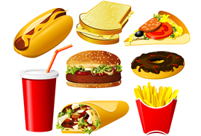
English: fast food |  | Slovene: hitra hrana
German: Fastfood |  | Norwegian: fast food
French: fast food |  | Portuguese: fast food
Italian:  Fast food |  | Greek: Φαστ Φουντ

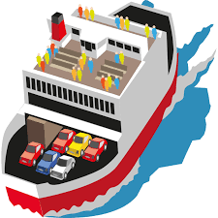
English: ferry |  | Slovene: trajekt
German: Fähre |  | Norwegian: ferge
French: ferry |  | Portuguese: ferry
Italian:  traghetti |  | Greek: (Οχηματαγωγό) Πλοίο

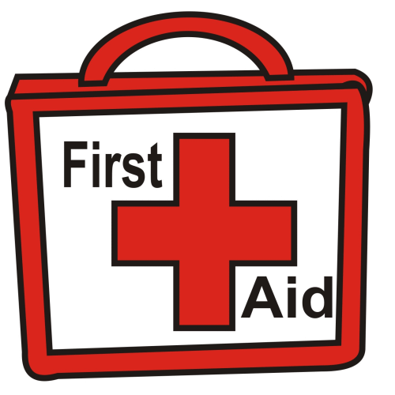
English: first aid |  | Slovene: prva pomoč
German: Erste Hilfe |  | Norwegian: førstehjelp
French: premiers secours |  | Portuguese: primeiros socorros
Italian:  Primo soccorso |  | Greek: Πρώτες Βοήθειες

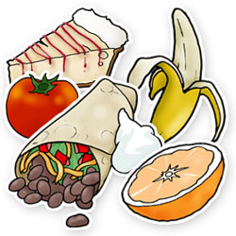
English: food |  | Slovene: hrana
German: Essen |  | Norwegian: mat
French: nourriture |  | Portuguese: Comida
Italian:  cibo |  | Greek: Φαγητό

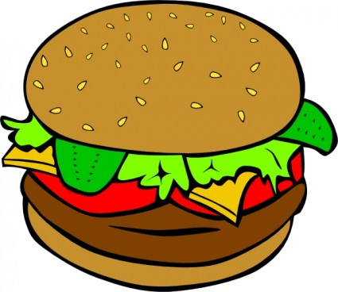
English: hamburger |  | Slovene: hamburger
German: Hamburger |  | Norwegian: hamburger
French: hamburger |  | Portuguese: hambúrguer
Italian:  hamburgher |  | Greek: Μπέργκερ

English: handkerchief, paper tissue |  | Slovene: robček, robec
German: Taschentuch |  | Norwegian: tørkle
French: mouchoir en papier (fam.= Kleenex) |  | Portuguese: lenço da mão/lenço de papel
Italian:  fazzoletto |  | Greek: Χαρτομάντηλο

English: hat |  | Slovene: klobuk, kapa
German: Hut |  | Norwegian: hatt
French: chapeau |  | Portuguese: chapéu
Italian:  Cappello |  | Greek: Καπέλο

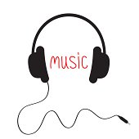
English: headphones |  | Slovene: slušalke
German: Kopfhörer |  | Norwegian: hodetelefoner
French: écouteurs |  | Portuguese: auscultadores/headphones
Italian:  auricolari |  | Greek: Ακουστικά

English: help |  | Slovene: pomoč
German: Hilfe |  | Norwegian: hjelp
French: aide, secours |  | Portuguese: socorro
Italian:  Aiuto |  | Greek: Βοήθεια

English: hill |  | Slovene: hrib
German: Hügel |  | Norwegian: ås
French: colline |  | Portuguese: colina
Italian:  Aiuto |  | Greek: Λόφος

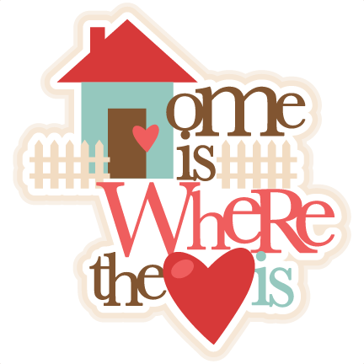
English: homeland |  | Slovene: domovina
German: Heimat |  | Norwegian: hjemland
French: patrie |  | Portuguese: Pátria/Terra Natal
Italian:  Patria |  | Greek: Πατρίδα

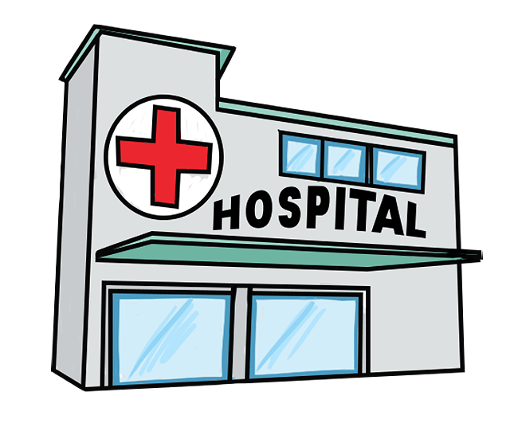
English: hospital |  | Slovene: bolnica, bolnišnica
German: Krankenhaus |  | Norwegian: sykehus
French: hôpital |  | Portuguese: Hospital
Italian:  ospedale |  | Greek: Νοσοκομείο

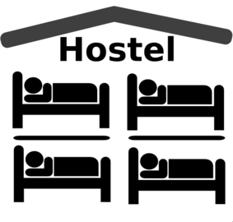
English: hostel |  | Slovene: hostel
German: Herberge |  | Norwegian: hostel
French: auberge |  | Portuguese: Hostel
Italian:  Ostello |  | Greek: Χόστελ

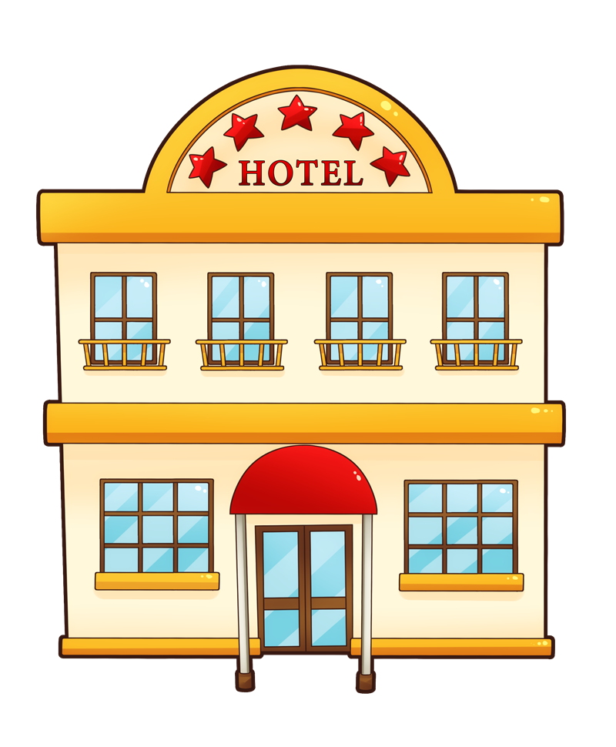
English: hotel |  | Slovene: hotel
German: Hotel |  | Norwegian: hotel
French: hôtel |  | Portuguese: hotel
Italian:  albergo |  | Greek: Ξενοδοχείο

English: ice cream |  | Slovene: sladoled
German: Eis |  | Norwegian: is
French: glace |  | Portuguese: gelado
Italian:  Gelato |  | Greek: Παγωτό

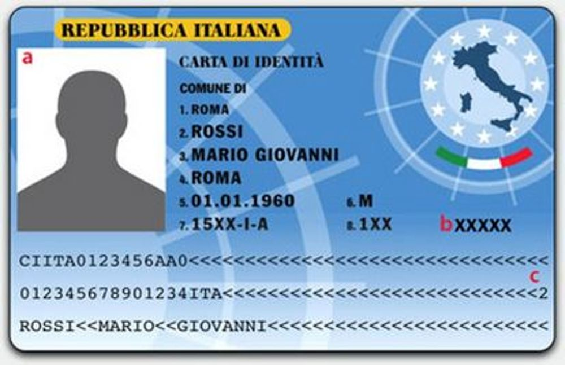

English: ID card, identity card |  | Slovene: osebna izkaznica
German: Personalausweis |  | Norwegian: legitimasjon
French: carte d'identité |  | Portuguese: Cartão de Cidadão
Italian:  Carta d'identità |  | Greek: Ταυτότητα

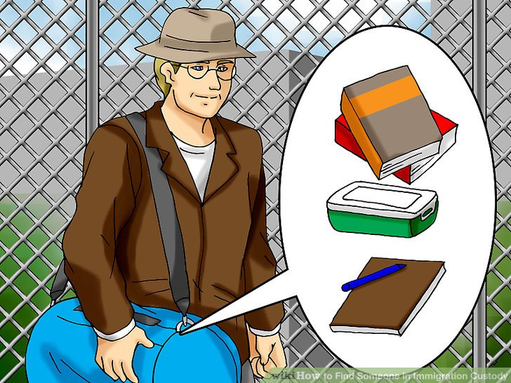
English: immigrant |  | Slovene: priseljenec
German: Immigrant, Einwanderer |  | Norwegian: innvandrer
French: immigrant |  | Portuguese: imigrante
Italian:  Immigrato |  | Greek: Μετανάστης

English: insurance |  | Slovene: zavarovanje
German: Versicherung |  | Norwegian: forsikring
French: assurance |  | Portuguese: seguro
Italian:  assicurazione |  | Greek: Ασφάλεια

English: island |  | Slovene: otok
German: Insel |  | Norwegian: øy
French: île |  | Portuguese: ilha
Italian:  Isola |  | Greek: Νησί

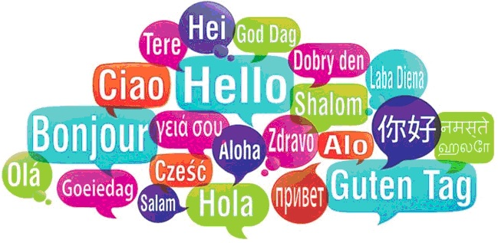
English: language |  | Slovene: jezik
German: Sprache |  | Norwegian: språk
French: langue |  | Portuguese: língua
Italian:  lingua |  | Greek: Γλώσσα

English: lake |  | Slovene: jezero
German: See |  | Norwegian: innsjø
French: lac |  | Portuguese: lago
Italian:  Lago |  | Greek: Λίμνη

English: laptop |  | Slovene: prenosnik
German: Laptop |  | Norwegian: bærbar PC
French: ordinateur portable (fam. = portable) |  | Portuguese: computador portátil
Italian:  portatile |  | Greek: Φορητός Υπολογιστής, Λάπτοπ

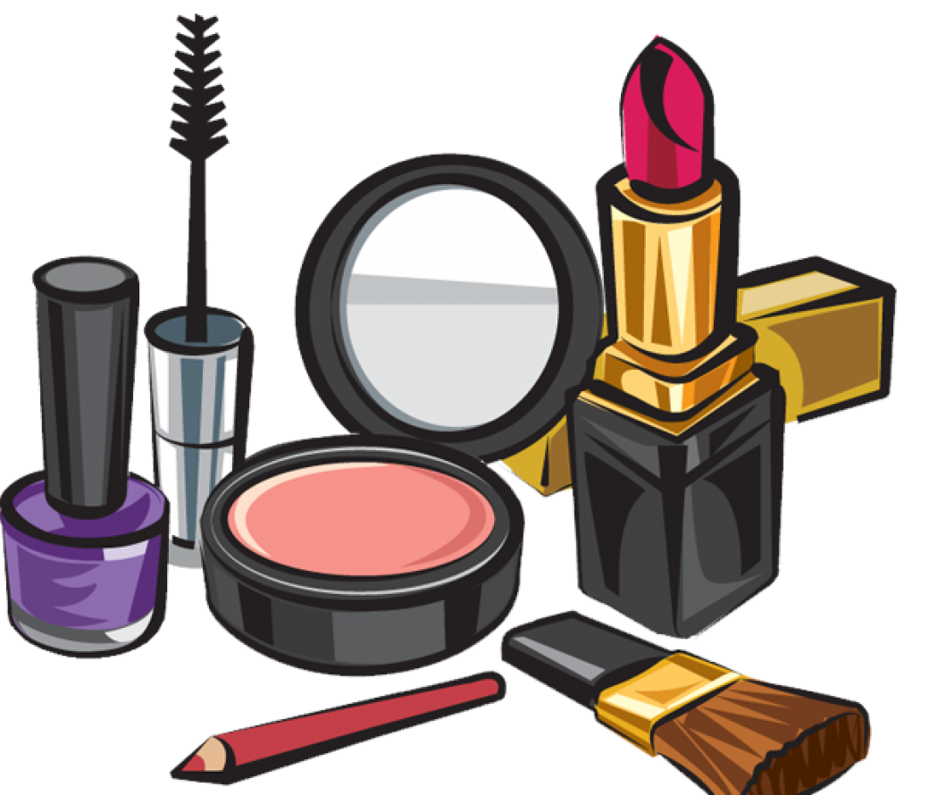
English: make-up |  | Slovene: ličilo
German: Schminke, Makeup |  | Norwegian: sminke
French: maquillage |  | Portuguese: makeup
Italian:  Trucchi |  | Greek: Μακιγιάζ

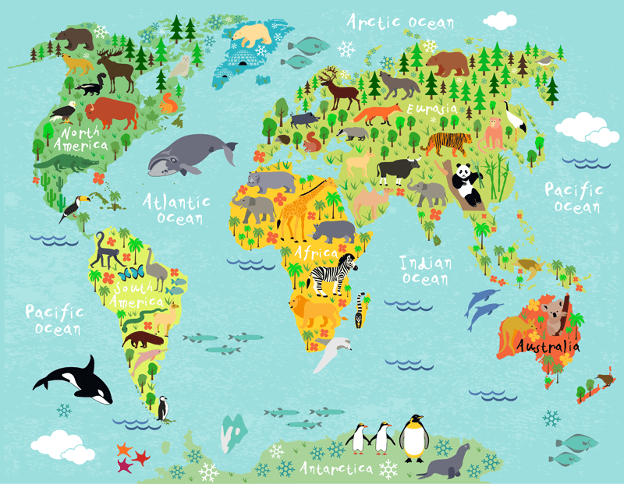
English: map |  | Slovene: zemljevid
German: Karte |  | Norwegian: kart
French: carte |  | Portuguese: mapa
Italian:  mappa |  | Greek: Χάρτης

English: market |  | Slovene: tržnica
German:Markt |  | Norwegian: marked
French: marché |  | Portuguese: mercado
Italian:  Mercato |  | Greek: Λαϊκή αγορά

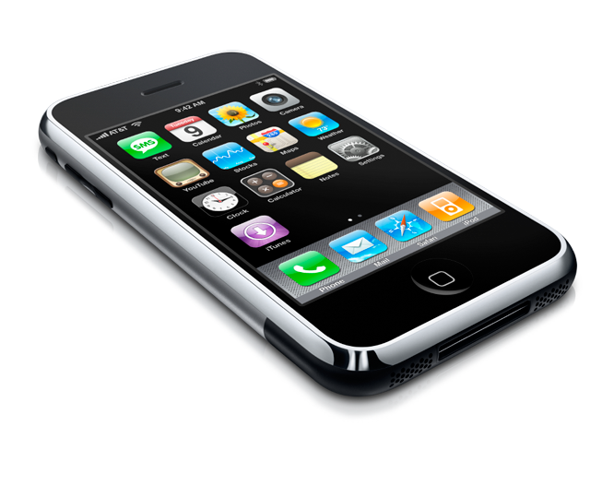
English: mobile(phone)  (Am. cellphone) |  | Slovene: mobilni telefon
German: Handy |  | Norwegian: mobiltelefon
French: téléphone portable (fam. = portable) |  | Portuguese: telemovel /smartphone
Italian:  cellulare |  | Greek: Κινητό τηλέφωνο

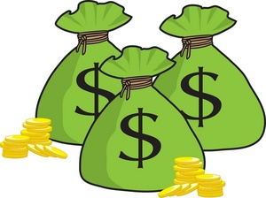
English: money |  | Slovene: denar
German: Geld |  | Norwegian: penger
French: argent |  | Portuguese: dinheiro
Italian:  Soldi |  | Greek: Χρήματα, Λεφτά

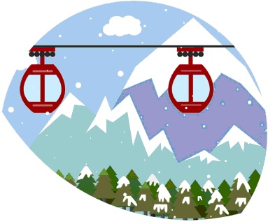
English: mountain |  | Slovene: gora
German: Berg |  | Norwegian: fjell
French: montagne |  | Portuguese: montanha
Italian:  montagna |  | Greek: Βουνό

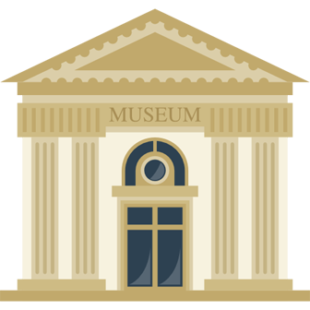
English: museum |  | Slovene: muzej
German: Museum |  | Norwegian: museum
French: musée |  | Portuguese: museu
Italian:  Museo |  | Greek: Μουσείο

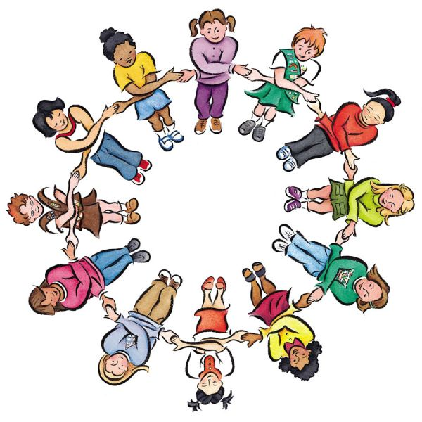
English: nationality |  | Slovene: narodnost
German: Nationalität |  | Norwegian: nasjonalitet
French: nationalité |  | Portuguese: nacionalidade
Italian:  nazionalità |  | Greek: Εθνικότητα

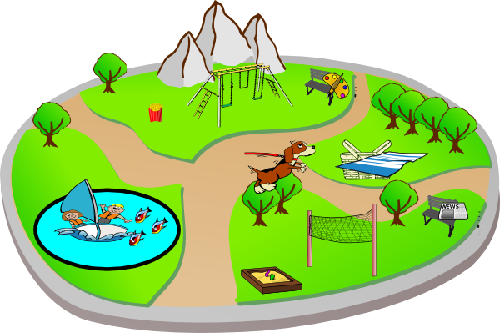
English: park |  | Slovene: park
German: Park |  | Norwegian: park
French: parc |  | Portuguese: parque
Italian:  Parco |  | Greek: Πάρκο

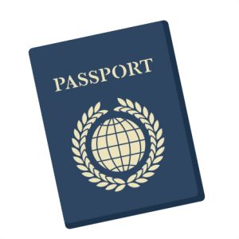
English: passport |  | Slovene: potni list
German: Pass |  | Norwegian: pass
French: passeport |  | Portuguese: passaporte
Italian:  passaporto |  | Greek: Διαβατήριο

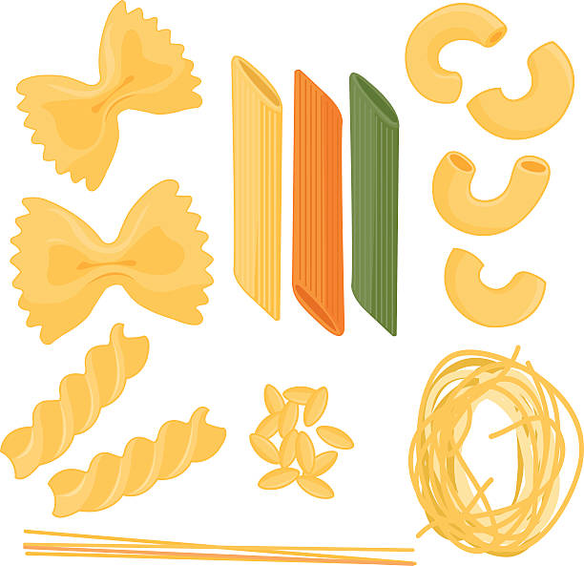
English: pasta |  | Slovene: testenine
German: Nudeln |  | Norwegian: pasta
French: pâte(s) |  | Portuguese: pasta / massa
Italian:  Pasta |  | Greek: Ζυμαρικά

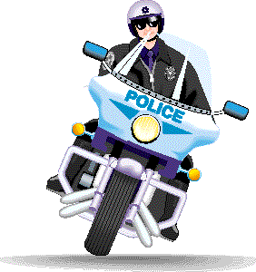
English: police |  | Slovene: policija
German: Polizei |  | Norwegian: politi
French: police |  | Portuguese: polícia
Italian: |  | Greek: Αστυνομία

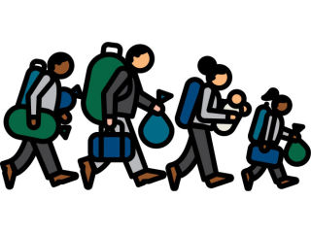
English: refugee |  | Slovene: begunec
German: Flüchtling |  | Norwegian: flyktning
French: réfugié |  | Portuguese: refugiado
Italian:  Rifugiato |  | Greek: Πρόσφυγας

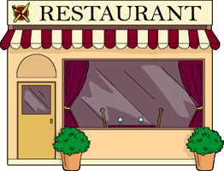
English: restaurant |  | Slovene: restavracija
German: Restaurant |  | Norwegian: resturant
French: restaurant |  | Portuguese: restaurante
Italian:  ristorante |  | Greek: Εστιατόριο

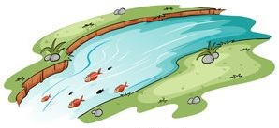
English: river |  | Slovene: reka
German: Fluss |  | Norwegian: elv
French: rivière |  | Portuguese: rio
Italian:  Fiume |  | Greek: Ποτάμι

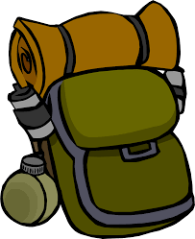
English: rucksack  (Am. backpack) |  | Slovene: nahrbtnik
German: Rucksack |  | Norwegian: ryggsekk
French: sac à dos |  | Portuguese: mochila
Italian:  zaino |  | Greek: Σακίδιο

English: school |  | Slovene: šola
German: Schule |  | Norwegian: skole
French: école |  | Portuguese: escola
Italian:  scuola |  | Greek: Σχολείο

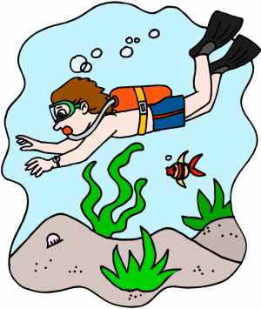
English: sea |  | Slovene: morje
German: See |  | Norwegian: sjø
French: mer |  | Portuguese: mar
Italian:  mare |  | Greek: Θάλασσα

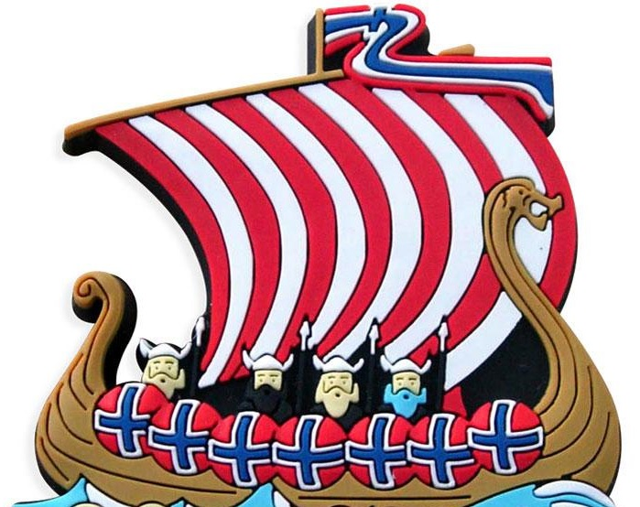
English: ship |  | Slovene: ladja
German: Schiff |  | Norwegian: skip
French: navire |  | Portuguese: barco/navio
Italian:  nave |  | Greek: Πλοίο

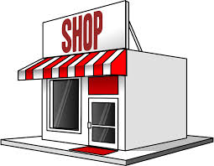
English: shop  (Am. store) |  | Slovene: trgovina
German: Laden |  | Norwegian: butikk
French: magasin |  | Portuguese: Loja
Italian:  negozio |  | Greek: Μαγαζί

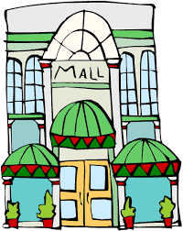
English: shopping centre  (Am. shopping center, mall) |  | Slovene: nakupovalni center
German:Einkaufszentrum |  | Norwegian: kjøpesenter
French: centre commercial |  | Portuguese: Centro comercial
Italian:  Centro commerciale |  | Greek: Εμπορικό Κέντρο

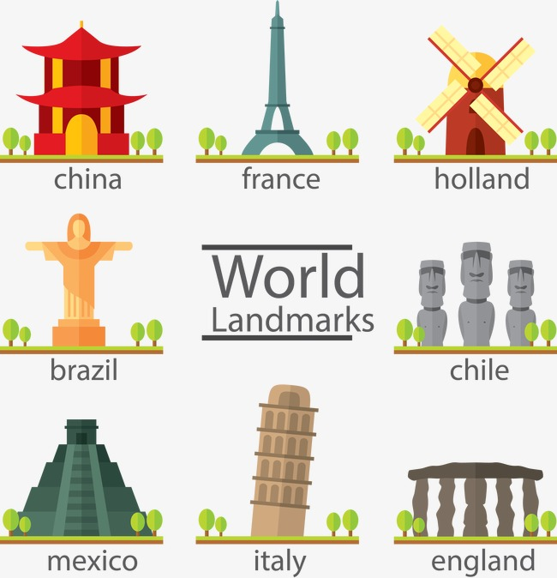
English: sights |  | Slovene: znamenitosti
German: Sehenswürdigkeiten |  | Norwegian: landemerker
French: lieux, édifices remarquables |  | Portuguese: Pontos de interesse
Italian:  monumenti |  | Greek: Αξιοθέατα

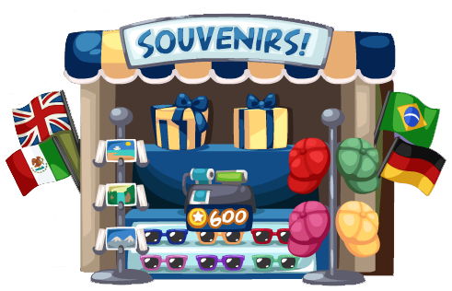
English: souvenir |  | Slovene: spominek
German: Souvenir |  | Norwegian: suvenir
French: souvenir |  | Portuguese: souvenir/lembrança
Italian:  souvenir |  | Greek: Ενθύμια, Σουβενίρ

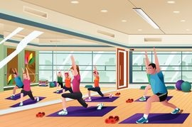
English: sports centre  (Am. sports center) |  | Slovene: športni center
German: Sportzentrum |  | Norwegian: treningssenter
French: salle de sport |  | Portuguese: ginásio
Italian:  Centro sportivo |  | Greek: Αθλητικό Κέντρο

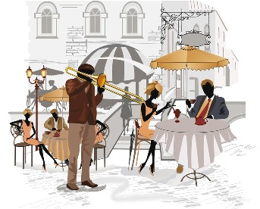
English: square |  | Slovene: trg
German: Platz |  | Norwegian: torg
French: place |  | Portuguese: praça
Italian:  piazza |  | Greek: Πλατεία

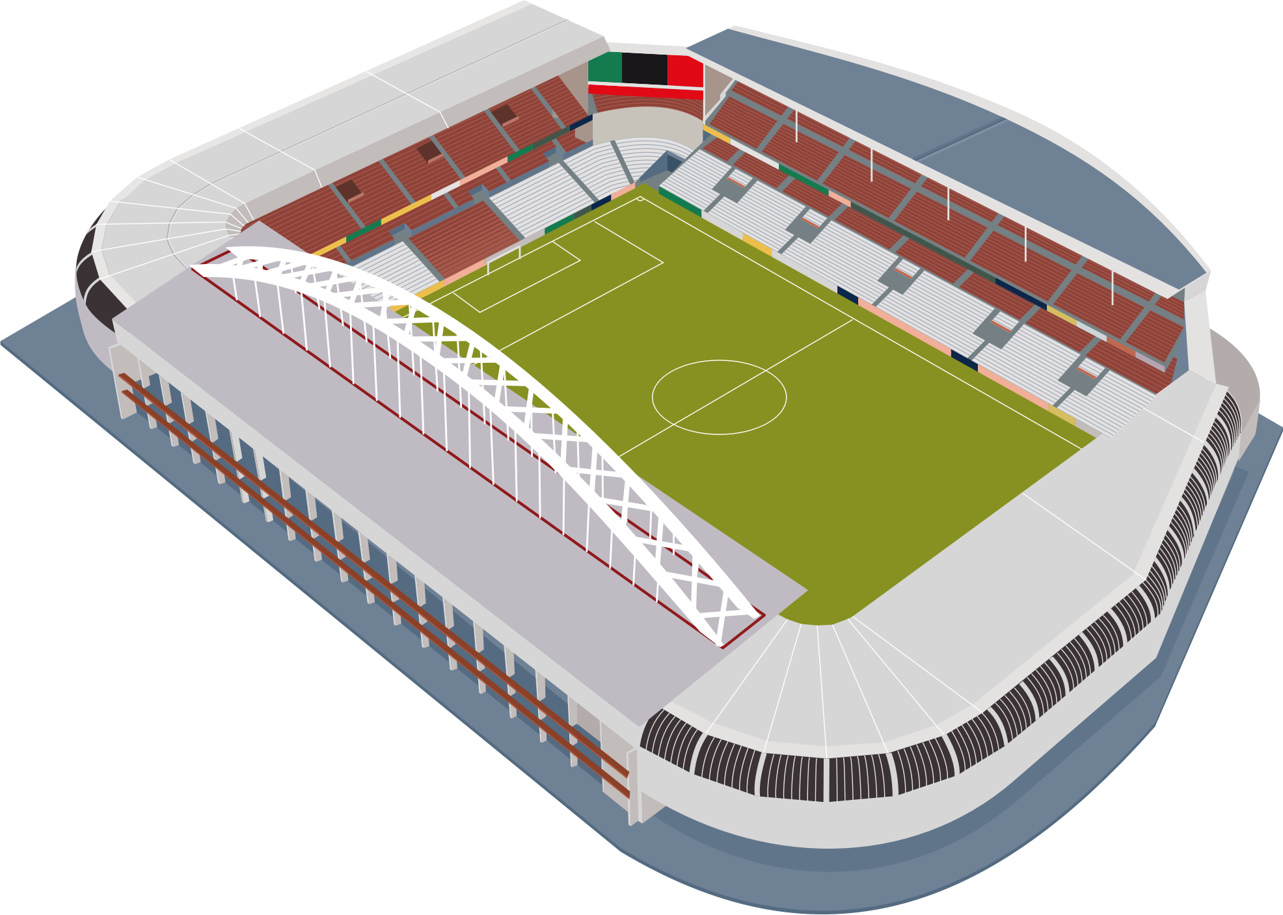
English: stadium |  | Slovene: stadion
German: Stadion |  | Norwegian: stadion
French: stade |  | Portuguese: Estádio
Italian:  piazza |  | Greek: Στάδιο

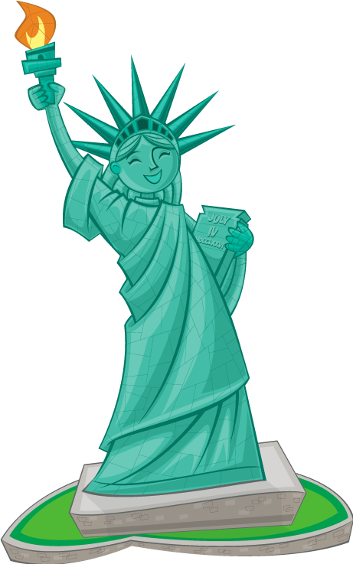
English: statue |  | Slovene: kip
German: Statue |  | Norwegian: statue
French: statue |  | Portuguese: Estátua
Italian:  statua |  | Greek: Άγαλμα

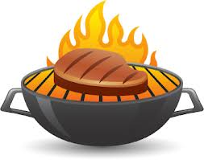
English: steak |  | Slovene: zrezek
German: Steak |  | Norwegian: biff
French: steak |  | Portuguese: bife
Italian:  bistecca |  | Greek: Μπριζόλα

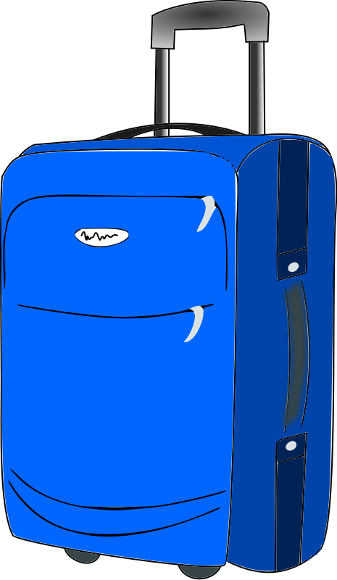
English: suitcase |  | Slovene: kovček
German: Koffer |  | Norwegian: koffert
French: valise |  | Portuguese: Mala
Italian:  valigia |  | Greek: Βαλίτσα

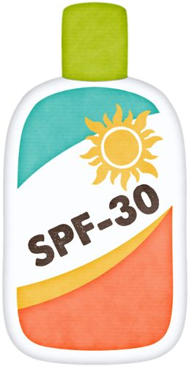
English: sunblock, sunscreen, suncream |  | Slovene: krema za sončenje
German: Sonnencreme |  | Norwegian: solkrem
French: crème solaire |  | Portuguese: protetor solar
Italian:  Crema solare |  | Greek: Αντιηλιακό

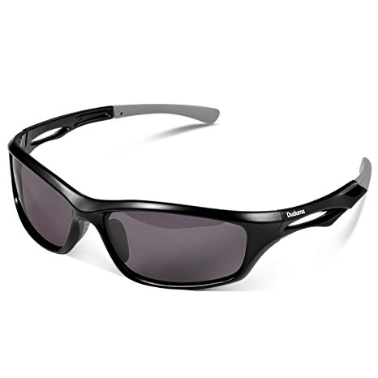
English: sunglasses |  | Slovene: sončna očala
German: Sonnenbrille |  | Norwegian: solbriller
French: lunettes de soleil |  | Portuguese: óculos de sol
Italian:  Occhiali da sole |  | Greek: Γυαλιά Ηλίου

English: supermarket |  | Slovene: supermarket
German: Supermarkt |  | Norwegian: supermarked
French: supermarché |  | Portuguese: supermercado
Italian:  supermercato |  | Greek: Σούπερ Μάρκετ

English: tablet |  | Slovene: tablica
German: Tablet |  | Norwegian: tablet
French: tablette |  | Portuguese: tablet
Italian:  tablet |  | Greek: Τάμπλετ

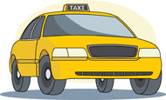
English: taxi  (Am. cab) |  | Slovene: taksi
German: Taxi |  | Norwegian: drosje
French: taxi |  | Portuguese: taxi
Italian:  taxi |  | Greek: Ταξί

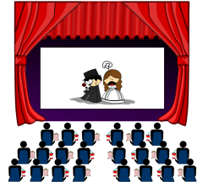
English: theatre  (Am. theater) |  | Slovene: gledališče
German: Theater |  | Norwegian: teater
French: théâtre |  | Portuguese: teatro
Italian:  teatro |  | Greek: Θέατρο

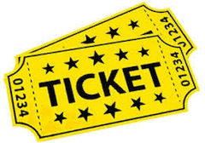
English: ticket |  | Slovene: vstopnica
German: Karte, Eintrittskarte., Fahrkarte |  | Norwegian: billett
French: ticket |  | Portuguese: bilhete
Italian:  biglietto |  | Greek: Εισιτήριο

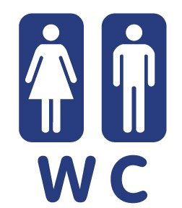
English: toilet, loo  (Am. bathroom, rest room) |  | Slovene: stranišče
German: Toilette |  | Norwegian: toalett
French: toilettes |  | Portuguese: casa de banho
Italian:  Bagno/servizi |  | Greek: Τουαλέτα, Μπάνιο

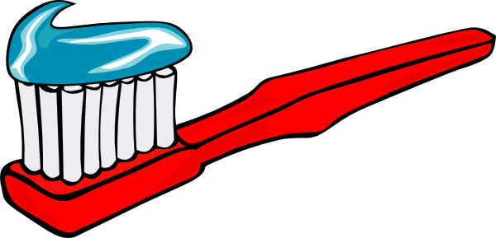
English: toothbrush |  | Slovene: zobna ščetka
German: Zahnbürste |  | Norwegian: tannbørste
French: brosse à dents |  | Portuguese: escova de dentes
Italian:  spazzolino |  | Greek: Οδοντόβουρτσα

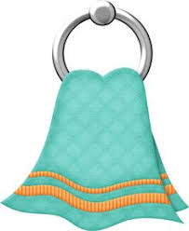
English: towel |  | Slovene: brisača
German: Handtuch |  | Norwegian: hånkle
French: serviette |  | Portuguese: toalha
Italian:  asciugamano |  | Greek: Πετσέτα

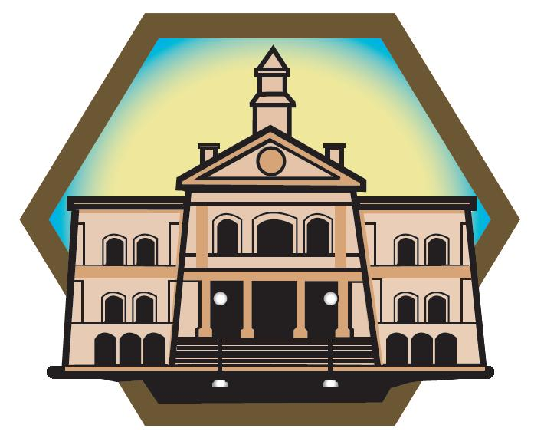
English: town hall, city hall |  | Slovene: mestna hiša
German:Rathaus |  | Norwegian: rådhus
French: mairie |  | Portuguese: Câmara Municipal
Italian:  municipio |  | Greek: Δημαρχείο

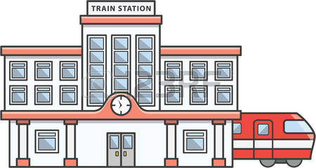
English: train station, railway station |  | Slovene: železniška postaja
German: Bahnhof |  | Norwegian: togstasjon
French: gare (ferroviaire) |  | Portuguese: Estação de comboios
Italian:  Stazione dei treni |  | Greek: Σταθμός Τρένου

English: underground, tube, metro (Am. subway) |  | Slovene: podzemna železnica
German: U-Bahn |  | Norwegian: undergrund
French: métro |  | Portuguese: Metropolotano / Metro
Italian:  metropolitana |  | Greek: Μετρό

English: umbrella |  | Slovene: dežnik
German: Regenschirm |  | Norwegian: paraply
French: parapluie |  | Portuguese: guarda-chuva
Italian:  ombrello |  | Greek: Ομπρέλα

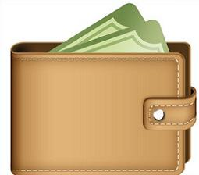
English: wallet  (Am. billfold) |  | Slovene: denarnica
German: Portemonnaie |  | Norwegian: lommebok
French: portefeuille |  | Portuguese: carteira
Italian:  portafoglio |  | Greek: Πορτοφόλι

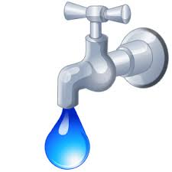
English: water |  | Slovene: voda
German: Wasser |  | Norwegian: vann
French: eau |  | Portuguese: água
Italian:  acqua |  | Greek: Νερό

“This project has been funded with support from the European Commission. This publication [communication] reflects the views only of the author, and the Commission cannot be held responsible for any use which may be made of the information contained therein.”

April, 2018

