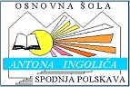

Erasmus+, the border obliterating project

The students of the 8th and the 9th class primary school Anton Ingolič have tirelessly begun with the work for Erasmus+ club and the preparations for the Erasmus+ meetings in the school year 2017/18. We are guided through this project by our encouraging mentors Barbara Jurista, Jana Zadravec, Leon Zajc and the project coordinator Cvetka Govejšek. At our work, we always think about Europe and homeland while answering the question “What does it mean to feel at home in Europe?” which is also the main objective of the project.

First, we introduced the concept of the project and the participating countries to the students at our school. We made presentation posters which are displayed at our school.
Soon after, we started with the preparations for the first meeting that took place on November 26th in Mülheim an der Ruhr, Germany. We prepared the presentation of Slovenia and our school, as well as the video presentation of the students involved in the project. The main subject of the meeting was answering the question “What does homeland mean to you?” After the introductory presentations, all of the participating teachers and students participated in the discussion on the main topic. We continued discussing and working on this broad topic inside the randomly assigned groups. We also started with presentations that we had to prepare in the group by Thursday.

We also visited a lot of interesting places on our trip. We saw the exhibition Nature's Miracles in Gasometer Oberhausen, the city of Cologne, the Camera Obscure Museum, the Zollverein Museum and of course we stopped to do some shopping, including in the biggest shopping centre in Europe. It was unforgettable. Through shared experiences, many new acquaintances have grown into friendship and I am convinced that we will meet again.

After our return, we started preparing for the second meeting. We were enriched with unforgettable experiences and acquaintances from Germany which we have already included in the new presentation video. This new video was also prepared for our new meeting in Thessaloniki, Greece. The meeting took place on April 15th. We discussed a lot about our own point of view and experiences of other, interviewed people, mostly Slovenians, who are living abroad with their families. Our points of view on the topic homeland and neighbourhood are different but we all share the common awareness with a respect to our homeland. After all, this is our home, our common world that we are living in, creating and contributing to our common future.

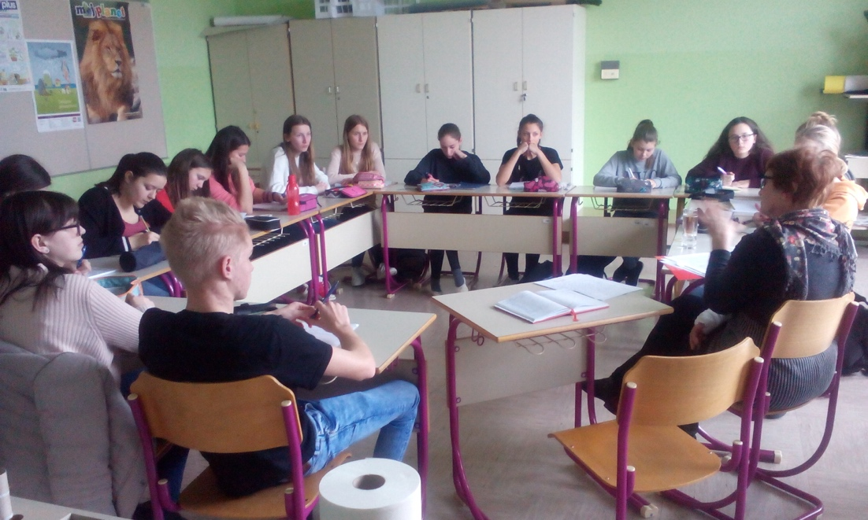

For our second meeting, the anticipated topic was Fugitives and Migrations. Therefore, we had a conversation with our region Red Cross commissioner, Marija Bračič, who has already participated in activities during the fugitive crisis. Mrs. Bračič introduced her own experience among different life circumstances of the people and how they were offered help by the organization. We learned a lot of new things during our interview, despite our previous knowledge of their life tragedies. Knowing the Red Cross mission and the other humanitarian actions, provided by its employees and volunteers, opened us the new horizon towards similar projects in Slovenia and European Union, such as Restoring family links, ESIRAS and others.

The students of our school are very grateful for all the priceless experiences, given to us by contributing to this project, meeting new people, friends and countries. We grow in awareness of the importance of respecting others and how intertwined we are. It is a special privilege to recognize the differences between us, accept and recognize them as opportunities for learning and personal growth.

Lina KOVAČ
OŠ Antona Ingoliča Spodnja Polskava
SLOVENIJA

p.s.
“This project has been funded with support from the European Commission. This publication [communication] reflects the views only of the author, and the Commission cannot be held responsible for any use which may be made of the information contained therein.”

