Stop Motion
We did a stop motion short film. Our topic was a stick man fight. Making a short film was very fun. I took pictures and my friend Valtteri edited. I did a rack, with which I took pictures. All went good.
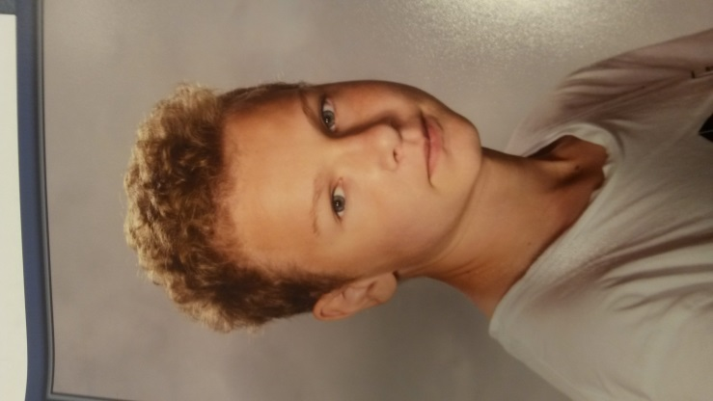
Akseli and Valtteri

