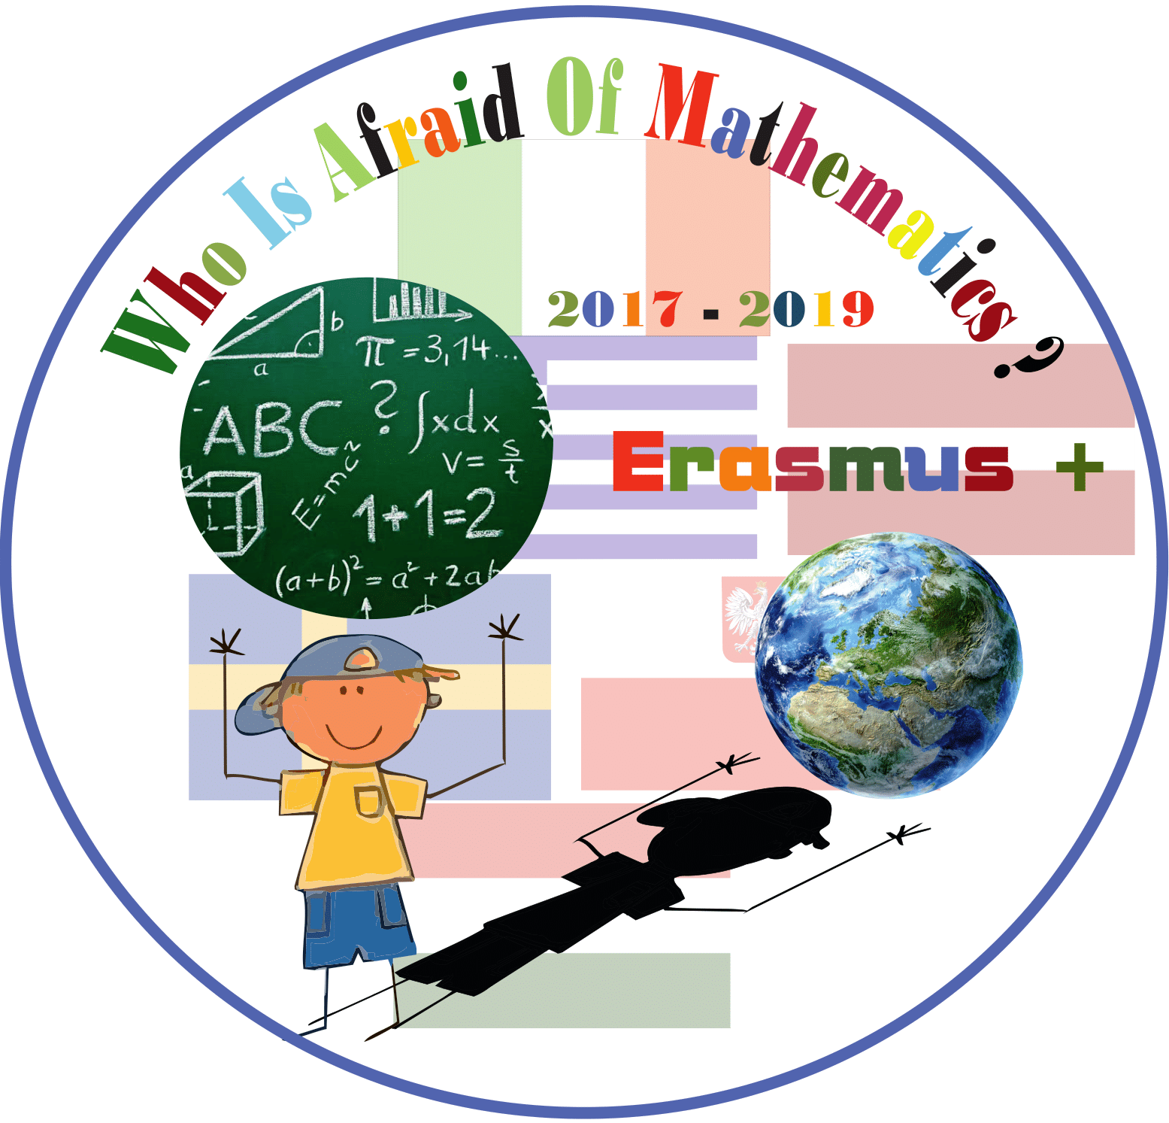

LESSON PLAN

Who is Afraid of Mathematics ?

**Category : MATHS IN HISTORY**

**Title of the activity: From early human counting tools till nowadays**

**Year Group: Grade 4 (9 years old)**

**Learning Objectives:**

**To find out information about the counting tools used in different historical periods.**

**To emphasize that people of different age groups normally use different counting style (from childhood to old age).**

**To encourage students to find information about the topic in different sources.**

**To improve pupils' skills to select and systematize the information.**

**To increase students interest about mathematics in an indirect, understandable way.**

**To provide cross-curricular link.**

**Lesson Description (including context) :**

**Interactive activity, where students learn through co-operation.**

**Students in groups are working on the different topics about counting in history, searching for information, deciding about the way of presentation, making posters and presenting their work to schoolmates**

**Resources:**

**Books.**

**Calculators.**

**Telephone with an internet connection.**

**Paper A1, pencils, markers, toys.**

**Teacher’s Quiz- presentation.**

**Voting cards.**

**Success Criteria:**

Students find out how many different counting styles have been used in history.

Pupils are ready to collaborate to make project about specific topic and to present their ideas to schoolmates.

Students are practicing finding information in books and on the internet.

**Introduction:**

Teacher asks some questions to encourage students to make assumptions about the history of numbers and counting.

Pupils make groups of 4 and choose a topic prepared by teacher.

Before the main lesson students discuss and bring to the classroom all the materials they need for work and presentation.

**Differentiation:** To pay attentione-Are pupils ready to find information about the topic, to systematize and present it? Is internet used for the purpose of the work? Do the group work efficiently? How to keep listeners active?

**Main Lesson (80 min.):**

**1** Teacher asks students to set individual tasks for cooperation in a group- who is going to be Facilitator, Recorder and 2 Presenters. Along with individual group tasks every student is expected to support the work of the team.

2 Students, in previously freely chosen groups of 4, work on the topics:

-Counting in different historical periods;

-How the numbers appeared;

-How people of different age groups count;

-How body parts were used for counting;

-Calculator in history;

-Modern counting devices.

Pupils use the information they have prepared by searching in books and on the internet in order to make posters. All the posters must cover theory and have to be appropriately designed.

3 Teacher sets the timing for group work- 40 minutes and observes efficiency of the work.

4 Students get prepared for presentation and write down 2 questions about the most interesting facts from their presentation to be asked to listeners after teacher’s quiz.

5 Students present their work to schoolmates, answer to the questions about their topic.

6 The quiz. Teacher asks random questions about the topics, showing them on the screen. Pupils vote for the right answer.

Groups in turns ask their prepared questions.

**Plenary : Closing activity helps to revise new information and to keep listeners active. Students evaluate themselves and each other during the presentations.**

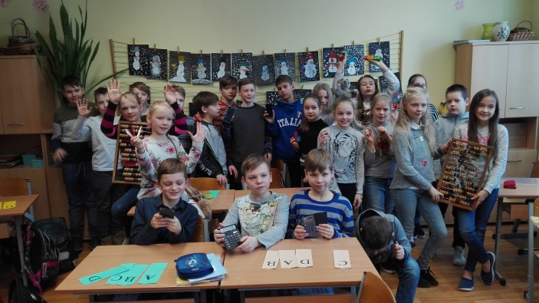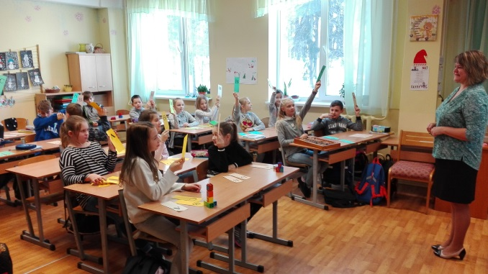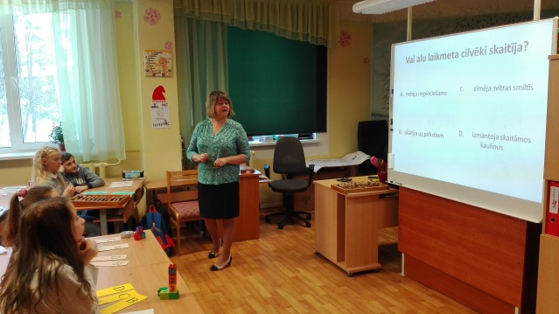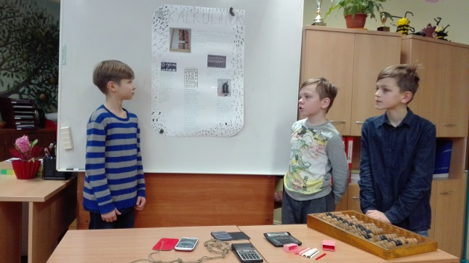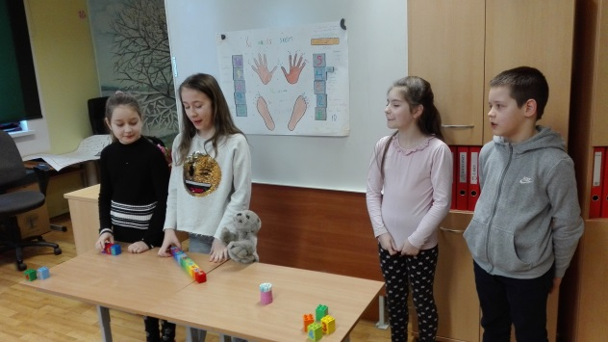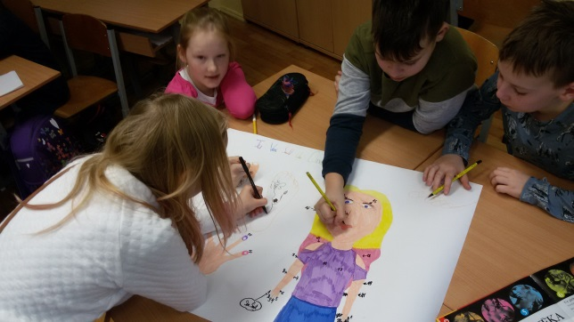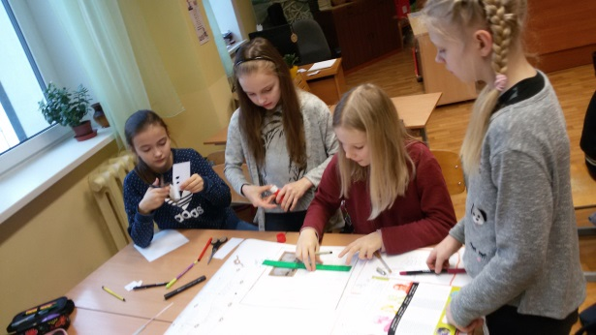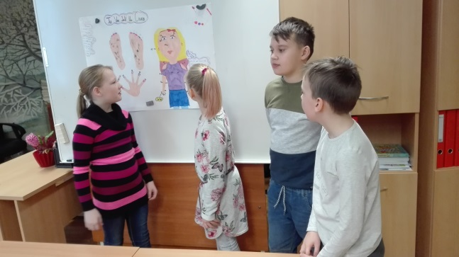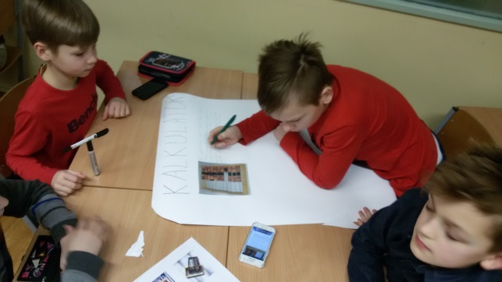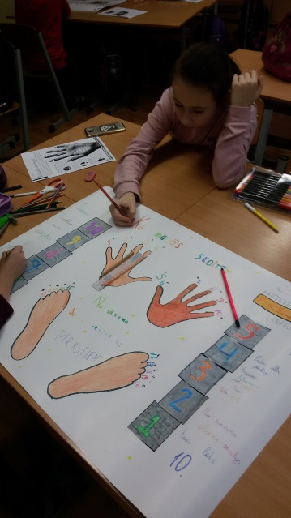

PHOTOS